**Mission Statements:**

* A comprehensive and flexible search engine for rankings of business programs to cater to the needs of aspiring students and academic executives.

**Mission Objectives:**

* Consolidate ranking information from various credible sources allowing users to make better and informed decisions.
* Eliminate uncertainty regarding rankings by providing a weighted rank.
* Assist decision makers of academic institutions to compare rankings of their competitors with their own.
* Conveniently filter rankings based on region, tuition and top five universities.

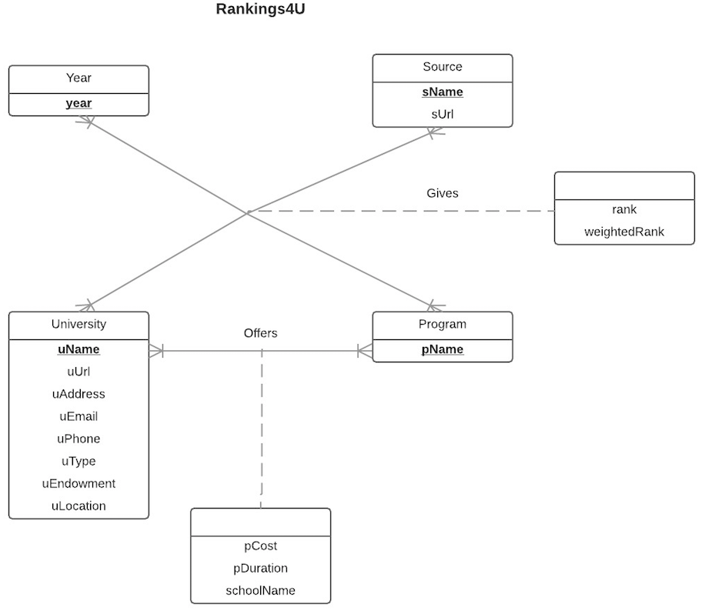

**Finalized Entity Relationship Diagram**

**Relations:**

* Year(**year**)
* Source(**sName**, sUrl**)**
* University(**uName,** uUrl, uEmail, uPhone, uType, uEndowment, uLocation)
* Program(**pName**)
* Gives(**rankId**, *year, sName, uName, pName*, rank, weightedRank)
* Offers(***uName,pName***, pCost, pDuration, , schoolName)

**Functional Dependencies:**

* sName🡪 sUrl
* uName🡪 uUrl, uEmail, uPhone, uType, uEndowment, uLocation
* rankId🡪 year, sName, uName, pName, rank, weightedRank
* uName, pName🡪 pCost, pDuration, schoolName

**Normalization:**

* Year(**year**)= 3NF
* Source(**sName**, sUrl**)** = 3NF
* University(**uName,** uUrl, uEmail, uPhone, uType, uEndowment, uLocation) = 3NF
* Program(**pName**) = 3NF
* Gives(**rankId**, *year, sName, uName, pName*, rank, weightedRank) = 3NF
* Offers(***uName,pName***, pCost, pDuration, , schoolName) = 3NF

**Business Rules:**

1. When a source is deleted from the database, the corresponding ranking information should be deleted from the database.
2. When a source is updated in the database, the corresponding ranking information should be updated in the database.
3. When a year is deleted from the database, the corresponding ranking information should be deleted from the database.
4. When a year is updated in the database, the corresponding ranking information should be updated in the database.
5. When a university is deleted from the database, the corresponding ranking information should be deleted from the database.
6. When a university is updated in the database, the corresponding ranking information should be updated in the database.
7. When a program is deleted from the database, the corresponding ranking information should be deleted from the database.
8. When a program is updated in the database, the corresponding ranking information should be updated in the database.
9. When a program is deleted from the database, the corresponding program information of the university should be deleted from the database.
10. When a program is updated in the database, the corresponding program information of the university should be updated in the database.
11. When a university is deleted from the database, all the corresponding program information of the university should be deleted from the database.
12. When a university is updated in the database, all the corresponding program information of the university should be updated in the database.

**Referential integrity:**

|  |  |  |  |  |  |  |  |
| --- | --- | --- | --- | --- | --- | --- | --- |
| Relation | Foreign Key | Base Relation | Primary Key | Constraint:  ON DELETE | Business  Rule | Constraint:  ON UPDATE | Business  Rule |
| Gives | sName | Source | sName | CASCADE | R1 | CASCADE | R2 |
| Gives | year | Year | year | CASCADE | R3 | CASCADE | R4 |
| Gives | uName | University | uName | CASCADE | R5 | CASCADE | R6 |
| Gives | pName | Program | pName | CASCADE | R7 | CASCADE | R8 |
| Offers | pName | Program | pName | CASCADE | R9 | CASCADE | R10 |
| Offers | uName | University | uName | CASCADE | R11 | CASCADE | R12 |

**Sample Data:**

* Year(**year**)
* Source(**sName**, sUrl**)**
* University(**uName,** uUrl, uEmail, uPhone, uType, uEndowment, uLocation)
* Program(**pName**)
* Gives(**rankId**, *year, sName, uName, pName*, rank, weightedRank)
* Offers(***uName,pName***, pCost, pDuration, schoolName)
* Year:

|  |
| --- |
| **year** |
| 2016 |

* Source:

|  |  |
| --- | --- |
| **sName** | **sUrl** |
| US News | [www.usnews.com](http://www.usnews.com) |

* University:

|  |  |  |  |  |  |  |
| --- | --- | --- | --- | --- | --- | --- |
| uName | uUrl | uEmail | uPhone | uType | uEndowment | uLocation |
|  |  |  |  |  |  |  |
| MIT | web.mit.edu | gradadmissions@mit.edu | (617)324-6730 | Private | 134747,43,000 | West |

* Program:

|  |
| --- |
| **pName** |
| MBA |

* Gives:

|  |  |  |  |  |  |  |
| --- | --- | --- | --- | --- | --- | --- |
| rankId | Year | sName | uName | pName | Rank | weightedRank |
| R001 | 2016 | US News | New York University | MIS | 6 | 95.66 |

* Offers:

|  |  |  |  |  |
| --- | --- | --- | --- | --- |
| uName | pName | pCost | pDuration | schoolName |
| New York University | MIS | 63720 | 2 | Stern |