Readme

1. Software Requirements:
   1. XAMP for windows version 5.6.28
      1. Apache/2.4.23 (Win32) OpenSSL/1.0.2h PHP/5.6.28
2. Application:
   1. Contents of the Source code package:
      1. Home page of the application is index.html.
      2. Action_page.php contains the code for the backend
      3. Folder js contains Javascript files
      4. Folder CSS contains the CSS files for Styling.

To access the source code package please place this file in the localhost folder (htdocs for xampp). Go to localhost/FileName/index.html

* 1. Home Page:



* 1. There are 5 types of searches:
     1. Normal Search
     2. Location Based Search
     3. Fee Base Search
     4. Top 5 Search
     5. University View

**Normal Search:** Normal search allows the user to see the rankings of universities from multiple sources for more than one year for one or more programs. This is a generalized search which allows the user to get an idea about how university rankings compare across years, sources and programs. This search can also be more specific, for example, the user can see how the rankings of a specific university compares across years and sources.

**Sample Business Transaction:**

What are the rankings of MBA program from US News for the year 2015?

The three fields Source, Year and Program can take multiple inputs and hence are implemented using check boxes. The University field is a drop down list where the user can select ‘All universities’ or a single university.

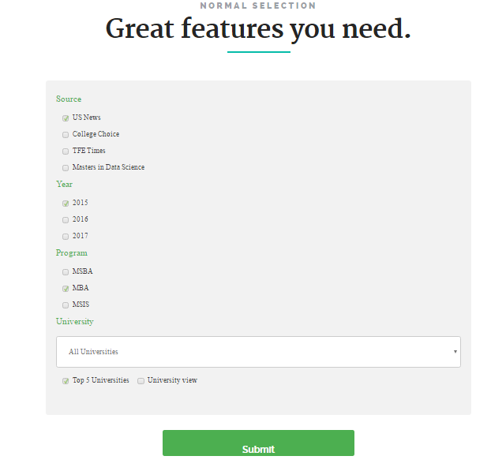

**Result of above selection:**

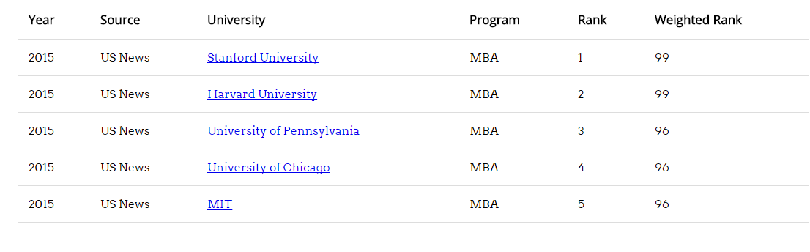

Caution: In the Normal search mode, it is compulsory to select **at least one** input each for source, year and program.

**Top 5 Search:** A ‘Top 5 Universities’ checkbox is implemented which will filter out only the top 5 universities that match your search and then display them ordered by ‘weighted rank’.

Example: Which are the top 5 universities from all sources for the year 2015 for the MSBA Program?

Note: Select the ‘All Universities’ option when performing a top 5 search.

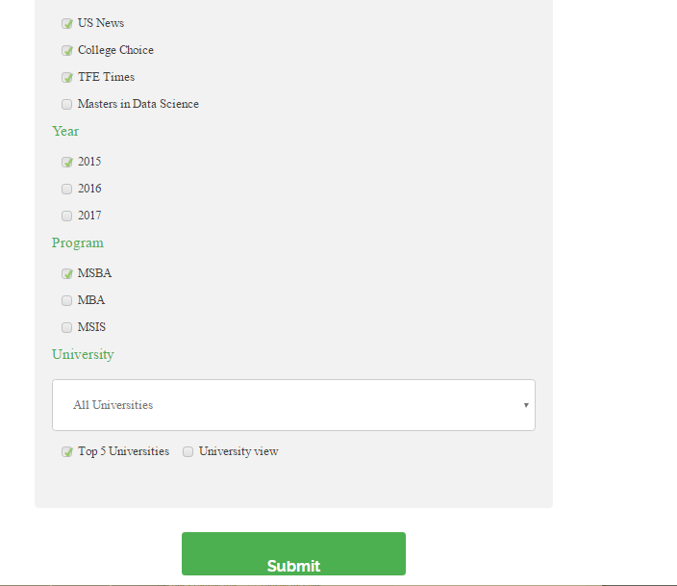

**Result of the Top 5 search:**

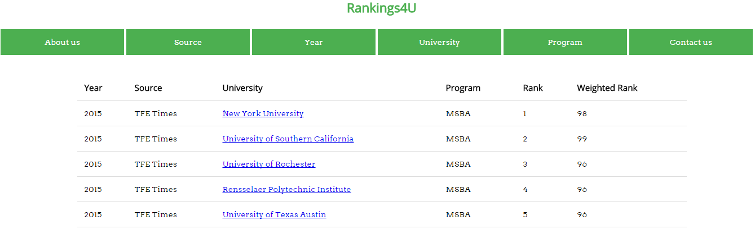

**University View:** The ‘University View’ option will display universities which have a higher or equal rank to the university selected. This is intended to assist the university executives to assess their competition. The user needs to select only one university and appropriate source, year and program to get the universities ranked just above it.

Example: Which are the universities ranked above Michigan State University for MSBA Program, year 2017 from TFE Times?

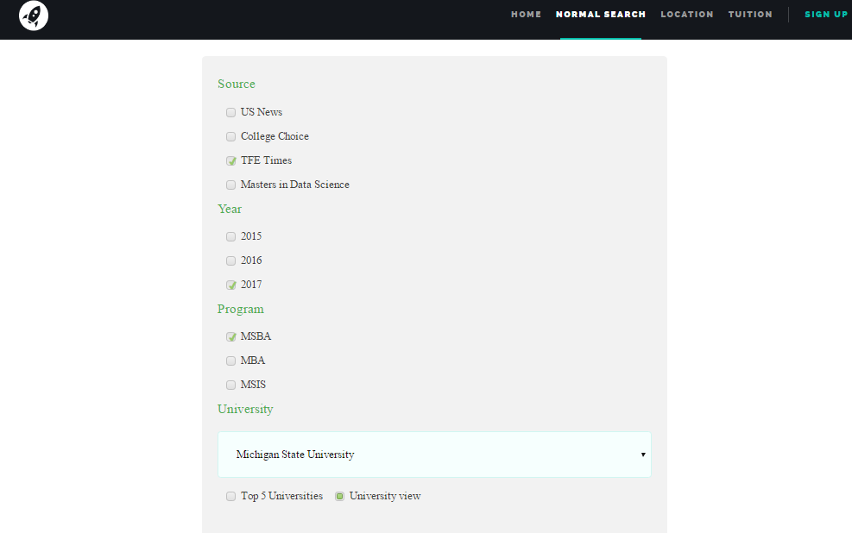

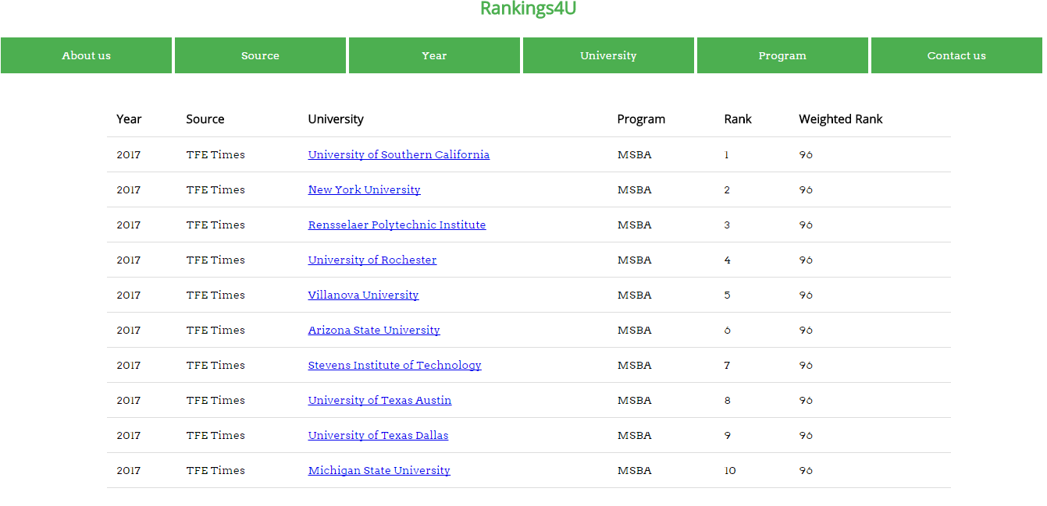

**Location based search:** Location based search allows the user to view all universities and their ranking for a particular program(s) within four different regions of USA: North-East, West, Mid-West and South.

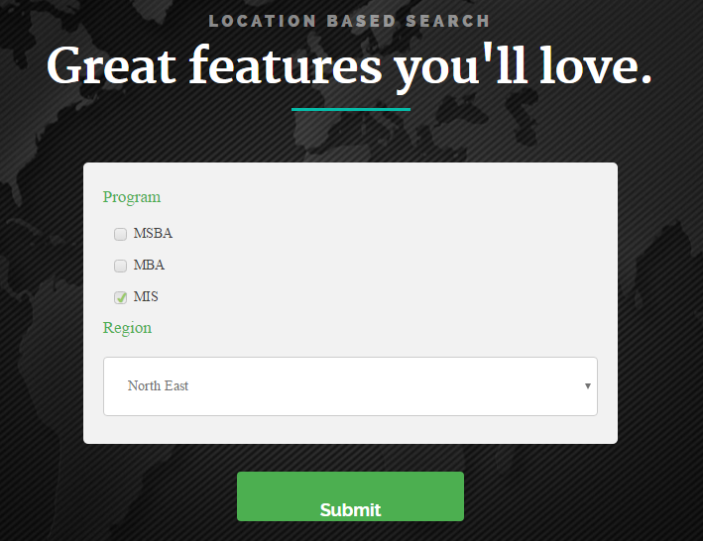

The Program and location preferred are taken as input and the corresponding universities are displayed along with their rankings.

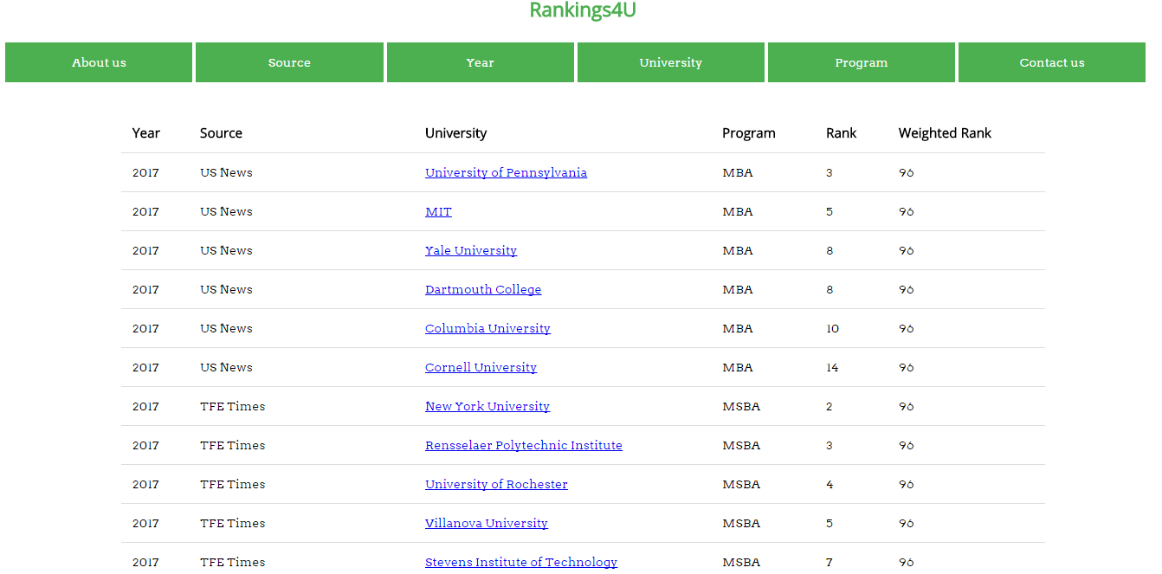**Result of above selection:**

**Tuition fee based search:** The user can view the top universities which fall in his/her affordable range by selecting the minimum and maximum program cost from the drop-down list



**Result of the above selection:**

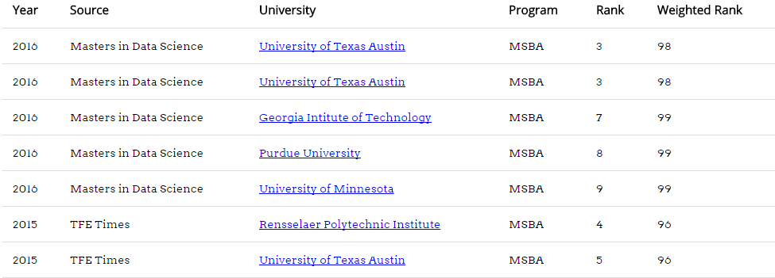

This UI heavily draws upon <http://www.free-css.com/free-css-templates/page206/lhander-1.0>