Technical Documentation
Giuseppe Naso Onofrio

Project: B06 - AI-Assisted MCP Server Exposing a CSV Directory as Data Tables

Goal
Use AI to help design and implement an MCP-compatible server that scans a directory of CSV files and exposes each file as a data source/table via MCP
tools/endpoints (e.g. list tables, describe schema, run simple queries or filtered reads).
Tasks
Design & Implement
Use AI to assist in designing and implementing an MCP server (language of your choice) that:
Reads a configurable directory of CSV files
Exposes each CSV as a named resource/table
Provides at least tools/endpoints to list tables, inspect columns, and retrieve filtered rows (e.g. by column equality or simple predicates).
Test & Demonstrate
Create a small set of example CSV files, connect your MCP server from a compatible client, and demonstrate interactions (listing tables, inspecting schemas,
fetching filtered data), documenting any limitations or edge cases.
AI Usage & Verification Report
Collect and submit the prompts you used with AI and write a short report explaining how you evaluated and corrected the AI-generated code (e.g. validating CSV
parsing, checking protocol compliance, handling malformed input).

Architecture
Java project using the Spring Boot framework. Maven is used for dependency management. Maven is a build automation and project management tool mainly used for Java applications.

Dependences:
Java 25 -- Oracle Open JDK 25.0.1
Spring Boot -- 3.5.8
Spring AI -- 1.1.1
OpenCSV – 5.12.0
Lombok – 1.18.42
Spring Boot Test
Maven – 3.9.11

Build and compilation
If you want to build the project, you must do so via Maven. Using the -- clean install -- command, you can optionally add the -DskipTests parameter to skip tests (junit). After the build, you can run the Spring Boot application using the command (also via Maven) -- spring-boot:run --

For simplicity, if you just want to run the application, a "fat-jar" has been created. You can find it in the git repository under the jar folder. To run it, you just need the jvm and run the command -- java -jar ServerMCP-0.0.1.jar --

TEST
MCP-Ispector was used for end-to-end testing.

Important: If you want to repeat the tests using MCP-Ispector, you must enable the proxy integrated into MCP-Ispector. The URL is http://localhost:8080/mcp.

Important: By default, if you don't specify it in the tool call, the path where the CSV files will be searched is the same as the one where the jar is launched.

Below are some test examples;

Configuring MCP-Inspector connection:
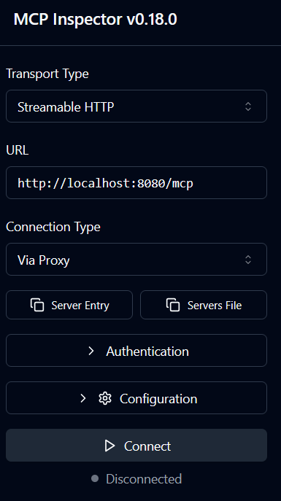

Tool list:
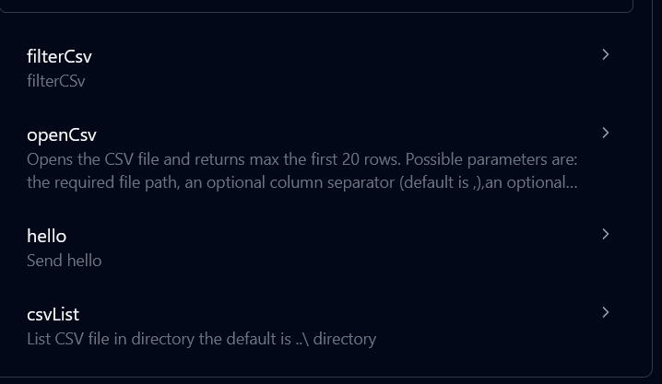

CSV list without passing the path as a parameter, as previously said by default it is the path where the jar is launched :
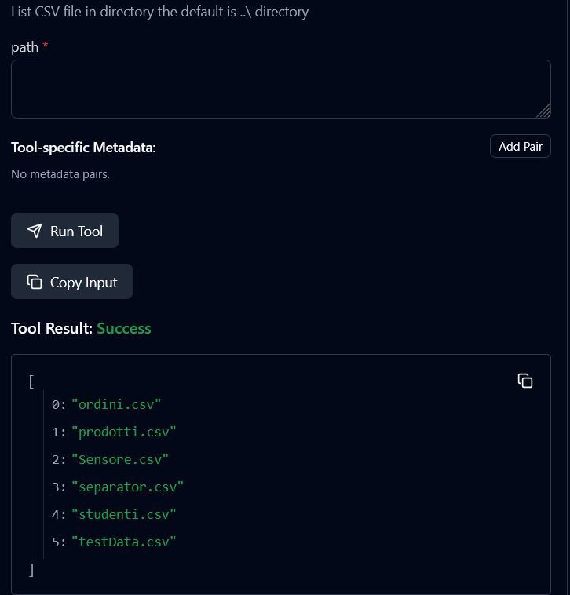

CSV list by passing the path C:\Users\PC\Desktop
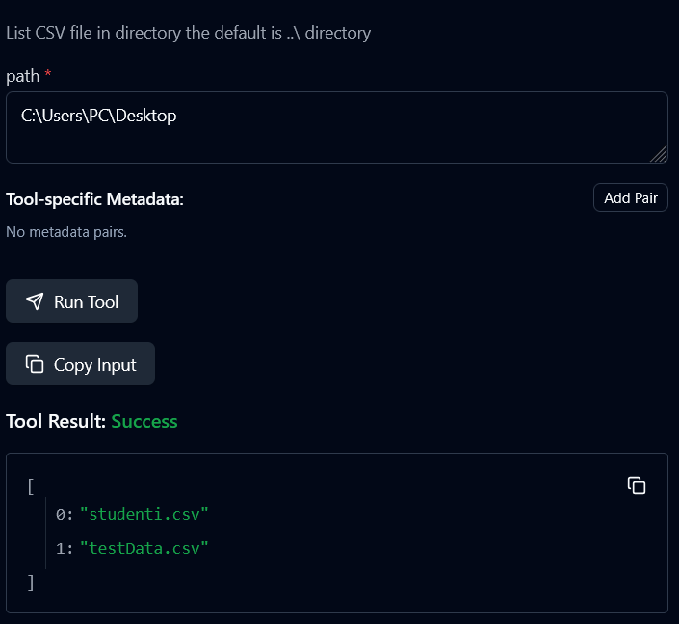

Test opening a CSV with a specified path, with field names in the first row. Showing the first five rows:
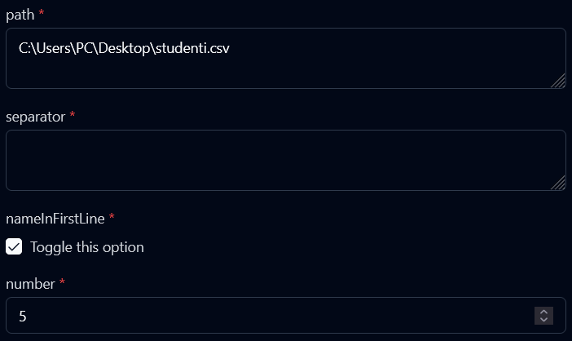

Response:
{
"colunsName": [
"id",
"nome",
"cognome",
"corso",
"anno"
],
"lines": [
[
"1",
"Luca",
"Rossi",
"Informatica",
"1"
],
[
"2",
"Giulia",
"Bianchi",
"Matematica",
"2"
],
[
"3",
"Marco",
"Verdi",
"Fisica",
"3"
],
[
"4",
"Sara",
"Neri",
"Informatica",
"2"
],
[
"5",
"Paolo",
"Gallo",
"Chimica",
"1"
]
]
}

Test opening CSV with separator passed as parameter, in this case it is the semicolon ";". The default is the colon ":"
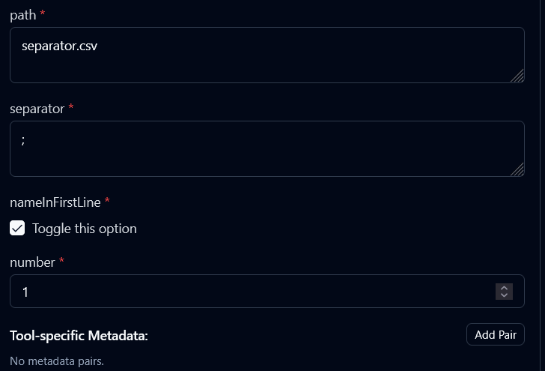
Response:
{
"colunsName": [
"id",
"prodotto",
"categoria",
"quantita",
"scaffale"
],
"lines": [
[
"1",
"Viti 3mm",
"Ferramenta",
"500",
"A1"
]
]
}

CSV Filter Test, As you can see below you have the possibility to apply multiple filters simultaneously per request.
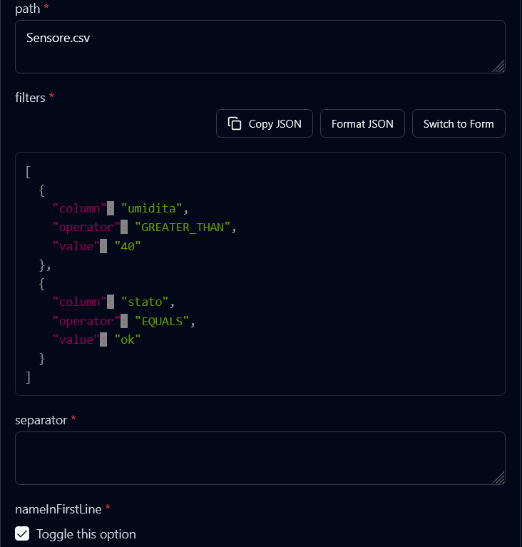
Response:
{
"filtersLines": [
{
"stato": "ok",
"umidita": "45",
"id": "1",
"temperatura": "21.5",
"timestamp": "2024-02-01T10:00"
},
{
"stato": "ok",
"umidita": "44",
"id": "2",
"temperatura": "21.7",
"timestamp": "2024-02-01T10:05"
},
{
"stato": "ok",
"umidita": "43",
"id": "3",
"temperatura": "22.0",
"timestamp": "2024-02-01T10:10"
},
{
"stato": "ok",
"umidita": "42",
"id": "4",
"temperatura": "22.3",
"timestamp": "2024-02-01T10:15"
},
{
"stato": "ok",
"umidita": "41",
"id": "5",
"temperatura": "22.8",
"timestamp": "2024-02-01T10:20"
}
]
}

