AI Output validation
Giuseppe Naso Onofrio

Project: B06 MCP Server

Validation of AI generations

1) I need to develop an MCP Server that exposes a CSV directory as data tables. What is the MCP protocol and what are its main features?

Validations:
MCP (Model Context Protocol) is an open-source standard for connecting AI applications to external systems. Using MCP, AI applications like Claude or ChatGPT can connect to data sources (e.g. local files, databases), tools (e.g. search engines, calculators) and workflows (e.g. specialized prompts)—enabling them to access key information and perform tasks. Think of MCP like a USB-C port for AI applications. Just as USB-C provides a standardized way to connect electronic devices, MCP provides a standardized way to connect AI applications to external systems.

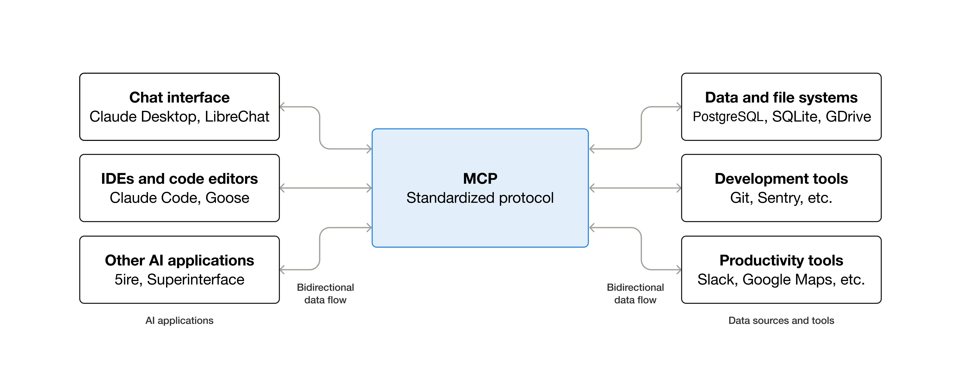

Official sources:
Official MCP Website | https://modelcontextprotocol.io
MCP Specification | https://modelcontextprotocol.io/specification
MCP Documentation | https://modelcontextprotocol.io/docs
GitHub Repository | https://github.com/modelcontextprotocol

2)I need to create a Model Context Protocol (MCP) server with Java, perhaps using Spring Boot. Is there a specific Spring module for this? What are the main features?

Validations:
As defined by the official Spring documentation:
The MCP Server is a foundational component in the Model Context Protocol (MCP) architecture that provides tools, resources, and capabilities to clients. It implements the server-side of the protocol, responsible for:
- Server-side protocol operations implementation
  - Tool exposure and discovery
  - Resource management with URI-based access
  - Prompt template provision and handling
  - Capability negotiation with clients
  - Structured logging and notifications
- Concurrent client connection management
- Synchronous and Asynchronous API support
- Transport implementations:
  - Stdio, Streamable-HTTP, Stateless Streamable-HTTP, SSE

For the project it was decided to use spring-ai-starter-mcp-server-webflux verssion 1.1.2
(maven repository (https://mvnrepository.com/artifact/org.springframework.ai/spring-ai-starter-mcp-server-webflux).

Still referring to the official documentation, the architecture description is correct. Note that the information in layer 6 (Application Layer), particularly when referring to the @McpTool and @McpFunction annotations, is incorrect. Note that these are specific to the MCP Server, but Spring AI also provides the @Tool annotation with more generic functions. (The project decided to use the @Tool annotation.)

Official sources:
1. Java MCP SDK – Documentazione ufficiale
https://modelcontextprotocol.io/clients/java

2. Java MCP SDK – Repository GitHub (include il modulo mcp-spring)
https://github.com/modelcontextprotocol/java-mcp

3. Spring AI – Documentazione ufficiale (sezione MCP)
https://docs.spring.io/spring-ai/reference/api/mcp/mcp-overview.html

4. Building a Model Context Protocol (MCP) Server Using Java and Spring AI
https://www.baeldung.com/spring-ai-mcp-server

5. Model Context Protocol
https://modelcontextprotocol.io/

3)I need to create a Java MCP server with Spring Boot. Can you list all the possible configurations?

Validations:
As defined in the official documentation, reporting the parameters and configurations described by copilote is correct. Note an error when the AI ​​generates "Typical application.yml keys." The properties reported are not in yaml format but in the classic (older) properties format. Below is an example of the yaml structure used in the project.

spring:
ai:
mcp:
server:
protocol: STREAMABLE

Official sources:
1) Spring ai module spring-ai-starter-mcp-server-webflux doc
https://docs.spring.io/spring-ai/reference/api/mcp/mcp-server-boot-starter-docs.html

2) Spring ai Streamable-HTTP MCP Servers
https://docs.spring.io/spring-ai/reference/api/mcp/mcp-streamable-http-server-boot-starter-docs.html

4)Can you give me a diagram that contains a comparison between the main features?
Available transports
• STDIO server (default for local tools)
• SSE server (Server-Sent Events)
• Streamable-HTTP server (bidirectional streaming over HTTP)
• Stateless HTTP server (no persistent session)

Validations:
As defined in the official documentation, the characteristics of the various "ways" to create the MCP server are correct. Specifically, for the project, it was decided to create a Streamable HTTP MCP server. Its main features are: Bidirectional Communication on a Single Endpoint: Unlike SSE, which required separate endpoints for requests and responses, Streamable HTTP manages both requests (via HTTP POST) and streaming responses (via optional SSE) on a single endpoint, simplifying configuration and management. Stateful and Stateless Session Management: Stateful Session Management: Supports the establishment of stateful sessions, allowing for the resumption of broken connections and the redelivery of potentially lost messages (resumability and redelivery). Stateless Streamable HTTP: Offers a stateless subset of the protocol, ideal for scalable microservices architectures, where session state is not maintained between requests. Integration with Existing HTTP Infrastructures: Standard HTTP-based design improves compatibility with existing network infrastructures, API gateways, and load balancers. Support for Complete MCP Features: Streamable HTTP supports all MCP features, including tools exposure and discovery, resource management, prompt patterns, structured logging, and progress notifications. Flexible Implementations: Spring AI provides implementations based on JDK Servlet, Spring WebMVC, and Spring WebFlux, offering flexibility in choosing the right technology stack. Reliable Connection Management: Includes features for reliable, long-lasting connections, such as configurable session pings and improved error handling with automatic retries. Streamable HTTP support is available in recent Spring AI releases, starting with 1.1.0-M1, and is the recommended transport method for new applications requiring real-time, highly responsive AI interactions.

Official sources:
1) STDIO
https://docs.spring.io/spring-ai/reference/api/mcp/mcp-stdio-sse-server-boot-starter-docs.html

2) SSE
https://docs.spring.io/spring-ai/reference/api/mcp/mcp-stdio-sse-server-boot-starter-docs.html

3) Streamable-HTTP
https://docs.spring.io/spring-ai/reference/api/mcp/mcp-streamable-http-server-boot-starter-docs.html

2) Stateless HTTP
https://docs.spring.io/spring-ai/reference/api/mcp/mcp-stateless-server-boot-starter-docs.html

5)I am using spring-ai-starter-mcp-server I am creating a mcp server and I need to create a helloWord example tool and create a simple junit

Validations:
Although the generated code is syntactically and likely semantically correct, the AI ​​in this case doesn't take into account the fact that Spring Boot is being used. It simply generates a class with a tool (using Spring AI), which, however, is not included in the Spring context. Again, it generates the application.yml file, which is not in yaml format. In the project, we decided not to use this approach but to create a Bean (Service) containing all the tools and to use the more generic @Tool annotation. This way, when the Spring Boot application is started automatically via component scan, the class annotated with @Service is "found" and the bean is created in context. As for the test, even if syntactically and semantically correct, it cannot be used. We decided to use the spring-boot-starter-test module, which provides the junit version 5 (Jupiter) dependency and the @SpringBootTest annotation, which allows us to create tests using the Spring context.
Note: The project created unit tests, not end-to-end tests, so ONLY the tool logic was tested, not the entire server. The end-to-end server tests were performed using mcp-ispector (see the project's readme).

6)I need to create tools to open and manage CSV files. Can you provide me with an image that describes the main features of the CSV management libs, perhaps with a table? Remember, I'm using Java 25 with Springboot.

7)for each detail more technically the characteristics, enter all the information in a tab and make an image of it

Validations:
As you can see from the generated table, there are many options, although for the purpose of the project, a simple CSV reader with simple filters, one might say they're as good as another. Note that for very large CSVs, this wouldn't be the correct approach; you should consider creating a batch. The generated information is essentially correct (see official sources below). For this project, we chose to use the OpenCSV library for its ease of integration into Spring Boot and ease of use. We won't use its specific annotations for direct parsing in Pojo classes, as neither the number of fields nor the field names are known a priori.

Official sources:
1) OpenCSV https://opencsv.sourceforge.net/

2)Apache CommonsCSV https://commons.apache.org/proper/commons-csv/

3)Univocity-parser https://github.com/uniVocity/univocity-parsers?tab=readme-ov-file

4)JacksonCSV https://docs.oracle.com/en/cloud/saas/analytics/25r4/fawlg/FasterXMLLLC_jackson-dataformat-csv.html

5)SuperCSV https://super-csv.github.io/super-csv/index.html

8)I chose OpenCSV. Can you give me an example to manage a CSV file and create simple filters?
Note: I don't know the number of fields or even their names in advance.

Validations:
The proposed solution for handling CSV files with OpenCSV—especially when the number and names of fields are unknown in advance—is correct, appropriate, and aligned with OpenCSV’s capabilities.

1. Use of CSVReaderHeaderAware
The explanation correctly states that OpenCSV’s bean-mapping features cannot be used when column names or positions are unknown. Using CSVReaderHeaderAware is the right choice because it:
- automatically reads the header row
- maps each subsequent row into a Map<String, String>
- supports dynamic and irregular CSV structures
The provided DynamicCsvService implementation is valid, idiomatic Java and correctly handles:
- unknown column names
- variable numbers of fields
- missing or extra values
- non-uniform CSV rows
The loop using reader.readMap() is the recommended approach for dynamic CSV parsing.
2. Generic Filtering Logic
The filtering method is also correct. Since the schema is unknown, filtering by column name and value is the most flexible strategy. The use of Java Streams and equalsIgnoreCase is appropriate and produces clean, readable code. But the logic implemented in the end will not be exactly this, as it was decided to give the possibility of applying multiple filters at the same time.

Official sources:
1)Doc https://opencsv.sourceforge.net/apidocs/com/opencsv/CSVReaderHeaderAware.html?utm_source=copilot.com
https://opencsv.sourceforge.net/apidocs/com/opencsv/CSVReader.html?utm_source=copilot.com

2)Example https://www.baeldung.com/opencsv?utm_source=copilot.com

8)To perform end-to-end tests, can you list the main MCP clients and their features?

Validations:
Among the various options, we decided to use MCP-Inspector because It enables quick debugging of MCP servers with clear visibility into tools, prompts, and resources. It provides direct access to raw protocol messages for accurate troubleshooting. It supports interactive testing of tools and schema validation. It requires no installation and works immediately via a simple command. Suitable for both local and remote development workflows. It also provides a proxy: The MCP-Inspector proxy serves as an intermediary between your MCP client and the MCP server you want to analyze. Its function is very simple but fundamental: it intercepts all protocol traffic. What the proxy does in practice It receives client requests (tool calls, resource requests, initialization messages). It forwards them to the real MCP server without modification. It captures server responses and sends them back to the client. It displays each message in clear text in the MCP-Inspector interface, so you can see exactly what is being sent and received. Why it's useful It allows you to debug the MCP protocol without touching the client or server code. It exposes errors, JSON payloads, parameters, and responses that would normally remain hidden. It makes it easier to understand the behavior of the MCP server during development.

Official sources:
1)MCP-ISPECTOR https://modelcontextprotocol.io/docs/tools/inspector

