Relevant Prompts
Giuseppe Naso Onofrio

Project: B06 MCP Server

List of the most relevant propmpts. the AI ​​used is Copilote (the free version)

1) I need to develop an MCP Server that exposes a CSV directory as data tables. What is the MCP protocol and what are its main features?

Copilote: (Excerpt from the response)
The Model Context Protocol (MCP) is an open, language-agnostic, bidirectional client–server protocol designed to let LLM-based applications communicate with external tools, data sources, and runtime environments in a standardized, structured, and secure way. It was introduced by Anthropic in 2024 and is now supported by multiple AI vendors.
- MCP uses a JSON-RPC–like message protocol over a transport (typically stdio, WebSockets, or process pipes).
- The client is usually an LLM host (e.g., ChatGPT, Claude Desktop, VS Code extension).
- The server exposes:
  - Tools (functions the LLM can call)
  - Resources (structured data sources)
  - Prompts (templated instructions)
  - Sampling endpoints (optional)

2)I need to create a Model Context Protocol (MCP) server with Java, perhaps using Spring Boot. Is there a specific Spring module for this? What are the main features?

Copilote: (Excerpt from the response)
Yes — Spring Boot does have a specific module for MCP servers.
It’s provided through Spring AI and built on top of the official MCP Java SDK.** The module is called mcp-spring (part of Spring AI’s MCP support). Sources:

Spring AI MCP Server Starter
This is part of the Spring AI ecosystem and is built on the official Java SDK for MCP.
- Module: mcp-spring
- Repository: Official MCP Java SDK (maintained with Spring AI)
- Documentation: Spring AI “Getting Started with MCP” guide
This module allows you to build an MCP server using standard Spring Boot idioms (annotations, auto-configuration, dependency injection).

What MCP Support in Spring Boot Provides
According to Spring AI documentation and the MCP Java SDK, the main features include:
A. Auto-configured MCP Server
Spring Boot automatically configures:
- MCP server lifecycle
- Transport (JSON-RPC over stdio or WebSocket)
- Tool registration
- Resource providers
- Prompt templates
Source: Spring AI MCP guide

Architecture Overview
Based on the official documentation:
Layer 1 — MCP Protocol
- Implementato dall’MCP Java SDK ufficiale.
- Gestisce: specifica MCP, JSON-RPC, tools, resources, prompts.
- Garantisce compatibilità con client MCP (Claude, Cursor, ecc.).
Layer 2 — Spring Integration (mcp-spring)
- Modulo di integrazione fornito da Spring AI.
- Aggiunge: auto-configurazione, gestione del lifecycle, dependency injection.
- Espone annotazioni per definire tools e resources in stile Spring.
Layer 3 — Spring Boot Starter
- Starter dedicato: spring-ai-mcp-server-spring-boot-starter.
- Fornisce configurazione automatica, properties, discovery dei componenti MCP.
- Riduce al minimo la configurazione manuale.
Layer 4 — Application Layer (Your App)
- Qui definisci la logica applicativa.
- Implementi tools MCP tramite annotazioni (@McpTool, @McpFunction).
- Definisci resource providers, prompt templates e servizi personalizzati.

3)I need to create a Java MCP server with Spring Boot. Can you list all the possible configurations?

Copilote: (Excerpt from the response)
All Possible Configuration Options for a Java MCP Server (Spring Boot)
Below is the authoritative list of configuration categories, with details and citations to the official sources.
1. Transport Configuration (STDIO, SSE, Streamable-HTTP, Stateless)
Spring Boot MCP Server Boot Starter supports multiple transports automatically.
Available transports
- STDIO server (default for local tools)
- SSE server (Server-Sent Events)
- Streamable-HTTP server (bidirectional streaming over HTTP)
- Stateless HTTP server (no persistent session)
Configurable parameters
- Port
- Path prefix
- Enable/disable specific transports
- Threading model (sync/async)
- Connection concurrency limits

3. Tool Configuration
Tools are the core of an MCP server.
Configurable tool parameters
- Tool name
- Description
- Input schema (JSON Schema)
- Output schema
- Execution mode (sync/async)
- Timeout
- Error handling strategy
- Tool categories (optional metadata)
- Tool visibility (public/private)
Spring Boot auto-configures tools via:
- @McpTool annotation
- Component scanning
- Manual registration via McpServerBuilder

4. Resource Configuration
Resources expose structured data via URIs.
Configurable resource parameters
- Resource URI pattern
- MIME type
- Resource provider implementation
- Resource listing behavior
- Resource read/write permissions
- Caching strategy
- Pagination behavior

5. Prompt Template Configuration
Prompts can be exposed as reusable templates.
Configurable prompt parameters
- Prompt name
- Description
- Input variables
- Template engine (string, handlebars, etc.)
- Output format
- Prompt categories
6. Server Runtime Configuration
These settings control the server’s behavior.
Configurable runtime parameters
- Max concurrent requests
- Request timeout
- Logging level
- Structured logging format
- Progress reporting granularity
- Notification throttling
- Exception mapping strategy
7. Spring Boot Auto-Configuration Properties
From the Spring AI MCP Server Boot Starter documentation
.
Typical application.yml keys

spring.ai.mcp.server.enabled=true
spring.ai.mcp.server.transport.stdio.enabled=true
spring.ai.mcp.server.transport.http.enabled=true
spring.ai.mcp.server.transport.http.port=8085
spring.ai.mcp.server.transport.sse.enabled=true
spring.ai.mcp.server.tools.auto-detect=true
spring.ai.mcp.server.resources.auto-detect=true
spring.ai.mcp.server.prompts.auto-detect=true
spring.ai.mcp.server.logging.structured=true
spring.ai.mcp.server.protocol-version=2024-11-05

10. Advanced Configuration
Concurrency
- Thread pool size
- Async executor configuration
Serialization
- JSON serializer (Jackson customization)
- Schema validation strictness
Observability
- Metrics
- Tracing
- Structured logs

4)Can you give me a diagram that contains a comparison between the main features?
Available transports
• STDIO server (default for local tools)
• SSE server (Server-Sent Events)
• Streamable-HTTP server (bidirectional streaming over HTTP)
• Stateless HTTP server (no persistent session)

Copilote: (Excerpt from the response)
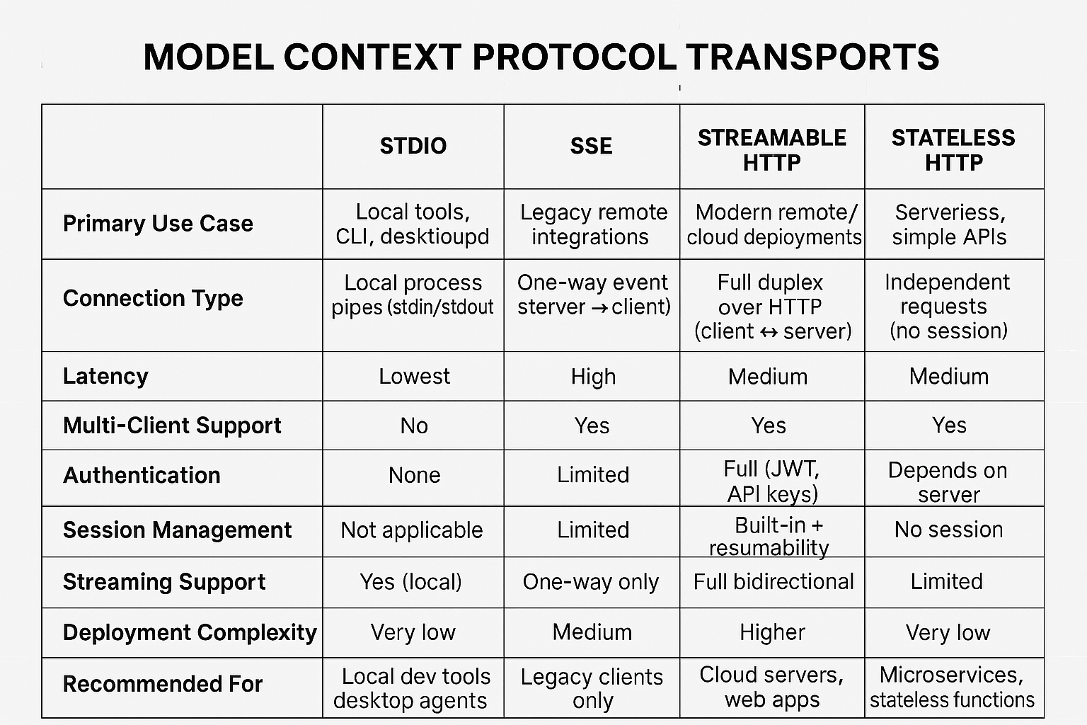

5)I am using spring-ai-starter-mcp-server I am creating a mcp server and I need to create a helloWord example tool and create a simple junit

Copilote: (Excerpt from the response)
Perfect! Here's a complete HelloWorld MCP tool implementation using spring-ai-starter-mcp-server, along with a simple JUnit test to verify it. This example uses Spring Boot auto-configuration and MCP annotations.

Step 1: Define the HelloWorld Tool
java
package com.example.mcpserver.tools;
import org.springframework.ai.mcp.tool.McpTool;
import org.springframework.ai.mcp.tool.ToolContext;
import org.springframework.ai.mcp.tool.ToolFunction;
@McpTool(name = "helloWorld", description = "Returns a greeting message")
public class HelloWorldTool {
@ToolFunction
public String greet(ToolContext context) {
return "Hello from MCP Server!";
}
}
@McpTool: Registers the class as an MCP tool.
- @ToolFunction: Marks the method as callable by the model.
- ToolContext: Provides metadata (caller, session, etc.) if needed.

Step 2: Enable MCP Server in application.yml
yaml
spring.ai.mcp.server.enabled: true
spring.ai.mcp.server.transport.http.enabled: true
spring.ai.mcp.server.transport.http.port: 8080
spring.ai.mcp.server.tools.auto-detect: true

Step 3: Create a Simple JUnit Test
java
package com.example.mcpserver;
import com.example.mcpserver.tools.HelloWorldTool;
import org.junit.jupiter.api.Test;
import static org.junit.jupiter.api.Assertions.*;
public class HelloWorldToolTest {
@Test
public void testGreet() {
HelloWorldTool tool = new HelloWorldTool();
String result = tool.greet(null); // ToolContext is optional here
assertEquals("Hello from MCP Server!", result);
}
}
Uses JUnit 5 (@Test)
- Verifies the output of the tool method

Step 4: Run the MCP Server
Once you start the Spring Boot app, the MCP server will expose the helloWorld tool automatically. You can invoke it from any MCP-compatible host (Claude, VS Code, etc.).

6)I need to create tools to open and manage CSV files. Can you provide me with an image that describes the main features of the CSV management libs, perhaps with a table? Remember, I'm using Java 25 with Springboot.

Copilote: (Excerpt from the response)
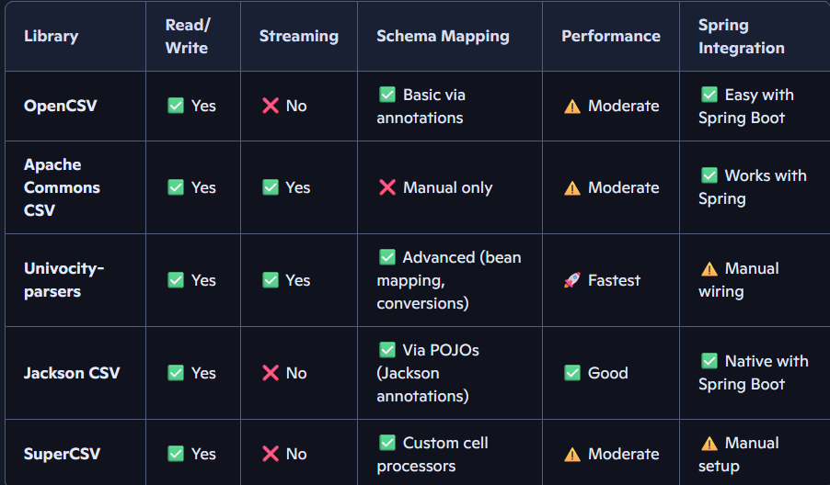

7)for each detail more technically the characteristics, enter all the information in a tab and make an image of it

Copilote: (Excerpt from the response)
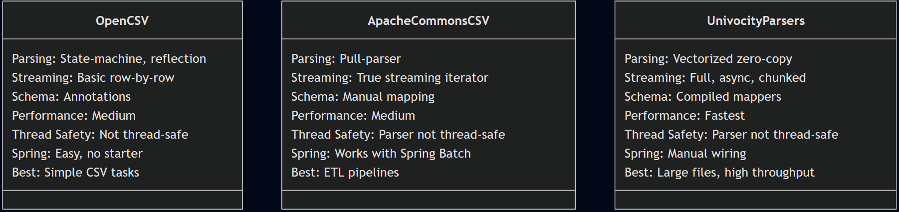
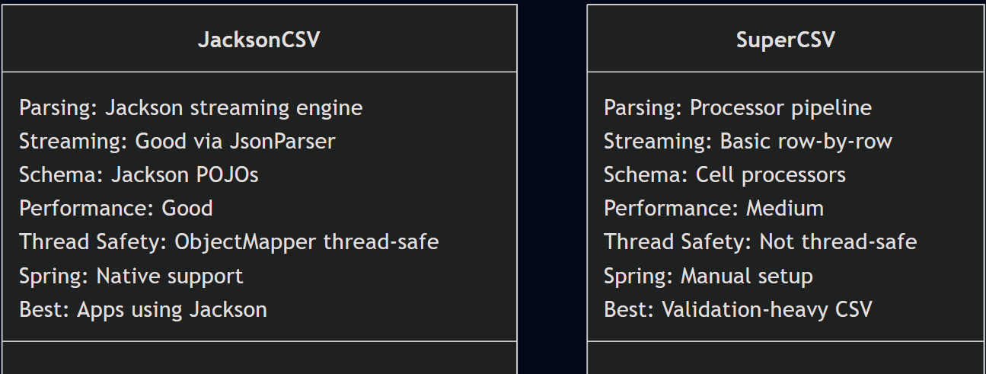

8)I chose OpenCSV. Can you give me an example to manage a CSV file and create simple filters?
Note: I don't know the number of fields or even their names in advance.

Copilote: (Excerpt from the response)
If you don’t know the number of fields or their names in advance, then you cannot use OpenCSV’s bean-mapping (@CsvBindByName, @CsvBindByPosition). Instead, you must use OpenCSV’s “CSVReader” or “CSVReaderHeaderAware”, which lets you work with:
- dynamic headers
- dynamic number of columns
- dynamic row structures
Below is a clean, robust approach that works with any CSV, regardless of structure.

1. Read a CSV with Unknown Columns (Dynamic Headers)
This version loads the CSV into a list of Map<String, String>, where:
- the key = column name
- the value = cell value

java
import com.opencsv.CSVReaderHeaderAware;
import org.springframework.stereotype.Service;
import java.io.FileReader;
import java.util.*;
@Service
public class DynamicCsvService {
public List<Map<String, String>> loadCsv(String path) {
try (CSVReaderHeaderAware reader = new CSVReaderHeaderAware(new FileReader(path))) {
List<Map<String, String>> rows = new ArrayList<>();
Map<String, String> row;
while ((row = reader.readMap()) != null) {
rows.add(row);
}
return rows;
} catch (Exception e) {
throw new RuntimeException("Error reading CSV", e);
}
}
}
Works with:
- unknown number of columns
- unknown column names
- missing or extra fields
- irregular CSVs

2. Filter Rows by Any Column (Dynamic Filtering)
Since you don’t know the fields, filters must be generic.
Filter by column name + value

java
public List<Map<String, String>> filterEquals(
List<Map<String, String>> data,
String column,
String value
) {
return data.stream()
.filter(row -> value.equalsIgnoreCase(row.get(column)))
.toList();
}

JUnit Test for Dynamic CSV

java
import org.junit.jupiter.api.Test;
import java.util.List;
import java.util.Map;
import static org.junit.jupiter.api.Assertions.*;
public class DynamicCsvServiceTest {
private final DynamicCsvService service = new DynamicCsvService();
@Test
void testLoadCsv() {
List<Map<String, String>> rows =
service.loadCsv("src/test/resources/people.csv");
assertFalse(rows.isEmpty());
assertTrue(rows.get(0).containsKey("name"));
}
}

8)To perform end-to-end tests, can you list the main MCP clients and their features?

Copilote: (Excerpt from the response)

MCP Client | Tools | Resources | Prompts | Roots | Sampling | Message Inspector | Notes
Claude Desktop | ✅ | ✅ | ✅ | ✅ | ❌ | ❌ | Best full-featured client
Cline | ✅ | ❌ | ❌ | ❌ | ❌ | ❌ | Lightweight tool tester
Cursor | ✅ | ❌ | ❌ | ❌ | ❌ | ❌ | Tool-only testing
Copilot-MCP | ✅ | ❌ | ❌ | ❌ | ❌ | ❌ | GitHub Copilot integration
Emacs MCP | ✅ | ❌ | ❌ | ❌ | ❌ | ❌ | Emacs plugin
GenAIScript | ✅ | ❌ | ❌ | ❌ | ❌ | ❌ | Script automation
5ire | ✅ | ❌ | ❌ | ❌ | ❌ | ❌ | Desktop assistant
Firebase Genkit | ⚠️ | ⚠️ | ⚠️ | ❌ | ❌ | ❌ | Partial support
Goose | ❌ | ❌ | ❌ | ❌ | ❌ | ❌ | Listed but no support
MCP-Inspector | ✅ | ✅ | ✅ | ⚠️ | ❌ | ✅ Full inspector | Best debugging client

Recommended Clients for End-to-End Testing
1. MCP-Inspector (Best for debugging)
Use this to validate:
- tool schemas
- dynamic CSV filters
- resource listing
- error handling
- raw MCP messages
2. Claude Desktop (Best for real-world usage)
Use this to test:
- prompts
- resources
- roots
- multi-step workflows
3. Cline or Cursor (Quick tool testing)
Use these to verify:
- tool input/output
- JSON schema correctness

