Instructions for updating the Chronopic chip.
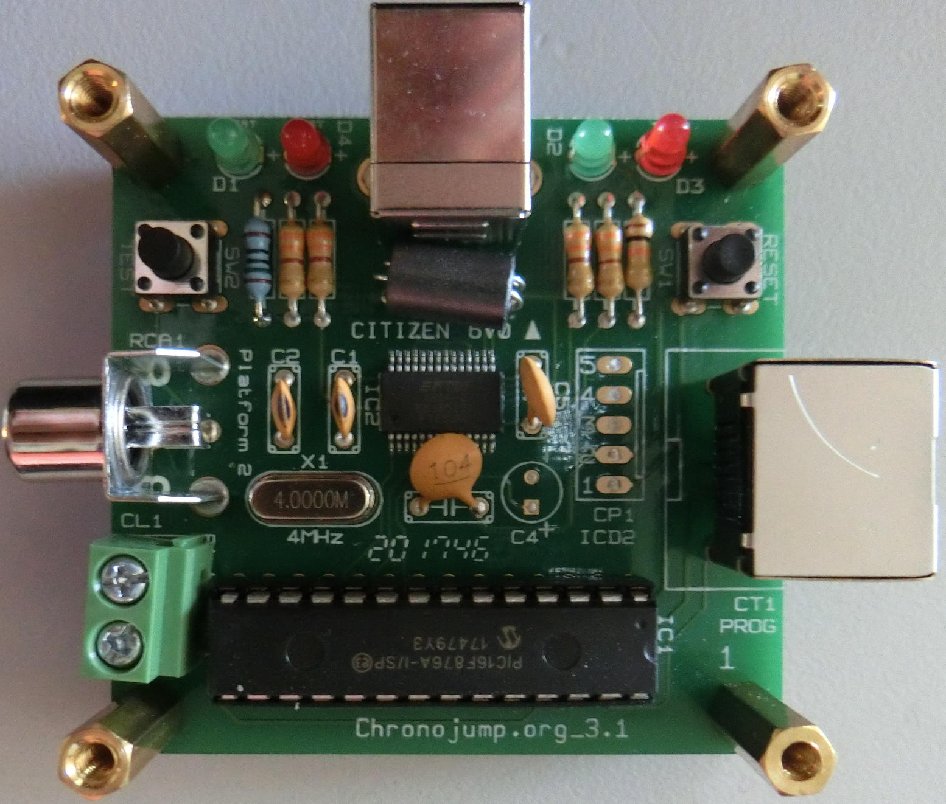 | Remove the upper cap with a star screwdriver
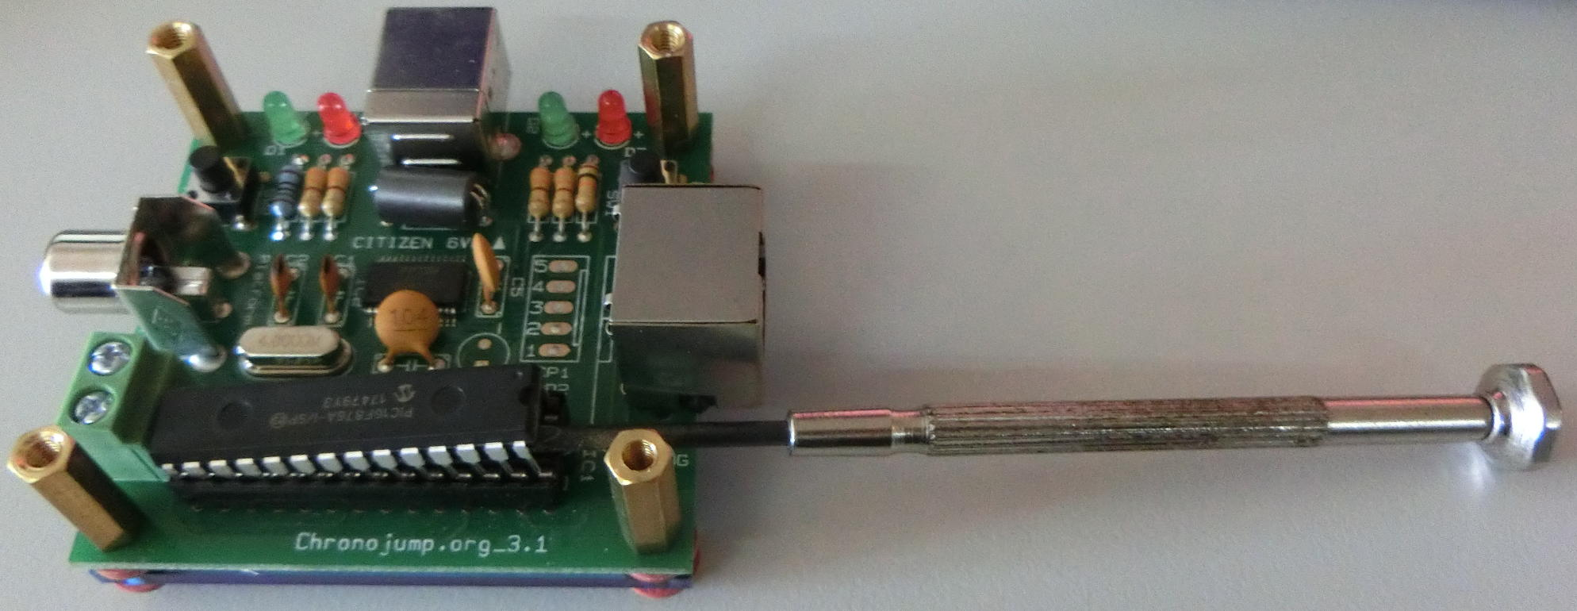 | Insert a thin flat screw under the chip
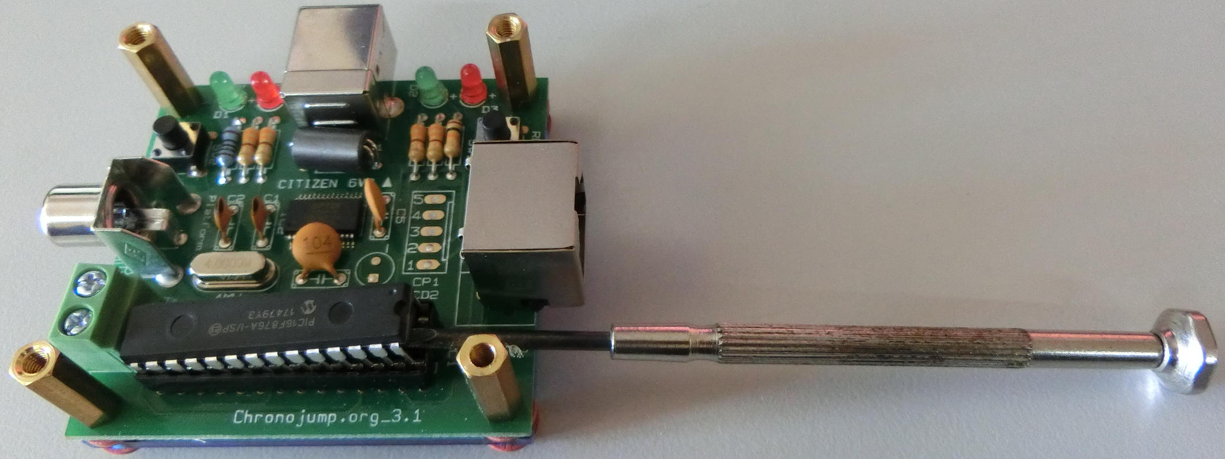 | Use the screw as a lever to detach the chip
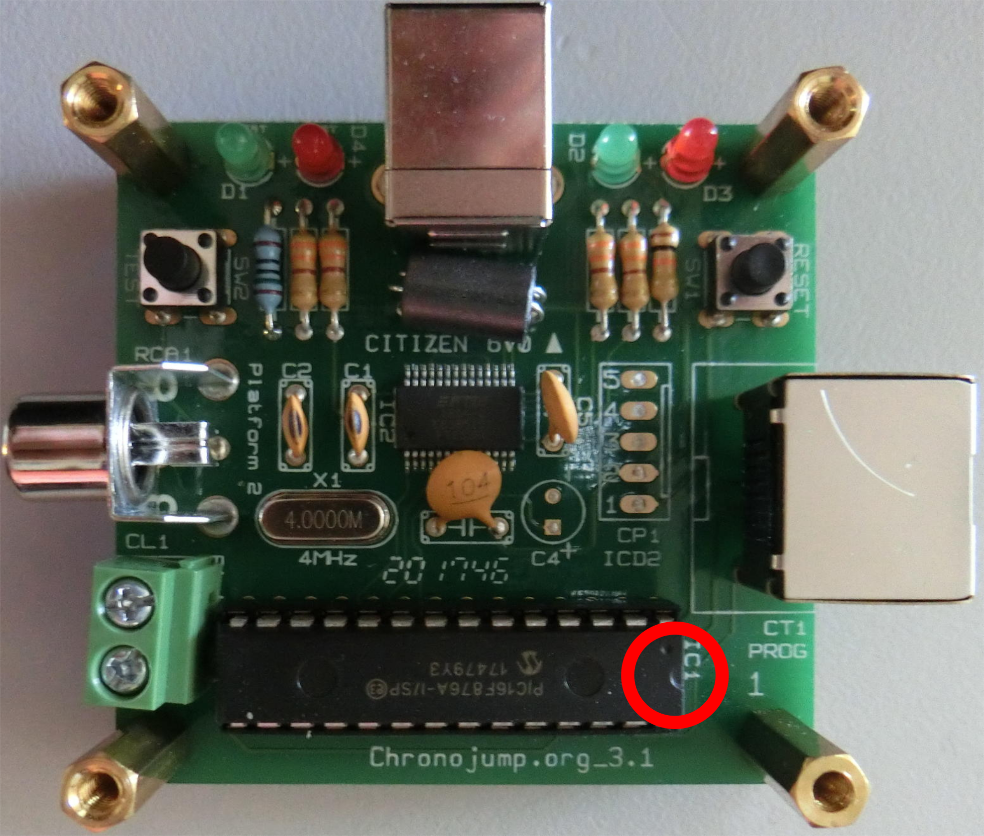 | Remove the chip and insert the new chip taking care that the notch is in the correct side and making sure that all the pins enter vertically.

