For updating the Chronopic firmware you will need a Windows PC. If you are using a Macintosh you will need a Windows on a partition, a virtual machine (Parallels, VirtualBox or VMWare) or another PC. Once it is updated the Chronopic will work in any operating system as usual.

Enter in Windows system and open a file browser and in the address bar write
%programfiles%\Chronojump\Share\chronojump\firmware
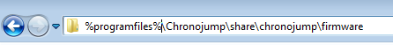

Copy the file chronopic-firmware-multitest.hex to
%programfiles%\Chronojump\Share\chronojump\firmware and replace the file that is in the folder.

Connect the Chronopic to your PC with an USB cable.

Go to Windows menú → All programs → Chronojump → Chronopic Firmware Record.

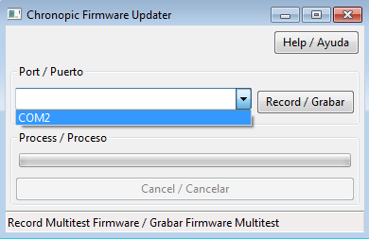
If you don’t see any COM port in the list, it means that Windows has assigned a high number to this port. You can change it by going to Control Panel → Hardware and sound → Device manager

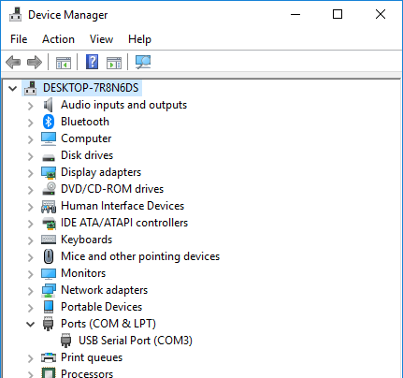
Expand Ports (COM & LPT) and double click on USB Serial Port (COM[NUMBER])

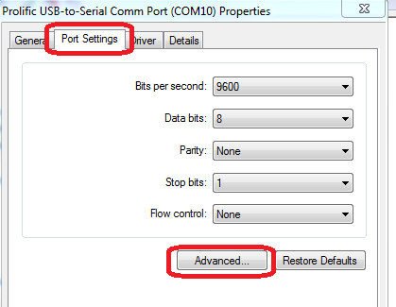

Click on Port Settings → Advanced

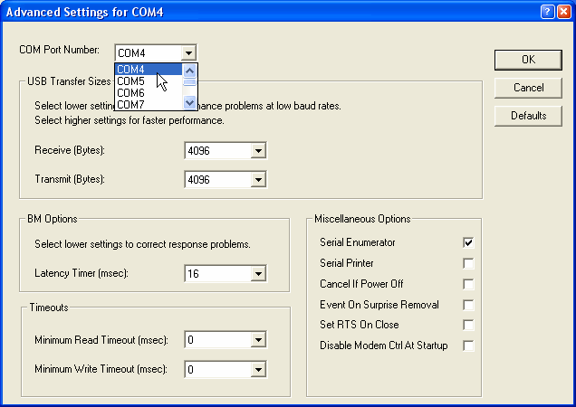
Select a port number between 1 and 12. Don’t worry if it says that the port number is in use.
Click Ok

Go to Windows menú → All programs → Chronojump → Chronopic Firmware Record.

Select the COM port and click on Record.

The program will tell you to press the reset button of the Chronopic.

Once you press it the process will finish and your Chronopic will use the last Firmware.

If that is not the case, and the program keep saying to press the Reset button, please contact testing@chronojump.org

