CHRONOJUMP ENCODER - INSTRUCTIONS MANUAL

April 24 2013
Updated to Chronojump 1.3.7

Xavier de Blas
http://chronojump.org

INDEX
1.- Safety instructions 2
2.- Concepts 3
Database 3
Sessions 3
Persons 3
Exercises 3
Signals 3
Curves 3
3.- Using the encoder 4
Chronojump main window 4
Connecting encoder (Chronopic window) 5
Encoder capture tab 5
A) Exercise frame 5
B) Camera record 6
C) Signal frame 6
D) Curves frame 7
Encoder analyze tab 7
Encoder settings at preferences 8
4.- Example of encoder use 8

1.- Safety instructions

An encoder is a precise instrument that has to be managed ALWAYS with care. Please follow this safety instructions.

A) Safety magnets  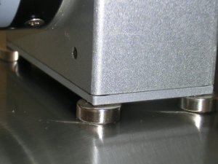  Fix the encoder on iron or metal surface like the weights on a gym.  Note some gym weights are covered with rubber and have not magnet power. | B) Do not let go  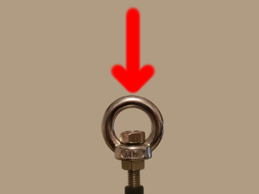  Do not let go the wire because it will return at high speed and will break.
C) Never use your fingers  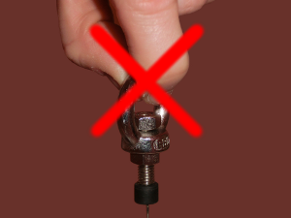  Never use your fingers on pulling the encoder. The wire or the metallic ring can easily slip from your fingers, return at high velocity and break.  Use the black plastic hook included in your encoder bag. | D) Measure wire length  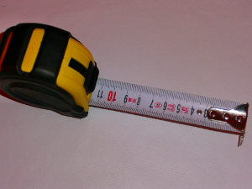  Measure with care (not pulling with the fingers) the length of the wire.  Do not do tests that can exceed this length.  Note you can fix encoder to a table or other place if needed.

If you broke your encoder contact us at hardware@chronojump.org

2.- Concepts
This manual briefly describes some concepts. Understanding them is important to use the software appropriately.

Database
Chronojump stores all data in one database file. Thus, instead of collecting the information in individual files for each session, all information is organized in a single file to facilitate the study of relationships between:
- sessions
- persons
- exercises
All modifications in session, persons and exercises, will be updated at any time in the database. So there isn’t need to save the information periodically. If rare case, the program crash, you wouldn’t lose any data except sometimes the exercise that is being performed at the time.

Sessions
The sessions represent situations where the coach or evaluator gathers persons for a series of tests. Every time you gather a group of athletes to be tested in a short space of time (usually one day), you should create a new session. Although the persons to assess can be the same as in other session, you should create a new one and load them from the other session. In this way, you can make comparisons between data over time.

Persons
All individuals able to perform the tests are known as persons. It’s strongly recommended to create one person only once in order to study the evolution over time. In following sessions the person can be loaded.

Exercises
Every time you want to measure, you perform an exercise. Exercise has a name (e.g. Bench press), and extra weight (e.g. 40Kg), type of contraction (e.g. concentric), laterality (e.g. both limbs), recording time (e.g. 45s) and others.

Signals
When person does the exercise, encoder generates lot of data and sends it to the computer. Exercise duration is defined by the user who manages the software, but can be shortened if wanted. All the data received is called a “signal”. This signal is saved automatically when capture ends. The signal is meaningless, it doesn't have any information on how many repetitions of the movement has been done by the person who executed the exercise.

Curves
When signal is analysed, n curves are found. This curves have the mechanical data wanted by the evaluator: start, duration, speed, force, power. The curves are detected by the software automatically following user criteria.

3.- Using the encoder

Chronojump main window
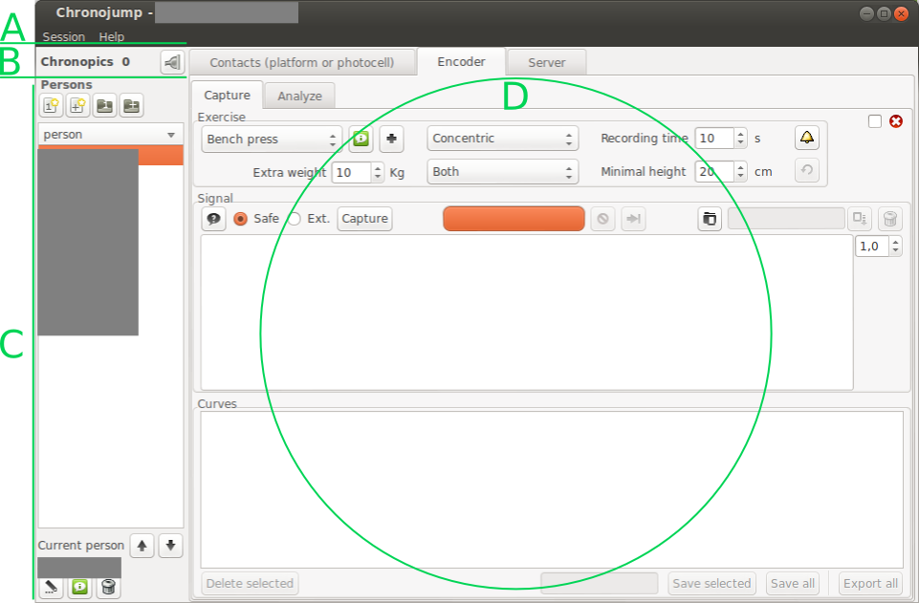
A) Starting on the top left of main window, there's a menu bar with session options and help. You should start your work creating a new session or loading an existing one.
B) Under the menu bar there's Chronopic information: number of Chronopics connected and the button to manage them. Chronopic is the microntroller used on Chronojump project to measure from external devices like a contact platform, photocells or the encoder. Use the Chronopic button to tell the software how Chronopic is connected.
C) The rest of the left part of the screen is related to persons. On the top you can create new persons or load from another session. Below you can select the current person and finally, at the bottom you can edit the person, see all it's tests and delete it.
D) The centre-right part of the screen is for managing the tests (or exercises). At the top there are three tabs: contacts, encoder and server. Select the encoder tab.

Connecting encoder (Chronopic window)
In order to connect the encoder, click on the Chronopic button (“B”, in the above image) and Chronopic window will be opened. On this new window select “Encoder” and the port where Chronopic is connected. If you have any problem press the help button in that window, it has little and useful information.
After Chronopic port has been selected, just close the window.

Encoder capture tab
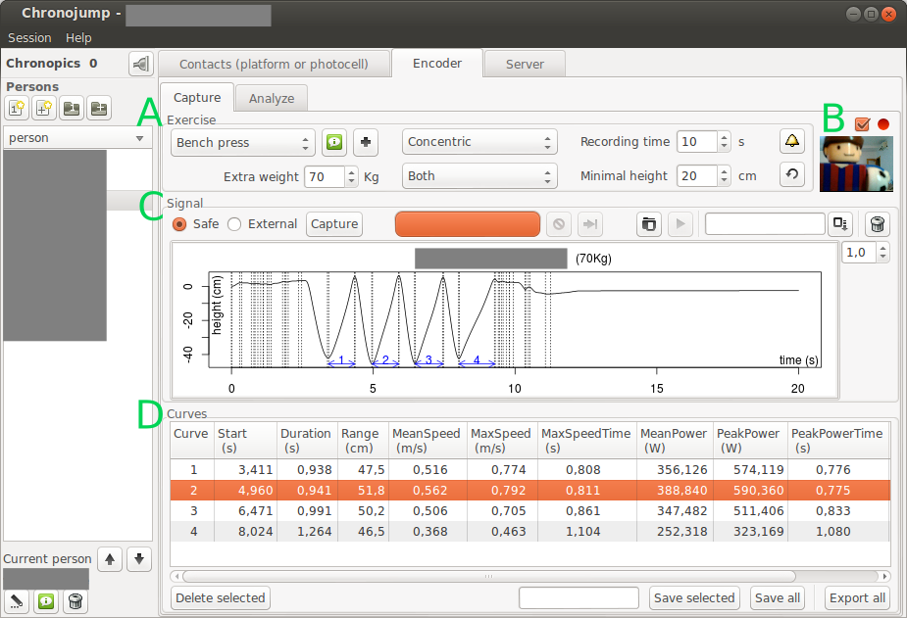
At this tab you can see four areas: A) Exercise, B) Camera, C) Signal and D) Curve.

A) Exercise frame
At exercise frame there's the exercise name, information of that exercise and a button to create a new exercise. Clicking at the information or at the new exercise creation you will notice there's a selector called “Displaced body weight (%)”. This selector is important to measure the force and power, because 100% of body weight is displaced during a jump, but 0% of body weight is displaced in a bench press. “Extra weight” selector is used to input how many Kg are moved (weight bearing is not considered). Summarizing, weight displacement is calculated like this:
(person weight * displaced body weight / 100) + extra weight
The exercise frame includes also the contraction type (eccentric-concentric or concentric), the laterality, the recording time selected, the minimal height, the feedback bell and the recalculate button.
Minimal height is the minimum range of centimetres that a curve has. E.g. In a bench press, when person lifts the bar for the first time before starting exercise (weight was in the support), this is not considered a curve because it's range of movement is lower than “Minimal height” defined.
The feedback bell opens a window where user can input what feedback want to be shown while exercise is being performed. Currently the feedback is only working in the “capture external” method (see below).
Recalculate can be used after a capture. When user detects that some selector has not been set correctly and want to perform calculations of the signal again, user can change the selector and press “recalculate”. E.g. 40 seconds squat has been done and the extra weight introduced was 40Kg but user forgot to add the weight of the lift bar. After capture, user can change 40Kg to 55Kg and then press ”recalculate” in order to have the force and power calculated correctly.

B) Camera record
At the right of the exercise frame there is a check box where a web cam can be activated. If it's active it will be used on encoder capturing. The resulting video will be attached to the encoder signal and can be watched using a button on signal frame.

C) Signal frame
At this frame you can capture using two methods: “Safe” (default) and “External”.
- Safe: Capture happens in this window.
- Advantages: Fast and without problems.
- Disadvantages: Currently at real-time only plots a simple graph.
- External: Capture happens in a new window.
- Advantages: Has real-time graphs and lots of features.
- Disadvantages: Open new window is slow and there are problems on some computers.
The default method is the “Safe” because is fast and works in all the computers. On the other hand, most users will select the external because they want a feedback.
If “Safe” mode is not working then Chronopic is connected to a different port than the port you have selected in the Chronopic window, or Chronopic driver is not installed. If “Safe” works but “External” doesn't, then maybe your anti virus software is not allowing the external capture program to work, or you need to install this software:
- 32 bits machines: Microsoft Visual C++ 2008 Redistributable Package (x86) http://www.microsoft.com/en-us/download/details.aspx?displaylang=en&id=29
- 64 bits machines: Microsoft Visual C++ 2008 Redistributable Package (x64) http://www.microsoft.com/en-us/download/details.aspx?displaylang=en&id=15336
This is the case of the users who use Parallels Desktop to run Chronojump (windows version) in a MacOSX machine.
During the capture, in “Safe” mode you will see a graph of the distance / time and you can cancel process or end it earlier if desired. In the other hand, in “External” mode you can finish capture earlier pressing ESC or trying to close the window, and you can close window repeating this action.
Both methods will produce the same result, curves will be identified on the signal graph, and signal will be automatically saved. Both methods will capture video if it's enabled.
The top right area of this frame allows to load a signal, play the video of the signal (if available), save signal again with a comment (just write comment in the area and press update), or delete the signal. The load signal window is used also to manage all the signals of current person. Use it to change the person who performed or delete any signal of a given person.

D) Curves frame
Once signal is loaded, captured or recalculated, Chronojump will find curves and write their data on a table. Here you can delete a curve, save the selected curve, save all or export them to an spreadsheet software. Most users will save only a curve, or delete a curve and the press “save all”. This curves can be analysed at the Encoder analyse tab.

Encoder analyse tab
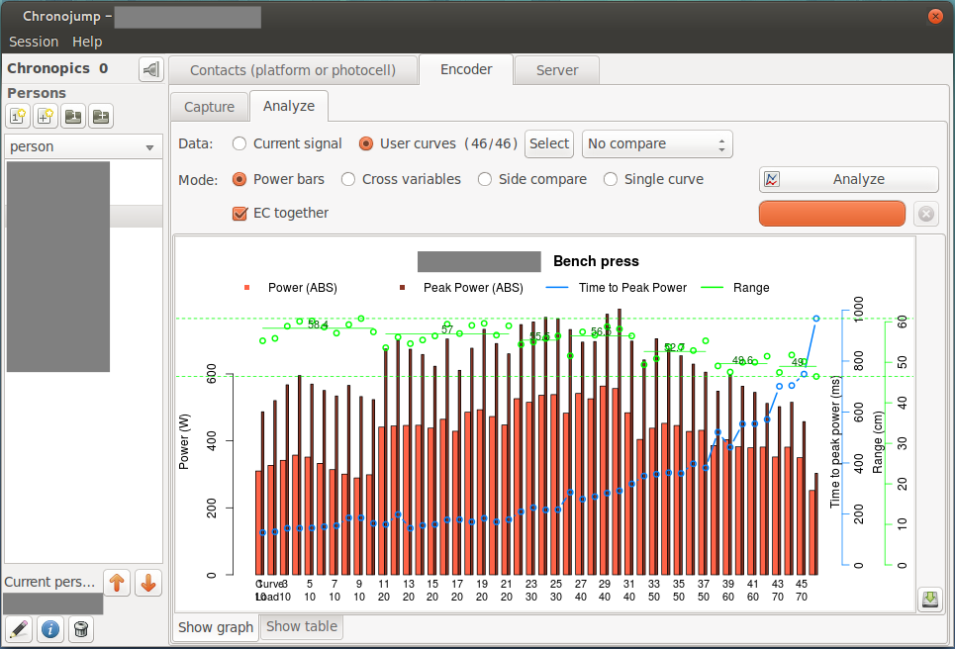
Regarding the data, two things can be analysed: current signal (the signal in the capture tab) or user curves.
When “User curves” is marked, then using the “Select” button, it can be discriminated the active curves and the not-active. The analysis will cover only the active curves. Also the “User curves” allow to make comparisons between persons (to compare the different persons in this session), or between sessions (to compare the evolution of a person during different sessions).
There are four modes of analysis:
- Power bars: Shows power, peak power, time needed to arrive to peak power and range of movement.
- Cross variables: to show relationships between variables like “Power / Load”. Includes the 1RM calculation. Cross variables is the only analysis that can be done on “compare” mode.
- Side compare: to see a graph of the mechanical variables of different curves all with the same axis.
- Single curve: to see a graph of the mechanical variables of a curve.
Some of the modes will show buttons to extend functionality. E.g. At “Power bars” and “Cross variables” the parameter “EC together” allows (only in eccentric-concentric curves) to show eccentric and concentric phases together or separated. The controls “mean”, “max” select if the average values have to be used: average speed, average power; or the maximums: maximum speed, peak power.
The analysis starts when user click in “Analyse”. After a while, a graph and a table will appear, both can be saved using each save button in the lower right.

Encoder settings at preferences
At preferences there are some options that are more advanced and are not changed frequently. Clicking at “Session / Preferences” you will see three tabs, the last one is related to encoder.
If you want to do calculations of mechanical parameters only in the propulsive phase just ensure the parameter “propulsive” is active. The meaning is the following: In a fast concentric movement where there's little weight displaced, the brake action of the person in the final phase of the movement will not be used in the calculations. Nowadays most coaches prefer this option active because they noticed that the comparison of mean power between a light weight and a heavy weight exercise is not fair because the brake phase in the light weight exercise is related to negative force and the power values get very low. Then, if “propulsive” phase is active, only this is used, and not the “brake” phase.
The other options are related to smoothing of the capture and we recommend to leave them untouched.

4.- Example of encoder use
At the Gym:
- On the floor, at the side of the weight bar, put a gym weight (not made by rubber) and encoder on the top of it (attached with the magnets).
- The plastic hook is attached to weight bar securely, and to encoder.
- Athlete1 and athlete2 start the warming up slowly and full range of movement (in a different place) while evaluator prepare the software.
- Evaluator starts Chronojump software, loads a session prepared the day before (session parameters and persons were already introduced).
- Evaluator connects Encoder-Chronopic to the computer using USB cable.
- Evaluator selects the port at Chronopic window, at the encoder tab.
- On main window, go to encoder, capture tab.
- Select exercise options: bench press, extra weight: 20Kg (10 bar + 10 gym weights).
- Select athlete1. Click on capture (“Safe” or “External”). See the results but have no time to analyse them now. Signal is automatically saved.
- Select athlete2. Click on capture (“Safe” or “External”). See the results but have no time to analyse them now. Signal is automatically saved.
- Select exercise options (extra weight: 30Kg). Change weight of bar + gym weights to 30Kg. Then repeat [9] and [10].
- Repeat the process every time with 10Kg more until one repetition cannot be done.
- Close the software and carefully detach the encoder hook from the weight bar.
Later, at home:
- Open software.
- Load session, select athlete1, load first signal, and “Save all” curves.
- Repeat [2] for all the signals of Athlete1 and Athlete2.
- Go to analyse tab. Select User curves, compare between persons, “Power / Load”.
- Use the resulting values to prepare training related to power.

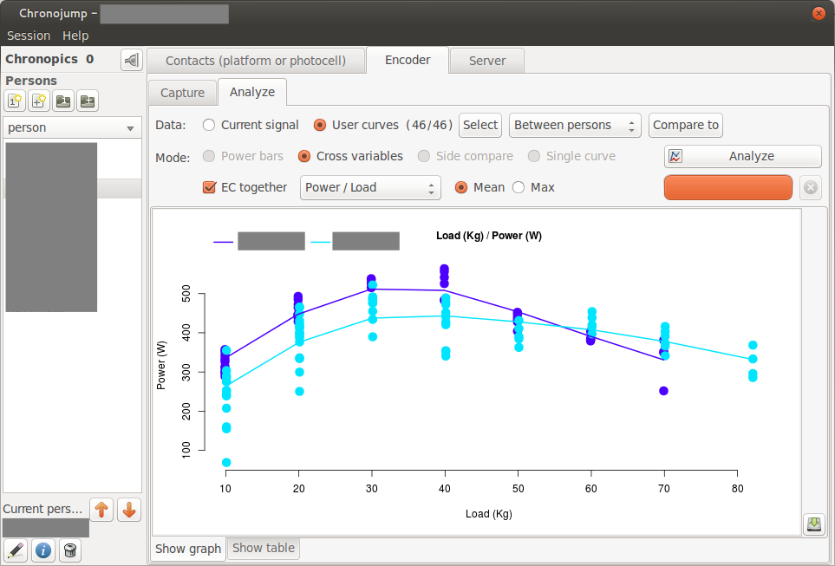
Example of encoder use.

As a general rule, if you don't know what a button does, just point it with the mouse and wait, a tooltip will be shown.
If you need more help, see Chronojump manual (you will find clicking on Help), and Documents section on our website: http://chronojump.org/documents.html
Use the forums to ask questions:
- English forum: http://forum.chronojump.org
- Spanish forum: http://foro.chronojump.org

Install Chronopic driver opening the file on the driver installation folder, similar to: C:\Program Files\Chronojump\drivers\

