Chronojump Troubleshooting

Contents:
1.- Chronopic
2.- Contact Platform
3.- Photocells
4.- Encoder
5.- Chronojump software

1 Chronopic

Chronojump doesn't detect the chronopic2.
In Windows it's usual that, when connecting a new USB-serial device, a new com port is assigned. If windows assign it to an already used port or in a higher than 10 port number, Chronojump could have difficulties in detecting it. Please follow this steps:
- Right-click on the My Computer icon on the desktop or Start Menu.
- Note My Computer can be called System in Windows Vista.
- Note also, you maybe have a My Computer icon that has no properties because it can be a link to the real My Computer icon. If you cannot see Properties, please use another My Computer icon.
- Select properties (last option).
- Go to hardware.
- Select administrate dispositives. It's the first button.
- Click on the '+' to the left of the COM and LPT ports.
- The port name will be what it's written like ("COMx") on the USB serial line.
- At the line where port is shown, right-click and select properties (last option).
- Go to Port configurations.
- Go to Advanced options.
- Select COM1, COM2, COM3 or COM4 on the list shown on that window.
- COM1 - COM4 are used, then select unused ports below 10.
- If doesn't work, try to select the COM1 - COM4 (normally they are not really used).

Chronopic doesn't send any signal to Chronojump.
If the Chronopic is connected but it doesn't respond to the state of the contact device (platform or photocell), check if chronopic can send the signal to Chronojump using the test button. When pressed, the green led should switch off, and when released the test button the green led should turn on again.

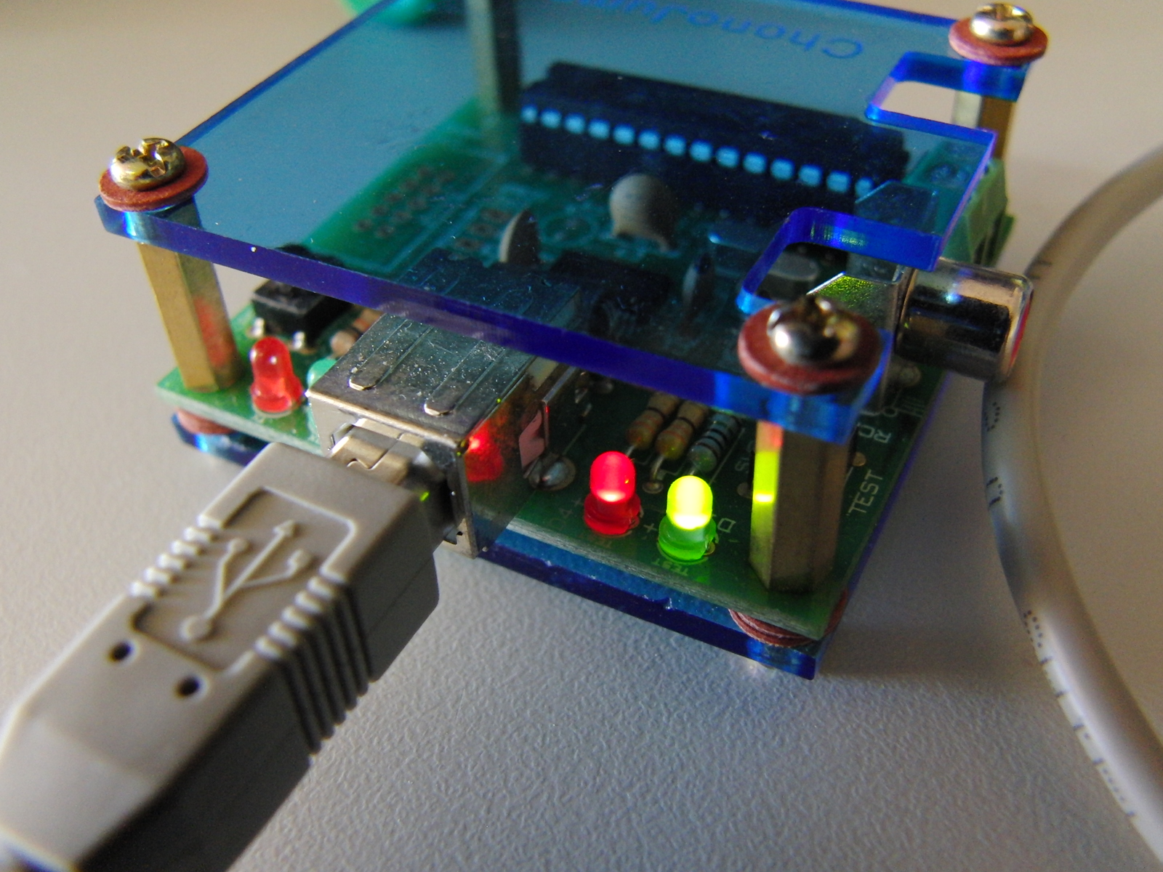  Test button not PRESSED. Green LED ON. | 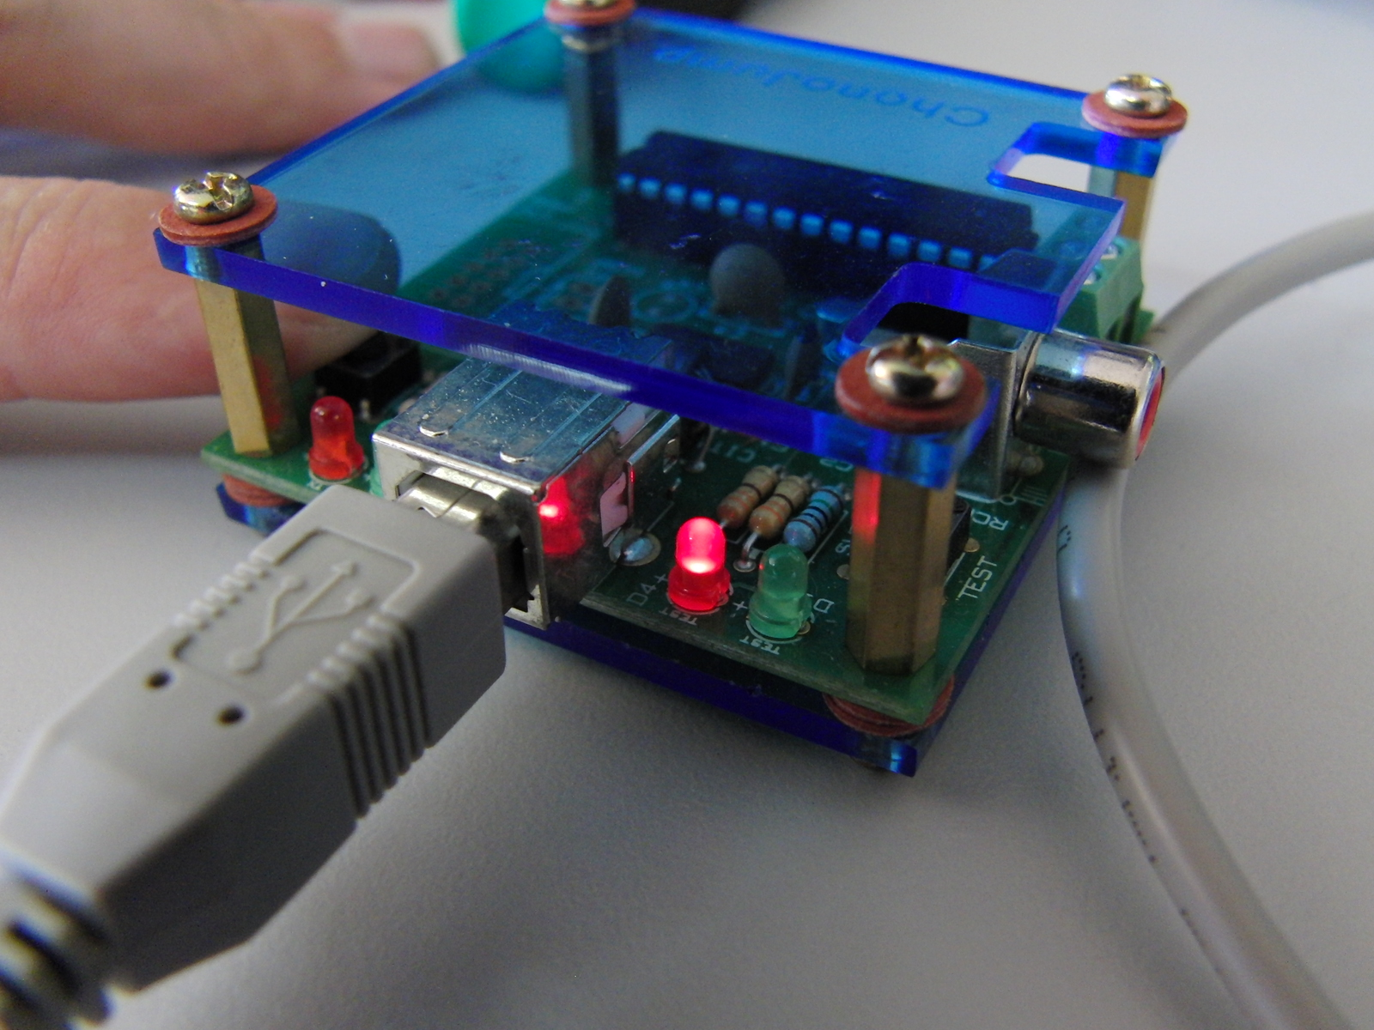  Test button RELEASED. Green LED OFF,

Pressing the test button is, from the point of view of Chronopic the same of pressing a contact platform or crossing a photocell barrier.
If Chronojump can detect the change of the test button state, it means that the problem is not in the Chronopic. Please check the wires and the contact device connected to Chronopic.

2 Contact platform

The platform seems to be always pressed.  It usually happens when the upper and the bottom copper plaque touches each other. The most common cause for this is a hit in one of the corners of the platform. Check the corners and, in case of some of them being in contact use a screwdriver to separate it. | 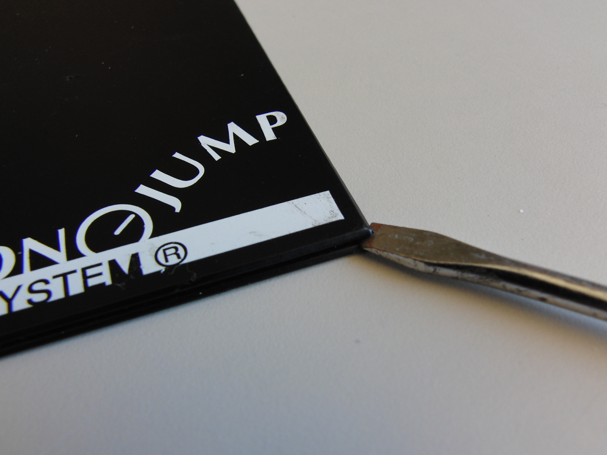

The flying time and/or contact time seem totally random
Check if Chronojump is in simulated mode. This mode is activated when no chronopic is connected.
You can also see if you are in simulated mode because the bar indicate it.

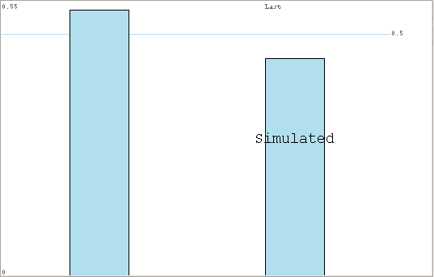

The platform doesn't detect being pressed.
Check that the cable connections are ok. Disconnect the platform from the RCA wire. With the Chronopic and the RCA cable connected, short circuit the RCA wire with some metal. If the leds in the chronopic are changing it means that the wire is ok and the problem could be in the platform. If the leds doesn't change the problem, will be probably in the wire.

3 Photocells

The photocell seems to work when you stand in the barrier but when passing at higher speed it doesn't work properly.
Ensure that the firmware of the chronopic is at 10ms. If you are not sure of the firmware you are using, record it again with the “chronopic firmware recorder” utility included with the Chronojump software. Find the Chronojump entry all programs list in windows and click on Chronopic firmware record
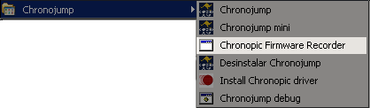
Once in the program, click on “Runs”, select the Port, click on Record and follow instructions.

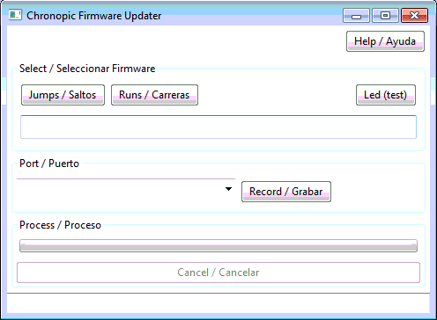

4 Encoder

Chronojump cannot connect to chronopic encoder.
With the usb cable connected to the computer and the chronopic, check that the com port you selected in Chronojump is the correct one. If this is the case check that the red and green test leds are on. If one or two of the two leds are off, please contact support@chronojump.org

5 Chronojump software

The data of the encoder has been lost.
There are two concepts that you must have in mind: the set (formerly signal) and the repetition (formerly curve).
The set is always recorded automatically by Chronojump, so you can recover the information of that exercise clicking in load button beside the capture button.
The repetition information must be saved by the user. If you forgot to save some repetition you can always load the set and select the repetition you want to save.

Lost encoder data.
If you try to move the encoder data to another computer or another user inside the same computer, the database will lost the localization of the encoder files. It doesn't mean that the files are lost. Moving Chronojump data one computer to another requires that the path to the files were the same. To do that ensure that the username of the first and the second computer use the same user name. If it's not possible, please contact support@chronojump.org.

