Tutorial##KK$$

Initially, the characters appear in boxes in a vertical column on the right hand side (figure 1). Start by clicking the left mouse button near the cross-hair move the pointer towards the first letter you want to write. e.g. 't'.

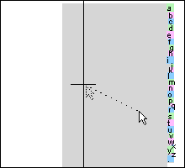
Figure 1: Initial configuration.

The display will start to zoom in towards the 't' (figure 2).

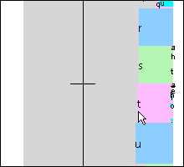
Figure 2: Writing 't'.

You can stop at any time by clicking on the left mouse button.

The horizontal direction controls the rate of zooming in. Moving the pointer to the right zooms in. Moving the pointer to the left zooms out. The vertical co-ordinates determines the place which is being zoomed in on. As the desired letter moves towards the crosshair, further letters can be selected by searching within the box of the current letter. In figure 3, 'h' is being selected.

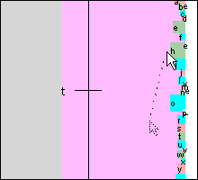
Figure 3: Writing 't' followed by 'h'.

Always look inside the current letter for the next letter. For example, to write 'the', point at the 'e' within 'h' (figure 4).
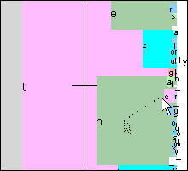
Figure 4: How to write 'the'.

An easy mistake to make is to go for the first e you see, and not the 'e' within 't' (figure 5).

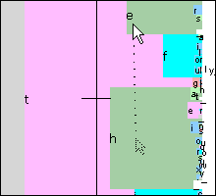
Figure 5: How not to write 'the'.

The text box above the display shows what is being written. To start again, tap New
The Language Model##KK$$

Dasher uses a language model, trained on two pieces of text.

The first is <DASHER_DIR>/source.txt which is installed with Dasher.

The second is <DASHER_DIR>/Dasher.txt. As you write with Dasher, text is appended to the file. Repeated use of Dasher will improve the language model and also writing speed.
Copying text to other applications##$$KK

Select the text by dragging. Select Edit->Copy from the menu to copy to the clipboard.

Release History##$$KK

Feedback##$$KK

If you have any comments or questions, please use MetaFAQ:

http://www.metafaq.com/faq/dasher/

You can discuss Dasher on Yahoo! Groups:

http://groups.yahoo.com/group/dasher-text-entry/

You can contact the Dasher project by email:

dasher@mrao.cam.ac.uk

# IDH_TUTORIAL
K tutorial
$ Tutorial
# IDH_MODEL
K language;model
$ The Language Model
# IDH_COPY
$ Copying Text
K copy;paste;other;applications
# IDH_RELEASE
$ Release History
K release;history;version
# IDH_FEEDBACK
$ Feedback
K feedback;comments;discuss

