The tutorial to GIMP’s Jenkins
Note: this is work in progress. Questions, hints and all sort of contributions are welcome. Please post them to the gimp-developer mailing list or contact scl in IRC.
Currently this document is temporarily in OpenDocument format. The final document is planned to be in DocBook format.

What is Jenkins?
Jenkins is a continuous integration software. It regularly pulls Babl’s, GEGL’s and GIMP’s source codes from the version control system, builds them and runs automated tests on them. Its purpose is mainly to assist the development and release process. Developers, testers, early users, release engineers can use it as well as third party plug-in developers and fork maintainers.
Developers get almost immediate feedback whether their software builds and works well.
Testers and early users obtain the latest builds right from the development.
Packagers can use it to see whether the current source code builds fine, passes automated tests and is ready to be released.
Third party plug-in developers and fork maintainers can use this information to keep their code up to date with upstream Babl, GEGL and GIMP as foundation of their own work.
Last but not least it is a tool for the project maintainer to get an overview about the code health and the decision to release the software.
Continuous integration helps detecting and fixing bugs much earlier than if testing was postponed or otherwise neglected. Thus using continuous integration increases the software quality. It also makes it possible to release the software more often.
Design goals of Jenkins in the GIMP project are quick feedback to code changes, stable builds for testers, security and maintainability.
You can access our Jenkins instance at https://build.gimp.org.
To learn more about the Jenkins product apart from GIMP see http://www.jenkins-ci.org.

How does it fit into our development infrastructure?
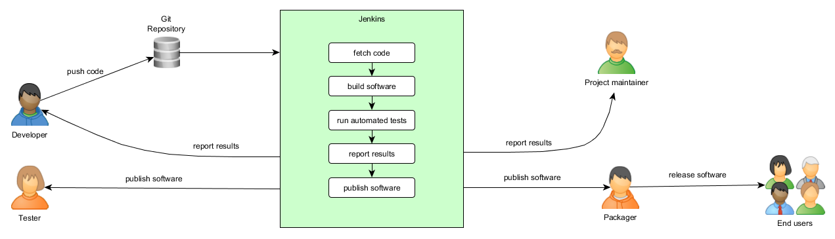

What do terms like ‚job‘, ‚build‘ etc. mean?
Jenkins uses some specific terms:
A job is a runnable task that is controlled and monitored by Jenkins. You can imagine it as a program that will be executed at some time.
A build is the result of an executed job, such as the built program and document files altogether. Builds are determined by the execution time and a sequential build number.
A project consists of a job, the builds and its configuration. Examples are gimp-master and gimp-2.8.
For more information see the Jenkins Terminology.
In the further text the word core products denotes Babl, GEGL and GIMP in order to make the text easier to understand and to distinguish them from third party products.

How do I…?

Check the sanity of Babl, GEGL and/or GIMP
To get an overview about the build status of the core products there are three ways:
- the Overview pages on https://build.gimp.org,
- IRC notifications and
- RSS notifications.
The overview pages list all jobs, their status and build trend at a glance. Similar to traffic lights the status information is depicted by red, yellow, green and gray balls.
the last build was successful
the last build was build successfully, but one or more tests or the virus scanner failed
the last build failed
the last build was aborted by a user

Weather symbols indicate how the job status has evolved during the last five builds. The sunnier the icon the better the build health. The chapter 'Job status and trend' tells you more about this. If you need more information, such as the time of the last success or failure or the duration of the last job execution, you find it on the Topic overview pages.
IRC notifications are the second way to get a feeling about the job status. Right after each job is finished or aborted the IRC user jenkins-bot will tell about it. GIMP status notifications are posted in the channel #gimp while Babl and GEGL notifications appear in #gegl and #gimp.
A third opprtunity to gather status information are RSS feeds. Jenkins provides feeds for all builds, failures, latest builds and per job. You find their subscription links at the bottom of the overview pages and on each job’s page. To read these feeds use a dedicated feed reader, the established e-mail clients or your mobile device.
Sometimes you want to know more about the sanity of a job than just a quick glance.
One way to know this is to look at a topic overview page. It will tell you time of last job success and failure and the duration of the jobs' execution. Additionally there is a link to the last console output to bring you right to all the information you need to know what has failed.
The second possibility are the job pages. To get there just click on the name of the desired job. Each job page contains a history about the latest builds, artifacts to download and check and links to the console output.
To see the raw console output either click 'Console output' or 'Raw console output' in the left menu. Per default the first one only shows the last lines of the console output, but you can show all by clicking the 'Show all' link on top of the text.
Another feature there is to see the parsed console output. To see it click the ‘Parsed console output’ link in the left menu. Additionally to the aforementioned console output it offers to see only the errors, warnings or additional information.

Know whether Babl, GEGL or GIMP is ready for a release
One sign whether a product is ready for a release is that it builds well and all tests succeed. See the chapter Check the sanity of Babl, GEGL and/or GIMP for more information.
However, this is just a hint whether a core product can be released. Manually testing the builds and before they are released is another important step to ensure quality. At the end of the day it is the maintainers' decision to make a release.

Find and install the latest version quickly
To download a core product go to the 'All Downloads' page. There you find the last successful builds of Babl, GEGL and GIMP for Linux (64 bit) platforms. Additionally you find a link to the nightly builds for Windows (32 bit). They are built each day at … UTC. Note that these builds are in the state of development and might not work well in all cases. Especially the builds denoted with 'master' are unstable and not for production use. You have been warned. If you want to be on the safe side go to the GIMP download site and get an official release there.
After you have downloaded a build, extract it to a separate folder on your disk. For the Linux builds you can use unzip or another tool that handles ZIP archives. The Windows builds are executable files and extract to their own folder automatically.

How do testers get the necessary dependencies?
TODO
- s. File/wiki/wgo
- add a script to download all dependencies?
- apt-get build-deps gimp, optionally apt-get remove Babl gegl gimp. Solution for Non-Debian-Derivatives? Distro-specificied user repos?

Know whether I can use the latest version without crashes and headache
In general there's no guarantee. The builds reflect the current state of development and some things might still not be finished to make a release. This is especially for the master builds – don't use them for critical production.
For increased security the Linux downloads are virus-checked with recent virus signatures. To see more about the check results, open the respective build page and click ‘ClamAV Virus report’.
To be sure whether the download isn’t malformed you can also get the MD5 and SHA256 checksums from the download page.
If you encounter crashes or bugs in the builds, please report them in Bugzilla. This will help making Babl, GEGL and GIMP better. For crashes start the summary with ‘[CRASH]’ and use severity ‘Critical’. It’s helpful to report how to reproduce the bug, the expected and the actual results. Thank you in advance.
Report a Babl or GEGL bug
Report a GIMP bug
Report a GIMP Help bug

Find out what is new since version xy or a given date
On each job page Jenkins has links to see the latest changes.
Example, Structure: TODO: fill
However, this only contains the most current information. If you want to know more, you can browse the repositories or get yourself a repository log.
To browse to the directories:
- Open https://git.gnome.org/browse/${project_name} in your browser (replace ${project_name} with babl, gegl or gimp).
- Select the branch you want to have more information to and click the respective link. For Babl this master, for GEGL this is currently gegl-0-2 and for GIMP select gimp-2-8 at time.
Now you see the commits in descending chronological order starting with the latest in a list. Scroll down that list and click [Next] to go the next page.
<Image>
To get yourself a repository log (TODO: add missing information)
- If you don't have a local copy of the code repository, then clone Babl, GEGL or GIMP to a directory on your disk: gi clone …. and continue with step 3. Otherwise go to step 2
- Change to the branch you are interested in (s.o.)
- Refresh your local copy: git pull origin
- Get the log: git log. If you want to have it all in a file for reading: git log > file.txt.

See whether a particular bug is fixed or enhancement is realized
Follow the steps from chapter Find out what’s new since version xy or a given date and then search for the bug number or a suitable keyword.
Filtering a git log for a given keyword will give you the needed information quickly. To get all occurences it’s recommended to search case insensitively. As user of Linux, OS X, BSD or Cygwin use the grep command: git log | grep –i keyword . Windows users filter the git log output with git log | find /I “keyword” .
The second way is to search in Bugzilla. If a bug fix or enhancement request is realized it will be marked as ‘RESOLVED FIXED’.
Search Bugzilla. Enter the bug number in the text field at top of the page or enter status, product and keywords in the simple search form.
Search Bugzilla with more search parameters. To see tooltips for each field please enable Javascript.

Find the important bug fixes and enhancements in the current version
This use case is currently badly supported by Jenkins. A very convenient way is to query Bugzilla for all closed bug reports since a given date with respect to importance.
Here are some examples:
Query changes in Babl since release of version 0.1.10
Query changes in GEGL since release of version 0.2.0
Query changes in GIMP since release of version 2.8.10
Query changes in GIMP Help since release of version 2.8.1
If you are a member of the ‘GIMP developer’ group in Bugzilla you will find these searches as ready-to-use links in the footer of the search page. They are named ‘Babl/GEGL/GIMP/GIMP Help – changes since last release’.
You can take these examples to make it fit to your own needs. Just click the ‘Edit Search’ link in the footer of the bug list and edit the search parameters.

Find out what still needs to be done to complete a bug fix or enhancement
The most reliable source of information is to speak to the developers. You can look into the history of that particular bug report in Bugzilla to find out who worked on it (or still does). In Jenkins you see the author of a particular commit on the Changes page to every job:
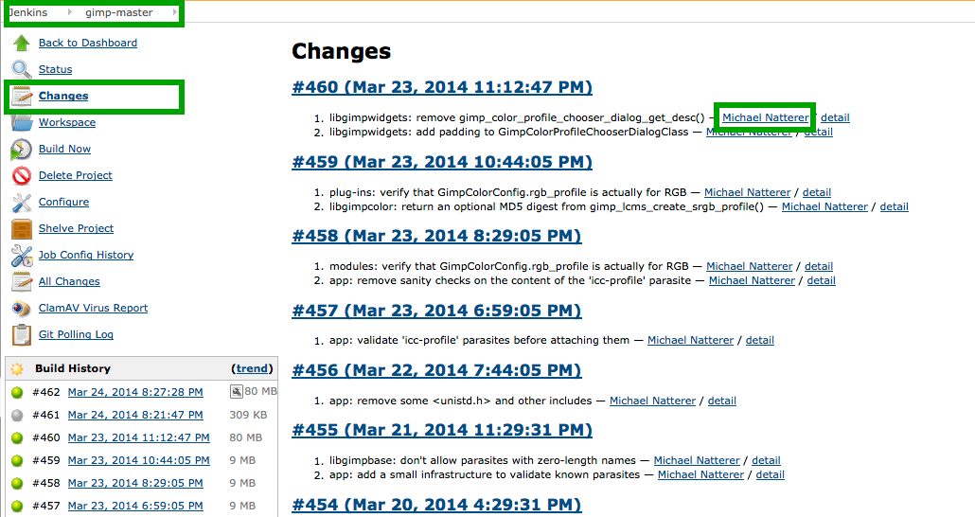
Once you have found out a person to speak to come to IRC or the developer mailing list and speak to that person or others there.

Find out whether the program still builds and works fine after my commit
Jenkins is configured to check every 15 minutes for changes in the Git repositories. Every change triggers a new build then. The results appear on the overview page and the job. Check the sanity of your job then.
To be on the safe side you are recommended to run make check in your local workspace before you commit to the public repository. Often it’s the little things you didn’t think of that break a build (for instance forgotten entry to the files POFILES.in or POFILES.skip). Doing this will ensure that your commit doesn’t break the build for the other developers. A broken public build hampers their work because they cannot fetch a clean version from the repository and will have to do additional work before they can publish their work. At the end development stalls. Treat your peers as you wish to be treated ;-)

React if Jenkins tells me that the program doesn’t build or run fine anymore after my commit
If the compiler is not able to create an executable program anymore or unit tests start to fail, then we call this a broken build.
When Jenkins tells you that your commit broke the build you should react immediately. To know why running make check is useful before committing to the public, read the chapter ‘Find out whether the program still builds and works fine after my commit’.
Read the console output. You find a link on the topic overview pages and the build page.

Also on the build page you find the item ‘Parsed Console Output’ in the left menu. It enriches the console log with bookmarks to interesting error, warning and information messages:
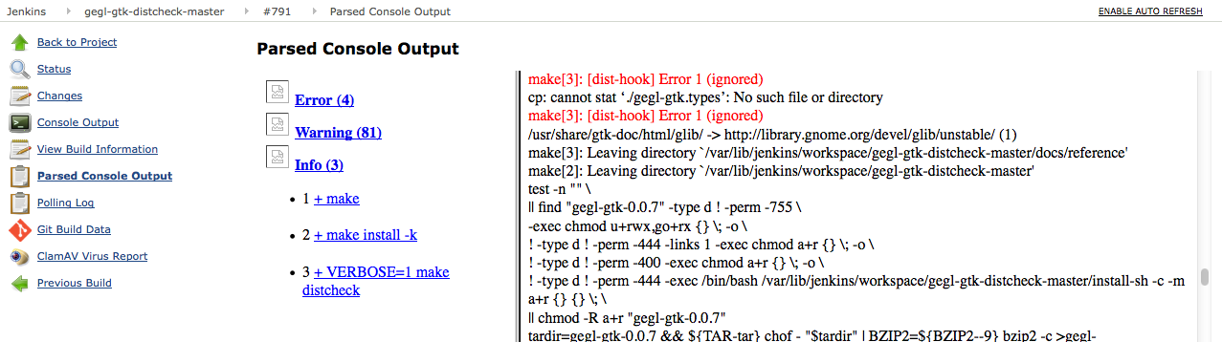

Once you know the cause fix it. To support you we maintain a ‘Problems and Solutions’ page in our developer wiki. Also in IRC (channels #gimp and #gegl) or at the gimp-developer and gegl-developer mailing lists you will surely find somebody to help you. If you have found a working solution push it to the repository. It would also be nice to let the other developers know by reporting it for the ‘Problems and Solutions’ page at one of the developer mailing lists.
If you are not able to solve the problem in short time, it is safer to revert your commit, push the revert to the Git repository and fix it later.
The goal is to always have a clean state of the repository where everybody can fetch code from and start working without hassle.

Know what a job does
The job configuration is not visible to the anonymous public. To see them please ask scl in IRC to grant you read permissions.

Know on which dependency versions a particular build depends on
TODO

Know on which subsequent builds a change of Babl or GEGL has an impact on
TODO

Check whether Jenkins is sane
TODO

Know what is wrong if Jenkins refuses to work
TODO

Report a Jenkins issue
Just report it in Bugzilla and for the Component field choose build-ci.

Second iteration:

Create and deliver a new release quickly
TODO

Know about API changes since a given version
TODO

Know whether third party code is good enough for integration into Babl, GEGL or GIMP
TODO

Use Jenkins to build my own product extensions easily
TODO

Configure Jenkins to achieve a particular goal
TODO

Which parts does Jenkins consist of?
TODO

How do Jenkins’ parts play together?
TODO

What are the cross-cutting concerns I have to keep in mind when configuring Jenkins?
TODO

The Jenkins user interface

Overview pages

Main overview page
The main overview page is named ‘All’ and contains all public jobs at a glance.
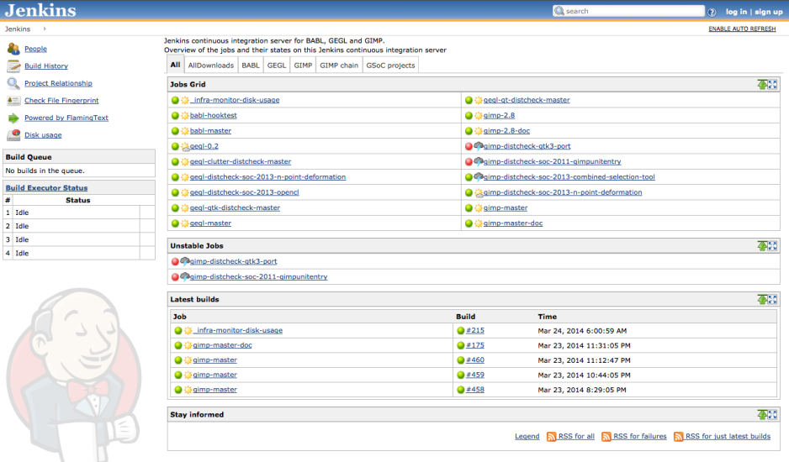

Topic overview pages
These pages show a topical subset of the main overview page to provide a bit more detailed information. For instance the page Babl lists all Babl related jobs and adds information about time of last success and failure, last duration of the jobs' execution and a link to the console output. To get the latter just click the dark console icon after the jobs' name in the column LC (LC means 'Last Console')
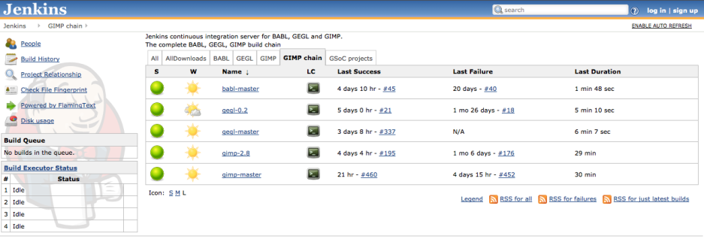

Job pages

Relevant dialogs

Downloadsite

