Now, I tested it on my phone with wiping all the data - we still have problems - most of it arent fixed
1) Screenshot 1 - When we press new profile, it opens up the new screen; but the bottom pop-up screen doesn't go away after I click "+New Profile". I need to explicitly press close - which is counter intuitive
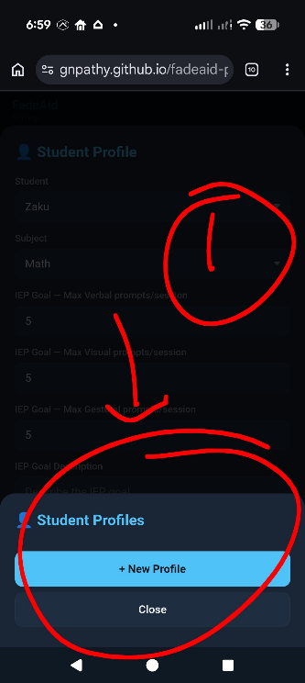

2) screenshot 2.2 and 2.1
In 2.2 I've already set-up sub-topics for three subject - Math, Lifeskills and Signs
in 2.1 you see, when I choose Lifeskills as the subject, it doesn't show the sub-topics options. It does when I choose Math though
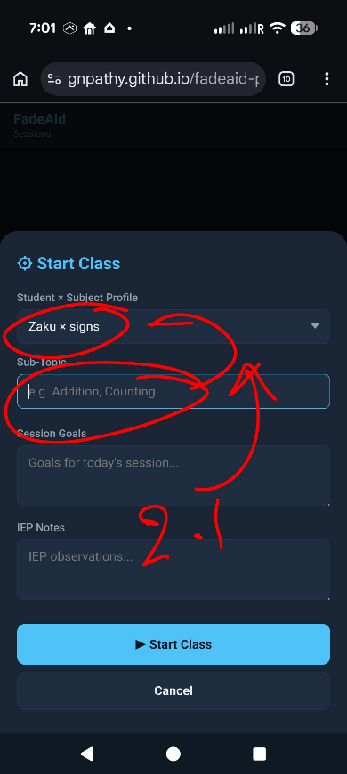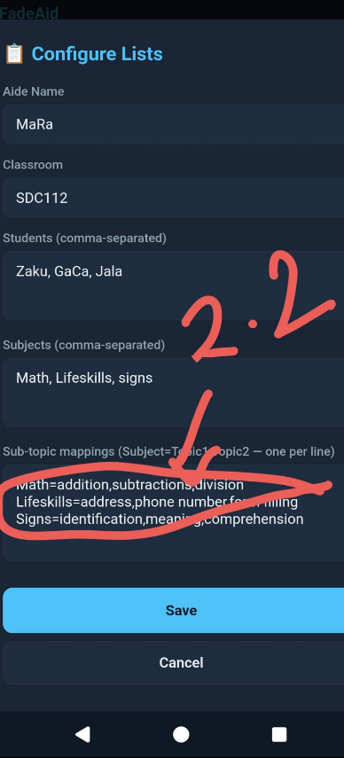

3) 3.1 and 3.2 JPG - are screenshot from Fadeaide Android APP - for your reference on how the questions and session were and how the subjects > sub-topics worked. See this in relation to Question 2.
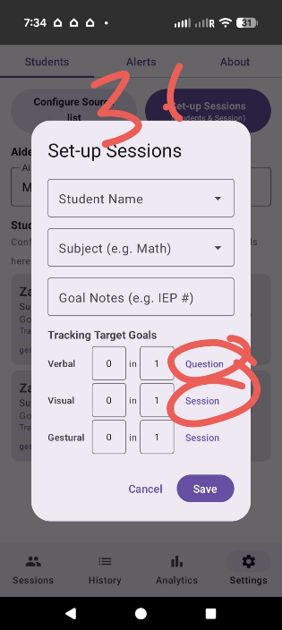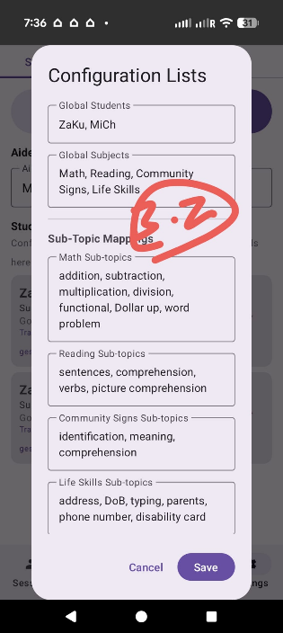
4) Screenshot #4.0 (reports), #4.1 (app) and 4.2(pwa) in the list - In the report, the attribute "questions" itself is missing. If you recall, every session (of a subject) has a question. and number of questions form a session. We have several problem
a) You are missing the construct of question from the design when you migrated to PWA
b) the IEP goal could either be (for example) 4 Prompts / session or 1 prompt / question - so when we set up the prompt goal, we had the choice for teacher to choose - if they want the goal to be per session or per question. That is totally missing from this design itself. It should start with goal and exist in the design of session.
c) If you recall, in the Android app, a "Correct" / Incorrect"; and when someone pressed Correct/Incorrect, the variable question was incremented. That is missing.
Also there was a "+" & "-" to the correct and incorrect that the teachers can incrment and decrement (and the data variable questions acts accordingly)
I’ve attached the screen shot of PWA app (middle screenshot) and the Android App (right screenshot) for reference.
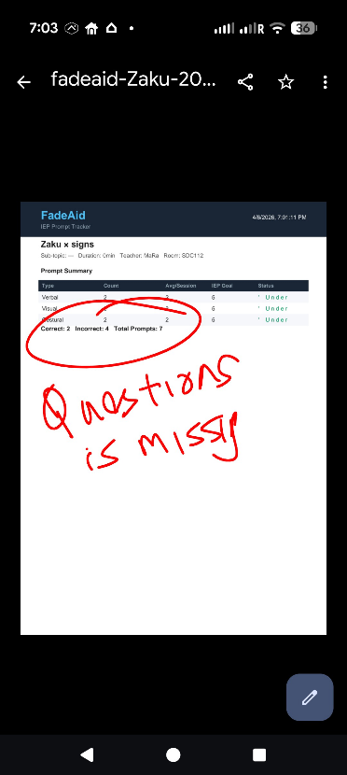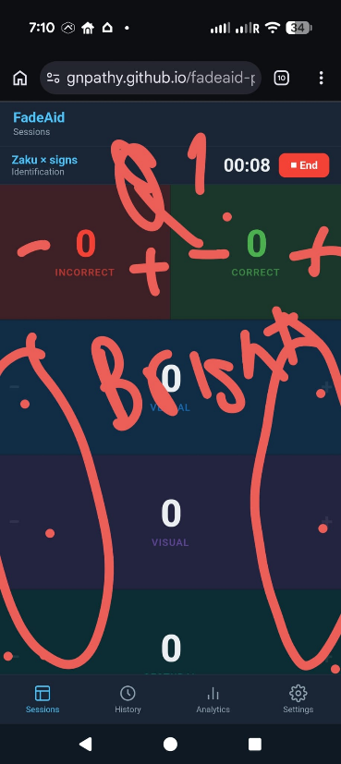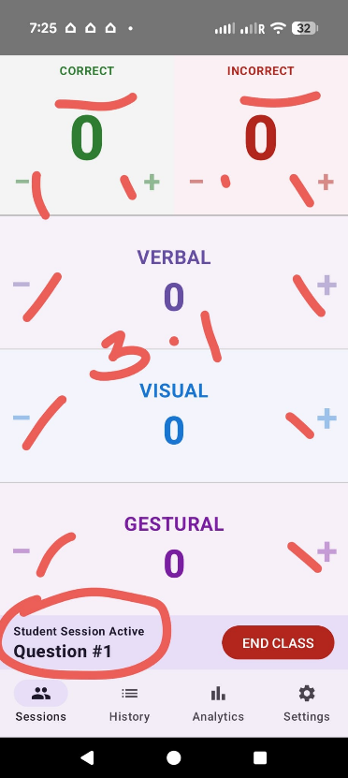

5) I saw your thinking - it is NOT IEP goals are per question. It could be either per session or per question. The IEP Goals will just be lesson based, but the teachers can break it down per question and work on it, before doing it per session. So you need to have that option for the teachers to choose.
1) now re your question #1 - the answer is in the intro above. We shouldn't really worry about "time of the class" - typically the class/session will be 12-15 minutes. But it will be bytes spread across.
2) Re question prompts to be tracked separately.
Here is the hiearchy
Subject > sub-topic
Sessions > questions
If you recall, when the teacher presses "correct" or "incorrect" (with a + sign), the question decrements. So the teacher should be able to measure the # of prompts per session or per question. The reports and analytics should break it down.
See Android report - (screenshot) -it had question by question breakdown of the top level - 1 session, 3 question, 2 correct answers, 1 incorrect and total 10 prompts,
Question 2 was C(orrect) 1: I(ncorrect) 0: P(rompt) 3 Meaning the studnet answer q2 correctly after 3 prompts.
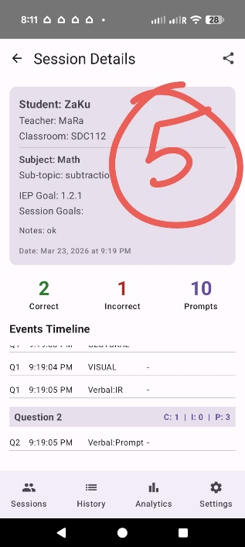

6) When set to "per question": does the goal mean max prompts before the outcome regardless of correct/incorrect? So if the goal is 2 prompts/question and the teacher gives 3 prompts before pressing Correct → that question exceeded the goal, even though the student eventually got it right?
When set to "per question": does the goal mean max prompts before the outcome regardless of correct/incorrect? So if the goal is 2 prompts/question and the teacher gives 3 prompts before pressing Correct → that question exceeded the goal, even though the student eventually got it right?
Yes, the goal is not just for student to get the right answer, but to get right answer within the number of prompts as specificd. So even if they get the right answer and the IEP prompt goals are exceeded (either a session goal or question goal), that needs to be reported as NOT meeting the goal (red). Also, can you mimic the screen colors of Android APP. These colors and the +/- are all not really visible Before you go do any of these, can you please document everything in issues, and implementation plan without overwriting the existing one.

