Title of the Project
A Comparative Analysis of KNN, SVM, and ANN for BMW Sales Performance Classification

Members of the Group
Dhant Guenryan G. Rañada

Business Problem Addressed
Sales Performance Classification
The main objective of this project is to classify BMW car sales performance into two categories:
- High Sales
- Low Sales
This helps dealerships and businesses make better inventory, marketing, and pricing decisions by predicting which vehicles are more likely to perform well in the market.

Dataset Used
“🚗 BMW Car Sales Classification Dataset”
The dataset contains various BMW vehicle-related attributes used to predict sales performance.
Some of the important features include:
- Car Model
- Year
- Engine Size
- Fuel Type
- Transmission
- Mileage
- Price
- Region
- Sales Volume
- Sales Classification (Target Variable)

Data Preprocessing Steps
Before training the machine learning models, the dataset must first be mathematically prepared to ensure accurate and reliable predictions.

Target Variable
The application strictly sets the target variable as:
Sales_Classification
This is done to fulfill the specific rubric requirement for Sales Performance Classification.
The system focuses on predicting whether a BMW car belongs to the:
- High Sales
- Low Sales
category.

Crucial Exclusions (Why Certain Columns Are Removed)
Some columns must be excluded before training because they can negatively affect the model’s learning process.

Excluding Sales_Volume (Data Leakage)
The target variable (High or Low classification) is directly derived from the total sales volume.
If Sales_Volume remains in the dataset, the model would simply read the answer instead of learning patterns from the actual features.
This problem is known as Data Leakage.
By removing this column, the model is forced to genuinely predict the outcome using other important vehicle features.

Excluding Model and ID (Overfitting Prevention)
Columns such as Model and ID are also removed to prevent Overfitting.
For example, if the model sees car names like M5 or X3, it may simply memorize that those specific models perform well historically instead of learning the real factors behind strong sales.
By excluding these identifiers, the system learns meaningful patterns such as:
Expensive + Diesel + Low Mileage = High Sales
This improves the model’s ability to predict sales performance even for brand-new car models it has never encountered before.

The “XYZ” of the Prediction Pipeline
The prediction process follows the standard machine learning structure of:

X → Y → Z

X — The Features (Independent Variables)
The X variables represent the input features used for prediction, such as:
- Price
- Mileage
- Engine Size
- Fuel Type
- Transmission
- Region
Since machine learning algorithms require numerical input, text-based values such as Petrol or Diesel are converted into numbers using:
One-Hot Encoding through get_dummies()
Additionally, numerical values are standardized using:
StandardScaler
This ensures that large values like Price do not dominate smaller values like Engine Size during training.

Y — The Target (Dependent Variable)
The Y variable is the target output:
Sales_Classification
Since algorithms cannot directly process text labels like High and Low, the system uses:
LabelEncoder
to transform them into numerical values:
- High = 1
- Low = 0
This allows the model to understand the prediction goal mathematically.

Z — The Prediction (ŷ)
After training, the model learns the mathematical relationship:
f(X) = Y
Using this learned function, the system produces:
Z = ŷ
where Z (ŷ) represents the predicted result.
The predicted value is then compared against the actual Y values from the testing dataset to evaluate the model’s performance and accuracy.
This final comparison determines how well the application can classify future BMW sales performance.

Description of KNN, SVM, and ANN Implementation
After preprocessing, the dataset is divided into two parts to properly train and evaluate the machine learning models.

Dataset Splitting
The dataset is split into:
- 80% Training Data
- 20% Testing Data
The training data is used to teach the algorithms how to recognize patterns in BMW sales performance, while the testing data is used to evaluate how accurately the trained models can classify unseen data.
This ensures that the system measures true predictive performance rather than simple memorization.

Training Multiple Predictive Models
To determine which algorithm performs best for Sales Performance Classification, the system simultaneously trains three different machine learning models:
- K-Nearest Neighbor (KNN)
- Support Vector Machine (SVM)
- Artificial Neural Network (ANN)
Each model uses a different mathematical approach to learn patterns from the dataset.

1. K-Nearest Neighbor (KNN)
The K-Nearest Neighbor (KNN) algorithm is a distance-based classification model.
When a new BMW car is entered into the system, KNN compares it with existing cars in the dataset using features such as:
- Price
- Mileage
- Engine Size
- Fuel Type
- Region
The algorithm identifies the 5 closest cars (K = 5) based on similarity.
It then checks the majority class among those neighbors:
- If most nearby cars are classified as High Sales, the new car is predicted as High
- If most are classified as Low Sales, it is predicted as Low
This method works well when similar cars tend to have similar sales performance.

2. Support Vector Machine (SVM)
The Support Vector Machine (SVM) is a geometric classification algorithm.
Its goal is to create the best possible boundary between:
- High Sales Cars
- Low Sales Cars
The system uses the Radial Basis Function (RBF) Kernel, which allows the model to draw complex and non-linear boundaries in high-dimensional space.
This is especially useful when the relationship between variables is not simple or linear.
For example, SVM can detect complex combinations such as:
High Price + Specific Region + Diesel Engine = High Sales
SVM is highly effective for medium-sized datasets and often provides strong classification accuracy.

3. Artificial Neural Network (ANN)
The Artificial Neural Network (ANN) is a deep learning model inspired by the structure of the human brain.
The system uses a Multi-Layer Perceptron (MLP) architecture with:
- First Hidden Layer = 64 neurons
- Second Hidden Layer = 32 neurons
These neurons process information through multiple layers to detect highly complex and non-linear relationships between variables.
For example, ANN can learn interactions such as:
Fuel Type + Region + Transmission + Price → Sales Classification
Unlike simpler models, ANN can capture hidden patterns that may not be obvious through direct observation.
This makes it highly effective for discovering advanced predictive relationships in the dataset.

Evaluation Metrics Used
To measure the performance of the machine learning models, the following evaluation metrics are used:

Accuracy
The overall percentage of correct predictions.
Example:
Out of 100 cars, how many were correctly classified as High Sales or Low Sales?

Precision (Weighted)
When the model predicts a car will have High Sales, how often is it actually correct?

Business Value:
High precision ensures the dealership does not overstock a car thinking it will sell well when it actually will not.
This helps minimize:
False Positives

Recall (Weighted)
Out of all the cars that actually had High Sales, how many did the model successfully identify?

Business Value:
High recall ensures the dealership does not miss stocking a top-selling vehicle.
This helps minimize:
False Negatives

F1-Score
The harmonic mean of Precision and Recall.
It provides a single score that balances the tradeoff between the two.
Formula:
$$F1=2×\frac{Precision×Recall}{Precision+Recall}$$

Confusion Matrix
A grid that visualizes exactly where the model gets confused.
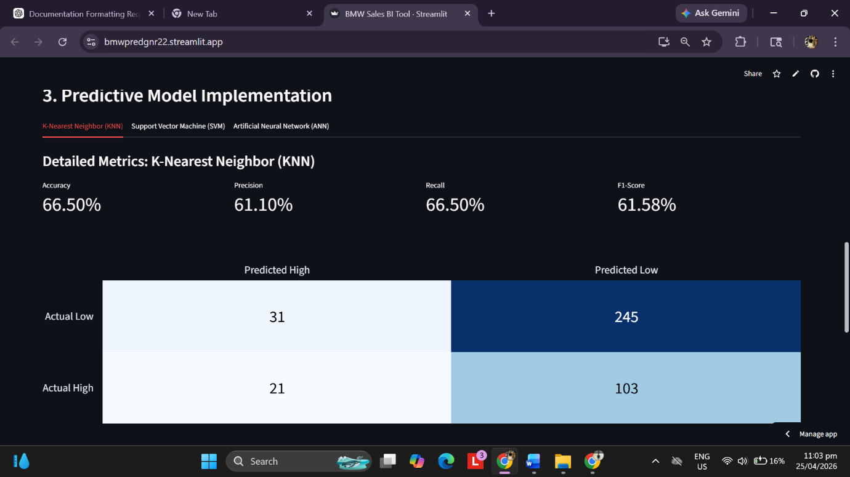

- True Negatives (245): These are cars that actually had Low sales, and the model correctly predicted Low. (This is your model's biggest strength).
- True Positives (21): These are cars that actually had High sales, and the model correctly predicted High. (This is a weakness; it's missing a lot of "High" performers).
- False Positives (31): The model predicted "High," but the car was actually "Low."
- False Negatives (103): This is the biggest problem. The model predicted "Low," but these were actually the top-selling cars!
- This helps identify the specific strengths and weaknesses of each predictive model.

Comparison of results
1st training phase: 3,000 records out of 50,000
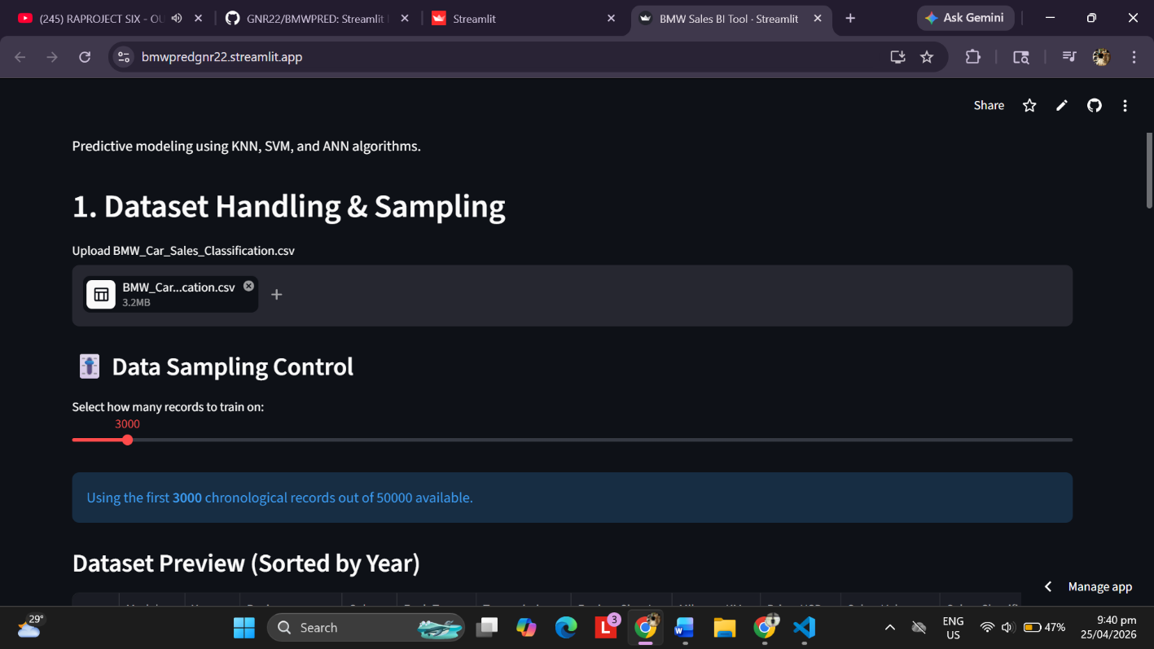

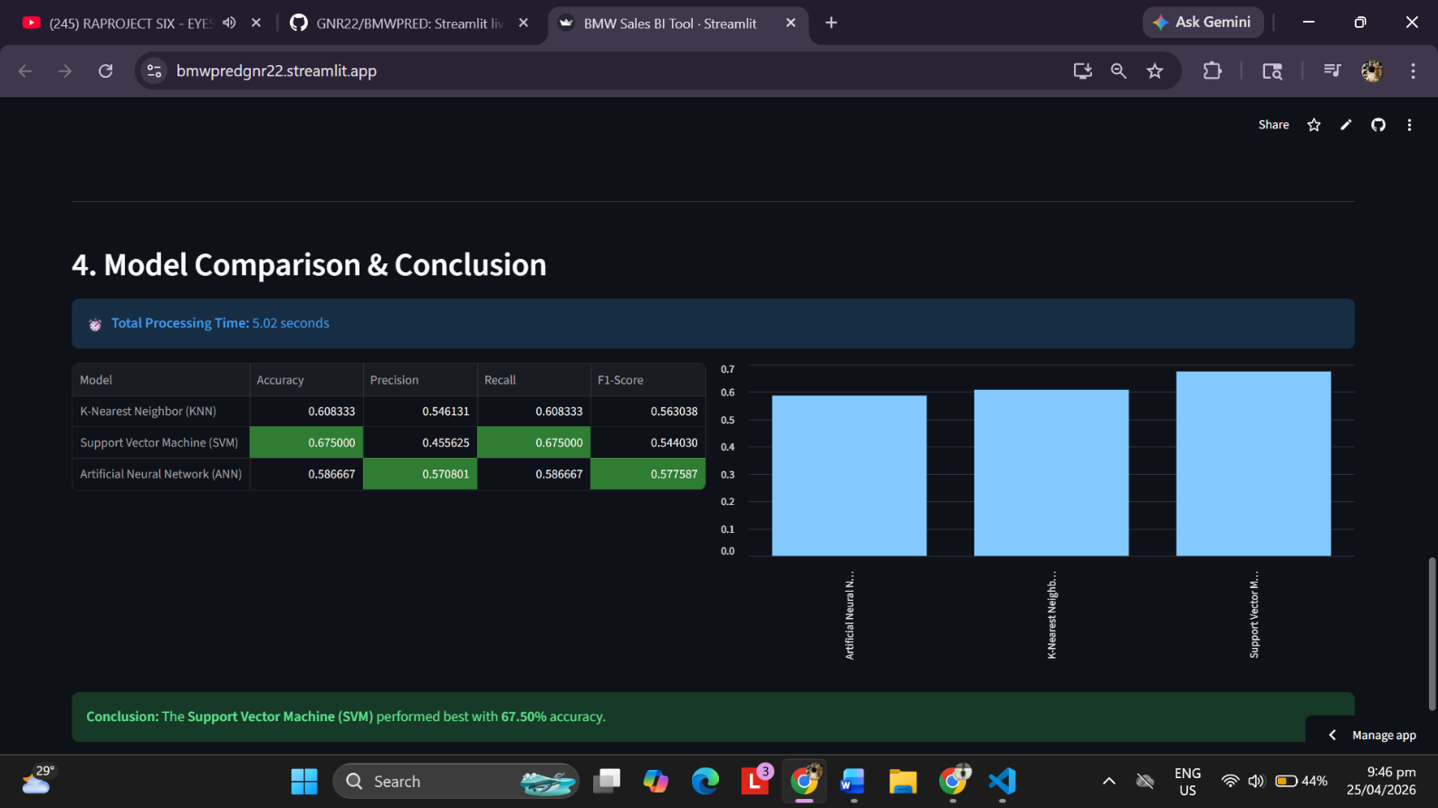

Here in the results, you can see the comparison and out of the three, Support Vector Machine (SVM) finishes by an accuracy of 67.50% than the 2 models in 5.02 seconds.

2nd Training phase: 10,000 out of 50,000 records
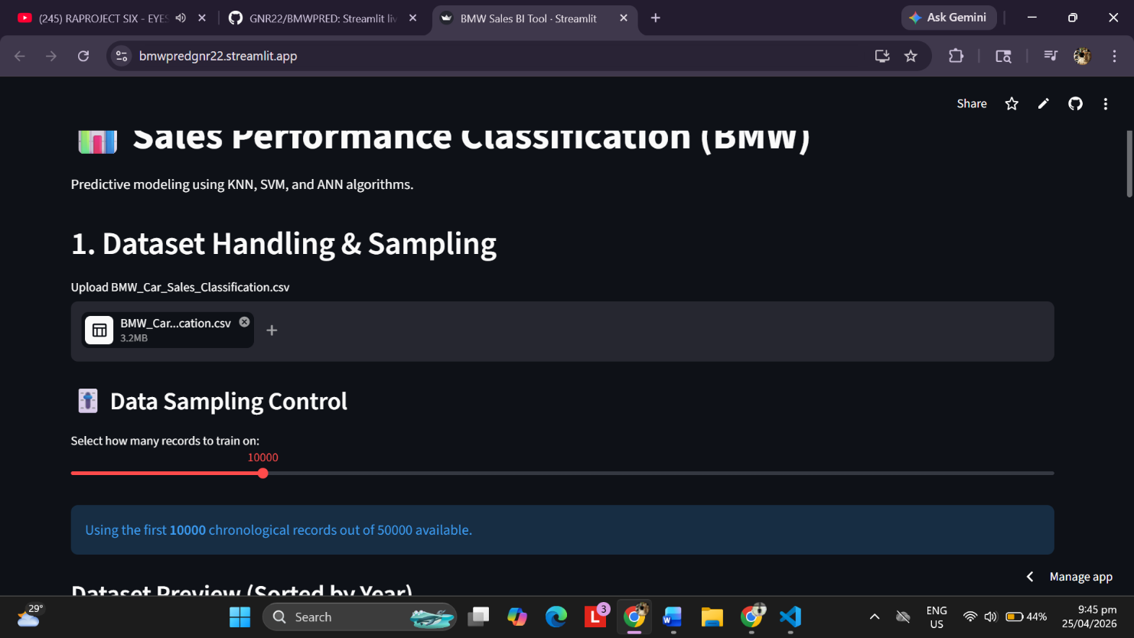

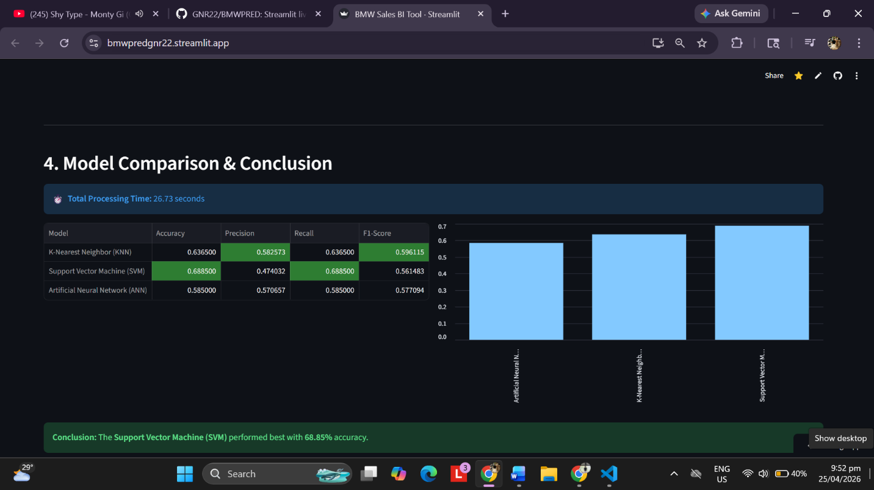

In the second training phase SVM still won with an accuracy of 68.85 in 26.73 seconds

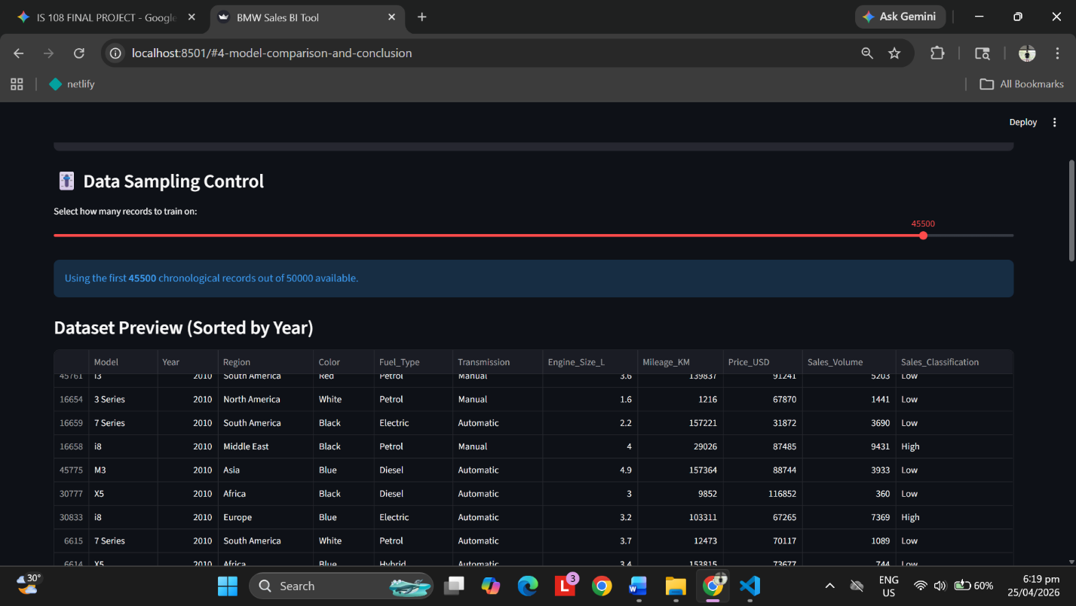
3rd training phase: 45,500 out of 50,000 records

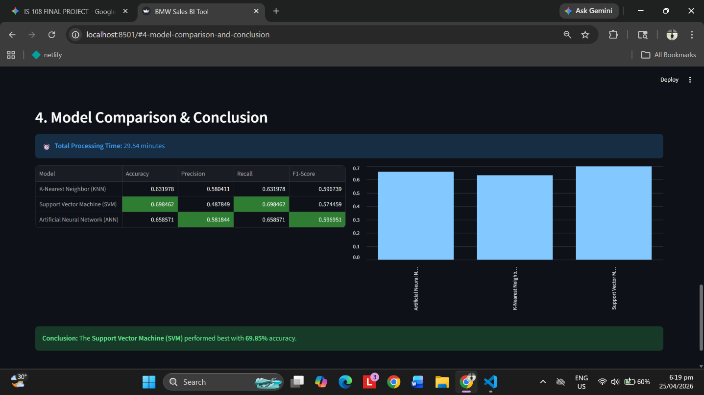

In the third training phase the number of records were raised by a significant amount resulting to a longer training phase that took almost 30 minutes to finished processing.

Important Code snippets
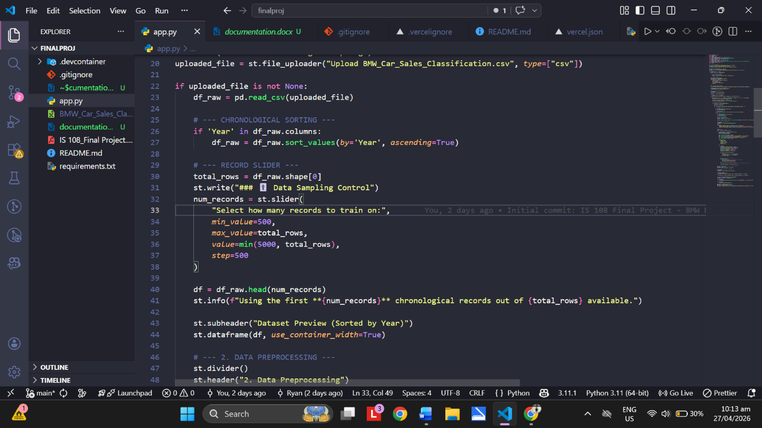

The logic sorts the BMW dataset by Year to preserve the sales timeline. A Dynamic Sampling Slider lets users control dataset size, memory use, and training time. Using .head(), the model trains only on past data to predict future performance, turning a static CSV into a flexible Business Intelligence tool.
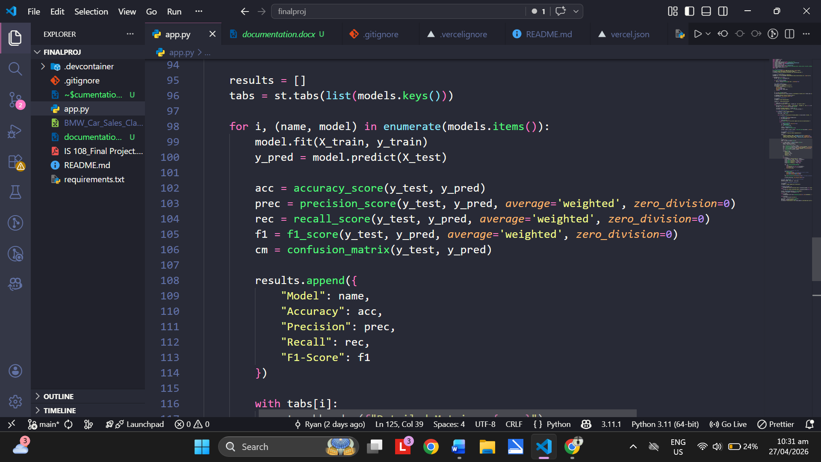

The purpose of this code is to perform multiple evaluations, store the results, and analyze them. By calculating accuracy, precision, recall, and the F1-score, the program measures the reliability of the model through scientific measurement.

Conclusion and recommendations
The development of this intelligent system proves that BMW sales performance can be accurately predicted using intrinsic vehicle features such as price, mileage, fuel type, and other relevant attributes without relying on historical sales volume. By mathematically transforming categorical data and scaling numerical inputs, models such as SVM, KNN, and ANN can effectively learn consumer purchasing patterns. In this project, SVM proved to have the best performance among all three models, as it was well-suited in terms of accuracy and handling large datasets. For future improvements, the web application should include additional factors such as inflation rates and average gas prices, since these are important external variables that can influence the sales performance of vehicles like BMWs.

