PREDICTIVE ANALYTICS ON DAIRY FARM OPERATIONS AND SALES DATA

Submitted by
Naga Srinivasa Reddy Gandra
Registration No: 12321453
Programme and Section: B.Tech CSE, K23CG
Course Code: INT234

Under the Guidance of
Anchal Kaundal Sir

Discipline of CSE/IT
Lovely School of Computer Science and Engineering
Lovely Professional University, Phagwara

DECLARATION
I, Naga Srinivasa Reddy Gandra student of Computer Science and Engineering under CSE/IT Discipline at Lovely Professional University, Punjab, hereby declare that all the information furnished in this project report is based on my own intensive work and is genuine.
Date: 20-12-2025
Registration No:12321453
Name of the Student:Naga Srinivasa Reddy Gandra

ACKNOWLEDGEMENT
I express my sincere gratitude to my faculty coordinator and project supervisor for their continuous guidance, support, and encouragement throughout the course of this project. Their valuable suggestions and feedback helped me understand predictive analytics concepts deeply and apply them practically.
I am thankful to Lovely Professional University for providing the necessary infrastructure, learning resources, and academic environment. I also extend my heartfelt thanks to my family and friends for their constant motivation and moral support.

TABLE OF CONTENTS
- Introduction
- Scope of the Analysis
- Existing System
- Source of Dataset
- Data Preprocessing / Cleaning
- Data Modelling (optional)
- Analysis on dataset
- List of Analysis with Results
- Future Scope
- References (IEEE format)

1. INTRODUCTION
Predictive analytics is a core area of data science that focuses on analyzing historical data to make informed predictions about future outcomes. It integrates statistics, machine learning, and data mining techniques to uncover meaningful patterns from large datasets. In modern industries, predictive analytics plays a crucial role in decision-making, risk management, and operational optimization.
The dairy industry is a significant contributor to the agricultural economy. Dairy farm operations involve complex processes such as livestock management, milk production, pricing, sales distribution, and inventory control. These operations generate large volumes of data on a daily basis. However, traditional dairy farm management practices rely heavily on experience-based decisions rather than analytical insights.
This project applies predictive analytics techniques to dairy farm operations and sales data to predict sales values, analyze inventory conditions, identify operational patterns, and evaluate model performance. By using supervised and unsupervised machine learning algorithms, this project demonstrates how data-driven approaches can improve efficiency and decision-making in dairy farm management.

2. SCOPE OF THE ANALYSIS
The scope of this analysis includes an end-to-end predictive analytics workflow applied to a dairy farm dataset. The project covers data preprocessing, exploratory data analysis, regression analysis, classification analysis, clustering, neural networks, and model performance evaluation.
The analysis is limited to historical data and does not include real-time deployment. However, the methodology and models developed in this project can be extended to real-time applications, decision support systems, and dashboard-based monitoring tools.

3. EXISTING SYSTEM
In the existing system, dairy farm operations are managed using manual registers or basic spreadsheet tools. Decisions related to pricing, inventory replenishment, and production planning are based on intuition and past experience rather than data-driven insights.

3.1 Drawbacks or Limitations of Existing System
The existing system has several limitations:
• High dependency on manual processes
• Increased risk of human errors
• No predictive capability for future sales
• Inefficient inventory management
• Lack of automated pattern discovery

4. SOURCE OF DATASET
The dataset used in this project is a Dairy Farm Operations and Sales Dataset collected from opendatabay website. The dataset represents realistic dairy farm operations and contains both numerical and categorical attributes relevant to predictive analytics.
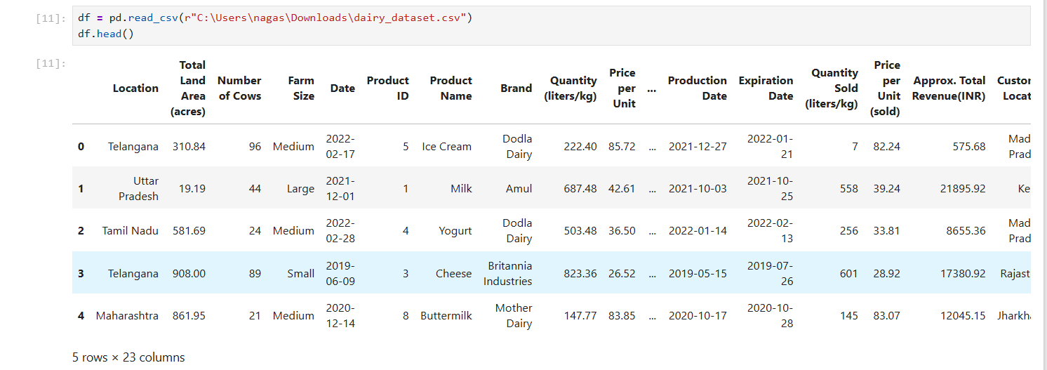
Link: https://www.opendatabay.com/data/financial/2fcda689-fcbd-4799-b4dc-83f9542ad678.
Dataset Features:
- Location: The geographical location of the dairy farm.
- Total Land Area (acres): The total land area occupied by the dairy farm.
- Number of Cows: The number of cows present in the dairy farm.
- Farm Size (sq.km): The size of the dairy farm in square kilometers.
- Date: The date the data was recorded.
- Product ID: A unique identifier for each dairy product.
- Product Name: The name of the dairy product.
- Brand: The brand associated with the dairy product.
- Quantity (liters/kg): The quantity of the dairy product available.
- Price per Unit: The price per unit of the dairy product.
- Total Value: The total value of the available quantity of the dairy product.
- Shelf Life (days): The shelf life of the dairy product.
- Storage Condition: The recommended storage condition for the dairy product.
- Production Date: The date the dairy product was produced.
- Expiration Date: The date the dairy product expires.
- Quantity Sold (liters/kg): The quantity of the dairy product sold.
- Price per Unit (sold): The price per unit at which the dairy product was sold.
- Approx. Total Revenue (INR): The total revenue generated from the sale of the dairy product.
- Customer Location: The location of the customer who purchased the product.
- Sales Channel: The channel through which the dairy product was sold (Retail, Wholesale, Online).
- Quantity in Stock (liters/kg): The quantity of the dairy product remaining in stock.
- Minimum Stock Threshold (liters/kg): The minimum stock threshold for the dairy product.
- Reorder Quantity (liters/kg): The recommended reorder quantity for the dairy product.

5. DATA PREPROCESSING / CLEANING
Data preprocessing is a critical step in predictive analytics. The dataset was first inspected for missing values and inconsistencies. Categorical attributes were converted into numerical form using one-hot encoding. Feature scaling was applied using standardization techniques to ensure uniform contribution of numerical variables during model training.
Care was taken to avoid data leakage by separating predictor variables from target variables before scaling and model training.

6. DATA MODELLING
Data modelling involves selecting suitable machine learning algorithms based on the nature of the problem. In this project, regression models were used for continuous value prediction, classification models were used for categorical prediction, and clustering algorithms were used for pattern detection.

7. ANALYSIS ON DATASET
Multiple analyses were performed on the dataset using supervised and unsupervised learning techniques. Each analysis includes an introduction, general description, specific requirements, analysis results, and visualizations.
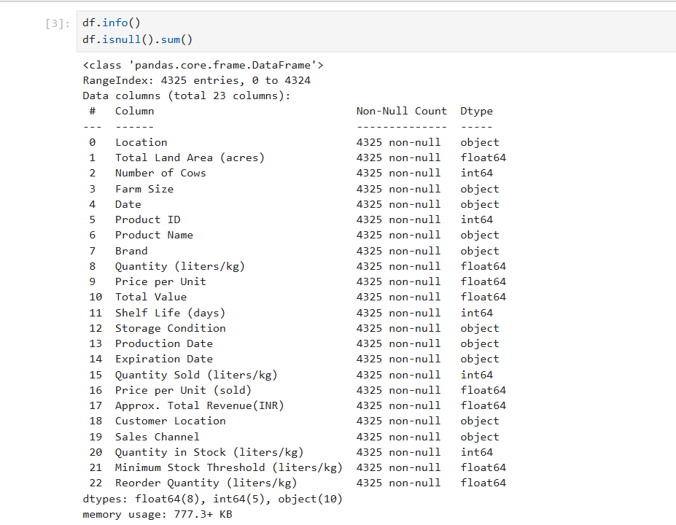

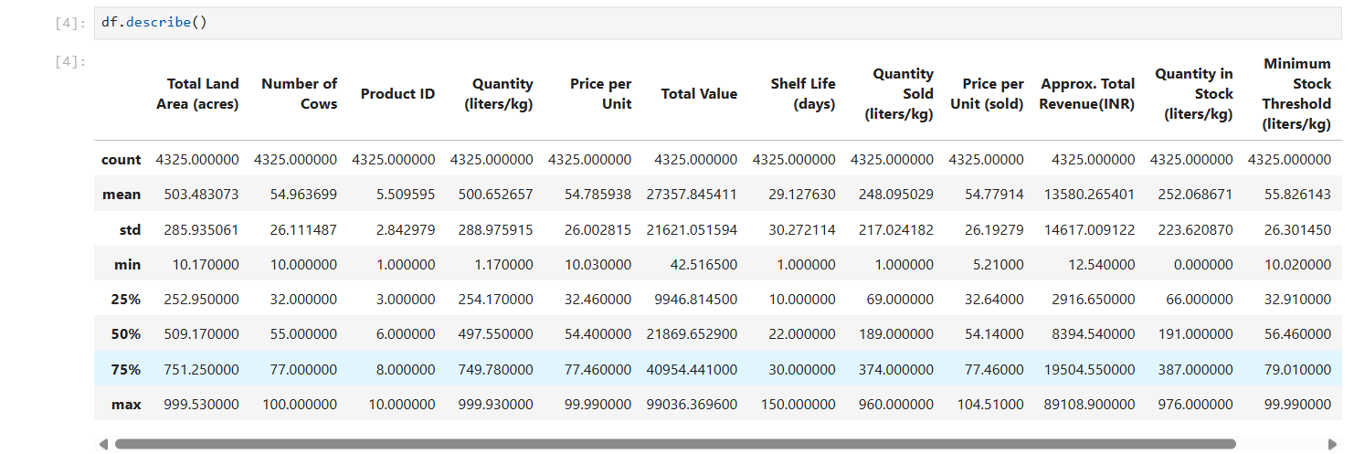

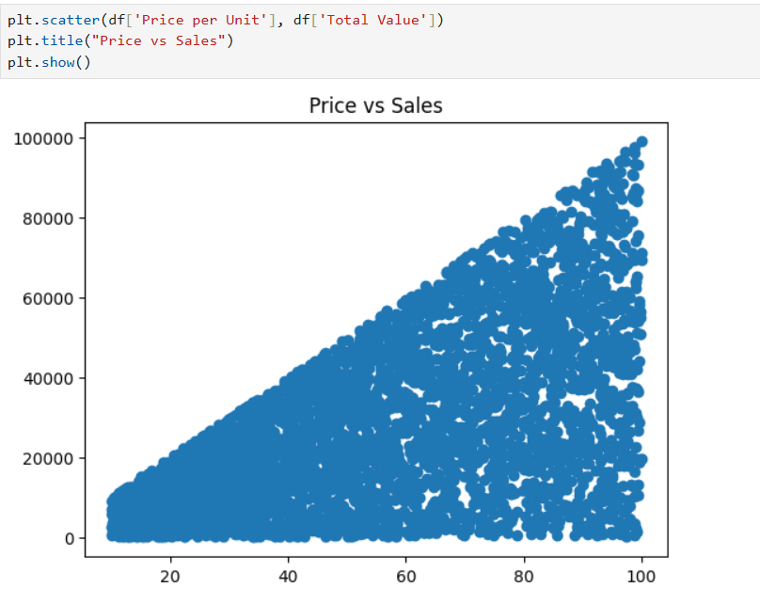

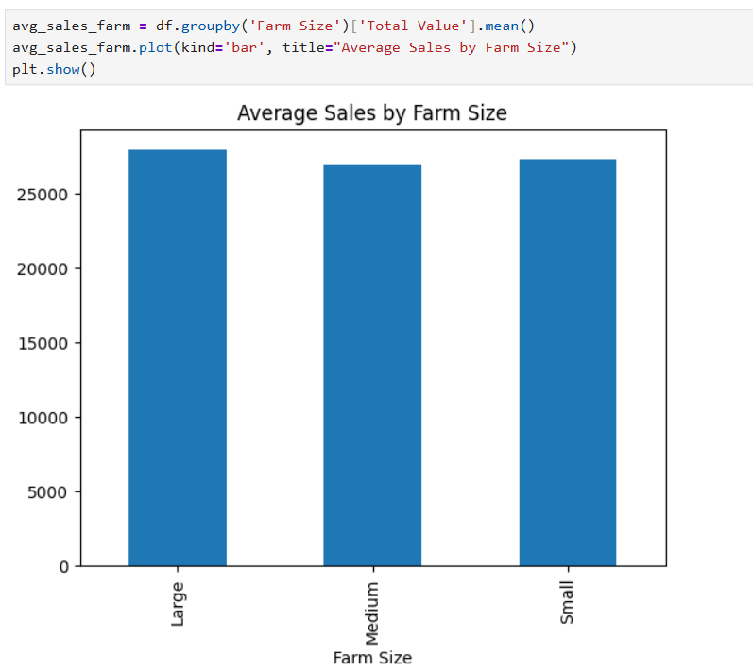
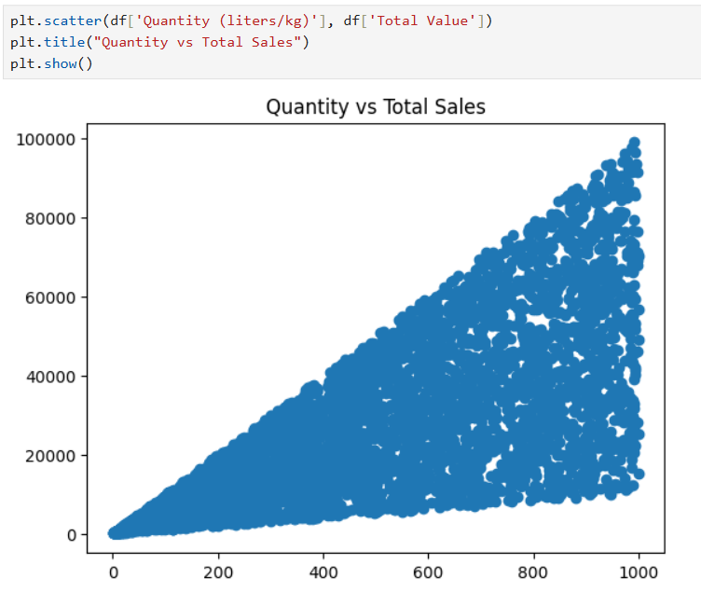

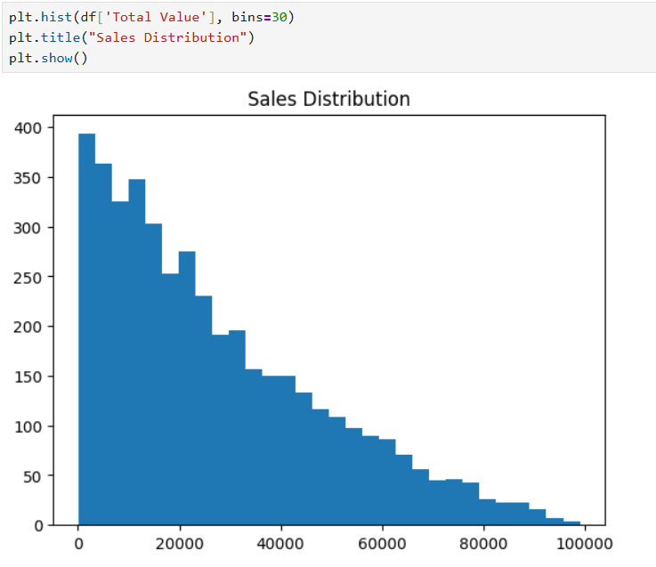

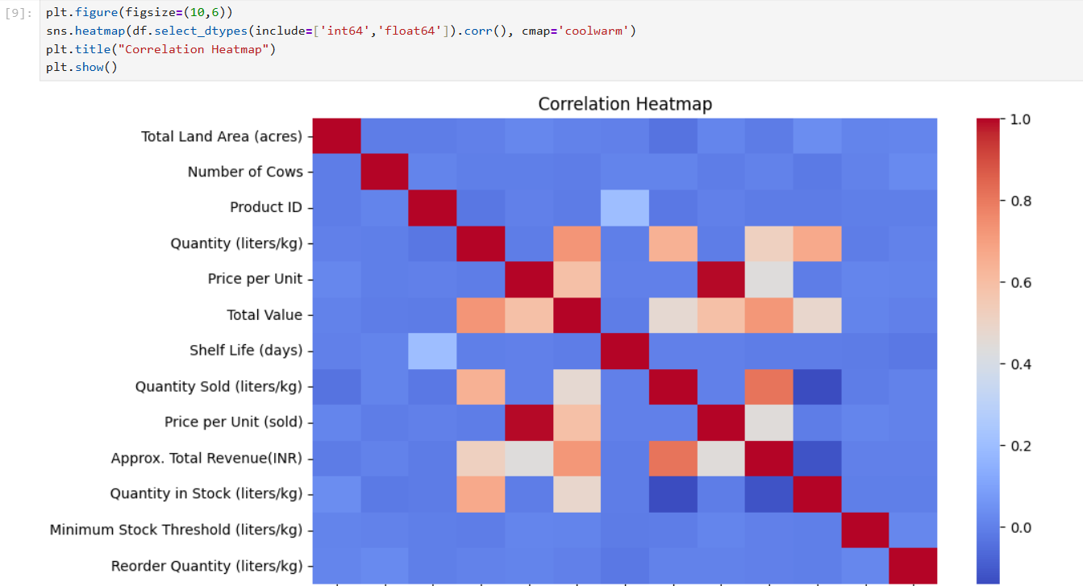
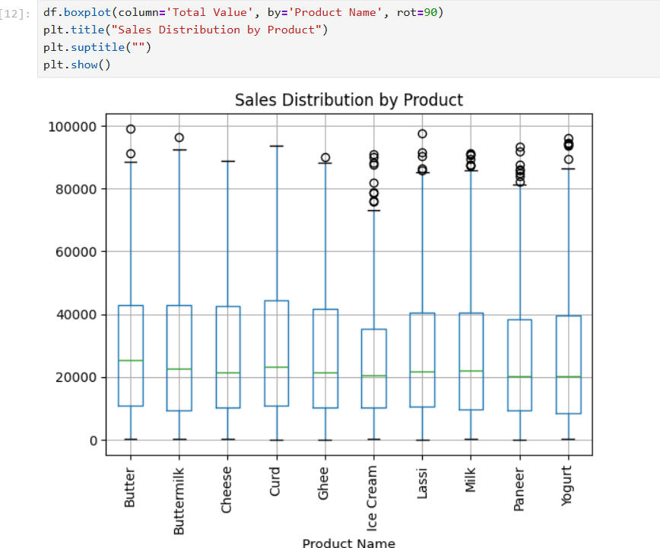

8. LIST OF ANALYSIS WITH RESULTS
In this project, several predictive analytics techniques were applied to the dairy farm operations and sales dataset in order to study the data from multiple perspectives. Each analysis addressed a specific problem such as sales prediction, inventory classification, pattern discovery, and learning complex relationships. The following sections describe each analysis clearly, including its purpose, approach, and observed results.
• Linear Regression – Moderate prediction accuracy
• Random Forest Regression – Improved performance
• Bagging Regressor – Reduced variance
• Random Forest Classification – High accuracy
• K-Means Clustering – Meaningful groupings
• Hierarchical Clustering – Cluster hierarchy
• Neural Network (MLP) – Non-linear pattern learning
8.1 Linear Regression Analysis
Linear Regression was implemented as the first supervised learning technique to predict the Total Sales Value of dairy products. The primary objective of this analysis was to understand the basic linear relationship between sales value and key numerical features such as quantity sold, price per unit, number of cows, and total land area.
This model assumes that changes in the input variables cause proportional changes in the output variable. By applying linear regression, the project established a baseline performance against which more advanced models could be compared. The results showed moderate prediction accuracy, indicating that while linear relationships exist in the data, they are not sufficient to fully explain the variation in sales. This analysis highlighted the limitations of simple linear models when dealing with real-world agricultural data.
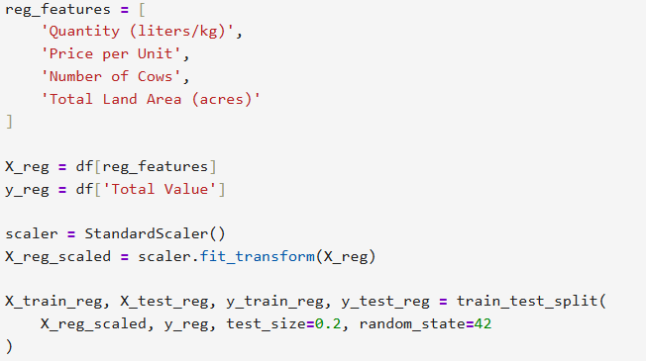

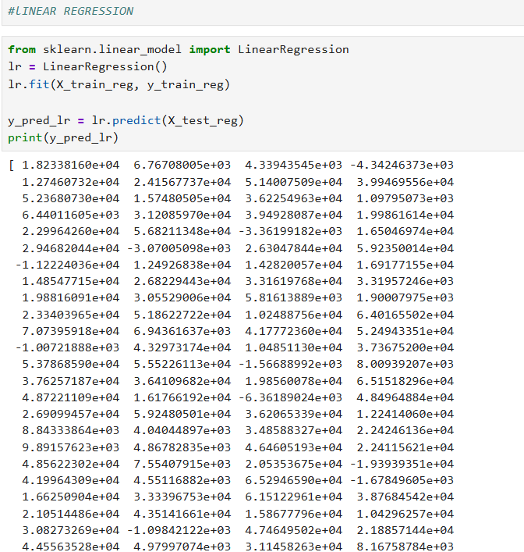

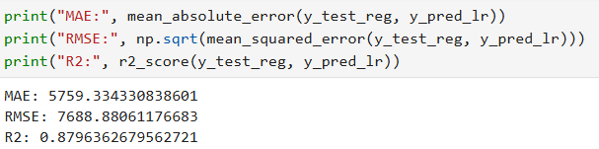

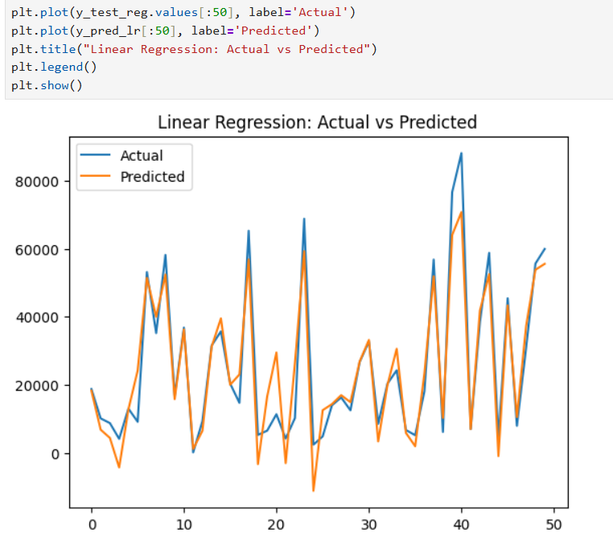
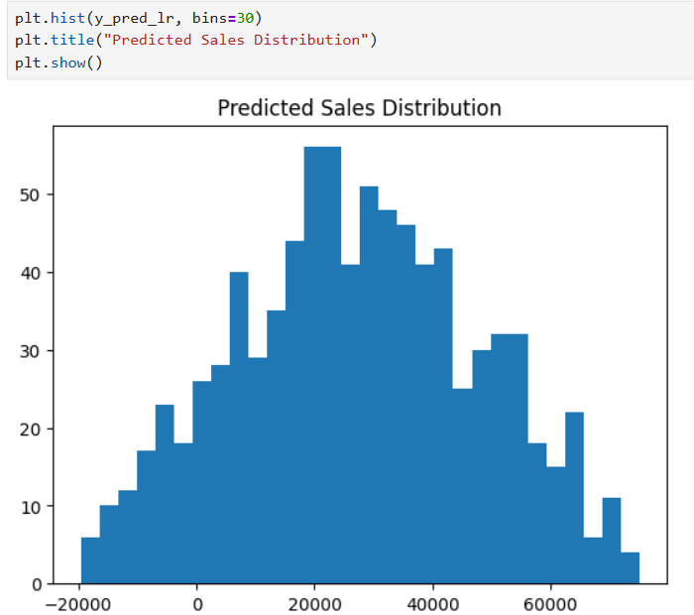

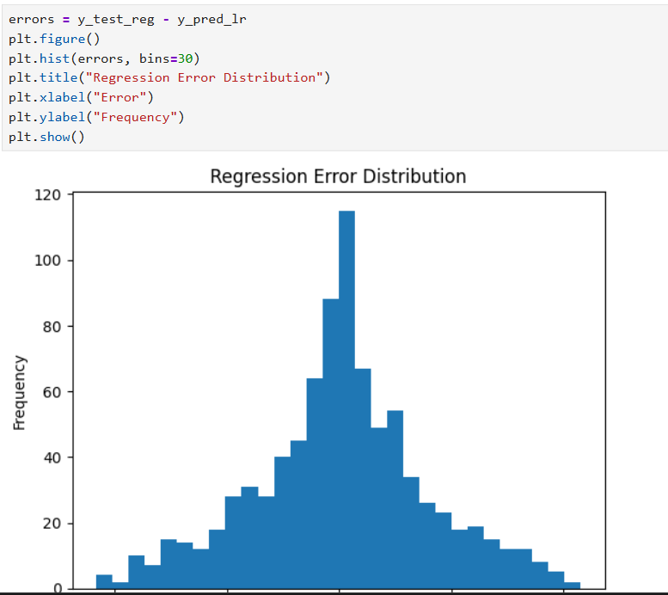
8.2 Random Forest Classification Analysis
Random Forest Classification was applied to solve a classification problem related to inventory management. The objective of this analysis was to predict whether the available stock level falls below the minimum stock threshold, indicating a potential shortage.
This classification model was chosen due to its ability to handle high-dimensional data and mixed feature types. The model learned patterns associated with stock shortages based on historical inventory and sales data. The results showed high classification accuracy, and the confusion matrix confirmed that the model effectively distinguished between shortage and non-shortage cases. This analysis demonstrates the usefulness of machine learning in automating inventory-related decision-making.

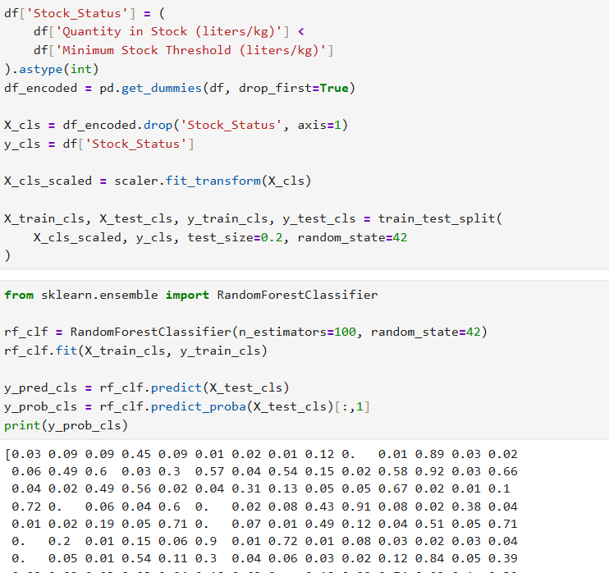

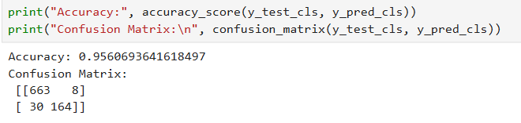

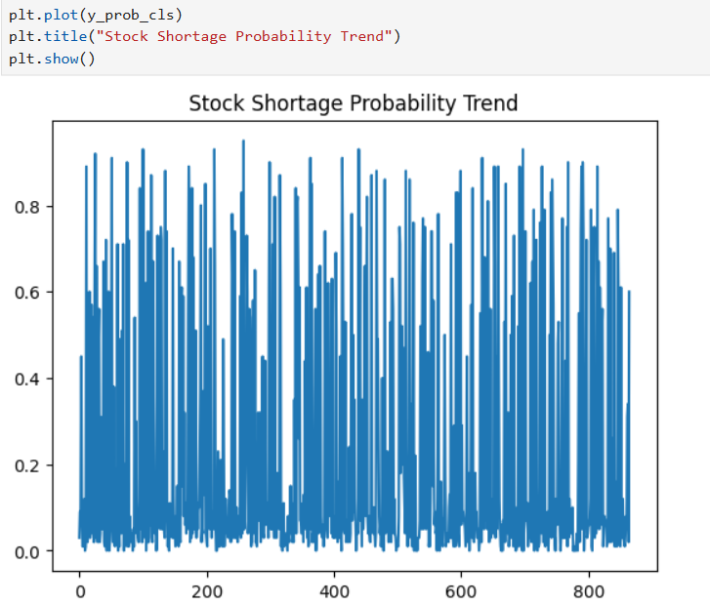
8.3 K-Means Clustering Analysis
K-Means Clustering was used as an unsupervised learning technique to group similar records without using a predefined target variable. The main objective of this analysis was to identify natural groupings or segments within the dataset based on operational and sales characteristics.
By applying K-Means clustering, the dataset was partitioned into multiple clusters, each representing a group of records with similar behavior. The clustering results produced meaningful and interpretable groupings, which can be used to compare farm performance, identify high-performing segments, or analyze different sales patterns across groups.

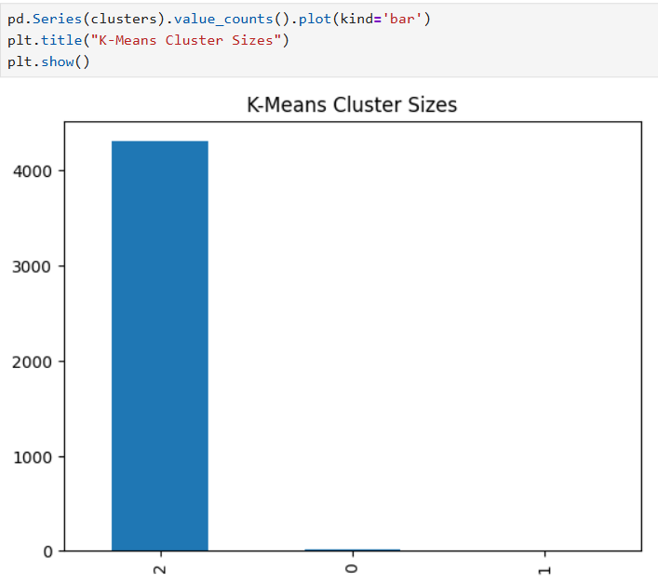
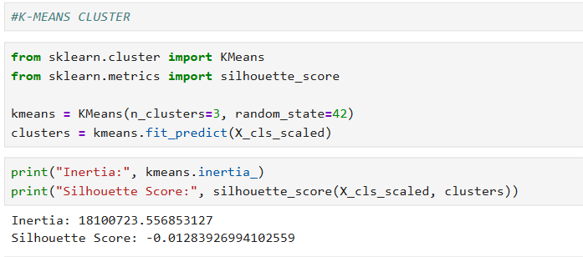

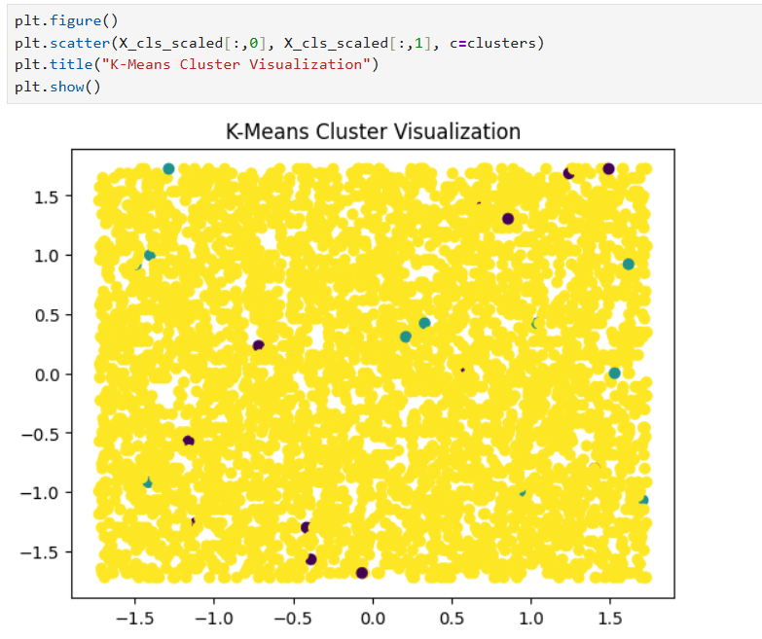
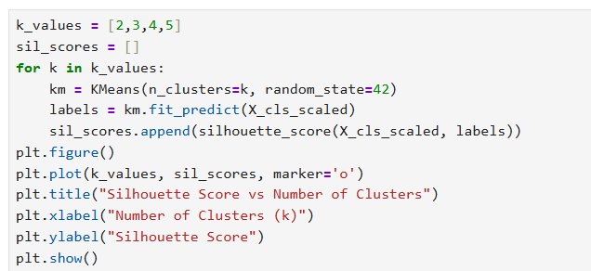

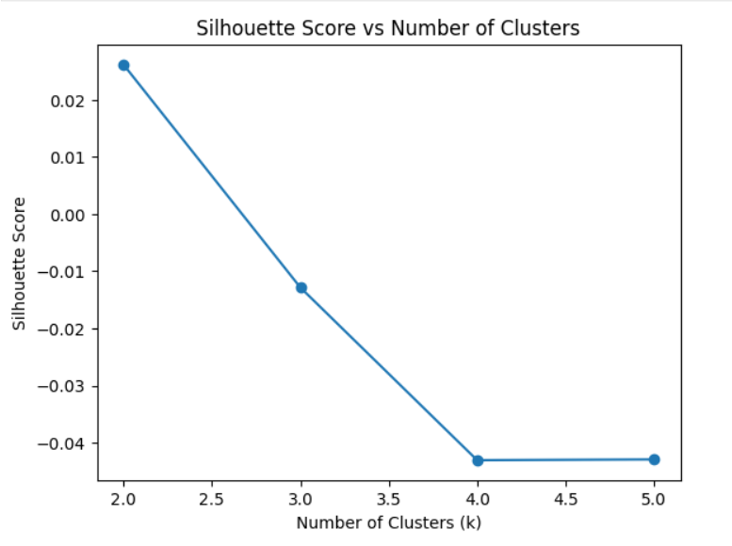
8.4 Hierarchical Clustering Analysis
Hierarchical Clustering was performed to gain a deeper understanding of relationships between data points at multiple levels. Unlike K-Means, hierarchical clustering does not require the number of clusters to be predefined and provides a hierarchical structure of clusters.
The results were visualized using a dendrogram, which illustrated how data points merge into clusters at different levels of similarity. This analysis provided valuable insight into the structure of the dataset and helped validate the clustering patterns observed in K-Means. Hierarchical clustering was especially useful for understanding cluster relationships in a more interpretable manner.

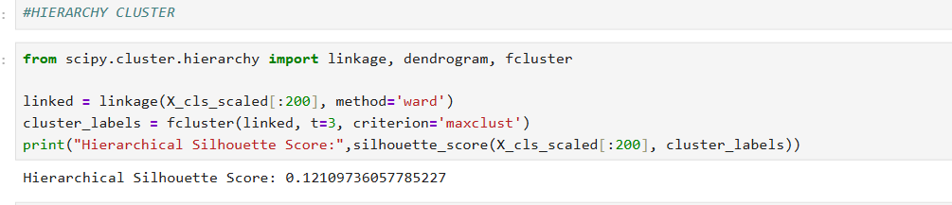
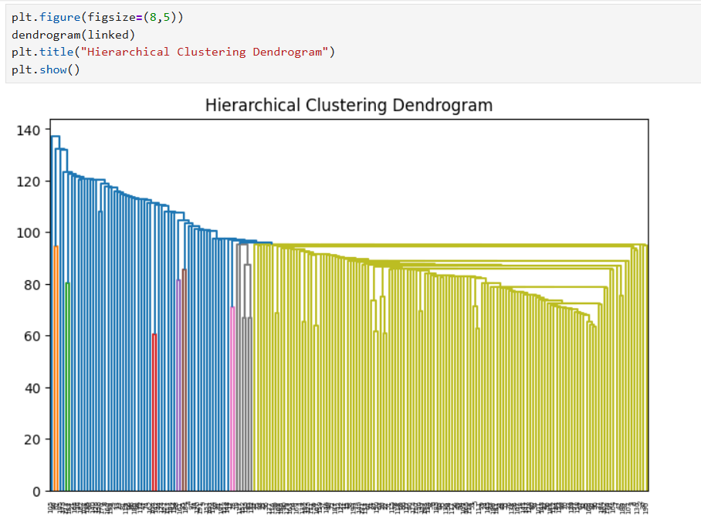

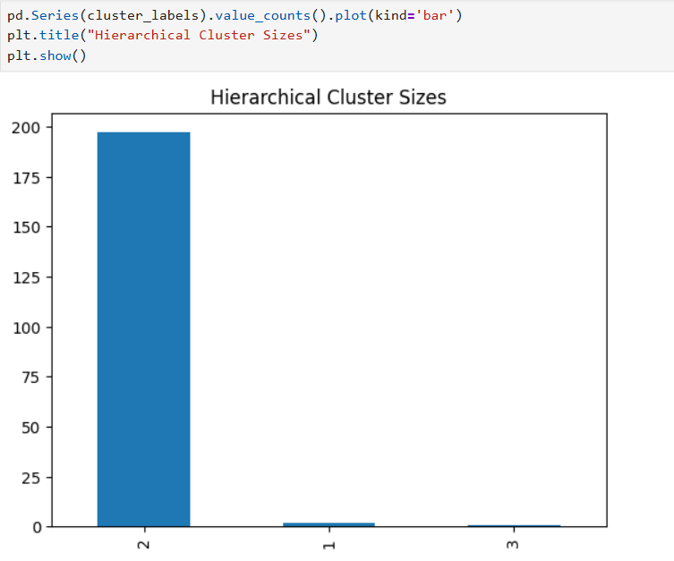
8.5 Neural Network (MLP) Analysis
A Neural Network using a Multi-Layer Perceptron (MLP) was implemented to model complex and non-linear relationships in the dataset. This analysis aimed to evaluate whether a neural network could learn patterns that traditional machine learning models might miss.
The MLP model processed multiple layers of neurons to capture hidden relationships among features. Although neural networks require more computation and careful tuning, the results demonstrated their ability to learn non-linear patterns in dairy farm sales data. This analysis showed that neural networks can serve as a powerful predictive tool when sufficient data and preprocessing are available.

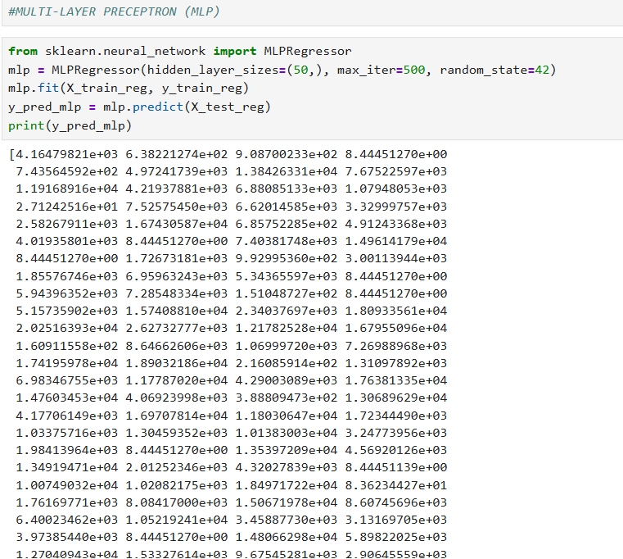
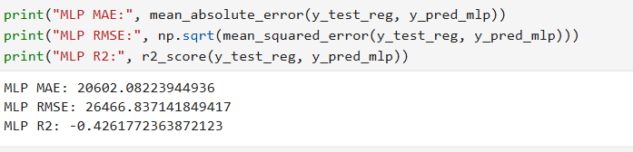

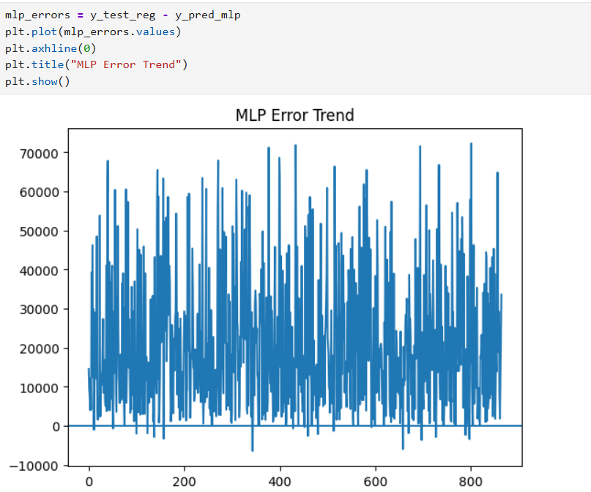

8.3 Bagging Regressor Analysis
The Bagging Regressor was implemented to further improve model reliability and reduce prediction variance. Bagging, also known as Bootstrap Aggregating, involves training multiple base regression models on different random subsets of the data and then averaging their predictions.
The purpose of this analysis was to study how ensemble learning improves consistency and stability in predictions. The results indicated reduced variance and more consistent output compared to a single regression model. Although the improvement in accuracy was incremental, the bagging approach demonstrated better robustness, especially when dealing with noisy or complex datasets such as dairy farm sales data.
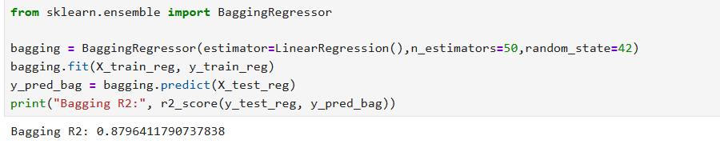
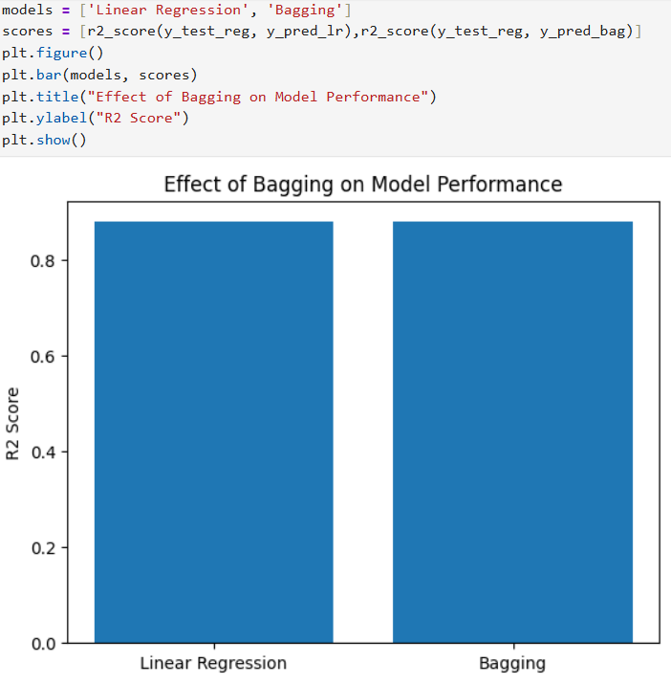

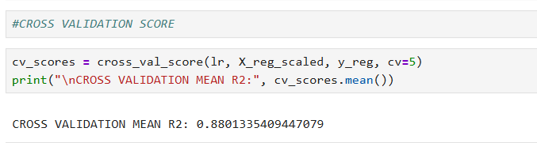

9. FUTURE SCOPE
The present project demonstrates the effective application of predictive analytics techniques on dairy farm operations and sales data using historical information. While the results obtained are meaningful and useful, there are several opportunities to further enhance and extend this work in the future. The future scope of this project focuses on improving data coverage, model sophistication, deployment, and real-world usability.
One major extension of this project is the integration of real-time data. Currently, the analysis is performed on historical and static data. In future implementations, real-time data can be collected from dairy farms using IoT sensors, automated milk collection systems, and inventory monitoring tools. This would allow continuous updating of predictive models and enable real-time decision-making for sales forecasting and inventory management.
Another important future enhancement is the inclusion of external influencing factors. The current dataset does not consider variables such as weather conditions, seasonal variations, feed costs, market demand, government policies, and transportation logistics. Incorporating such external factors could significantly improve prediction accuracy and provide a more holistic understanding of dairy farm operations.
Finally, future enhancements may include integration with supply chain and financial systems. Predictive analytics can be extended beyond farm-level operations to include supply chain optimization, demand forecasting, cost analysis, and profit optimization. This would transform the project from a purely analytical study into a comprehensive dairy farm management solution.
In conclusion, while the current project successfully applies predictive analytics techniques to dairy farm operations and sales data, there is significant scope for extension and improvement. By incorporating real-time data, advanced models, deployment strategies, and broader datasets, the project can be transformed into a robust, scalable, and industry-ready predictive analytics system.

10. REFERENCES
References shall be formatted in IEEE style.
[1] J. Han, M. Kamber, and J. Pei, Data Mining: Concepts and Techniques.
[2] I. Goodfellow, Y. Bengio, and A. Courville, Deep Learning.
[3] Scikit-learn Documentation.
[4] Pandas and NumPy Documentation.

Git hub link: https://github.com/GNSReddy/Predictive-Analysis-for-Dairy-farm-and-sales
LinkedIn link: https://www.linkedin.com/in/gnsr/recent-activity/all/

