Project Planning Phase
Project Planning Template (Product Backlog, Sprint Planning, Stories, Story points)

Date | 14 October 2026
Team ID | ServiceNow - 92
Project Name | Medical Diagnosis Center (MDC)
Maximum Marks | 5 Marks

Product Backlog, Sprint Schedule, and Estimation :
Note : The team member mentioned in the table is my roll number
Sprint | Functional Requirement (Epic) | User Story Number | User Story / Task | Story Points | Priority | Team Members
Sprint-1 | E1 — Core Data Tables | USN-01 | As an administrator, I can maintain patient name, contact details and date of birth so appointments can be linked to the correct patient. | 3 | High | 92
Sprint-1 | E1 — Core Data Tables | USN-02 | As an administrator, I can maintain diagnostic test names, categories, descriptions, prices, durations and preparation instructions. | 3 | High | 92
Sprint-1 | E1 — Core Data Tables | USN-03 | As a receptionist, I can create appointments with patient and diagnostic-test references and an appropriate status. | 3 | High | 92
Sprint-1 | E1 — Core Data Tables | USN-04 | As a lab technician, I can access a medical report linked to the correct patient and appointment. | 3 | High | 92
Sprint-1 | E2 — Catalog and Roles | USN-05 | As a patient, I can browse active diagnostic tests before choosing a test to book. | 2 | Medium | 92
Sprint-1 | E2 — Catalog and Roles | USN-06 | As an administrator, I can configure separate roles for administrators, patients, receptionists and lab technicians. | 5 | High | 92
Sprint-2 | E3 — Portal and Booking | USN-07 | As a portal user, I can navigate from the home page to test booking, my appointments and medical reports. | 2 | Medium | 92
Sprint-2 | E3 — Portal and Booking | USN-08 | As a patient, I can view available tests and review their details before booking. | 3 | High | 92
Sprint-2 | E3 — Portal and Booking | USN-09 | As a patient, I can submit a test booking form and receive validation when required details are missing. | 5 | High | 92
Sprint-2 | E3 — Portal and Booking | USN-10 | As the system, I can save an appointment linked to the selected patient, diagnostic test and scheduled date/time. | 3 | High | 92
Sprint-2 | E3 — Portal and Booking | USN-11 | As a patient, I can view my appointments and understand their current status. | 3 | High | 92
Sprint-3 | E4 — Appointment Workflow | USN-12 | As authorized staff, I can update the appointment status to reflect progress through the diagnostic workflow. | 3 | High | 92
Sprint-3 | E5 — Report Generation | USN-13 | As the system, I can create a linked medical report when an appointment changes to Completed and avoid duplicate reports. | 5 | High | 92
Sprint-3 | E5 — Report Generation | USN-14 | As a report user, I can see the report number, date, patient, appointment and the findings stored on that report. | 3 | High | 92
Sprint-3 | E5 — Report Generation | USN-15 | As a patient, I can open Medical Reports and view reports linked to my appointments when they are available. | 3 | High | 92
Sprint-3 | E6 — Notifications | USN-16 | As a patient, I can receive booking or report notifications when outbound email has been configured. | 3 | Medium | 92
Sprint-4 | E7 — Report Access | USN-17 | As a patient, I can print or save an available report in a readable format. | 3 | High | 92
Sprint-4 | E8 — Security and QA | USN-18 | As an administrator, I can verify that roles and access controls prevent patients from viewing other patients’ records. | 5 | High | 92
Sprint-4 | E8 — Security and QA | USN-19 | As the project team, we can test the end-to-end booking-to-report workflow and resolve defects found during testing. | 5 | High | 92
Sprint-4 | E8 — Security and QA | USN-20 | As a portal user, I see clear labels, understandable reference values and useful validation messages. | 3 | Medium | 92
Sprint-4 | E9 — Project Delivery | USN-21 | As the project team, we can prepare project documentation, screenshots and demonstration steps for submission. | 2 | Medium | 92

Project Tracker, Velocity & Burndown Chart:
Sprint | Total Story Points | Duration | Sprint Start Date | Sprint End Date (Planned) | Story Points Completed (as on Planned End Date) | Sprint Release Date (Actual)
Sprint-1 | 19 | 6 Days | 22 Sep 2026 | 27 Sep 2026 | 19 | TBD
Sprint-2 | 16 | 6 Days | 28 Sep 2026 | 3 Oct 2026 | 16 | TBD
Sprint-3 | 17 | 6 Days | 3 Oct 2026 | 8 Oct 2026 | 17 | TBD
Sprint-4 | 18 | 6 Days | 8 Oct 2026 | 13 Oct 2026 | 18 | TBD

Velocity and Planned Average Workload:
Planned backlog = 70 story points across 4 sprints. Planned average workload = 70 ÷ 4 = 17.5 story points per sprint. This is a planning estimate, not measured velocity. Actual team velocity should be calculated from story points completed at the end of completed sprint
Burndown Chart:
This ideal line shows the planned reduction from 70 remaining story points to zero over four six-day sprints. Update the chart with actual remaining work at each check-in to compare real progress with the plan.
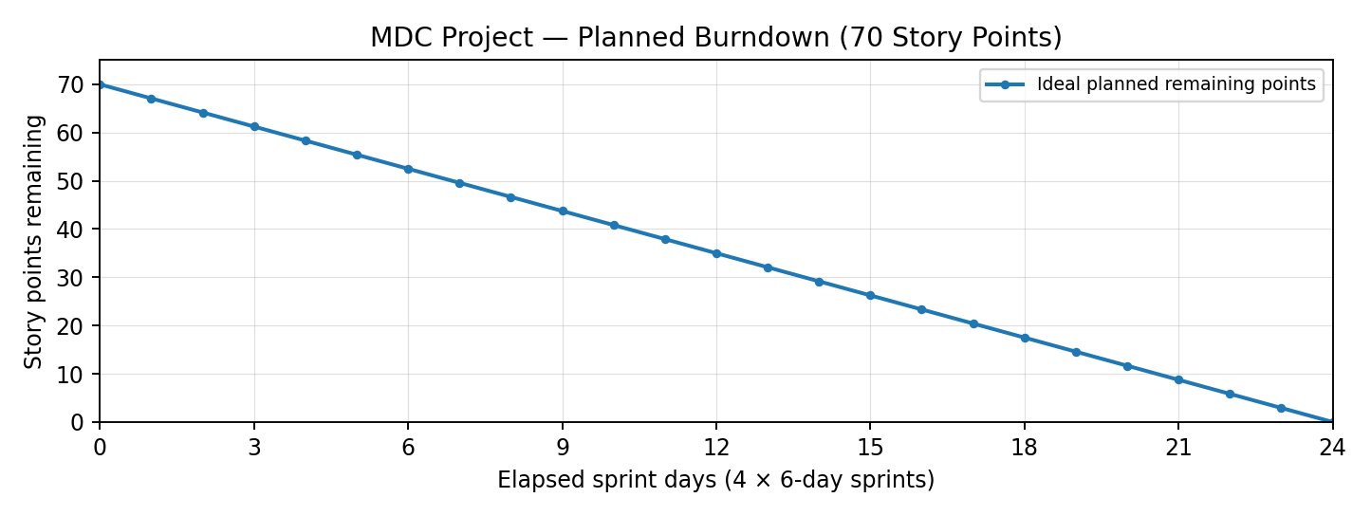
Planning assumption only: actual remaining story points have not been provided.

