*Xiaoran Li , Yuchuan Lin , Dandan Xu*

*Nuid: 001023070, 001302756, 001085731*

Assignment design 1.

Group: GOAT

**Deliverables**

1. Report outlining your proposed solution.

Through the five years’ data of graduates’ quality of employment, career prospects, subjective evaluation of employers and employers, and objective data of educational impact, to evaluate and track the growth of all aspects of the graduates within 5 years. The comprehensive feedback learned creates a set of evaluation dimensions for the university education system to measure the performance of university education quality, thus helping to improve the system and serve students.

The final dashboard will rank the colleges’ score from evaluation program.

Following is our settings of evaluation frame:

Form1: dimensions and weights of evaluation

|  |  |  |  |
| --- | --- | --- | --- |
| Score type | Score class | Percentage(%) | Description |
| Salary and career future | Median annual salary | 18 | record the medium number of salary of all students each year for 5 years |
| salary Growth rate | 17 | Record the salary growth rate of all graduates each year for 5 years |
| Alumni Donation Rate | 5 | Total donations from graduates within 5 years |
| Professional career matching | 10 | Investigate how many students' current work and professional matches |
| Subjective feedback | Student satisfaction | 20 | Graduates' satisfaction with school education |
| Employer's reputation | 10 | Feedback from employers on school students' work ability and professional skills |
| Objective feed back | quantity of academic achievements | 10 | Number of citations in related fields reached the top 1% |
| academic Impact | 10 | percentage among all paper of citations in related fields reached the top 1% |

2. Sequence diagrams showing how to navigate the university object model to deliver performance

metrics needed for performance and feedback.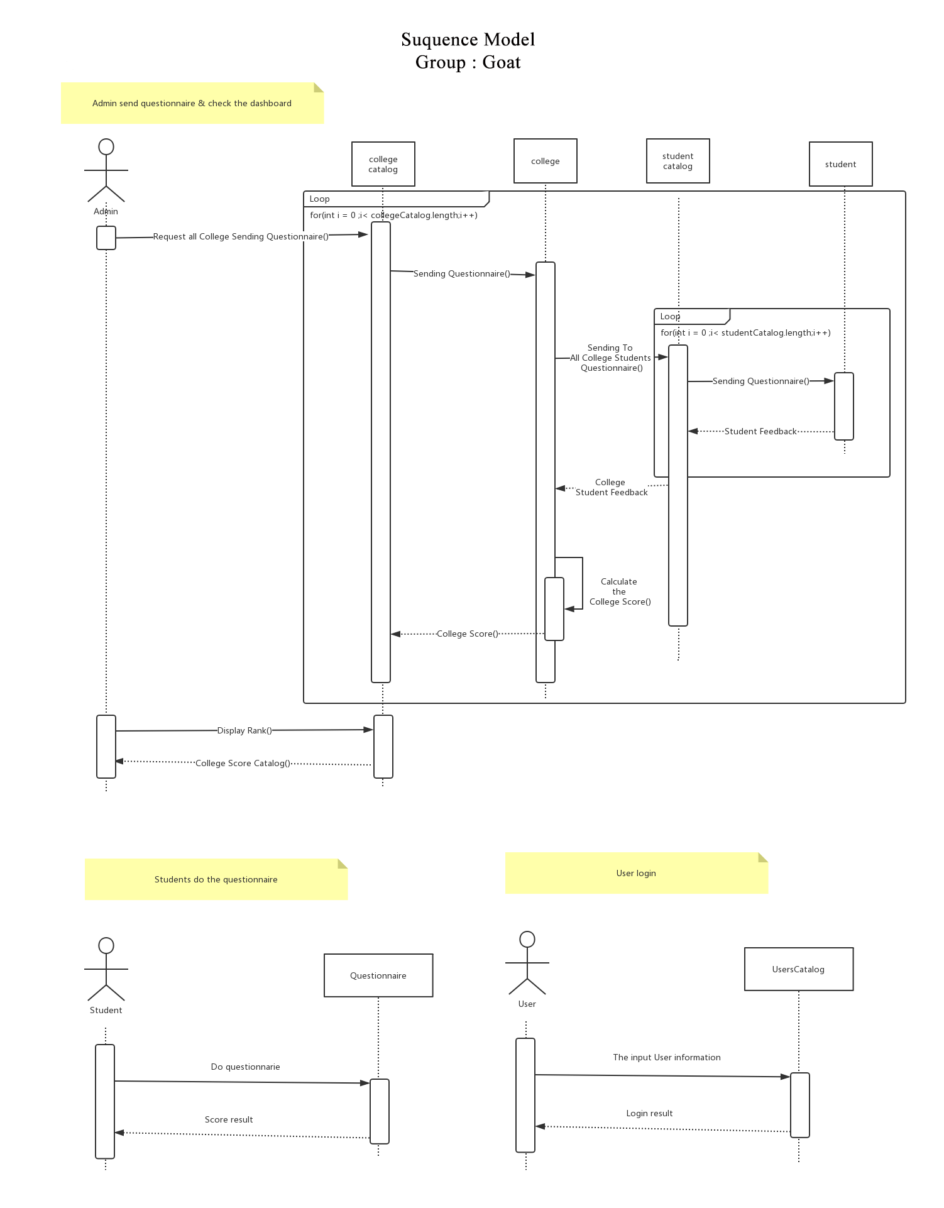

3. An object model showing the changes to the university model to support the new capabilities. This

must include the additional methods and attributes required to deliver the results.