

F.A.I.R.
Freight Agentic Investigation & Resolution
Agentic AI CA-3 Academic Project Report
Gatik Johar | Harman Singh | October 2026

Table of Contents

Executive Summary 3
Introduction 4
Proposed Solution 5
System Architecture 6
Agent Design 7
Implementation 9
Evaluation & Testing 11
Limitations & Future Scope 13
Conclusion 14

Executive Summary
F.A.I.R. (Freight Agentic Investigation & Resolution) is an autonomous multi-agent proof-of-concept designed to investigate and resolve freight exceptions through a structured five-agent workflow. The system demonstrates core agentic AI principles including task planning, multi-step execution, decision-making under uncertainty, adversarial validation, and human-in-the-loop governance.
Freight exceptions, including damage, delay, customs hold, misroute, and refused delivery, occur on 8-15% of all shipments. Current manual investigation processes require coordinators to query multiple disconnected systems, consuming 60-70% of their time on evidence gathering rather than decision-making. F.A.I.R. addresses this by automating the entire investigation pipeline while maintaining deterministic safety for all financial computations.
The system was evaluated against a 25-case synthetic dataset with 36 automated pytest cases covering boundary conditions, workflow paths, critic rejection, bounded revision loops, and human gate triggers. All tests pass successfully, validating the correctness of deterministic safeguards and agent coordination logic.

Introduction

Business Problem
Global freight operations handle millions of shipments daily across complex multimodal networks. Despite process improvements, exceptions remain a persistent challenge:
- Damage: Cargo arrives with visible or concealed damage requiring carrier claims assessment.
- Delay: Shipments miss committed delivery windows due to weather, operational failures, or missed connections.
- Customs Hold: Shipments detained at borders due to documentation issues or regulatory inspections.
- Misroute: Cargo directed to incorrect hubs or destinations due to label or routing errors.
- Refused Delivery: Consignees reject cargo due to damage, wrong items, or order cancellations.
Each exception family requires a completely different evidence set and resolution logic. A fixed, one-size-fits-all rule cannot handle the combinatorial complexity of exception type, severity, cargo value, customer tier, SLA terms, and carrier performance.

Why Agency?
Agency is required because the system must decide what to investigate, how deeply, and when to escalate. Static business rules cannot adapt to the dynamic nature of freight exceptions. A multi-agent architecture provides the necessary flexibility while maintaining deterministic safety through typed state machines, budget enforcement, and adversarial validation.

Proposed Solution
F.A.I.R. introduces five collaborative agents operating on a typed InvestigationState that flows sequentially through the workflow. The architecture implements conditional branching based on exception type, evidence sufficiency, confidence thresholds, and Critic verdicts.
Key design principles:
- Deterministic Safety: All monetary calculations are pure Python functions with no LLM involvement.
- Adversarial Validation: An independent Critic agent tests Resolver conclusions against alternative hypotheses.
- Human-in-the-Loop: High-risk cases route to human operators for approval, override, or rejection.
- Full Auditability: Every agent action is recorded in an append-only audit log.
- Budget Enforcement: Tool calls are limited by severity tier to prevent runaway investigations.

System Architecture
The F.A.I.R. architecture follows a state-machine pattern where a typed InvestigationState transitions through five agent stages. Conditional branching routes cases based on evidence quality, confidence, and safety thresholds.

State Machine Design
The InvestigationState dataclass encapsulates the entire case context including the FreightCase, EvidencePlan, EvidenceBundle, ProposedResolution, CriticVerdict, and audit log. State transitions are immutable - each agent returns a new state rather than mutating the existing one.

Conditional Branching
- Evidence Gap > 30%: Auto-escalation to human review.
- Critic REVISE: One bounded revision attempt (max 2 iterations).
- Critic REJECT: Immediate human escalation.
- High Value: Amount > $10,000 triggers mandatory human approval.
- Low Confidence: Confidence < 0.7 triggers human review.
- Strategic Customer: All Strategic tier cases require human gate review.
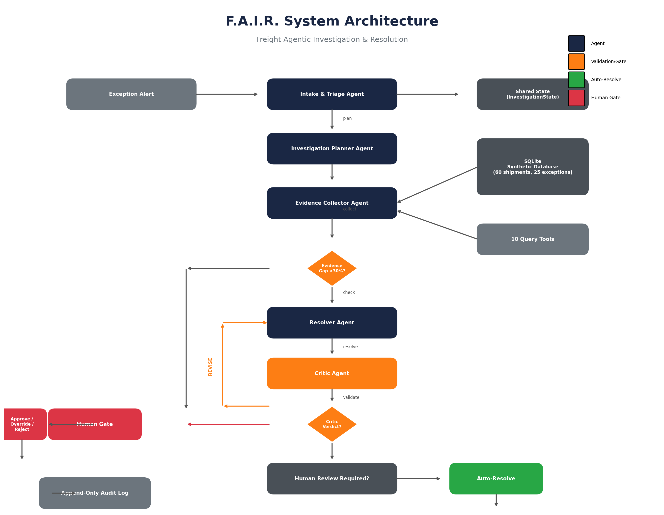
Figure 1: F.A.I.R. System Architecture Diagram

Agent Design

Agent 1: Intake & Triage
Normalizes raw exception events into structured FreightCase objects. Assigns severity based on cargo value thresholds (LOW < $5K, MEDIUM $5K-$15K, HIGH $15K-$50K, CRITICAL > $50K). Sets investigation budget based on severity tier (5-12 tool calls). Determines customer tier implications for downstream liability calculations.

Agent 2: Investigation Planner
Generates tailored evidence plans per exception family. For DAMAGE cases, the plan includes POD details, damage photos, tracking timeline, carrier performance, and claims history. For DELAY cases, the plan includes weather alerts, SLA terms, and route history. Each plan is dynamically constructed based on exception type.

Agent 3: Evidence Collector
Executes read-only tool calls against the synthetic SQLite database. Enforces the investigation budget - if the budget is exhausted, remaining tools are skipped and recorded as gaps. Tracks evidence gap ratio (missing / expected) for downstream escalation decisions.

Agent 4: Resolver
Correlates evidence signals to classify root cause and propose resolution. Uses deterministic rule-based classification with no LLM involvement. Computes resolution amounts using pure functions based on action type, cargo value, and severity. Applies liability caps from customer tier multipliers.

Agent 5: Critic
Independently validates Resolver conclusions through adversarial checks: tests evidence sufficiency, checks for contradictory facts, evaluates alternative hypotheses, and validates confidence justification. Returns one of three verdicts: VALID, REVISE, or REJECT.

Implementation

Technology Stack
Layer | Technology
Language | Python 3.10+
Data Layer | SQLite with synthetic data
UI / PoC | Streamlit
Visualization | Plotly
Testing | pytest

Database Schema
The synthetic database contains 11 tables with realistic freight data: 60 shipments, 8 carriers, 8 customers, 25 injected exceptions, 200+ tracking events, POD records, damage photos, customs entries, weather alerts, claims history, and SLA terms.

Ten Query Tools
All tools are read-only SQL SELECT wrappers: get_shipment_info, get_tracking_timeline, get_pod_details, get_damage_photos, get_customs_entry, get_weather_alerts, get_carrier_performance, get_customer_history, get_sla_terms, get_claims_history.

Streamlit UI
The five-page Streamlit application provides: Exception Queue for browsing cases, Investigation Console for real-time agent trace, Resolution & Approval for human gates, Operations Dashboard for metrics, and Audit & Compliance for full traceability.
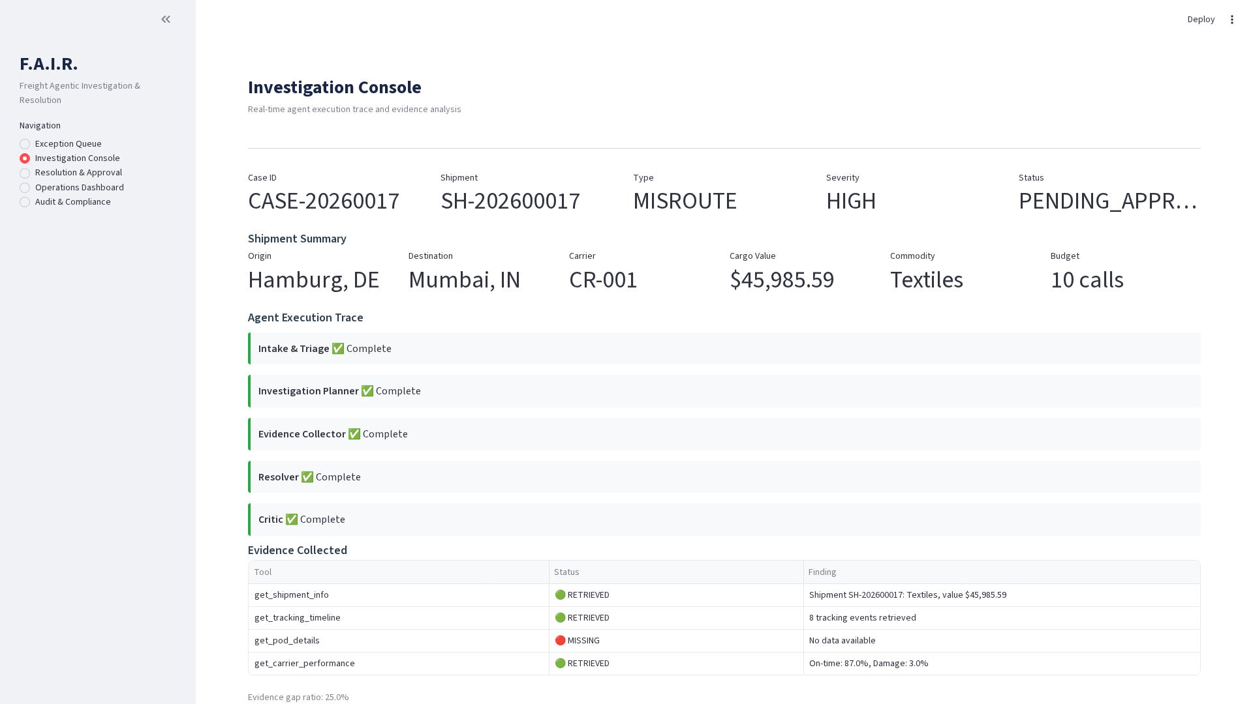
Figure 2: Streamlit Investigation Console Screenshot

Evaluation & Testing
The system was validated through 36 automated pytest cases organized into six categories:
Category | Tests | Focus
Severity & Budget | 4 | Boundary thresholds for LOW/MEDIUM/HIGH/CRITICAL
Evidence Gap | 3 | Zero, threshold, and no-expected scenarios
Human Review | 5 | Amount, confidence, critic, tier triggers
Resolution | 2 | No-action, credit, and claim calculations
Full Workflow | 12 | Damage, delay, customs, misroute, refused paths
Critic & Gate | 10 | Rejection, bounded revision, approve/reject
All 36 tests pass with 100% success rate, validating the correctness of deterministic safeguards, agent coordination logic, and human gate persistence.

Limitations & Future Scope

Current Limitations
- Synthetic data only - no live TMS, carrier, or customs API integrations.
- Rule-based classification - deterministic logic with no LLM reasoning (Ollama integration possible).
- Single-modal evidence - structured data and text only, no image analysis.
- No real-time streaming - simulated agent trace, not event-driven.

Future Enhancements
- Real carrier APIs: integrate live TMS, EDI, and carrier portals.
- Computer vision: damage assessment from photos using CV models.
- Predictive prevention: anomaly detection to catch exceptions before they occur.
- ERP connectors: SAP, Oracle WMS integration for automated resolution execution.

Conclusion
F.A.I.R. demonstrates that agentic AI can automate freight exception investigation while maintaining deterministic safety and full auditability. The five-agent architecture with adversarial validation and human-in-the-loop governance provides a production-ready blueprint for logistics AI transformation.
Key contributions include: a typed state-machine architecture for multi-agent coordination, deterministic financial safeguards for all monetary computations, an adversarial Critic agent for validation, and comprehensive testing with 36 automated test cases achieving 100% pass rate.

