**THE INSTITUTE OF FINANCE MANAGEMENT**



|  |  |
| --- | --- |
| **Module Name:** | Information System Security and Risk Management |
| **Module Code:** | ITU 08115 |
| **Department** | Computer Science and Mathematics |

|  |  |
| --- | --- |
| **Student Name** | **Registration Number** |
| MAYENGO DOTTO | IMC/BAIT/2123631 |
| PASIAN YONA LEMEI | IMC/BAIT/2123804 |
| GODFREY ERNEST MAPUNDA | IMC/BAIT/2123823 |
| VERONICA C. MAKOI | IMC/BAIT/2113714 |
| ANITA C. TAIRO | IMC/BAIT/2113768 |
| FRAVIUS FORTUNATUS PONTIAN | IMC/BAIT/2123503 |
| MICHAEL CHRISTOPHER PAUL | IMC/BAIT/2123269 |
| IRENE L MICHAEL | IMC/BAIT/2113814 |
| HAPPYNESS C MUSA | IMC/BAIT/2111580 |
| CHACHA M. CHACHA | IMC/BAIT/2121824 |

**Group Assignment 2**

You've been tasked with implementing an encryption strategy for a government agency to

protect sensitive data. Outline the encryption methods and tools you would recommend,

considering the different types of data and the balance between security and usability.

**Data** is a fundamental element that encompasses facts, statistics, and information in various formats. In the organizational context, data holds immense importance as it serves as the bedrock for decision-making processes, strategic planning, and overall operational efficiency. It encompasses everything from customer information and financial records to performance metrics and research findings. In essence, data is the lifeblood of organizations, facilitating informed decision-making and providing insights critical for growth and success. T

Two primary types of data, each with its unique characteristics, shape the information landscape within organizations:

**Structured Data:** refers to information that is meticulously organized and formatted according to a predetermined schema or model. This type of data is characterized by its clear, tabular structure, making it easily understandable and accessible. Examples of structured data include relational databases, where information is neatly organized into rows and columns, and spreadsheets with well-defined data relationships. This structured format enables efficient storage, retrieval, and analysis, allowing organizations to derive valuable insights and support various business functions. Financial records, inventory databases, and employee directories are common instances of structured data.

**Unstructured Data:** In contrast, unstructured data lacks a predefined organizational structure, presenting a more fluid and flexible nature. This type of data encompasses a wide array of content, including text documents, images, audio files, and multimedia presentations. Unstructured data poses a challenge for traditional data management systems due to its variability and lack of a fixed format. Examples of unstructured data include email communications, social media posts, and multimedia files. Harnessing meaningful insights from unstructured data often requires advanced technologies, such as natural language processing and machine learning.

**ENCRYPTION AND ENCRYPTION STRATE**GY

**Encryption** is a process of securing sensitive information by converting it into a coded format that can only be deciphered with the appropriate decryption key. It is a crucial aspect of information security, ensuring the confidentiality and integrity of data. An encryption strategy involves the systematic application of encryption techniques to safeguard data throughout its life cycle, from storage and transmission to processing. The choice of encryption methods depends on the nature of the data and the specific security requirements. For structured data, encryption may involve methods tailored for relational databases, while unstructured data may necessitate more adaptable encryption approaches. An effective encryption strategy integrates encryption into the overall security framework, considering factors such as key management, access controls, and regulatory compliance to create a robust defense against unauthorized access and data breaches.

**MAIN TYPES OF ENCRYPTION ALGORITHM**

****Symmetric Encryption**:** Symmetric encryption involves the use of a single key for both the encryption and decryption processes. This key must be securely shared between the communicating parties. Common symmetric encryption algorithms include the Advanced Encryption Standard (AES), a widely adopted and secure method. AES, with its variations like AES-128, AES-192, and AES-256, is particularly favored for its efficiency and resistance to brute-force attacks. Symmetric encryption is notably fast and resource-efficient, making it suitable for large-scale data processing. However, its primary challenge lies in secure key distribution, especially in scenarios involving multiple parties.

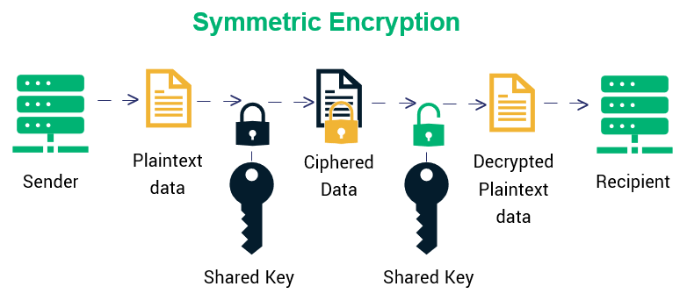

****Asymmetric Encryption (Public Key Cryptography):**** Asymmetric encryption employs a pair of keys - a public key for encryption and a private key for decryption. It addresses the key distribution challenge present in symmetric encryption. The most prominent example is the RSA (Rivest-Shamir-Adleman) algorithm. RSA's security is based on the difficulty of factoring the product of two large prime numbers. While effective, RSA can be computationally intensive, particularly as key sizes increase for enhanced security. Asymmetric encryption is often utilized in securing communication channels, digital signatures, and key exchanges.

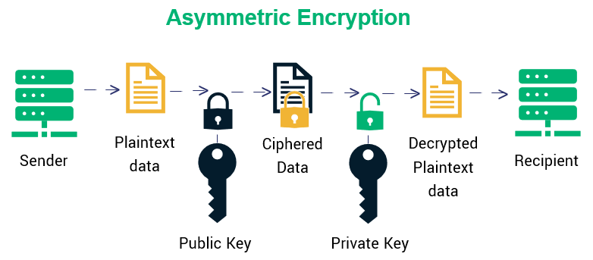

****Hash Functions:**** Hash functions play a critical role in ensuring data integrity. The widely used SHA-256 (Secure Hash Algorithm 256-bit) generates fixed-size hash values. Hash functions are integral to blockchain technology, contributing to the immutability of transaction records, and are fundamental to password security

****Elliptic Curve Cryptography (ECC):**** ECC is an advanced asymmetric encryption method that combines elliptic curves and number theory. Known for its efficiency, ECC provides robust security with significantly smaller and more efficient keys compared to traditional methods. Its applications are particularly advantageous in resource-constrained environments, such as the Internet of Things (IoT).

****Quantum-Safe Encryption:**** With the rise of quantum computers, there's an increasing need for quantum-safe encryption. Post-quantum cryptography explores algorithms resilient to quantum attacks. Lattice-based cryptography and hash-based cryptography are examples. Organizations are actively preparing for the integration of quantum-safe encryption to ensure long-term data security.

**Reference:** Source: NIST Special Publication 800-57 Part 1 Revision 4

**SPECIFIC TYPES OF DATA ENCRYPTION:**

Here are some examples of common types of encryption used today, each catering to specific security needs:

**Triple DES:** The Triple Data Encryption Standard (3DES) is a symmetric encryption algorithm that enhances the security of the original DES by encrypting data three times. This method employs three 64-bit keys, resulting in a total key length of 192 bits. Classified as a block cipher, 3DES processes data in 64-bit segments. However, it's important to note that its encryption mode, Cipher Block Chaining (CBC), may encounter challenges at high data rates. Despite its historical use, modern encryption standards often recommend more advanced alternatives.

**Blowfish:** Designed by Bruce Schneier in 1993, Blowfish is a symmetric block cipher known for its flexibility and efficiency. Similar to 3DES, Blowfish operates on fixed-size blocks of data. However, it distinguishes itself by supporting variable-length key encryption, ranging from 32 to 448 bits. Remarkably, Blowfish is an unpatented and unlicensed encryption technique, making it freely available for public use. While it has demonstrated robustness, the evolving cryptographic landscape suggests consideration of more recent and widely adopted alternatives.

**RSA:** The RSA encryption key, named after its creators Ron Rivest, Adi Shamir, and Leonard Adelman, is a widely used asymmetric cryptography method. Operating with a pair of keys – one public and one private – RSA relies on the challenge of prime factorization for security. Despite its historical significance, RSA becomes computationally intensive and less efficient as security levels increase. For organizations, particularly those dealing with sensitive data, RSA may be suitable for lower security requirements, but higher security demands could benefit from more modern alternatives.

**AES:** Addressing vulnerabilities identified in the original DES, the Advanced Encryption Standard (AES) was introduced in 2002. A symmetric block cipher originally named Rijndael, AES employs three separate keys: AES-128, AES-192, and AES-256, providing varying levels of security. These keys are used to encrypt and decrypt 128-bit information blocks. AES has gained widespread adoption, especially in safeguarding classified government information and sensitive data. Its robustness against brute-force attacks positions it as a stalwart choice for encryption in diverse applications.

**ECC:** Elliptic Curve Cryptography (ECC) represents a highly advanced approach, combining elliptic curves and number theory to encrypt data. Often rooted in a common public key algorithm, ECC offers robust security with significantly smaller and more efficient keys compared to traditional methods. For instance, an RSA key of 15,360 bits is equivalent in strength to an ECC key of just 512 bits. This efficiency is particularly advantageous in resource-constrained environments. Organizations should consider ECC for its enhanced security in scenarios where computational efficiency and key size are critical factors.

**CHOOSING ENCRYPTION ALGORITHMS:**

Selecting the right encryption algorithm is a nuanced and critical task that necessitates thorough consideration of several key factors. Each factor plays a pivotal role in ensuring the robustness and resilience of the encryption mechanism.

**1. Is this algorithm up to date?**

Staying abreast of advancements in encryption technology is not merely a best practice; it is imperative for maintaining a secure information environment. Opting for algorithms aligned with the latest industry standards ensures that your encryption methodology remains at the forefront of security measures. Regular updates and compliance with contemporary cryptographic advancements fortify the algorithm against emerging threats.

**2. Has this algorithm been through a validation process?**

Rigorous testing and comprehensive validation are pivotal checkpoints in the selection of encryption algorithms. Choosing algorithms that have undergone meticulous validation processes instills confidence in their effectiveness and reliability across diverse scenarios. Validation provides assurance that the algorithm can withstand various attack vectors and performs consistently under real-world conditions. This step is fundamental in establishing the trustworthiness of the encryption method.

**3. Does the OS, application, or hardware support the encr**yption?

Seamless integration is paramount for the success of any encryption strategy. Ensuring compatibility with the broader ecosystem is crucial. Verify that the selected encryption algorithm is fully supported by the operating system, applications, and hardware components within your infrastructure. Compatibility issues may lead to vulnerabilities or operational inefficiencies, highlighting the need for a cohesive encryption solution that aligns with the technological environment.

Navigating the dynamic landscape of encryption is undoubtedly challenging. The complexity of the field underscores the importance of informed decision-making. In instances where comprehensive knowledge about encryption may be lacking, a prudent approach is to rely on cryptography designed and built by experts. Entrusting the security of sensitive data to well-vetted cryptographic solutions helps mitigate risks associated with partial knowledge. The consequences of neglecting these considerations could expose the organization to potential security breaches, emphasizing the critical role of due diligence in the encryption algorithm selection process.

Regular reassessment of encryption strategies is a strategic imperative. The fluidity of the Cybersecurity landscape demands a proactive approach to stay ahead of emerging threats and to incorporate advancements in cryptographic techniques. Embracing a continuous improvement mindset ensures that the encryption strategy remains robust, adaptive, and resilient over time.

**RECOMMENDED ENCRYPTION TOOLS**

In the dynamic landscape of encryption tools, a spectrum of solutions caters to the unique needs of government agencies, each designed for specific data types and usage scenarios:

**File-level Encryption:**

VeraCrypt and BitLocker stand out as exemplary tools for encrypting individual files, folders, or entire drives. These user-friendly interfaces seamlessly integrate with operating systems, providing a robust shield against unauthorized access.

**Email Encryption:**

Protocols like PGP and S/MIME exemplify the gold standard in email encryption. They ensure secure communication channels, preventing unauthorized access to email content – critical for secure government communications.

**Database Encryption:**

Oracle Data Masking and SQL Server Transparent Data Encryption offer fortified protection for sensitive data stored in databases. Even if database credentials are compromised, these tools encrypt specific columns or fields, preserving data confidentiality.

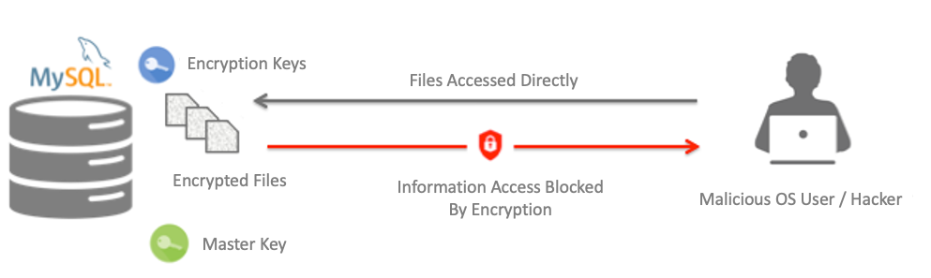

**Network Encryption:**

IPsec and TLS/SSL serve as stalwart network encryption protocols, safeguarding data transmitted over networks. These standards prevent eavesdropping and interception, ensuring the secure transfer of sensitive information.

**Cloud Encryption:**

Cloud-based encryption services, such as AWS Key Management Service (KMS) and Microsoft Azure Key Vault, are indispensable for securing data stored in the cloud. With robust key management capabilities, these services integrate seamlessly with cloud platforms, offering comprehensive protection.

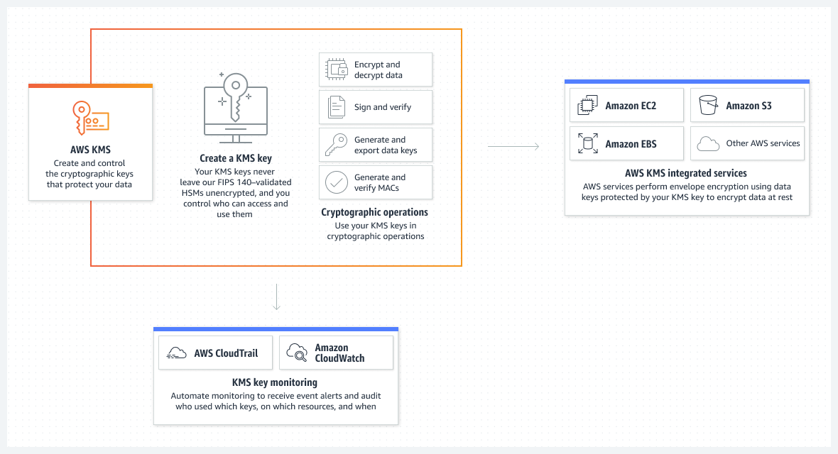

In deploying these tools, government agencies can fortify their encryption strategies, safeguarding sensitive data while maintaining operational efficiency and user satisfaction. These examples illustrate the practical implementation of encryption measures within the complex framework of governmental data protection.

**BALANCING SECURITY AND USABILITY**

In the intricate realm of data protection, achieving a harmonious equilibrium between robust security measures and user-friendly interfaces is paramount. A well-balanced encryption strategy recognizes that excessively stringent security measures can impede productivity and user satisfaction. The following considerations delineate the delicate interplay between security and usability:

**Data Classification:**

Data classification stands as a cornerstone for tailoring encryption measures to the specific risk levels associated with different types of information. For example, highly sensitive government documents may necessitate advanced encryption algorithms and stringent access controls. In contrast, less sensitive data could be safeguarded with lighter encryption measures, minimizing disruption to routine workflows.

**Key Management:**

Secure key management is fundamental to the protection of encrypted data. Encryption keys, the linchpin of data security, require meticulous handling. Robust key management systems encompass the secure generation, storage, distribution, and revocation of encryption keys. Physical and digital security measures, such as Hardware Security Modules (HSMs), fortify key storage against unauthorized access.

**User Education:**

Effective user education is pivotal in fostering a security-conscious culture. Users must receive comprehensive training on encryption protocols, procedural nuances, and the rationale behind encryption measures. Understanding the importance of encryption, secure usage of encryption tools, and the safeguarding of cryptographic keys should be ingrained through clear and consistent education initiatives.

**Transparent Encryption:**

Transparent encryption solutions streamline the encryption process without necessitating extensive user intervention. These tools automatically encrypt data, minimizing disruptions to user workflows. This approach is particularly beneficial for frequently accessed or shared sensitive data. Transparent encryption can safeguard data at rest (stored on local devices or in the cloud) and in transit (transmitted over networks).

**Real-World Examples:**

Imagine a government agency handling classified documents. Data classification allows for a tiered approach to encryption, ensuring that top-secret files receive a higher level of protection compared to less sensitive administrative documents. Robust key management would involve utilizing **HSMs (Hardware Security Module)** to secure encryption keys, preventing unauthorized access even in the event of a security breach. In user education, government employees could undergo training programs elucidating the significance of encryption in safeguarding national security. Clear instructions on using encryption tools securely and understanding the responsibility associated with cryptographic keys enhance user awareness. Transparent encryption finds practical application when government officials need seamless access to sensitive information stored in the cloud or shared among departments. Automation ensures that data remains secure without impeding essential workflows. This well-rounded approach to balancing security and usability underscores the intricate dance required to protect sensitive government data effectively.

**REFERENCES**

National Institute of Standards and Technology. (2016). NIST Special Publication 800-57 Part 1 Revision 4. Retrieved from [URL]

Amazon Web Services. (n.d.). Retrieved from https://aws.amazon.com/

Microsoft Azure. (n.d.). Retrieved from https://azure.microsoft.com/en-us

Microsoft Support. (n.d.). Finding your BitLocker recovery key in Windows. Retrieved from <https://support.microsoft.com/en-us/windows/finding-your-bitlocker-recovery-key-in-windows-6b71ad27-0b89-ea08-f143-056f5ab347d6>