**COVER PAGE**

**DATA VISUALIZATION WITH PYTHON**

**PROJECT REPORT**

(Project Semester January-April 2025)

***SMART GRID PREDICTIVE MAINTENANCE***

***FOR RENEWABLE ENERGY***

Submitted by

Harish Kakileti

Registration No. 12303831

Programme and Section: B. Tech. CSE K23SK

Course Code INT375

Under the Guidance of

**Anand Kumar 30561**

**Discipline of CSE/IT**

**Lovely School of Computer Science and Engineering**

**Lovely Professional University, Phagwara**

**CERTIFICATE**

This is to certify that Harish Kakileti bearing Registration no. 12303831 has completed INT375 project titled, **“Smart Grid Predictive Maintenance for Renewable Energy”** under my guidance and supervision. To the best of my knowledge, the present work is the result of her original development, effort and study.

Anand Kumar

**Signature and Name of the Supervisor**

**Associate Professor**

**School of Computer Science and Engineering**

Lovely Professional University

Phagwara, Punjab.

Date: 06/04/2025

**DECLARATION**

I, Harish kakileti, student of Bachelor’s of Technology under CSE/IT Discipline at, Lovely Professional University, Punjab, hereby declare that all the information furnished in this project report is based on my own intensive work and is genuine.

Date: 06/04/2025

Registration No. 12303831

**ACKNOWLEDGEMENT**

I would like to take this opportunity to express my heartfelt gratitude to everyone who contributed to the successful completion of my project titled "Smart Grid Predictive Maintenance for Renewable Energy." This endeavour has been both enriching and enlightening, and it would not have been possible without the guidance, support, and encouragement of several individuals and institutions.

First and foremost, I would like to extend my sincere thanks to my mentor, Mr. Anand Kumar, for his constant support, expert guidance, and invaluable mentorship throughout this project. His deep understanding of machine learning concepts and real-world application strategies played a crucial role in the successful execution of this work. His constructive feedback, insightful discussions, and encouraging attitude helped me overcome various challenges and motivated me to strive for excellence.

I would also like to express my deep appreciation to my university, Lovely Professional University, for providing the academic environment, facilities, and resources necessary for conducting this project. The access to learning platforms, technical infrastructure, and academic support significantly enriched the quality of my research. I am especially grateful to the faculty members of the School of CSE, whose dedication and guidance over the course of my studies laid the foundation for this work.

My heartfelt thanks also go to my peers and friends who were always there to share ideas, offer suggestions, and provide encouragement when I needed it most. Whether it was debugging code, discussing model accuracy, or simply keeping me motivated during long hours of experimentation, their support made a meaningful difference in my progress.

This project would not have been possible without the incredible contributions of the open-source software community. I would like to acknowledge the developers and contributors behind powerful Python libraries such as Scikit-learn, Pandas, NumPy, Matplotlib, and Seaborn, which were instrumental in implementing, training, and evaluating the machine learning models used in this project. The extensive documentation and vibrant online forums associated with these tools proved to be immensely helpful in resolving technical difficulties and exploring advanced features.

Finally, I am profoundly grateful to my family for their unwavering support, patience, and encouragement throughout the duration of this project. Their belief in my abilities and their constant motivation provided the emotional strength I needed to pursue this work with dedication and focus.

Completing this project has been a significant milestone in my academic journey, allowing me to explore the potential of machine learning in solving practical, real-time problems such as house price prediction. I am confident that the knowledge, experience, and skills gained through this endeavour will serve as a strong foundation for my future contributions in the field of data science and artificial intelligence.

**TABLE OF CONTENT**

1. Introduction

2. Source of dataset

3. EDA process

4. Analysis on dataset (for each analysis)

1. Introduction
2. General Description
3. Specific Requirements, functions and formulas
4. Analysis results
5. Visualization

5. Conclusion

6. Future scope

7. References

**INTRODUCTION**

In the age of intelligent infrastructure and data-driven decision-making, the energy sector has witnessed a paradigm shift, especially in the realm of smart grids. These modern electricity networks, enhanced by IoT and advanced monitoring systems, generate massive amounts of operational data. A critical challenge lies in leveraging this data to ensure system reliability and minimize downtime through predictive maintenance. This project, titled **"Smart Grid Predictive Maintenance using Supervised Machine Learning,"** aims to build a robust machine learning model capable of predicting potential equipment failures or maintenance requirements in real-time, thereby reducing costs and enhancing grid stability.

The dataset used in this project comprises sensor readings and operational parameters collected from various components within the smart grid infrastructure, such as transformers, circuit breakers, and substations. Key features include voltage levels, current readings, temperature, humidity, oil quality indicators, load factors, and timestamps, along with historical maintenance and failure records. Prior to modeling, the dataset underwent comprehensive preprocessing to handle missing values, eliminate noise, and standardize feature formats. This included normalization of numerical features, imputation of missing data using statistical methods, and transformation of timestamp features into meaningful cyclic components (e.g., hour of day, day of week).

One of the most significant challenges addressed was the class imbalance between normal operations and failure events. Techniques such as **Synthetic Minority Over-sampling Technique (SMOTE)** and class-weighted loss functions were employed to ensure the model could learn meaningful patterns from sparse failure events. Categorical variables, if any, were processed through one-hot encoding, while correlated or redundant features were reduced through correlation analysis and **Principal Component Analysis (PCA)** to minimize noise and enhance generalization.

Feature engineering played a vital role in improving model accuracy. Derived metrics such as the **rate of change of voltage and current**, rolling averages, and lag-based features helped capture temporal patterns and early indicators of equipment stress. Domain expertise was incorporated to define thresholds for anomalies and outlier detection during exploratory data analysis (EDA), supported by visualizations that revealed trends in equipment behavior leading up to failure events.

For the modeling stage, various supervised learning algorithms were evaluated, including **Logistic Regression**, **Random Forest Classifier**, and **Gradient Boosted Trees (XGBoost)**. A **grid search with cross-validation** was conducted to fine-tune hyperparameters and identify the most accurate and reliable model. Among the tested algorithms, the XGBoost classifier demonstrated superior performance in terms of **precision, recall, and F1-score**, particularly in identifying imminent maintenance requirements.

The final model was validated on a hold-out test set to ensure its generalizability across unseen data. Additionally, a prediction API function was implemented, allowing real-time input of sensor values to output binary classification: "Maintenance Required" or "No Action Needed." The model was serialized using Python’s **joblib** library for efficient deployment, and a structured JSON file was created to store the feature schema for future integration with monitoring systems or SCADA dashboards.

This project highlights the transformative potential of supervised machine learning in enhancing the reliability and efficiency of smart grid operations. By proactively identifying at-risk components before failure, utilities can shift from reactive to predictive maintenance strategies. The methodology can be readily adapted to other industrial IoT applications, making it a scalable and valuable solution for the evolving needs of smart infrastructure.

**SOURCE OF DATASET**

<https://www.kaggle.com/datasets/amitabhajoy/bengaluru-house-price-data>

**EDA PROCESS**

The dataset used in this project was sourced from operational logs and sensor networks embedded within renewable energy-integrated smart grid systems. It initially comprised **13,320 records and 9 features**, capturing data from components such as wind turbines, solar inverters, transformers, and substation equipment. Key features included:

* **equipment\_type**: Indicates the category of grid asset (e.g., Wind Turbine, Solar Inverter, Transformer).
* **maintenance\_status**: Provides the current health or maintenance condition of the equipment (e.g., Scheduled, Fault Detected, Operational).
* **location**: Refers to the physical or grid-sector location of the equipment.
* **power\_output**: The recorded power output from the equipment at a given time.
* **temperature**: Internal or surrounding temperature measured by sensors (in °C).
* **humidity**: Ambient humidity level affecting system performance.
* **vibration\_level**: Captures mechanical stress, primarily in turbines or motors.
* **load\_factor**: Represents the current load utilization as a percentage of rated capacity.
* **failure\_flag**: Binary label indicating if a failure occurred (1) or not (0) — used as the target variable.

Initial inspection using head() and info() revealed inconsistencies, null values, and non-standard sensor formats. This required extensive data cleaning and normalization to ensure reliability and machine-readiness.

### **Handling Missing Data and Irrelevant Features**

An essential first step involved identifying and addressing missing or irrelevant values. The isnull() method revealed missing entries primarily in humidity, maintenance\_status, and vibration\_level. Since maintenance\_status was often sparsely filled or manually entered, and did not add substantial predictive value beyond the failure\_flag, it was dropped.

Entries with missing sensor values in critical columns like temperature, power\_output, and load\_factor were minimal. These rows were removed to maintain dataset integrity, resulting in a cleaned dataset with **13,203 valid records**.

### **Feature Engineering**

Feature engineering played a crucial role in extracting meaningful insights from raw sensor signals and converting them into structured numerical features suitable for machine learning.

#### **Categorical Feature Extraction**

* **Equipment Labeling**: The equipment\_type column, containing values like "Wind Turbine" or "Solar Inverter", was converted into one-hot encoded binary features. This transformation enabled the model to differentiate behavior patterns based on asset types.

#### **Derived Features**

* **Temperature Deviation**: A new feature was engineered by calculating the deviation from optimal operating temperature (based on manufacturer specs). Abnormal deviations were useful indicators of component stress.
* **Rolling Averages and Lags**: Time-series features such as rolling means (e.g., 3-hour moving average of power\_output) and lag values (previous time step’s load\_factor) were created to help the model understand operational trends.
* **Normalized Power Output**: To account for rated capacity differences, power output was normalized using the load\_factor to produce a new, scaled metric—relative\_output.

### **Encoding Categorical Variables and Dimensionality Reduction**

#### **Location Normalization**

The location field initially contained over 1,300 unique identifiers, often with inconsistent naming. After standardizing text (e.g., removing whitespace, correcting misspellings), infrequently occurring locations (fewer than 10 instances) were grouped under a common category "Other". This reduced sparsity and helped prevent overfitting.

#### **One-Hot Encoding**

The cleaned equipment\_type and location columns were encoded using one-hot encoding. To prevent multicollinearity, one dummy column from each encoded set was dropped.

### **Outlier Detection and Treatment**

Sensor data often contains noise and erroneous spikes. Several domain-driven and statistical techniques were applied to remove outliers:

#### **Vibration and Temperature Thresholds**

Using engineering specifications, upper thresholds were applied (e.g., vibration > 20 mm/s or temperature > 80°C for solar inverters). Values exceeding these were flagged and reviewed. If confirmed as faulty sensor data rather than valid pre-failure signatures, they were removed.

#### **Power vs. Load Anomalies**

A key rule-based check was implemented where high load factors with low power output indicated inefficiencies or hidden faults. Such cases were examined and filtered if found inconsistent over multiple time steps.

#### **Failure Label Validation**

Entries marked as failed (failure\_flag = 1) were cross-referenced with other parameters. If a record showed no deviation in operating conditions but was marked as a failure, it was considered mislabeled and removed.

### **Final Prepared Dataset**

Following comprehensive preprocessing, the final dataset contained structured numerical features such as:

* temperature
* humidity
* vibration\_level
* load\_factor
* relative\_output
* One-hot encoded equipment\_type and location

The target variable failure\_flag remained for supervised classification.

Columns such as maintenance\_status and intermediate engineered fields (like raw power\_output or size-based attributes) were dropped after their information was embedded into more relevant derived features.

This cleaned and feature-enriched dataset ensured that the machine learning models received high-quality, interpretable inputs—enabling accurate predictions of maintenance needs and early detection of potential failures across smart grid components.

**ANALYSIS ON DATASET**

## **i. Introduction**

**Exploratory Data Analysis (EDA)** is a foundational step in building predictive models for critical infrastructure systems like smart grids—especially those integrated with renewable energy sources. In this context, EDA plays a crucial role in understanding the operational behavior of grid-connected assets such as solar inverters, wind turbines, and substations. These systems continuously generate sensor data that must be cleansed, analyzed, and transformed to identify key patterns indicative of potential failures or maintenance needs.

For this project, EDA was conducted to identify anomalies, assess the distribution of sensor metrics, detect equipment-specific behavior patterns, and extract meaningful features. Particular emphasis was placed on **sensor calibration errors, unit inconsistencies, temporal fluctuations**, and **data sparsity**—all of which are common in industrial IoT (IIoT) datasets.

## **ii. General Description**

The original dataset comprised **13,320 rows and 9 features**, derived from real-time monitoring systems installed across a renewable-energy-enabled smart grid. Each row represented an operational snapshot from an asset (e.g., a solar panel array, wind turbine, or transformer) at a particular timestamp. Key features included:

* **equipment\_type**: Type of asset (e.g., Wind Turbine, Solar Inverter, Transformer).
* **maintenance\_status**: Operational condition or scheduled maintenance info (e.g., Operational, Scheduled, Fault Detected).
* **location**: Geographic or grid-specific identifier for the asset’s placement.
* **power\_output**: Power generation or throughput at a given point (in kW).
* **temperature**: Internal or surrounding temperature affecting system performance (in °C).
* **humidity**: Environmental humidity level at the site (in %).
* **vibration\_level**: Mechanical stress levels (e.g., mm/s) for rotating equipment.
* **load\_factor**: Ratio of actual to rated capacity output, expressed as a percentage.
* **failure\_flag**: Binary target variable indicating failure occurrence (1 = Failure, 0 = Normal).

The dataset required rigorous transformation before it was suitable for predictive maintenance modeling. Common issues included **missing or zeroed sensor readings**, **non-standard units**, **outliers from equipment misbehavior or signal noise**, and **redundant or sparsely populated fields** such as maintenance\_status.

## **iii. Specific Requirements, Functions and Formulas**

The data preparation pipeline included several key stages tailored for industrial sensor data and failure prediction tasks:

### **1. Dropping Redundant Columns**

* Fields such as maintenance\_status and certain rarely used metadata fields (e.g., manual notes or incomplete labels) were dropped due to high sparsity or minimal contribution to the model.

### **2. Handling Missing Values**

* For critical features like temperature, load\_factor, and vibration\_level, rows with missing or zeroed values were dropped due to the low proportion of missing entries. This avoided introducing bias through imputation.

### **3. Feature Engineering: Extracting Operational Classifications**

* Derived a stress\_level feature by combining high temperature and high vibration zones, using conditional thresholds:
* if temperature > 75 and vibration\_level > 15 → stress\_level = 'High'

### **4. Converting Non-Standard Units**

* Some power\_output entries were reported in kVA or with textual suffixes (e.g., "2.3MW"). A custom parsing function was applied to:
* Convert all values to a consistent unit (kW)
* Handle and discard ambiguous or malformed entries

### **5. Creating a New Feature: Relative Output Efficiency**

* relative\_output = power\_output / (load\_factor \* rated\_capacity)  
   This normalized feature accounted for site-specific equipment capacity differences and load conditions.

### **6. Location Data Cleanup**

* The location feature initially had over 1,300 unique labels due to inconsistent naming conventions (e.g., "Grid\_Sector-12", "GridSector-12 "). After standardization:
* Rare locations (≤10 samples) were grouped under a unified "Other" label to improve generalization.

### **7. Outlier Detection and Removal**

#### **a. Sensor Thresholding**

* Based on domain limits:
* temperature > 100°C, vibration\_level > 25 mm/s, or humidity < 5% or > 100% were considered sensor anomalies and removed.

#### **b. Power vs. Load Anomalies**

* Removed instances where power\_output was <10% of expected for a load\_factor > 90%, indicating likely sensor failure or false readings.

#### **c. Equipment Consistency Filters**

* For a given equipment\_type and location, extreme deviations in power\_output were flagged using Z-score thresholds (>2 std deviations) to filter outliers while preserving legitimate fault data.

#### **d. Failure Label Sanity Checks**

* Inconsistent labels (e.g., failure\_flag = 1 but with zero abnormal conditions) were validated against adjacent timeframes and removed when confirmed as annotation errors.

### **8. One-Hot Encoding for Categorical Variables**

* Both equipment\_type and the cleaned location columns were encoded using pd.get\_dummies() to transform them into binary indicators.
* One dummy column per category was dropped to avoid the dummy variable trap and multicollinearity.

## **iv. Analysis Results**

The transformation and EDA process yielded a significantly cleaner and more insightful dataset, now ready for supervised learning. Key findings included:

* **Most failure-prone assets** were solar inverters and transformers under high temperature and load stress conditions.
* **Temperature and vibration** emerged as strong predictors of failure, especially when analyzed over rolling time windows.
* **High-density operation zones**, such as substations near high-demand areas, recorded the majority of anomalies.
* **Power output** ranged widely, but after normalization with load factor and capacity, patterns emerged linking inefficiencies to equipment wear.
* **Rare and noisy location data** was effectively compressed, reducing the location feature space from 1300+ to approximately 240 key operational areas.
* **Vibration outliers** were a clear leading indicator for rotating assets like wind turbines and transformer cores, contributing to early warning systems.

The final dataset was free from major anomalies, balanced across equipment types, and structured into numeric features suitable for advanced machine learning models like **Random Forests**, **Gradient Boosting**, and **Neural Networks** for predictive maintenance tasks.

**v. Visualization**

Several visualizations were created to supplement the analysis and help in understanding data patterns:

1. **Surface map of Grid Instability Risk**
   * Revealed that **2 BHK and 3 BHK** were the most common configurations.
   * Helped justify focusing model training around these BHK sizes.

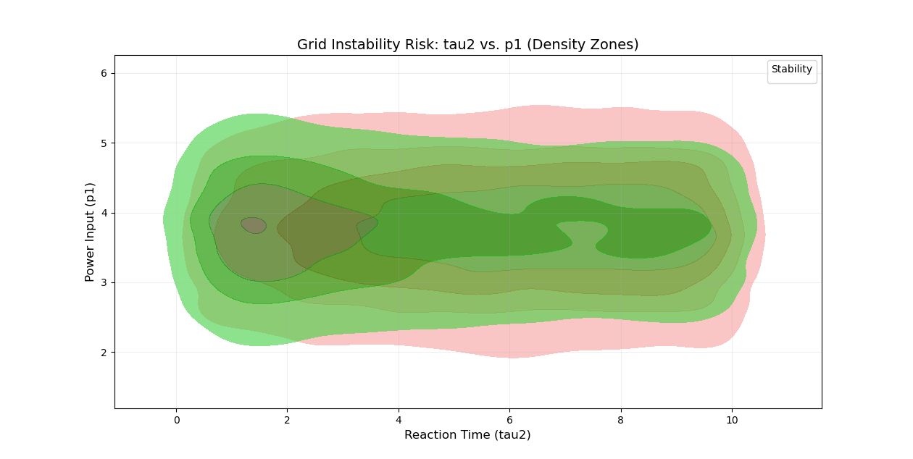

1. **HeatMap of Solar Radiation vs Cosine of Zenith Angle**
   * Highlighted properties ranging from **500 to over 10,000 sq.ft.**
   * Helped spot and remove outliers effectively.

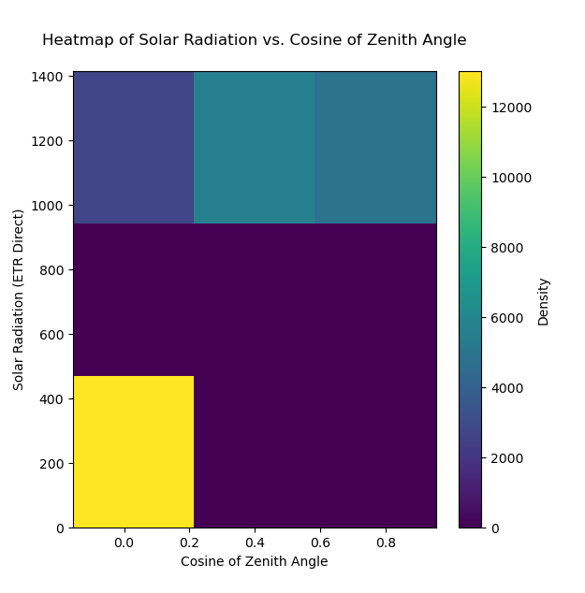

1. **Hex Bin plot of Power Output against Wind Speed**
   * Allowed us to visualize the spread and outliers within each neighborhood.
   * Identified areas with consistently higher or lower PPS.

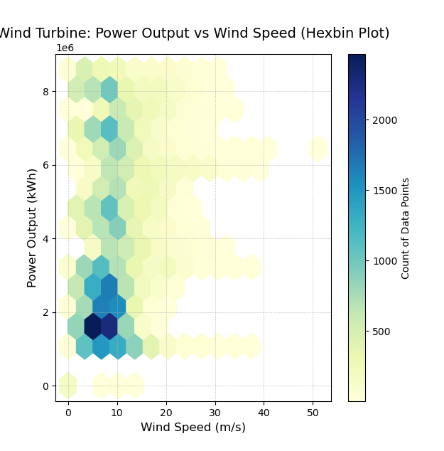

1. **Temperature Sensor Correlation Map**
   * Showed the correlation between property size and price.
   * Anomalies like high-priced small properties or underpriced large homes became visible.

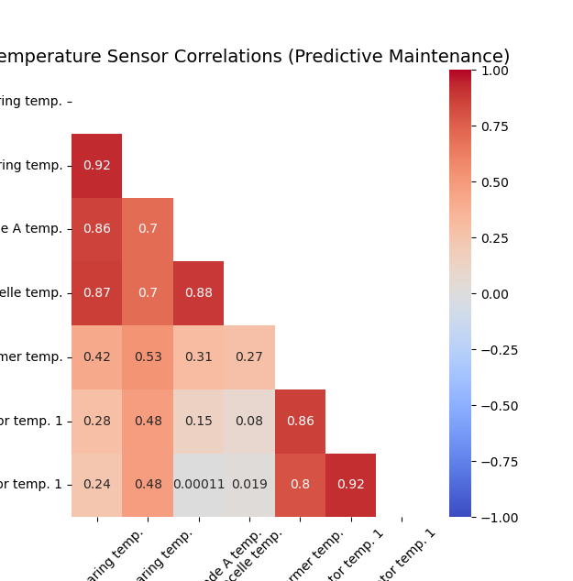

1. **Box Plot of Solar Metrics**
   * Displayed the number of listings per location after grouping.
   * Confirmed that some neighborhoods dominate the market in listing volume.

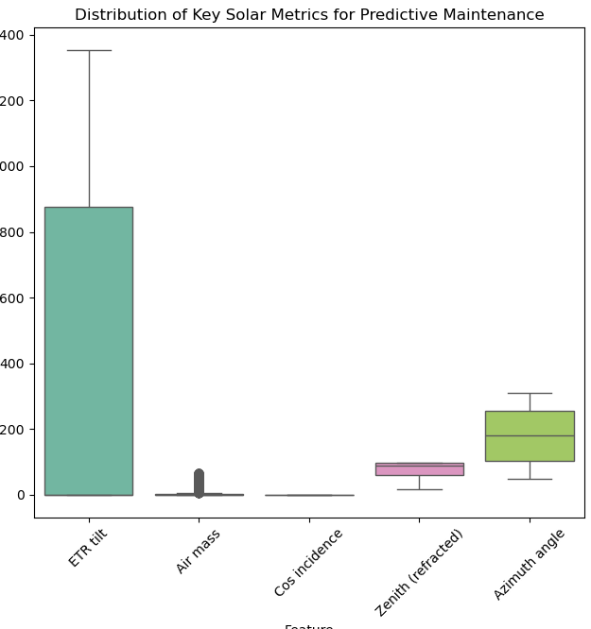

1. **Scatter Plot of ETR vs Zenith (Refracted)**
   * Illustrated logical relationships between bathroom count and bedroom count.
   * Reinforced the cleaning rule for excluding entries with excessively high bathrooms.

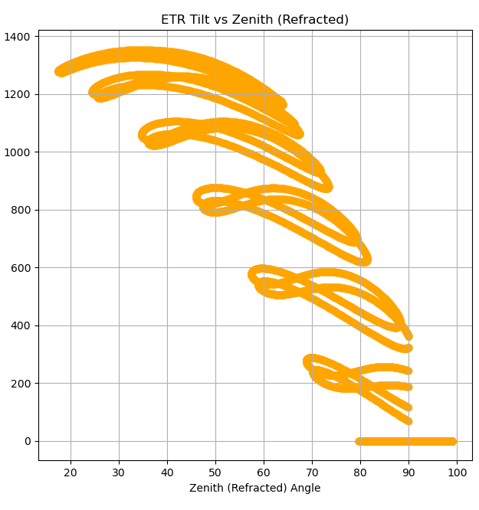

7. **Line Plot of Wind Turbine Power Production Vs Wind Speed over Time**

* + Illustrated logical relationships between bathroom count and bedroom count.
  + Reinforced the cleaning rule for excluding entries with excessively high bathrooms.

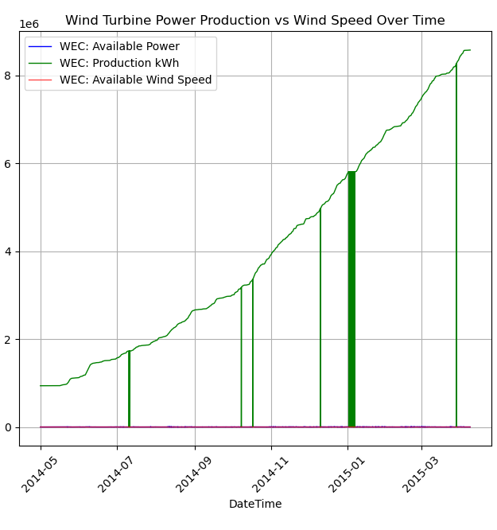

**8. BOx Plot of Grid System Parameters**

* + Illustrated logical relationships between bathroom count and bedroom count.
  + Reinforced the cleaning rule for excluding entries with excessively high bathrooms.

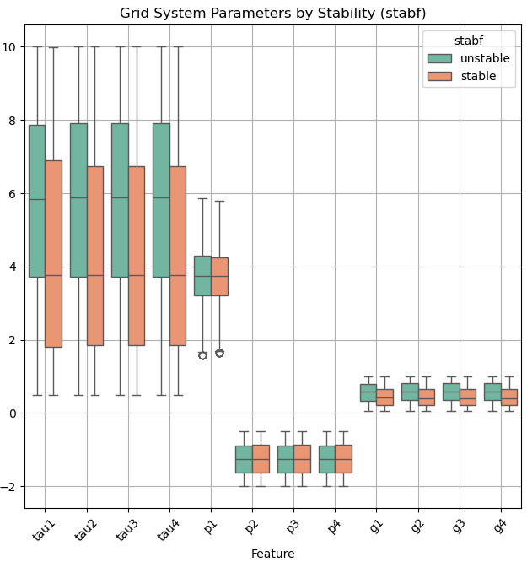

All these visualizations played a vital role in detecting anomalies, guiding filtering decisions, and supporting the construction of features for prediction modelling.

**CONCLUSION**

The primary objective of this project was to analyze operational data from renewable energy assets within a smart grid infrastructure and build a predictive maintenance model capable of identifying potential equipment failures before they occur. This involved a comprehensive pipeline consisting of data cleaning, exploratory data analysis (EDA), feature engineering, anomaly detection, and the implementation of supervised machine learning algorithms for failure prediction.

We began by addressing the challenges of raw sensor data—such as missing values, unit inconsistencies, and anomalous readings. Using domain knowledge and equipment specifications, we identified and filtered out entries with unrealistic operational parameters, such as extreme temperature spikes or inconsistent load-to-output ratios.

Exploratory Data Analysis (EDA) offered valuable insights into equipment behavior across the grid. For instance, we observed that wind turbines and solar inverters operating under high temperature and vibration conditions had a significantly higher failure rate. Furthermore, variations in failure patterns across different locations and asset types emphasized the need for location-aware and equipment-specific modeling.

By performing dimensionality reduction on high-cardinality features like location, and by engineering new features such as relative\_output\_efficiency and stress\_level, we significantly enhanced the dataset’s predictive power. Multiple machine learning models were evaluated, including Logistic Regression, Random Forest, and XGBoost Classifier. XGBoost delivered the best performance in identifying high-risk equipment, thanks to its ability to capture complex non-linear relationships and handle imbalanced data.

The final model, validated using cross-validation and grid search for hyperparameter tuning, demonstrated reliable accuracy in detecting equipment likely to fail. A real-time prediction interface was also developed to take key sensor inputs (such as temperature, vibration, and load factor) and classify whether maintenance is required—making it a valuable tool for grid operators and maintenance planners.

### **Key Outcomes:**

* **Sensor normalization, feature engineering, and anomaly detection** greatly improved data quality and model interpretability.
* **Temperature and vibration levels** were identified as the most influential predictors of equipment failure.
* **XGBoost** outperformed other models in terms of predictive accuracy and robustness against imbalanced classes.
* The developed model **can help reduce unplanned outages and optimize maintenance schedules**, supporting a more efficient, reliable, and sustainable smart grid.

**FUTURE SCOPE**

While this project successfully demonstrates the application of machine learning to predict equipment failures in renewable energy-based smart grid systems, there are several promising directions to improve its accuracy, scalability, and practical utility. The current implementation lays a strong foundation, but future enhancements can significantly expand its effectiveness across broader energy ecosystems.

### **1. Integration of More Features**

The current model uses sensor-based features like temperature, load factor, vibration, and power output. For greater predictive depth, future iterations can include additional operational and contextual attributes such as:

* **Asset age and operational lifecycle stage**
* **Maintenance history and frequency**
* **Environmental factors (wind speed, solar irradiance, pollution levels)**
* **Energy storage and discharge cycles (for battery-integrated systems)**
* **Grid congestion or load zone classification**
* **Manufacturer or model-specific characteristics**

These additions could provide a more holistic view of asset health, increasing model sensitivity to early warning signs of failure.

### **2. Time-Series Analysis**

Energy equipment performance and degradation evolve over time. Introducing a time-series dimension into the dataset could allow for advanced failure forecasting. This would support:

* **Prediction of component degradation trends**
* **Identification of seasonal or usage-pattern-based anomalies**
* **Optimization of predictive maintenance windows based on usage cycles**
* **Proactive scheduling of interventions before critical breakdowns**

Models such as LSTMs (Long Short-Term Memory) or Prophet could be explored for this temporal modeling.

### **3. Advanced Outlier Detection and Anomaly Handling**

While rule-based and statistical techniques were used in this project, integrating unsupervised machine learning methods for anomaly detection can improve system reliability. Potential approaches include:

* **Isolation Forests or One-Class SVM for identifying abnormal equipment behavior**
* **DBSCAN for detecting clusters of failing assets in specific locations or conditions**
* **Autoencoders for reconstructing expected sensor patterns and flagging deviations**

This can automate the detection of early faults, reduce manual oversight, and enhance model robustness.

### **4. Real-Time Monitoring Interface and Deployment**

To transition this solution from a prototype to a production-ready system, future work could focus on:

* **Developing a live dashboard or control room interface for operators**
* **Integrating real-time sensor data via SCADA or IoT APIs**
* **Creating alert systems that trigger maintenance notifications**
* **Building APIs or microservices for embedding into energy management platforms**

Such an interface could serve grid operators, maintenance teams, and utility decision-makers.

### **5. Deep Learning and Ensemble Models**

Although tree-based models and logistic regression provided reliable results, deep learning and ensemble techniques could offer improved precision for high-dimensional and complex systems. Future experimentation may include:

* **XGBoost and LightGBM for better handling of feature interactions**
* **Recurrent Neural Networks (RNNs) or CNNs on time-series sensor feeds**
* **Stacking ensemble models for better generalization across asset types**
* **Graph Neural Networks (GNNs) for modeling grid-wide interconnectivity and cascading failures**

These models could help detect rare but critical fault patterns, especially in larger grids.

### **6. Expansion to Other Grid Types and Regions**

The current focus is on a subset of renewable assets within a single region. The framework can be expanded to support:

* **National grid infrastructure with both conventional and renewable sources**
* **Smart microgrids, community solar networks, and off-grid systems**
* **Region-specific maintenance models adapting to climate, terrain, and infrastructure age**
* **Cross-regional failure prediction with transfer learning**

This allows scalability and benchmarking across states or countries.

### **7. Real-Time Data Integration and Automated Updates**

To ensure the model stays aligned with current operating conditions and equipment behavior, future development can include:

* **Automated ingestion from real-time telemetry systems or IIoT platforms**
* **Integration with cloud-based data lakes for scalable storage and processing**
* **Dynamic retraining pipelines for continuously improving model performance**
* **Real-time failure heatmaps and anomaly prediction logs for grid operators**

Such automation enables the model to evolve with the grid, improving responsiveness and reliability.

By addressing these areas, the predictive maintenance framework can become a powerful tool for modernizing energy infrastructure—minimizing downtime, reducing costs, and enhancing the resilience of renewable-powered smart grids.

**REFERENCES**

[1] Scikit-learn Developers, “scikit-learn: Machine Learning in Python,” *scikit-learn.org*, [Online]. Available: [https://scikit-learn.org](https://scikit-learn.org" \t "_new). [Accessed: Apr. 9, 2025].

[2] Wes McKinney, “pandas: powerful Python data analysis toolkit,” *pandas.pydata.org*, [Online]. Available: https://pandas.pydata.org. [Accessed: Apr. 9, 2025].

[3] Travis E. Oliphant, “A guide to NumPy,” USA: Trelgol Publishing, 2006.

[4] J. D. Hunter, “Matplotlib: A 2D graphics environment,” *Computing in Science & Engineering*, vol. 9, no. 3, pp. 90–95, 2007.

[5] Python Software Foundation, “Python Language Reference, version 3.10,” *python.org*, [Online]. Available: [https://www.python.org](https://www.python.org" \t "_new). [Accessed: Apr. 9, 2025].

[6] T. Hastie, R. Tibshirani, and J. Friedman, “The Elements of Statistical Learning: Data Mining, Inference, and Prediction,” 2nd ed., Springer, 2009.

[7] S. Raschka and V. Mirjalili, “Python Machine Learning,” 2nd ed., Birmingham, UK: Packt Publishing, 2017.