Experiment No. 03 Title - Apply DES algorithm for practical applications

Objectives:
To implement the DES (Data Encryption Standard) algorithm for encrypting and decrypting a plaintext message to ensure secure data transmission. This lab demonstrates how symmetric key cryptography can be used to protect information in real-world communication systems.

Problem Statement:
You are working as a software security analyst for a company that needs to transmit sensitive employee data (like Social Security Numbers or salary information) between two systems over a network. To ensure data confidentiality, you are required to implement the DES algorithm in encryption and decryption mode.
Your task is to write a program that:
1. Takes a plaintext input from the user.
2. Uses a user-defined 64-bit key (as a hexadecimal or ASCII string).
3. Encrypts the plaintext using the DES algorithm.
4. Outputs the encrypted text (ciphertext).
5. Decrypts the ciphertext back to plaintext using the same key to verify correctness.

Equipment/Tools:
- Windows
- JDK (Java Development Kit 8 or above)
- VS Code
- Terminal

Theory:
DES (Data Encryption Standard) is a symmetric key block cipher algorithm developed by IBM and adopted by NIST in 1977.
Key features of DES:
- Block size: 64 bits
- Key size: 64 bits (56 bits effective, 8 bits parity)
- Number of rounds: 16
- Uses Feistel structure
Working of DES:
- Initial Permutation (IP)
- 16 rounds of processing (Expansion, Substitution, Permutation)
- Final Permutation (FP)
DES uses the same key for both encryption and decryption. The only difference is the order of round keys.
Although DES is now considered insecure due to small key size, it is historically important and helps understand symmetric cryptography.

Procedure
Start the Java development environment.
- Create a new Java class named DESExample.
- Import required cryptographic libraries (javax.crypto).
- Accept plaintext input from the user.
- Accept an 8-character key (64-bit).
- Generate DES SecretKey using DESKeySpec.
- Initialize Cipher in ENCRYPT_MODE.
- Encrypt the plaintext and encode using Base64.
- Initialize Cipher in DECRYPT_MODE.
- Decrypt the ciphertext using the same key.
- Display encrypted and decrypted results.
- Verify decrypted text matches original plaintext.

Implementation and Steps:
Code:
import javax.crypto.*;
import javax.crypto.spec.DESKeySpec;
import java.util.*;

public class DESProgram {

public static void main(String[] args) throws Exception {

Scanner sc = new Scanner(System.in);

System.out.print("Enter plaintext: ");
String plaintext = sc.nextLine();

System.out.print("Enter 8-character key (64-bit): ");
String keyString = sc.nextLine();

if (keyString.length() != 8) {
System.out.println("Key must be exactly 8 characters (64 bits).");
return;
}

DESKeySpec desKeySpec = new DESKeySpec(keyString.getBytes());
SecretKeyFactory keyFactory = SecretKeyFactory.getInstance("DES");
SecretKey secretKey = keyFactory.generateSecret(desKeySpec);

Cipher cipher = Cipher.getInstance("DES/ECB/PKCS5Padding");

cipher.init(Cipher.ENCRYPT_MODE, secretKey);
byte[] encryptedBytes = cipher.doFinal(plaintext.getBytes());
String ciphertext = Base64.getEncoder().encodeToString(encryptedBytes);

System.out.println("\nEncrypted Text (Ciphertext): " + ciphertext);

cipher.init(Cipher.DECRYPT_MODE, secretKey);
byte[] decryptedBytes = cipher.doFinal(Base64.getDecoder().decode(ciphertext));
String decryptedText = new String(decryptedBytes);

System.out.println("Decrypted Text: " + decryptedText);

sc.close();
}
}

- Output:
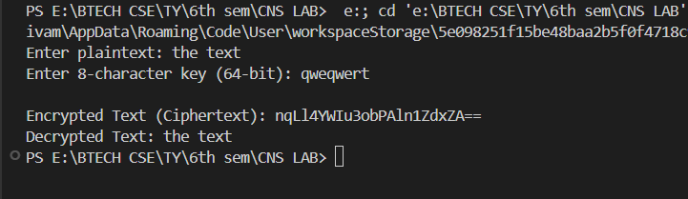

Observations and Conclusion:
Observations:
- The encrypted output is different from the original plaintext.
- The ciphertext appears as unreadable Base64 encoded string.
- After decryption using the same key, the original plaintext is successfully recovered.
- If an incorrect key is used, decryption fails or produces incorrect output.
Conclusion:
The DES algorithm was successfully implemented in Java. The program demonstrated symmetric key encryption and decryption. Sensitive information can be protected during transmission using cryptographic techniques. Although DES is outdated for modern security applications, it provides foundational understanding of block cipher mechanisms and symmetric encryption principles.

