Pakistan and Climate Change: An Analysis of Emissions Trends, Carbon Inequality, and Mitigation Responsibility

As a part of the assignment under the course
Climate Change, Sustainability and development
(Course Code 212)

Under the Guidance of
Dr. Praveen Kumar

Submitted By:

Jeel Anilkumar Markana (M2024BSASS013)

Bachelor of Science (BS) in Analytics and Sustainability Studies,
Tata Institute of Social Science, Mumbai



07th April 2026

Declaration

I, Jeel Anilkumar Markana a 2nd Year student pursuing Bachelor of Science (BS) in Analytics and Sustainability Studies at Tata Institute of Social Science, Mumbai hereby declaring that while preparing this report, I have utilized content generated through AI for the following:

- Making the text grammatically correct
- Extraction of Dataset and finding out the useful indicators
- Converting the references to APA format

I acknowledge the importance of academic integrity and have appropriately referenced in the report.

Date: 07/4/2026

Signature: 

Jeel Anilkumar Markana
M2024BSASS013

1. Country Profile and Data Compilation
A very few nations demonstrate the paradox embedded in the climate crisis as vividly as Pakistan. For instance, it has the world's 5th largest population, nearly 235 million in 2020, increasing by around 2% annually however its emission of global CO2 hardly makes a mark at all (World Bank, 2023). Geographically the country runs from the Karakoram and Hindu Kush peaks in the north, home to one of the densest concentrations of glaciers outside the poles, all the way down to the flat Indus plains and a long Arabian Sea coastline in the south (Immerzeel et al., 2020). That range matters because glacial melt feeds the Indus river system that most of the country depends on, which is why even a relatively small warming signal upstream translates into serious water stress downstream.

Economically, Pakistan is just above the low income country globally. By 2018, each person on average generated about $1,569, from $642 two decades ago. Though, the numbers ensured fell to $1,278 by 2020, owing to shifting of money values as sickness spread (World Bank, 2023). Agriculture accounts for between nearly 1/5th of national output, while providing employment for about 40% of the working population (Government of Pakistan, 2021). The industrial sector, dominated by textiles, has been held back for years by an electricity crisis that at its worst meant 18 hours of load-shedding a day in some areas (Kessides, 2013). That energy deficit directly shapes the emissions numbers this report examines, and not always in the way one might expect.

Things are bad in view of climate risks. Pakistan features high on a global scale of nations most affected by disasters from storms and flash floods repeatedly occurring since 2000s. One flood that happened in 2010 flooded large areas of land, while outbursts from mountain lakes have become prevalent in northern areas. Meanwhile, southern cities see summer temperatures that no one has ever seen before, with each event corresponding exactly to what scientists had predicted would occur as heating takes control of meteorological events in this area. There is a real tension here, and it runs through every section of this report: Pakistan has emitted comparatively little, yet is absorbing a disproportionate share of the consequences.

1.1 Dataset and Sources
Ritchie et al’s (2023) OWID emissions database that draws on figures from the Global Carbon Project (Friedlingstein et al., 2023); the World Bank Open Data portal, regarding the population and income variables (World Bank, 2023), and the EDGAR database (Crippa et al., 2022), which crosschecks the emissions figures are the three primary sources from which data for this report was compiled. The dataset runs from 2000 to 2020 and includes Pakistan along with India, China, the United States, Bangladesh, and the World average. Variables compiled are CO₂ in total million tonnes, population, per capita CO₂ in tonnes per person, GDP per capita in current US dollar, and Pakistan in global emissions as a %. One small caveat worth flagging: the COVID-19 pandemic pushed global emissions down by about 5.4% in 2020 (Le Quere et al., 2021), so that year's numbers are slightly lower than the underlying trend would suggest.

Year | Total CO₂ (Mt) | Population (M) | Per Capita (t/person) | GDP/Capita (USD) | Global Share (%)
2000 | 103.94 | 154.88 | 0.671 | 642 | 0.407
2002 | 110.57 | 163.22 | 0.677 | 600 | 0.430
2004 | 124.64 | 171.29 | 0.728 | 772 | 0.453
2006 | 137.91 | 179.68 | 0.768 | 901 | 0.470
2008 | 147.90 | 189.50 | 0.780 | 1,067 | 0.484
2010 | 147.50 | 199.24 | 0.740 | 987 | 0.462
2012 | 150.56 | 207.67 | 0.725 | 1,204 | 0.442
2014 | 150.81 | 214.26 | 0.704 | 1,267 | 0.442
2016 | 176.74 | 220.14 | 0.803 | 1,425 | 0.503
2018 | 203.50 | 226.93 | 0.897 | 1,569 | 0.573
2020 | 215.51 | 235.00 | 0.917 | 1,278 | 0.657
Table 1: Pakistan CO₂ Emissions and Development Data, Selected Years (2000-2020). Sources: Ritchie et al. (2023); Friedlingstein et al. (2023); World Bank (2023); Crippa et al. (2022).

2. Emissions Trend Analysis
2.1 Total CO₂ Emissions (2000-2020)
In Figure 1, we can see that Pakistan's total CO₂ emissions has been doubled from 2000 to 2020(103.94 Mt to 215.51 Mt), which works out to a 107% rise (Ritchie et al., 2023). But describing it simply as growth misses what the chart actually shows. There are three quite different periods embedded in that overall trend.

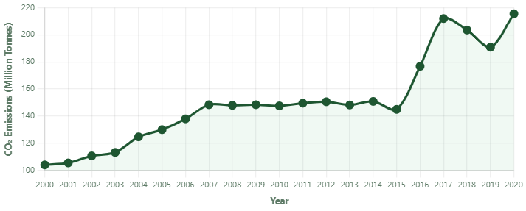
Figure 1: Total CO₂ Emissions (Million Tonnes) – Pakistan (2000-2020). Source: Ritchie et al. (2023); Friedlingstein et al. (2023).
The early 2000s saw steady upward movement, from 103.94 Mt in 2000 to 148.35 Mt by 2007. This tracks reasonably well with the economic growth that Pakistan saw under the Musharraf government, when GDP was expanding at 5-7% per year (Government of Pakistan, 2021). More manufacturing, vehicles on the road, natural gas being piped into homes for cooking and heating, all of this pushed energy demand upward and emissions followed.

Then something odd happens from about 2008 to 2015: the line flattens. Emissions stay stuck between roughly 144 and 151 Mt for nearly eight years. This was not the result of any climate policy. Pakistan's electricity grid was in crisis, with shortfalls of up to 18 hours a day in some parts of the country (Kessides, 2013). Factories cut production, businesses ran on generators or not at all. The carbon flat line was basically an accidental outcome of economic stagnation, which is a deeply uncomfortable fact when you think about what it implies for emissions accounting.

The third phase begins around 2016 and it is steep. Between 2015 and 2017, total emissions jumped from 144.90 Mt to 211.98 Mt, a 46% increase in just 2 years. This is almost entirely explained by China-Pakistan Economic Corridor (CPEC), specifically the coal-fired power stations that came online under its Early Harvest energy projects, including the 1,320 MW Port Qasim and 1,320 MW Sahiwal plants (Kugelman, 2018). The Friedlingstein et al. (2023) tells that from 2016 the coal combustion has increased sharply. CPEC did resolve the electricity crisis. But the way that they choose, left Pakistan with a coal dependency that now sits at roughly 7.6 GW of installed capacity.
2.2 Per Capita CO₂ Emissions (2000-2020)
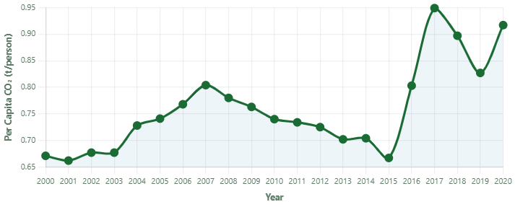
Figure 2: Per Capita CO₂ Emissions (t/person) – Pakistan (2000-2020). Source: Ritchie et al. (2023); World Bank (2023).
Figure 2 tells a slightly different version of the same story. In 2000, the amount of pollution per person was 0.671 tons. By 2017, it had risen to 0.949 tons per person, and by 2020, it had dropped to 0.917 tons per person. The average person share goes down because one method makes it look smaller than it really is. Back then, Pakistan added about 2% more people each year (World Bank, 2023), which meant that pollution spread out more each time. That drop down to 0.667 tons per person in 2015. Then suddenly, out of nowhere almost, comes a spike – to 0.949 by 2017 – and once more, those new coal stations tied to CPEC explain most of it. Such abrupt shifts in individual emission levels are never due to high fertility rate but instead represent actual jumps in the level of electricity each one uses coupled with compromised fuel burning behind the scenes.

3. Carbon Inequality Analysis
3.1 Per Capita Emissions and Global Share
To know where Pakistan stands when compared to the world, it helps to put the per capita number next to some comparators. In 2020, Pakistan emitted 0.917 t/person. The global average that year was 4.476 t/person (Ritchie et al., 2023). So the average Pakistani was responsible for roughly 1/5th of what the average person globally produced. Against the United States (14.14 t/person), Pakistan's number is about fifteen times smaller. Even India, which faces many of the same developmental pressures as Pakistan, had per capita emissions of 1.73 t/person that year, which is nearly double Pakistan's figure. The only country in this comparison that falls below Pakistan is Bangladesh at 0.58 t/person, which has virtually no heavy industry rather textile industries which is more human resource dependent and significantly less emissions.

The global share number tells a story that is just as important. Pakistan made 0.657% of the world's CO₂ in 2020, even though it only has about 2.9% of the world's population (World Bank, 2023). The country lets out less than 25% of its total population. Oxfam (2021) makes a similar point about income: the richest 10% of people in the world are responsible for about 52% of all emissions, while the poorest half of people, which includes Pakistan, is only responsible for about 7%. This situation is caused by both the geography of the area and rules for protecting the climate. It reflects decades of industrialisation concentrated in high-income countries, which is precisely why the UNFCCC established the principle of common but differentiated responsibilities in the first place (United Nations, 1992).

3.2 Comparison with India and Global Average
Country | Per Capita (t/person) 2020 | Total CO₂ (Mt) 2020 | Global Share (%) 2020 | GDP per Capita (USD) 2020
United States | 14.14 | 4,689.95 | 13.42 | 63,516
China | 7.72 | 10,896.52 | 31.05 | 10,627
World Average | 4.48 | 35,158.23 | 100.00 | 10,938
India | 1.73 | 2,422.73 | 6.89 | 1,907
Pakistan | 0.92 | 215.51 | 0.66 | 1,278
Bangladesh | 0.58 | 95.73 | 0.27 | 2,249
Table 2: Cross-Country Emissions and Development Comparison (2020). Pakistan highlighted. Sources: Ritchie et al. (2023); World Bank (2023); Crippa et al. (2022).
The comparison with India in Table 2 deserves some attention because it tends to get flattened in climate discussions. Both countries are labelled developing, both have large poor populations, both are in the same region. But India's per capita emissions in 2020 were 1.73 t, almost twice Pakistan's 0.92 t, and India's total was 2,422 Mt against Pakistan's 215 Mt, a factor of eleven. India industrialised faster, built more coal and thermal power capacity, and grew its cement and steel sectors at a pace Pakistan did not match. Roberts and Parks (2007) argue that bundling countries like India and Pakistan under a single 'developing nations' label in climate negotiations obscures these differences and, as a result, obscures their different levels of responsibility too.

To be clear, Pakistan qualifies as a low emitter on every measure examined here. But the post-2016 CPEC coal expansion makes the direction of travel concerning. If that coal infrastructure runs for its full lifespan(around 30 to 40 years), Pakistan will be emitting at elevated levels well into the 2050s, by which point the IPCC (2022) warns the 1.5 degree window will almost certainly have passed.

4. Visualisations and Interpretation
4.1 Dashboard KPI Tiles
The dashboard built for this assignment shows four summary tiles at the top, each pulling a single headline number from the dataset. Taken together they give a quick read on where Pakistan stands.

Total CO₂ Emissions (215.5 Mt): At 215.5 Mt in 2020, Pakistan's total output has more than doubled since 2000. The post-2016 coal surge under CPEC drove the steepest part of that rise (Friedlingstein et al., 2023). For context, this is still just 2% of China's 10,896 Mt or 4.6% of the United States' 4,690 Mt in the same year (Ritchie et al., 2023).

Per Capita CO₂ (0.92 t/person): This is the number that matters most for any climate justice argument. At 0.92 t/person, Pakistan sits at about 1/5th of the 4.48 t/person global average (Ritchie et al., 2023). The average Pakistani's carbon footprint is not the problem.

Global CO₂ Share (0.66%): Pakistan produces 0.66% of global CO₂ while being home to about 2.9% of the global population (World Bank, 2023). Its emissions share is less than a quarter of its population share, which speaks directly to the question of proportionate responsibility.

GDP per Capita ($1,278): This places Pakistan in the lower-middle-income bracket and explains why the domestic resources needed for a green energy transition are simply not available at scale (World Bank, 2023). Any serious climate mitigation plan for Pakistan has to reckon with this constraint.

4.2 Figure 3: Per Capita CO₂ by Country (2020)
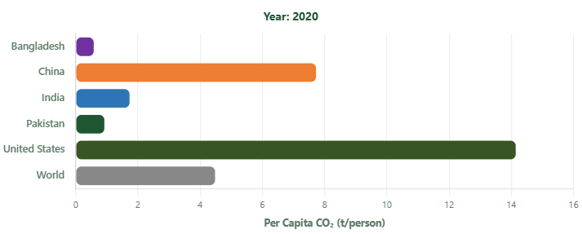
Figure 3: Average Per Capita CO₂ Emissions (t/person) by Country, 2020. Source: Ritchie et al. (2023).
The bar chart in Figure 3 makes the disparity in per capita emissions which cannot be ignored. The United States bar at 14.14 t stretches about fifteen times further than Pakistan's at 0.92 t. China's at 7.72 t is more than eight times wider. Even the world average of 4.48 t dwarfs Pakistan's figure. What this visualisation captures, in a way that tables cannot quite convey, is the sheer concentration of the global carbon burden in a handful of wealthy nations. Shue (1993) draws a distinction between subsistence emissions, those linked to meeting basic needs, and luxury emissions linked to high-consumption lifestyles. Looking at this chart, it is hard to place Pakistan anywhere other than the subsistence end of that spectrum.

4.3 Figure 4: Global CO₂ Share, Pakistan vs India (2000-2020)
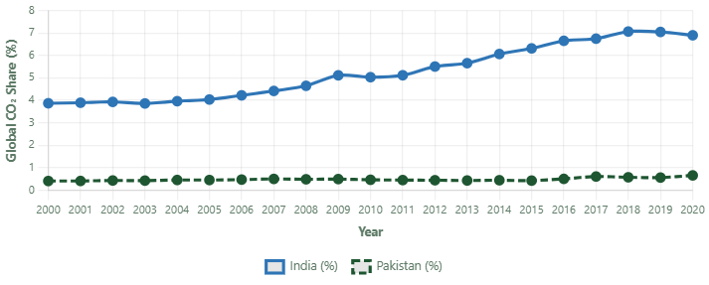
Figure 4: Share of Global CO₂ Emissions (%) – Pakistan vs India (2000-2020). Source: Ritchie et al. (2023).
Figure 4 compares Pakistan and India on the same chart and the gap between them is shocking. India's share rose consistently from 3.87% in 2000 to 6.89% in 2020, while Pakistan's line stayed flat between 0.40% and 0.50% for most of the period before nudging up to 0.657% after 2016. That post-2016 uptick in Pakistan's line is the CPEC coal effect striking up again. The broader point the chart raises is the one Roberts and Parks (2007) make about how the developing country label papers over enormous differences. India at 6.89% of global emissions is totally different from Pakistan at 0.66%, and treating them on same page in mitigation frameworks is not a good practice.

4.4 Figure 5: GDP per Capita vs Per Capita CO₂ (2020)
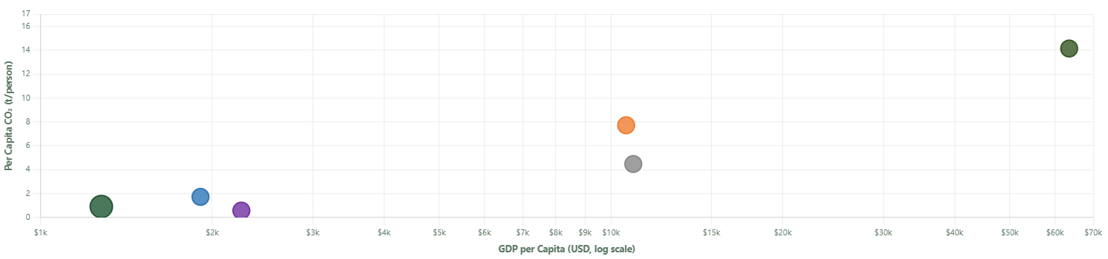
Figure 5: Scatter Plot – GDP per Capita (USD, log scale) vs Per Capita CO₂ (t/person), 2020. Source: Ritchie et al. (2023); World Bank (2023).
Figure 5 is probably the most analytically driven figures of the five. Putting the countries on graph which shows GDP per capita vs per capita CO₂, shows a clear positive relationship: wealthier countries emit more per person. Pakistan and Bangladesh sit together in the bottom-left corner, low income and low emissions. India is a bit further along both axes. China and the United States anchor the upper right. Stern (2004) reviewed the evidence on whether emissions eventually decline at very high income levels, the Environmental Kuznets Curve argument, and found only partial support. What the scatter does confirm without ambiguity is the spatial inequality at the heart of the climate problem: the countries in the lower left, the ones with the least money to adapt, are there precisely because they industrialised least, which also means they contributed least to the warming that is now affecting all of them. Pakistan's position in that lower-left corner while simultaneously ranking among the world's most climate-vulnerable countries (Eckstein et al., 2021) captures the injustice of the situation about as plainly as any chart can.

5. Climate Justice Reflection
The data shows one clear result. Pakistan's contribution to the global CO₂ problem is small because it only made 0.66% of all emissions in 2020, which is only 0.92 tons per person, or 1/5th of the global average (Ritchie et al., 2023). The IPCC (2022) says that climate change caused by people made the monsoon patterns stronger and the glaciers less stable, which led to the floods in 2022. The floods affected one-third of the country, forced 33 million people to leave their homes, and caused about $30 billion in damage (UNDP, 2022; United Nations, 2022). There is still a clear difference between Pakistan's past emissions and its current climate impact through emissions absorption.

Given this, what role should Pakistan actually play in global climate efforts. The most honest answer is that it shouldn't have to deal with the same amount of pollution as countries like the US or China, whose emissions over time have made the CO₂ in the atmosphere that is now causing global warming. The principle of common but differentiated responsibilities exists for exactly this reason (United Nations, 1992), and Pakistan is one of the strongest arguments for taking it seriously.

That being said, Pakistan also has some responsibility. Since 2016, the CPEC coal expansion has been a real problem. It locks in carbon-heavy infrastructure for 30 to 40 years, even though the IPCC (2022) says that this decade is the time to quickly decarbonize. Pakistan has a lot of potential for renewable energy. For example, Balochistan and Sindh have an estimated 40,000 MW of solar capacity, and the north has more than 50,000 MW of hydropower (Government of Pakistan, 2021). These resources should be developed as a matter of national energy security as much as climate responsibility.

Internationally, Pakistan's most important role is as an advocate. The $100 billion annual climate finance pledge from Copenhagen 2009 remained unmet for over a decade, and what eventually arrived was largely in loan form rather than grants (UNFCCC, 2022). The Loss and Damage Fund agreed at COP27 was progress, but far short of what is needed. Pakistan's 2022 flood alone demonstrated the scale of loss that developing nations are absorbing. That evidence should be front and centre in every negotiation Pakistan participates in.
References

- Crippa, M., Guizzardi, D., Pagani, F., Banja, M., Muntean, M., Schaaf, E., Monforti-Ferrario, F., Quadrelli, R., Rossi, S., & Vignati, E. (2022). GHG emissions of all world countries: 2022 report. European Commission, Joint Research Centre. https://edgar.jrc.ec.europa.eu/
- Eckstein, D., Kunzel, V., & Schafer, L. (2021). Global Climate Risk Index 2021: Who suffers most from extreme weather events? Germanwatch. https://www.germanwatch.org/en/cri
- Friedlingstein, P., O'Sullivan, M., Jones, M. W., Andrew, R. M., Gregor, L., Hauck, J., & Zheng, B. (2023). Global carbon budget 2023. Earth System Science Data, 15(11), 5301-5369. https://doi.org/10.5194/essd-15-5301-2023
- Government of Pakistan. (2021). Pakistan's updated nationally determined contribution. Ministry of Climate Change. https://unfccc.int/sites/default/files/NDC/2022-06/Pakistan%20Updated%20NDC%202021.pdf
- Immerzeel, W. W., Lutz, A. F., Andrade, M., Bahl, A., Biemans, H., Bolch, T., Hyde, S., & Baillie, J. E. M. (2020). Importance and vulnerability of the world's water towers. Nature, 577(7790), 364-369. https://doi.org/10.1038/s41586-019-1822-y
- Intergovernmental Panel on Climate Change (IPCC). (2022). Climate change 2022: Impacts, adaptation and vulnerability. Working Group II contribution to the Sixth Assessment Report. Cambridge University Press. https://doi.org/10.1017/9781009325844
- Kessides, I. N. (2013). Chaos in power: Pakistan's electricity crisis. Energy Policy, 55, 271-285. https://doi.org/10.1016/j.enpol.2012.12.005
- Kugelman, M. (2018). Why the China-Pakistan Economic Corridor is in trouble. Foreign Policy. https://foreignpolicy.com/2018/07/09/why-the-china-pakistan-economic-corridor-is-in-trouble/
- Le Quere, C., Jackson, R. B., Jones, M. W., Smith, A. J. P., Abernethy, S., Andrew, R. M., & Peters, G. P. (2021). Temporary reduction in daily global CO₂ emissions during the COVID-19 forced confinement. Nature Climate Change, 10(7), 647-653. https://doi.org/10.1038/s41558-020-0797-x
- Oxfam. (2021). Carbon inequality in 2030: Per capita consumption emissions and the 1.5 degree goal. Oxfam International. https://www.oxfam.org/en/research/carbon-inequality-2030
- Ritchie, H., Roser, M., Mathieu, E., Macdonald, B., & Rosado, P. (2023). CO₂ and greenhouse gas emissions. Our World in Data. https://ourworldindata.org/co2-and-greenhouse-gas-emissions
- Roberts, J. T., & Parks, B. C. (2007). A climate of injustice: Global inequality, North-South politics, and climate policy. MIT Press.
- Shue, H. (1993). Subsistence emissions and luxury emissions. Law and Policy, 15(1), 39-59. https://doi.org/10.1111/j.1467-9930.1993.tb00093.x
- Stern, D. I. (2004). The rise and fall of the Environmental Kuznets Curve. World Development, 32(8), 1419-1439. https://doi.org/10.1016/j.worlddev.2004.03.004
- United Nations. (1992). United Nations Framework Convention on Climate Change. FCCC/INFORMAL/84. https://unfccc.int/resource/docs/convkp/conveng.pdf
- United Nations. (2022). Pakistan floods: Secretary-General calls for climate justice. UN News. https://news.un.org/en/story/2022/09/1126231
- United Nations Development Programme (UNDP). (2022). Pakistan: Flood impacts 2022. UNDP Pakistan. https://www.undp.org/pakistan/publications/pakistan-flood-impacts-2022
- United Nations Framework Convention on Climate Change (UNFCCC). (2022). Climate finance for developing countries reached USD 83.3 billion in 2020. UNFCCC. https://unfccc.int/news/climate-finance-for-developing-countries-reached-usd-83-3-billion-in-2020
- World Bank. (2023). World development indicators. The World Bank Group. https://data.worldbank.org/

