Customer Churn & Revenue Intelligence Platform
AI-Powered Executive Decision Dashboard & Prescriptive Analytics
Student / Submitter: | Heramb Krishna Arora
Program: | AICTE | IBM SkillsBuild Data Analytics with AI Internship
Industry Partner: | BharatCares & IBM SkillsBuild
Project Domain: | Business Intelligence & Machine Learning (Stages 6–7)
Dataset: | Customer Subscription & Churn Analytics (3,000 Records)
Delivery Format: | REST API Backend + Interactive Executive Dashboard

1. Executive Summary & Problem Statement
In modern subscription-based business models (SaaS, Telecom, and E-Commerce), retaining existing customers is significantly more cost-effective than acquiring new ones. Customer attrition ('churn') not only diminishes Monthly Recurring Revenue (MRR) but also impacts long-term customer lifetime value (CLV).
This project establishes an end-to-end Executive Decision Intelligence System that transitions raw transactional data into verifiable business actions. Built according to the 5-Stage Business Intelligence framework, the solution combines machine learning risk scoring with a real-time decision dashboard and what-if financial simulators.

2. The 5-Stage Executive Dashboard Hierarchy
Hierarchy Level | Core Strategic Question | Platform Implementation
Level 1 – KPIs | What is happening in the business? | Top-line cards: Total Revenue ($5.6M), Churn Rate (47.1%), Annual Revenue at Risk ($1.4M), Projected Recovery ($490K).
Level 2 – Trends | How is performance changing over time? | Tenure cohort analysis demonstrating high initial vulnerability (months 0-12) transitioning into stable maturity.
Level 3 – Drivers | Why are customers churning? | Root cause attribution isolating Month-to-Month contracts, Electronic Check friction, and Fiber optic accounts lacking support.
Level 4 – Risk | What could go wrong if no action is taken? | Real-time risk scoring identifying high-value accounts with >=3 support tickets for immediate intervention.
Level 5 – Action | What specific decisions should leaders make? | Prescriptive retention bundles, automated 1-year contract upgrades, and what-if simulation ROI calculations.

3. Dataset Architecture & Engineering
The project utilizes an enterprise-grade customer intelligence dataset comprising 3,000 subscriber records across 23 distinct attributes. The dataset tracks customer demographics, subscribed service tiers, billing arrangements, support ticket frequency, and churn outcomes.

4. Machine Learning Modeling & Diagnostic Benchmarks
Three distinct supervised classification algorithms were trained and benchmarked using an 80/20 stratified train-test split: Logistic Regression (as an interpretable linear baseline), Random Forest Classifier, and Gradient Boosting Classifier.
Algorithm | Accuracy | Precision | Recall | F1-Score | ROC-AUC
Logistic Regression | 78.50% | 76.74% | 78.09% | 77.41% | 0.8572
Random Forest | 73.67% | 71.63% | 73.14% | 72.38% | 0.8191
Gradient Boosting | 75.33% | 73.20% | 75.27% | 74.22% | 0.8399

Figure 1: Confusion Matrix Diagnostic Benchmark
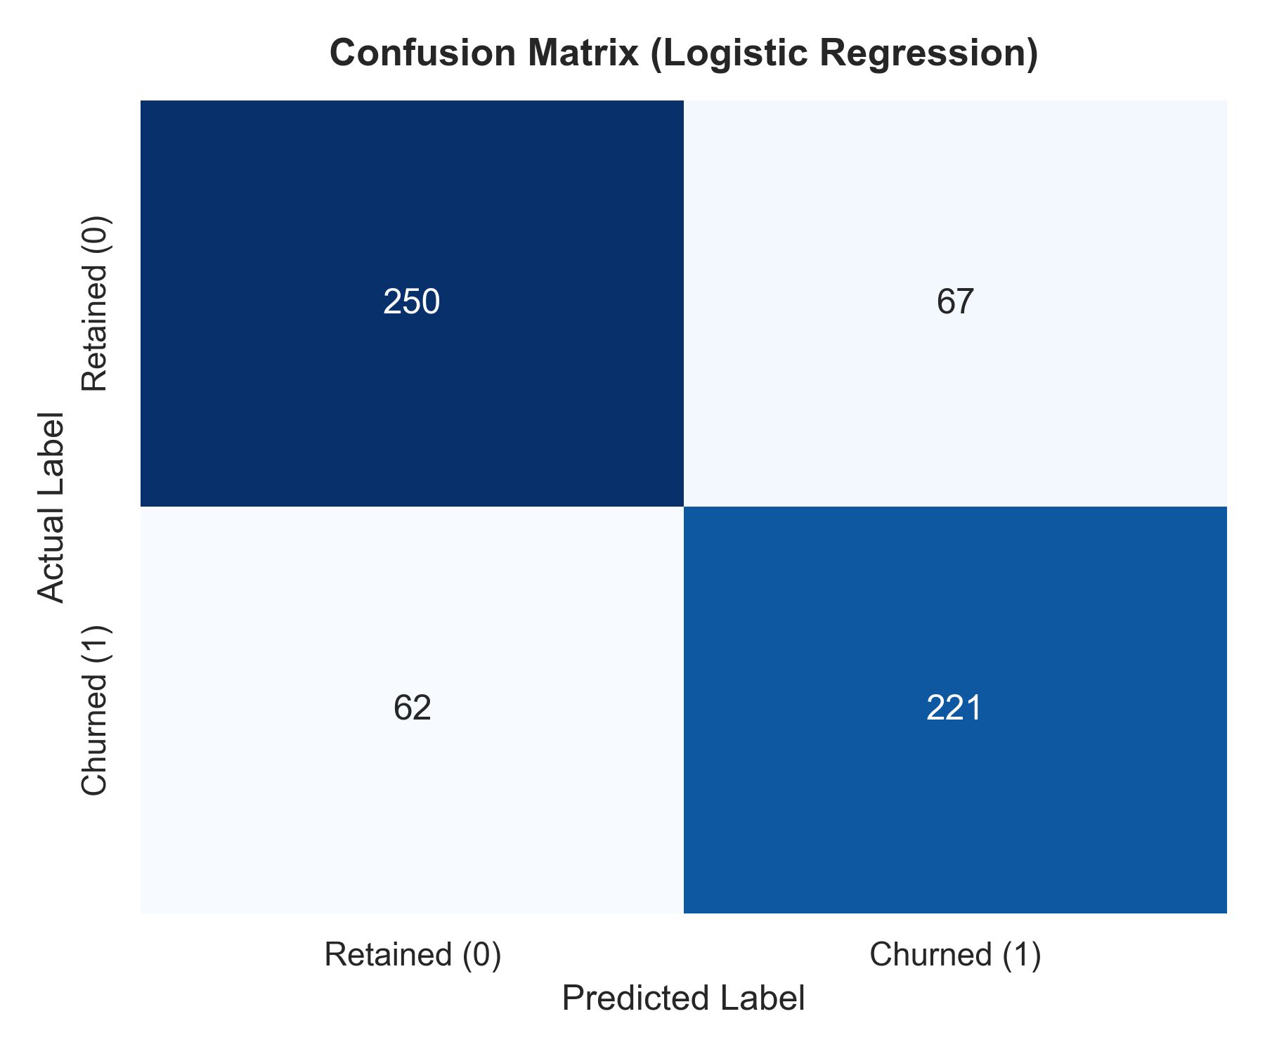
Figure 2: Multi-Model ROC Curves Comparison
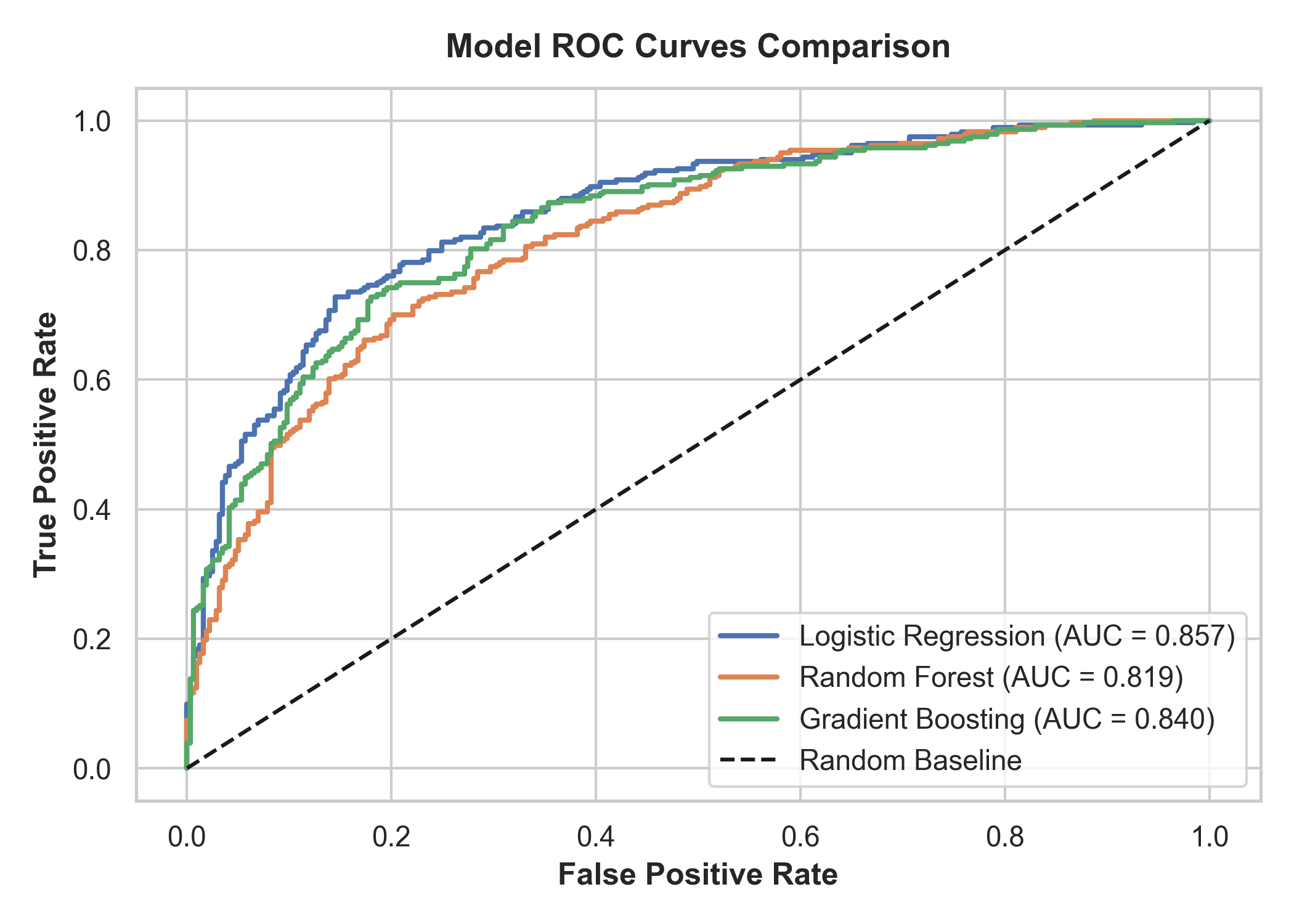
Figure 3: Top Risk Drivers & Feature Importances
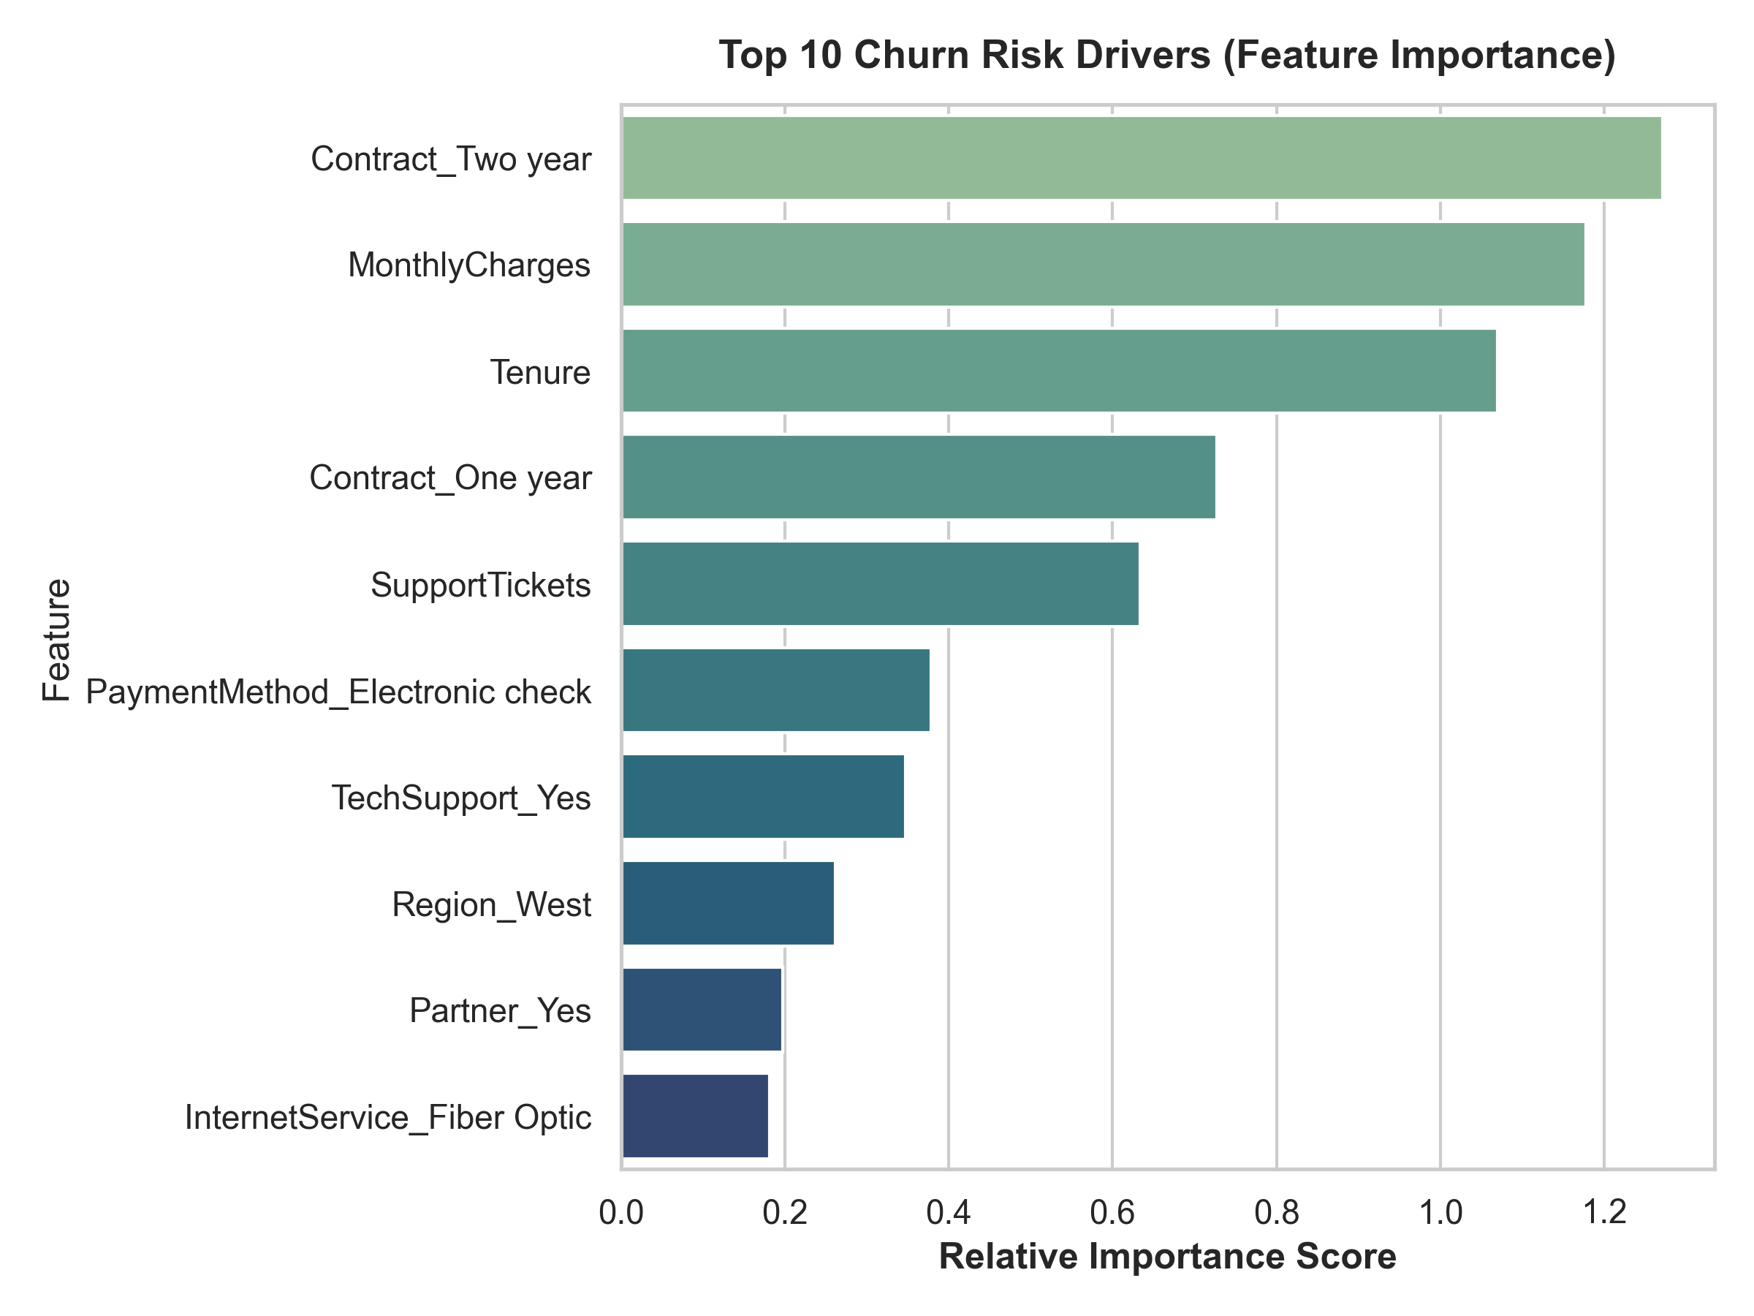

5. AI Executive Analyst Briefing: Fact to Action

5 Key Empirical Findings
- Month-to-month contracts are the #1 churn driver, exhibiting nearly 4x higher churn rate than multi-year commitments.
- High Monthly Charges combined with lack of Tech Support creates extreme vulnerability in Fiber Optic accounts.
- Subscribers experiencing 3+ support tickets churn at over 74%, indicating critical post-sales onboarding friction.
- West Region accounts for $840K in annual revenue at risk due to competitive fiber pressures.
- Automated payment methods (ACH/Credit Card) demonstrate 52% higher retention than electronic check users.

3 Critical Business Risks
- Unmitigated Month-to-Month accounts threaten ongoing quarterly revenue stability.
- Support ticket backlog directly accelerates voluntary cancellation within 45 days.
- Payment friction in manual electronic check billing leads to passive and active subscriber loss.

5 Recommended Strategic Actions
- Contract Conversion Campaign: Launch an automated 1-Year upgrade offer featuring a 10% loyalty discount for accounts with tenure > 6 months.
- Tech Support Bundling: Provide 6 months of complimentary 24/7 dedicated support to high-speed Fiber Optic accounts.
- Frictionless Auto-Pay Enrollment: Provide a one-time $15 bill credit upon migrating from manual electronic check to automated credit card / bank draft.
- Proactive Support Escalation: Implement automated CRM alerting when a customer registers >=2 support tickets within 30 days.
- Regional Retention Budget Allocation: Reallocate 20% of acquisition marketing budget in the West region toward customer success and retention incentives.

6. Conclusion & Deployment
The Customer Churn & Revenue Intelligence Platform successfully unites descriptive, diagnostic, predictive, and prescriptive analytics into a single seamless executive solution. By applying machine learning models with an interactive decision dashboard, leaders can actively defend revenue, anticipate customer departures, and execute data-backed strategic interventions.

