Ex. No. : 04 Date: 25/02/2026
Register No.: 231701014 Name: GOKUL KRISHNA N

Gesture-Based Interaction App

Aim
To develop a gesture-based mobile application that detects double-tap and swipe gestures, displays text on double tap, navigates between screens on subsequent double taps, and shows toast messages on left and right swipe actions.
Procedure:
Activity_main.xml
<?xml version="1.0" encoding="utf-8"?>
<androidx.constraintlayout.widget.ConstraintLayout xmlns:android="http://schemas.android.com/apk/res/android"
xmlns:app="http://schemas.android.com/apk/res-auto"
xmlns:tools="http://schemas.android.com/tools"
android:id="@+id/main"
android:layout_width="match_parent"
android:layout_height="match_parent"
tools:context=".MainActivity">
<TextView
android:id="@+id/gesture_text"
android:layout_width="wrap_content"
android:layout_height="wrap_content"
android:text="Hello World!"
android:visibility="gone"
app:layout_constraintBottom_toBottomOf="parent"
app:layout_constraintEnd_toEndOf="parent"
app:layout_constraintStart_toStartOf="parent"
app:layout_constraintTop_toTopOf="parent" />
</androidx.constraintlayout.widget.ConstraintLayout>

Activity_second.xml
<?xml version="1.0" encoding="utf-8"?>
<androidx.constraintlayout.widget.ConstraintLayout xmlns:android="http://schemas.android.com/apk/res/android"
xmlns:app="http://schemas.android.com/apk/res-auto"
xmlns:tools="http://schemas.android.com/tools"
android:layout_width="match_parent"
android:layout_height="match_parent">
<TextView
android:layout_width="wrap_content"
android:layout_height="wrap_content"
android:text="Second Screen"
app:layout_constraintBottom_toBottomOf="parent"
app:layout_constraintEnd_toEndOf="parent"
app:layout_constraintStart_toStartOf="parent"
app:layout_constraintTop_toTopOf="parent" />
</androidx.constraintlayout.widget.ConstraintLayout>
MainActivity.xml
package com.example.gestureapp
import android.content.Intent
import android.os.Bundle
import android.view.GestureDetector
import android.view.MotionEvent
import android.view.View
import android.widget.TextView
import android.widget.Toast
import androidx.appcompat.app.AppCompatActivity
import androidx.core.view.GestureDetectorCompat
class MainActivity : AppCompatActivity(), GestureDetector.OnGestureListener, GestureDetector.OnDoubleTapListener {
private lateinit var gestureDetector: GestureDetectorCompat
private lateinit var gestureText: TextView
private var doubleTapCount = 0
override fun onCreate(savedInstanceState: Bundle?) {
super.onCreate(savedInstanceState)
setContentView(R.layout.activity_main)
gestureText = findViewById(R.id.gesture_text)
gestureDetector = GestureDetectorCompat(this, this)
gestureDetector.setOnDoubleTapListener(this)
}
override fun onTouchEvent(event: MotionEvent): Boolean {
gestureDetector.onTouchEvent(event)
return super.onTouchEvent(event)
}
override fun onDown(e: MotionEvent): Boolean = true
override fun onShowPress(e: MotionEvent) {}
override fun onSingleTapUp(e: MotionEvent): Boolean = true
override fun onScroll(e1: MotionEvent?, e2: MotionEvent, distanceX: Float, distanceY: Float): Boolean = true
override fun onLongPress(e: MotionEvent) {}
override fun onFling(e1: MotionEvent?, e2: MotionEvent, velocityX: Float, velocityY: Float): Boolean {
if (e1 != null) {
val diffX = e2.x - e1.x
if (diffX > 0) {
Toast.makeText(this, "Right Swipe", Toast.LENGTH_SHORT).show()
} else {
Toast.makeText(this, "Left Swipe", Toast.LENGTH_SHORT).show()
}
}
return true
}
override fun onSingleTapConfirmed(e: MotionEvent): Boolean = true
override fun onDoubleTap(e: MotionEvent): Boolean {
if (doubleTapCount == 0) {
gestureText.visibility = View.VISIBLE
doubleTapCount++
} else {
val intent = Intent(this, SecondActivity::class.java)
startActivity(intent)
}
return true
}
override fun onDoubleTapEvent(e: MotionEvent): Boolean = true
}

Output
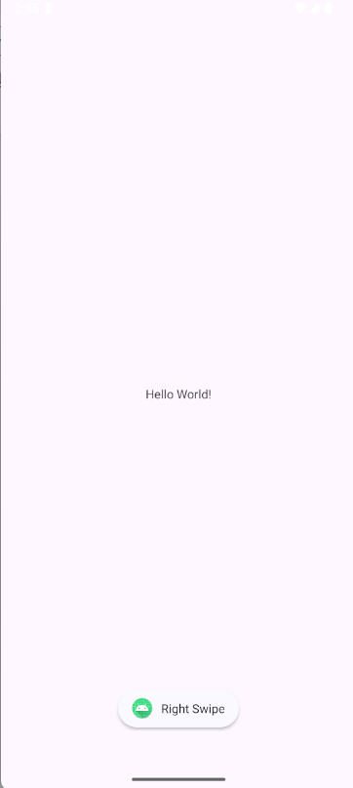

Result:
Hence the experiment is completed and the output is verified..

