### **Aim**

To design a modern and functional remote control interface in Figma, showcasing various button layouts and interactive features.

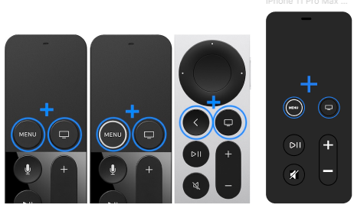

### **Procedure**

1. **Conceptual Sketching**:
   * Started by sketching different remote control layouts to explore various button arrangements and styles.
   * Analyzed existing remote designs for inspiration to ensure familiarity and ease of use.
2. **Button and Icon Design**:
   * Used Figma’s vector tools to create custom icons for key buttons (e.g., Menu, Play/Pause, volume controls).
   * Added recognizable and intuitive icons, such as the “+” button for volume or navigation purposes, to enhance usability.
   * Ensured consistent sizing and spacing between buttons for a balanced design.
3. **Color Scheme and Highlighting**:
   * Chose a sleek black background with blue highlights to indicate active or selected buttons.
   * Incorporated subtle gray tones for less prominent buttons to provide a clear hierarchy of functions.
4. **Layout Variations**:
   * Created multiple variations of the remote layout to demonstrate different button placements and styles, catering to different user preferences.
   * Experimented with both minimalistic and more feature-rich designs.
5. **Prototyping and Interaction**:
   * Used Figma’s prototyping feature to simulate button interactions and test user flows.
   * Applied hover and press states to buttons for a realistic user experience in the prototype phase.

### **Result**

The final result showcases a set of remote control designs that are intuitive and user-friendly. Each design variation offers clear navigation and highlights essential functions with well-placed, visually distinct buttons. The interactive prototype enables a realistic experience, demonstrating the functionality and visual appeal of the remote control interface.