=================================
17 Jun 2026 12:53
=================================

Original Images


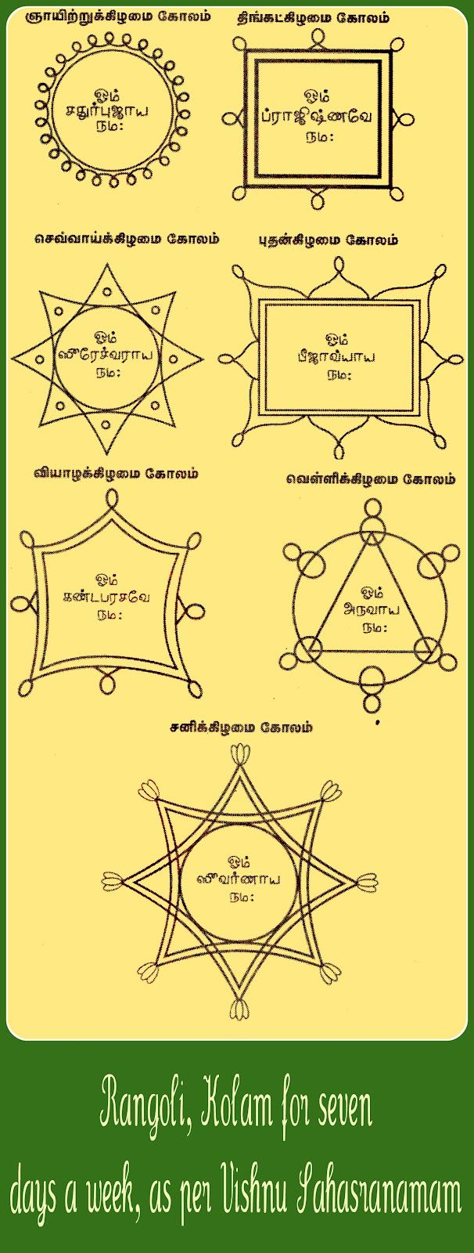

Generated Notes
# Debugging and Development Notes
## Goals (This Month)
- Learn Java Deeply
- Build WebApp (Java + Vue.js)
- Improve DSA
- Contribute to Project
- Learn from Mistakes
## Tech Stack
- Java
- Vue.js
- HTML/CSS
- MySQL
## Focus & Motivation
- Consistency > Motivation
- Focus > Distraction
## Remember
- Understand
- Practice
- Build
- Debug
- Don't Give Up
## Today Plan
- Fix bug in UserService
- Add validation
- Dashboard
- Learn something new
## Notes / Learnings
- Optional in Java
- DTO vs Entity
- @Service
- @Transactional
- Exception Handling
## Debugging Checklist
- Reproduce
- Understand
- Fix
- Test
- Refactor
## Coding Process Advice
"First, solve the problem. Then, write the code." - Gokul
"Help me debug this issue in UserService.java"
"Code. Learn. Improve. Repeat."
"Ask doubts anytime. I'm here."
"Good logic! But check edge cases here."
"One step at a time."
## Student Information
**Gokul**
First Year Computer Science
Java Intern
## Rangoli / Kolam (as per Vishnu Sahasranamam)
This section displays various rangoli or kolam designs. The Tamil text above each design appears to indicate the day of the week or a specific type of kolam.
### [Design 1]
(Appears to be a circular design with multiple smaller circles around the perimeter)
**Significance:** (Tamil text indicating its name/purpose)
### [Design 2]
(Appears to be a square-based design with corner embellishments)
**Significance:** (Tamil text indicating its name/purpose)
### [Design 3]
(Appears to be an eight-pointed star-like design)
**Significance:** (Tamil text indicating its name/purpose)
### [Design 4]
(Appears to be a rectangular design with corner embellishments)
**Significance:** (Tamil text indicating its name/purpose)
### [Design 5]
(Appears to be a square-based design with extended corner embellishments)
**Significance:** (Tamil text indicating its name/purpose)
### [Design 6]
(Appears to be a triangular design with connecting lines)
**Significance:** (Tamil text indicating its name/purpose)
### [Design 7]
(Appears to be a seven-pointed star design)
**Significance:** (Tamil text indicating its name/purpose)
# Debugging and Development Notes
## Goals (This Month)
- Learn Java Deeply
- Build WebApp (Java + Vue.js)
- Improve DSA
- Contribute to Project
- Learn from Mistakes
## Tech Stack
- Java
- Vue.js
- HTML/CSS
- MySQL
## Focus & Motivation
- Consistency > Motivation
- Focus > Distraction
## Remember
- Understand
- Practice
- Build
- Debug
- Don't Give Up
## Today Plan
- Fix bug in UserService
- Add validation
- Dashboard
- Learn something new
## Notes / Learnings
- Optional in Java
- DTO vs Entity
- @Service
- @Transactional
- Exception Handling
## Debugging Checklist
- Reproduce
- Understand
- Fix
- Test
- Refactor
## Coding Process Advice
"First, solve the problem. Then, write the code." - Gokul
"Help me debug this issue in UserService.java"
"Code. Learn. Improve. Repeat."
"Ask doubts anytime. I'm here."
"Good logic! But check edge cases here."
"One step at a time."
## Student Information
**Gokul**
First Year Computer Science
Java Intern
## Rangoli / Kolam (as per Vishnu Sahasranamam)
This section displays various rangoli or kolam designs. The Tamil text above each design appears to indicate the day of the week or a specific type of kolam.
### [Design 1]
(Appears to be a circular design with multiple smaller circles around the perimeter)
**Significance:** (Tamil text indicating its name/purpose)
### [Design 2]
(Appears to be a square-based design with corner embellishments)
**Significance:** (Tamil text indicating its name/purpose)
### [Design 3]
(Appears to be an eight-pointed star-like design)
**Significance:** (Tamil text indicating its name/purpose)
### [Design 4]
(Appears to be a rectangular design with corner embellishments)
**Significance:** (Tamil text indicating its name/purpose)
### [Design 5]
(Appears to be a square-based design with extended corner embellishments)
**Significance:** (Tamil text indicating its name/purpose)
### [Design 6]
(Appears to be a triangular design with connecting lines)
**Significance:** (Tamil text indicating its name/purpose)
### [Design 7]
(Appears to be a seven-pointed star design)
**Significance:** (Tamil text indicating its name/purpose)

