UNLOCKING INSIGHTS INTO THE GLOBAL AIR TRANSPORTATION NETWORK WITH TABLEAU

1 INTRODUCTION

1.1

This Global Air Transportation Network dataset is a comprehensive collection of information on airports, airlines and their routes. It contains information such as names, cities, countries, codes (IATA and ICAO) longitudes, latitudes and altitudes of airports across the world with detailed time zone and daylight saving time data. Additionally, this includes information about airlines including their IDs, name aliases, IATA and ICAO codes, callsigns country of origin and active/inactive status. Similarly, it also covers route details such as airline sources to destination airports along with essential details like codeshare stakeholder if any stops required during this journey along with the type of aircraft being used for that particular journey. This dataset has been compiled through meticulous labor by researchers all over the world to give you a comprehensive detail into air transportation networks from around the globe.

1.2

Air transport is an important enabler to achieving economic growth and development. Air transport facilitates integration into the global economy and provides vital connectivity on a national, regional, and international scale. It helps generate trade, promote tourism, and create employment opportunities. The World Bank has financed aviation-related projects for over sixty years. Today, the WBG remains actively engaged in every region on projects related to air transport policy and regulation, safety, infrastructure rehabilitation, institutional strengthening, and capacity building.

2.PROBLAM DEFINITION&DESIGN THINKING
2.1 EMPATHY MAP

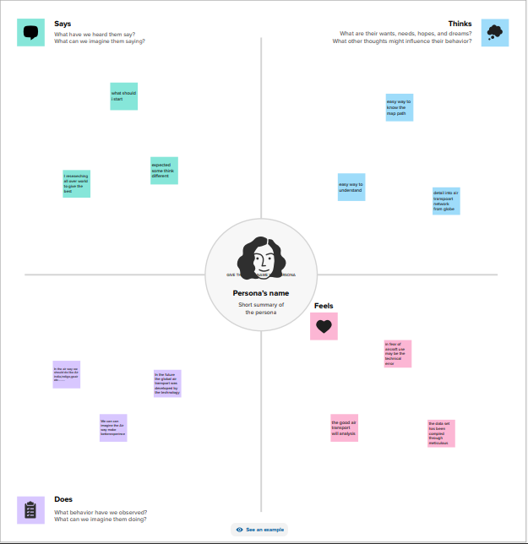
  - BRAINSTORMING MAP

Airlines Reporting Corporation (ARC) provides fexible distribution solutions to help airlines and travel agencies connect, grow and thrive. By developing innovative business intelligence (BI) products and services for the global travel community, ARC provides the critical link that enables airlines like British Airways, United Airlines, Air China, and more than 200 others selling tickets through travel agents in the US. ARC helps its customers operate more effectively and grow their businesses by building the world’s most comprehensive data on global air transactions. In 2018 alone, ARC settled more than $94.7 billion in transactions between airlines and travel agencies, representing more than 295 million passenger trips.
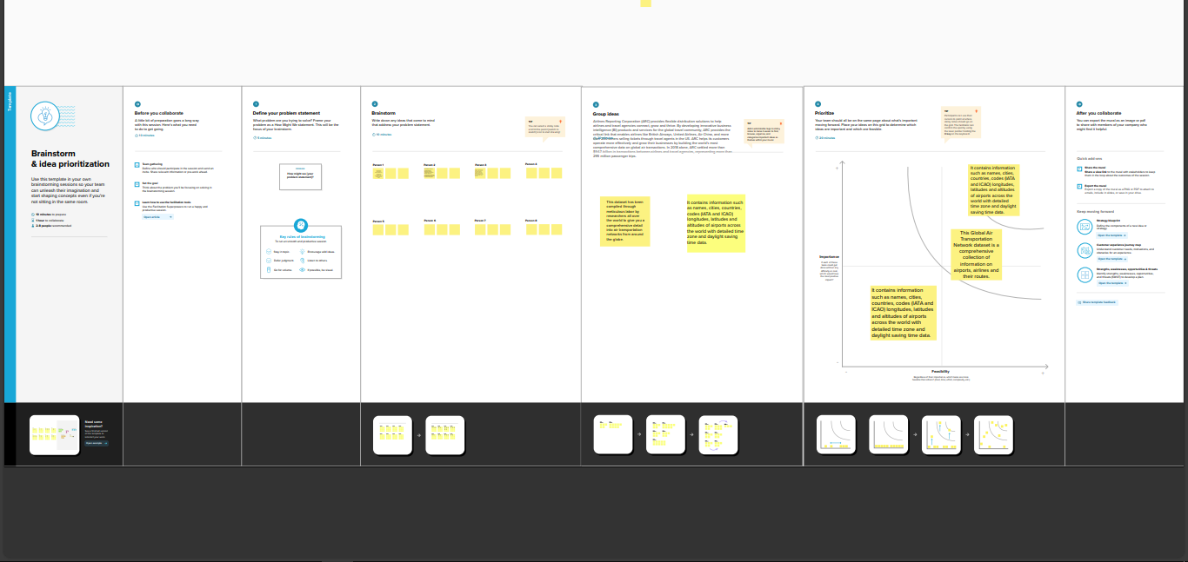

3.RESULT:

Here we provide tha result of the tableau provide result of the airline in the global airpoart in the world to has be shown in the example of the result
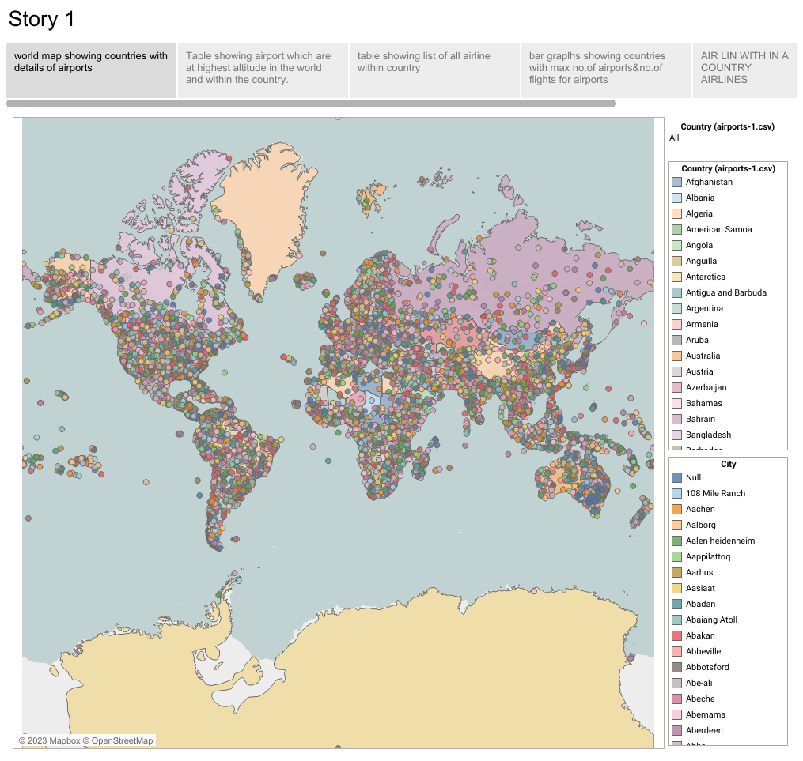

4 .ADVANTAGES&DISADVANTAGES

ADVANTAGES

* It is the fastest mode of transport.
* It is eco-friendly.
* It is the cheapest mode of travel.
* It is beneficial during emergencies.

DISADVANTAGES:

air transport can involve higher costs than other options, and is not suitable for all goods
flights are subject to delay or cancellation
you will need to pay taxes at each airport you use
fuel and currency surcharges will usually be added to freight costs
further transportation may be needed from the destination airport to the final destination

5.APPLICATIONS

The air transport mode is defined by four basic elements: airlines, commercial transport aircraft, the air space used for their flights, and the infrastructure required to supporting their operations, like airports and ATM (Air Traffic Management) facilities.
Aircraft performance has a decisive influence on the fuel consumption of a certain flight, but obviously, there are aspects in the flight depending on how they are operated by airlines and especially on the infrastructure management that may largely affect the overall flight energy efficiency.Airports, in particular, have a different energy balance and offer more chances to use alternative energy sources and achieve a zero carbon footprint, but the way in which they manage their traffic has a large effect in the fuel consumption by the operators. In the case of ATM, it is obvious it has decisive influence on optimizing the trajectory and flight regime of the operations in order to optimize the energy bill. Over these three elements, the regulatory system has an obvious relevance because a great number of operational regulations have direct effects on the energy use and the operational efficiency.
In this Chapter, a description of the four industries, i.e., airlines, aircraft manufacturers, airports, and air navigationservices providers, is given, aiming at understanding the different roles they play in the global objective of improving the air transport energy efficiency.

6.CONCLUSION

The air transport industry is not only a vital engine of global socio-economic
growth but is also of vital importance as a catalyst for economic development in most countries and for many regions within each country. Its importance arises not only from its ability to facilitate the movement of people but also its ability to expedite the movement of goods. Currently, rising operating costs, stoked by the high price of aviation fuel combined with slowing or even negative demand growth, will lead to dramatic restructuring of the airline industry and the collapse of many airlines especially smaller ones. Reduced access to air services for both passengers and freight may put many communities at a disadvantage.

The air transport industry needs not only to be financially sound to be effective as an economic catalyst for growth but also to be environmentally responsible. Governments need to be sensible, transparent and long-term in their approach. Priority must be given to tackling obstacles such as inefficient and fragmented ATMs, restrictive air service agreements, inadequate airport infrastructures and unjustified government charges and taxes. The development of more fuel efficient aircraft and engines must also be encouraged

7.FUTURE SCOPE

For a start, mobility actors should come together in a shared vision. This is where the World Bank-led Sustainable Mobility for All (SuM4All) steps in. For the first time ever, the SuM4All provides the transport sector and its modes of transport with the opportunity to speak with one voice and jointly unpack a Roadmap of Actions that is tailored to countries and cities to implement on a voluntary basis. The SuM4All includes all modes of transport, including aviation. Aviation facilitates access to countries and cities, increases multi layered efficiencies in travel and makes safety and security in travel top priorities. The aviation sector is rapidly taking gender equality at heart

In addition, innovation in technology and approaches (e.g. by redefining efficiencies in travel) are essential to redefining mobility. Cutting-edge technology, such as autonomous devices and ultralight materials, creates opportunities to transform the mobility system by enabling new business models and mobility services. Innovations abound in aviation, e.g. unmanned aircraft innovations; artificial intelligence; biometrics; robotics; block chain; alternative fuels and electric aircraft. Aviation is therefore ideally positioned to support the innovation discourse and its potential impacts on new mobility.

The World Economic Forum proposes that the deployment of these private sector and government innovations to address mobility challenges can contribute to an improved mobility landscape – if they are deployed in a coordinated and collaborative way that aims to optimize the entire transport system. Unfortunately to date, these efforts in many instances may be exacerbating transport issues, most notably by adding congestion and complexity while also creating inefficiencies between public and private modes of transport.

8.APPENDIX

Anti-hijacking or Air Transportation Security Act of 1974 (Public Law 93-366) August 5, 1974. This law provided the statutory basis for the December 5, 1972, rule and ''as part of its obligation under this Act, the FAA began a research and development program that emphasized the development of devices to protect air travelers against acts of criminal violence and aircraft piracy." (NRC. 1993.)
National Academies of Sciences, Engineering, and Medicine. 1996. Airline Passenger Security Screening: New Technologies and Implementation Issues.

International Security and Development Act of 1985 (Public Law 99-83). This act provides for Federal Air Marshals, expansion of FAA R&D, assessment of security at foreign airports, and approval of foreign air carrier security programs.
National Academies of Sciences, Engineering, and Medicine. 1996. Airline Passenger Security Screening: New Technologies and Implementation Issues.

