ADVANCED PYTHON PROGRAMMING

NAME : GOKULA J

REG NO : 22MID0127

ERRORS:

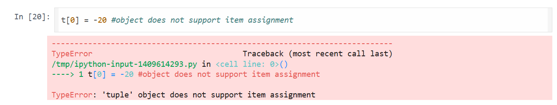

ERROR: Object not support item assignment

Solution : Tuple is Immutable