DAY 10

## EXERCISE :1

Create an EC2 instance with the following requirements.

Install and run the Docker engine on the EC2 instance.

Download a default docker image from the docker hub.

Create a docker container with the downloaded image.

Make sure the container should run a simple website.

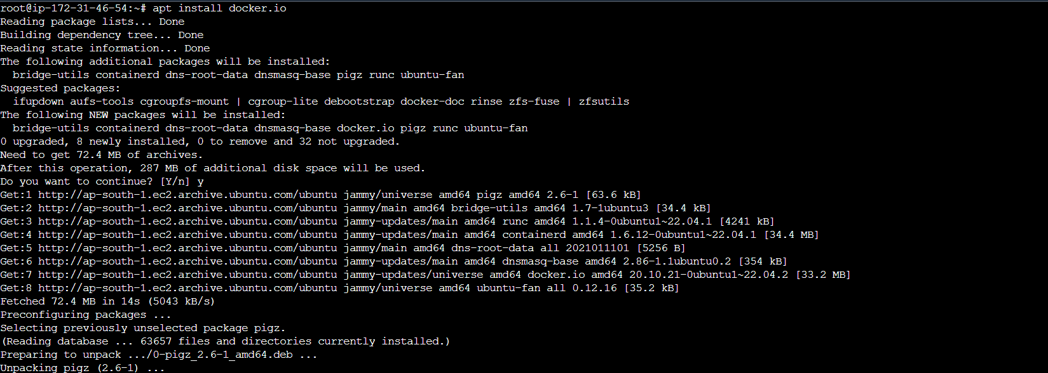

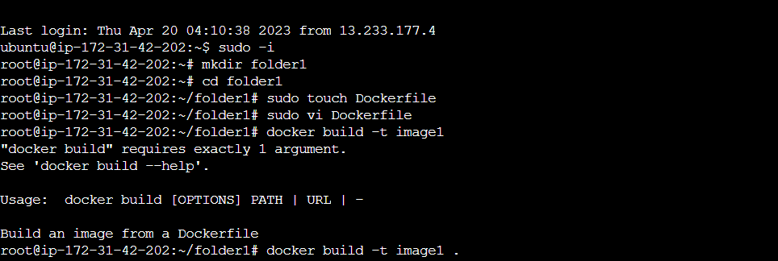

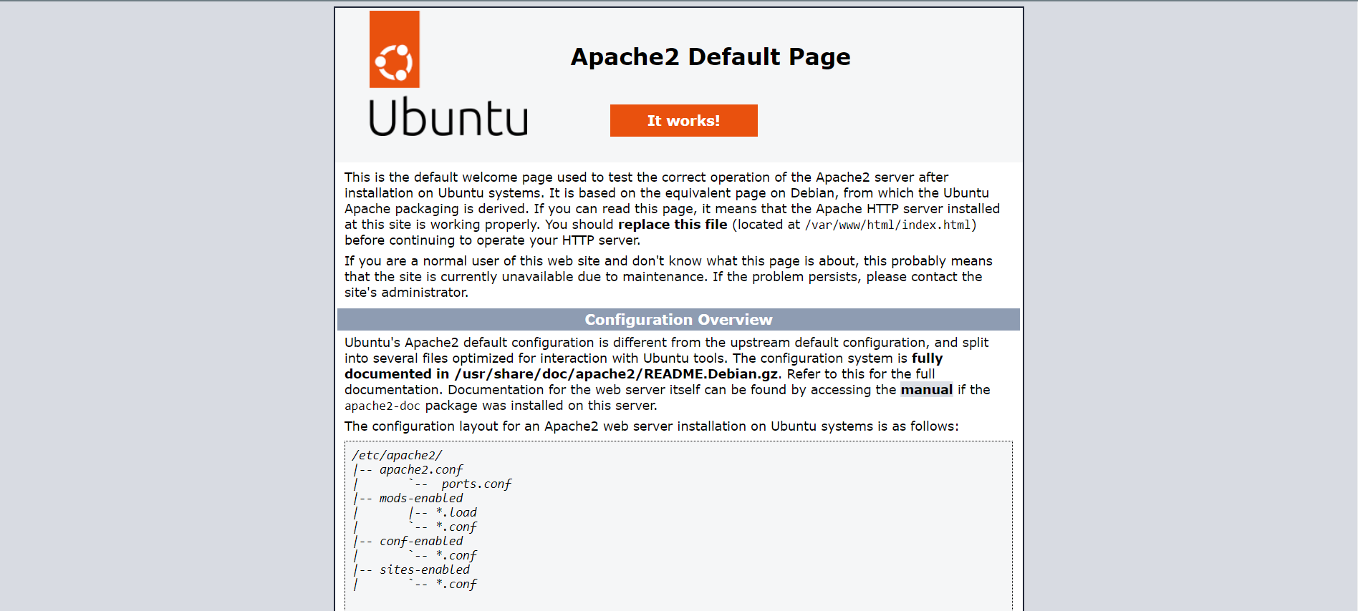

## Exercise:2

Store a Docker image in the AWS ECR with the following requirements

Write a dockerfile for creating a docker image from the source of ‘centos’.

Make a webservice for the new docker image by using the docker file.

Create a docker container from the created image and make it run in the host.

Push the created docker image in to a Public Repository of the Amazon ECR

