Day 2:

## EXERCISE:1

Create a Windows EC2 instance with t2.micro Instance and show the remote connection of that EC2 Instance.

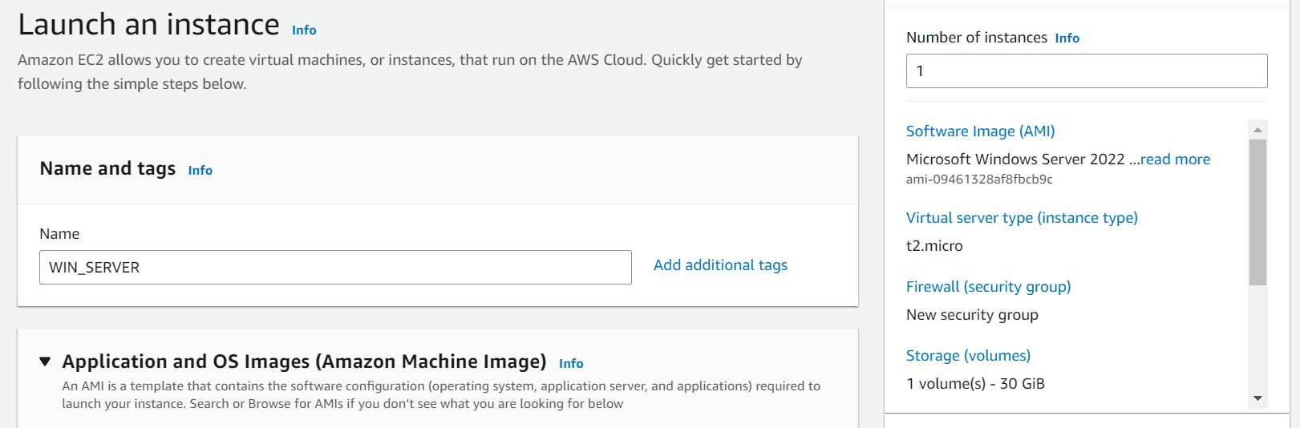

REMOTE DESKTOP CONNECTION:

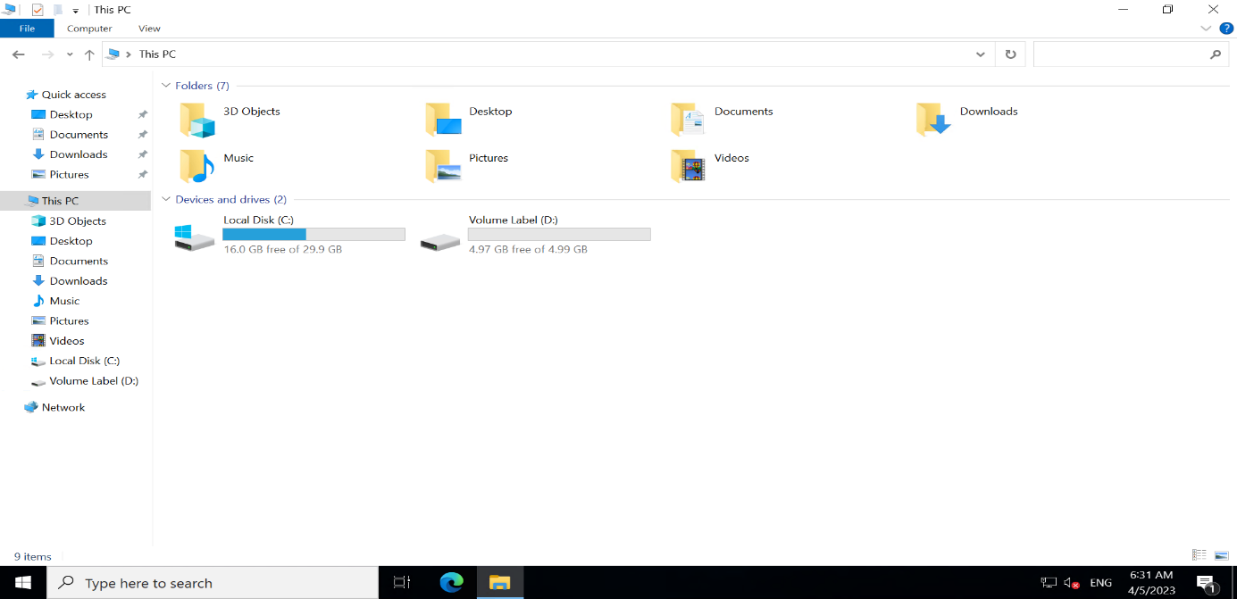

## EXERCISE:2

Create an EBS volume of 5 GB and attach to a windows EC2 instance and make partition of that EBS volume.

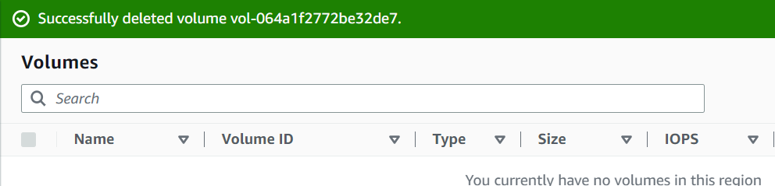



## EXERCISE:3

Create some files and folders into 5 GB EBS volume of the previous exercise and take a snapshot of that EBS volume.

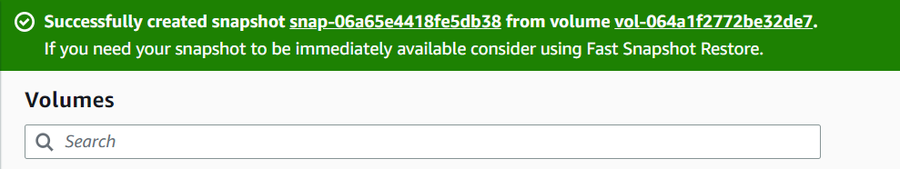



## EXERCISE:4

Create a Linux EC2 instance with t2.micro-Instance and show the remote connection of that EC2 Instance.

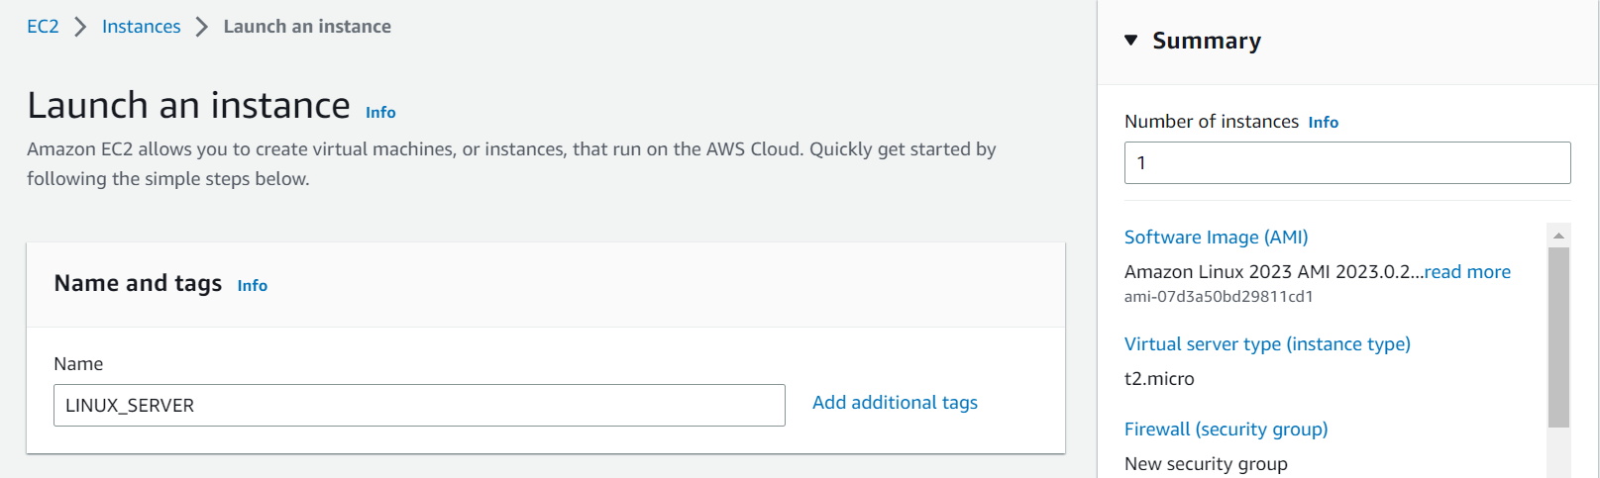

REMOTE CONNECTION:

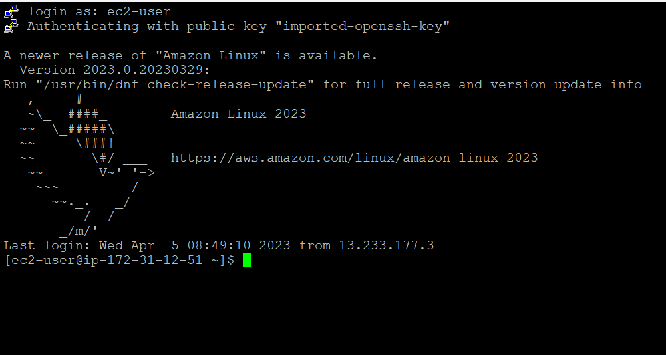

## EXERCISE:5

Install, Start and Enable the httpd webservice in that Linux EC2 Instance, then host a static website in EC2.

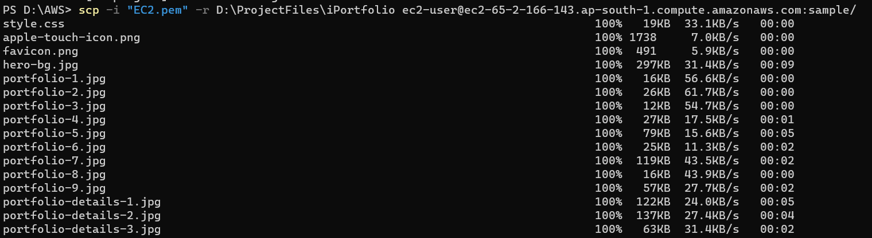

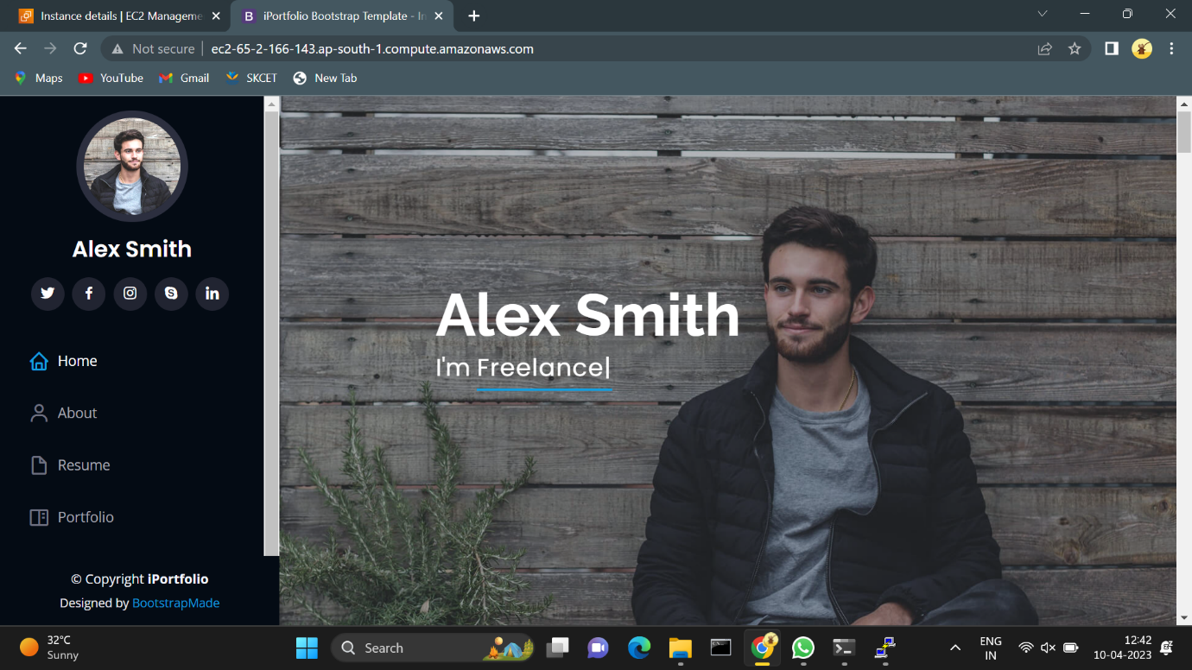

## EXERCISE:6

Create Image (MyAMI) of the Linux Webserver (from the previous exercise) and launch new EC2 instance from the created Image (MyAMI)

