Day 5

## EXERCISE 1

Create a launch template with a custom AMI and t2.micro instance type

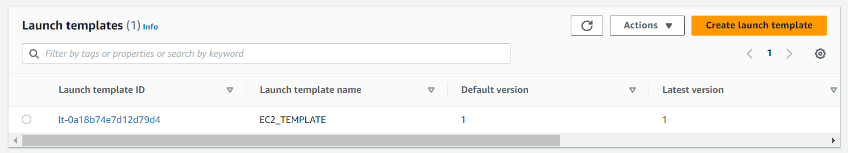

## EXERCISE 2

Create an autoscaling group with the above-created launch template

