DAY 6

## EXERCISE 1

Create a vpc with multiple subnets(at least 1 subnet in each zone)

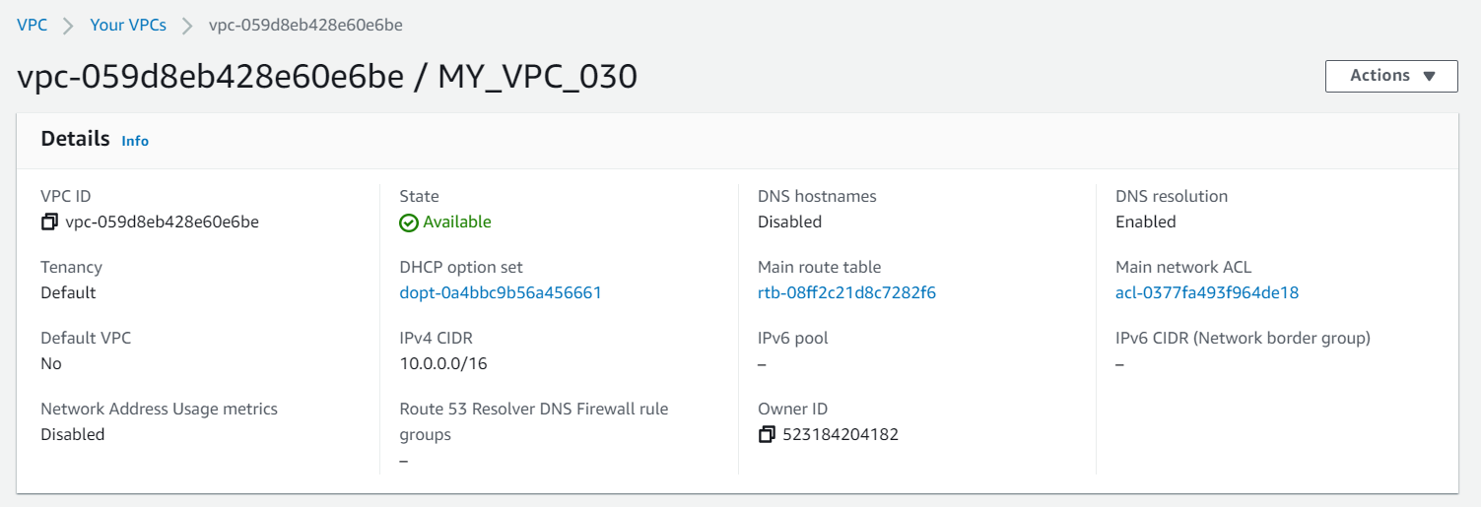

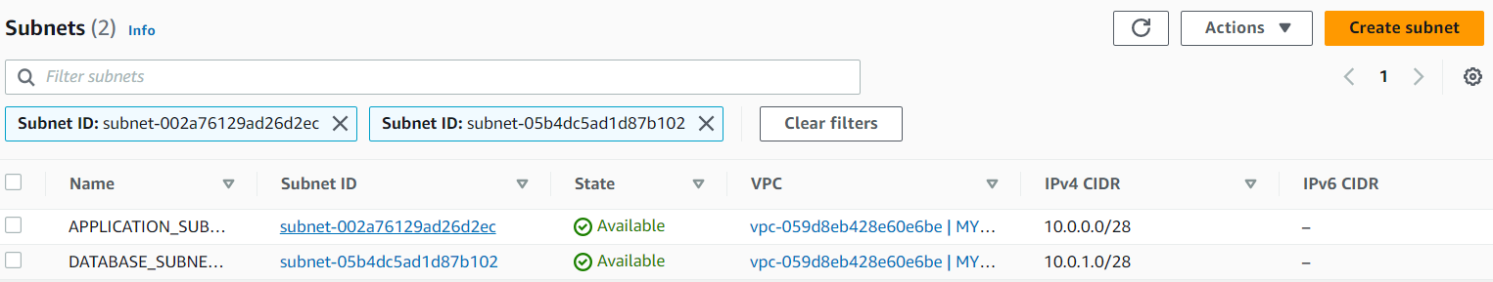

## EXERCISE:2

Make 1 public subnet and 2 private subnets in the created VPC

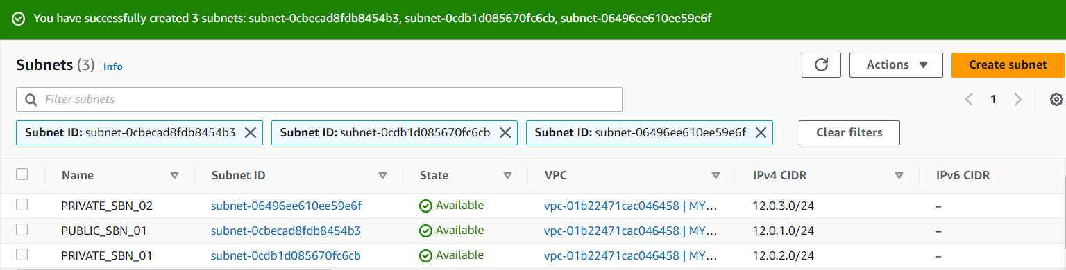

## EXERCISE:3

Make internet connection using NAT gateway for the 2 private subnets.

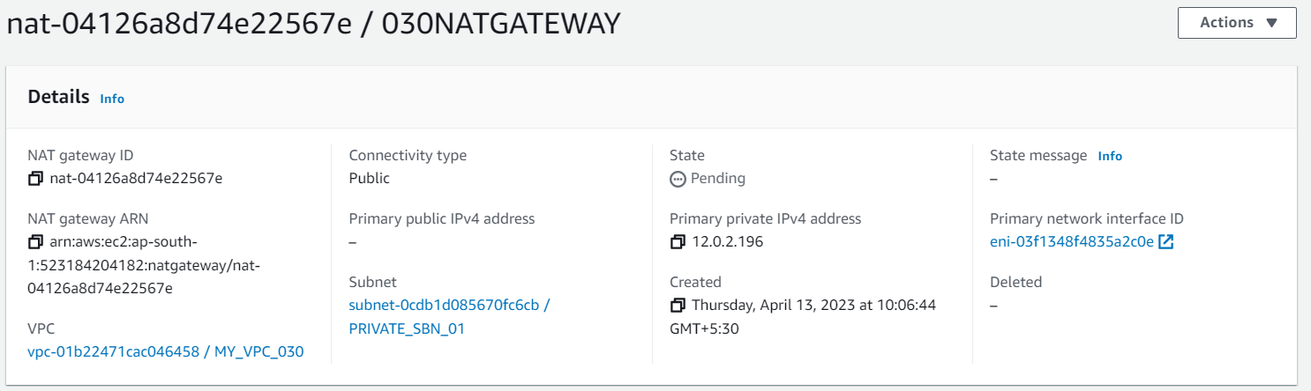

## EXERCISE:4

Create a VPC peering connection between 2 different VPCs from 2 different regions.

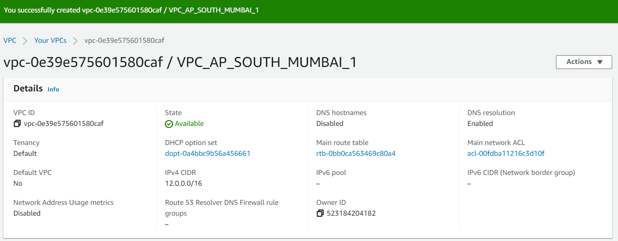

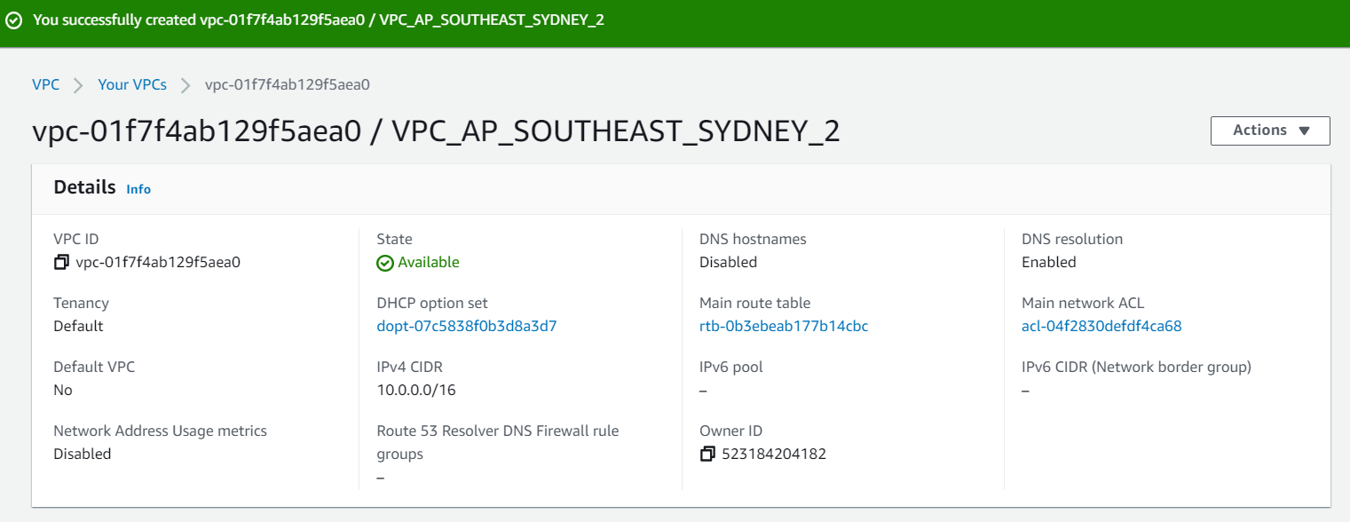

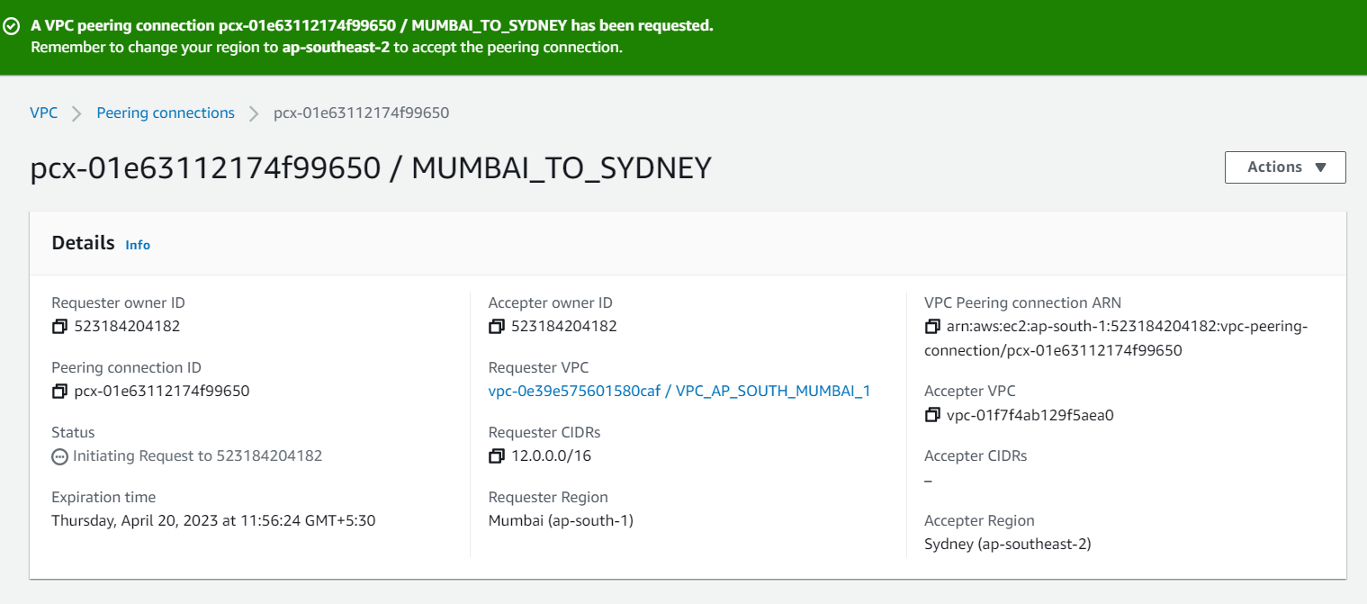

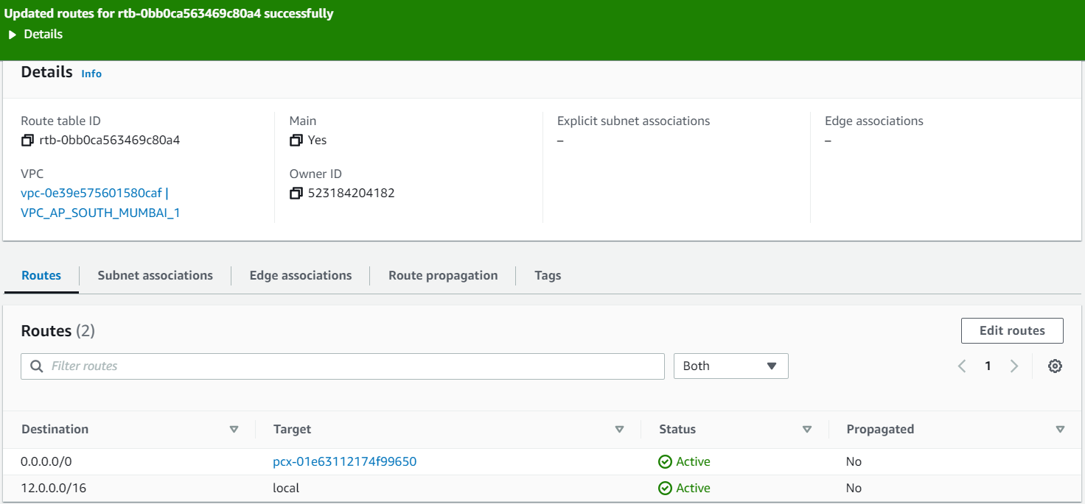

## EXERCISE:5

Create VPC peering connections for 3 different VPCs from the same region.

