CLOUD INFRASTRUCTURE
PLANNING & STRATEGY
A scalable, secure and cost-aware design for a hypothetical e-commerce platform

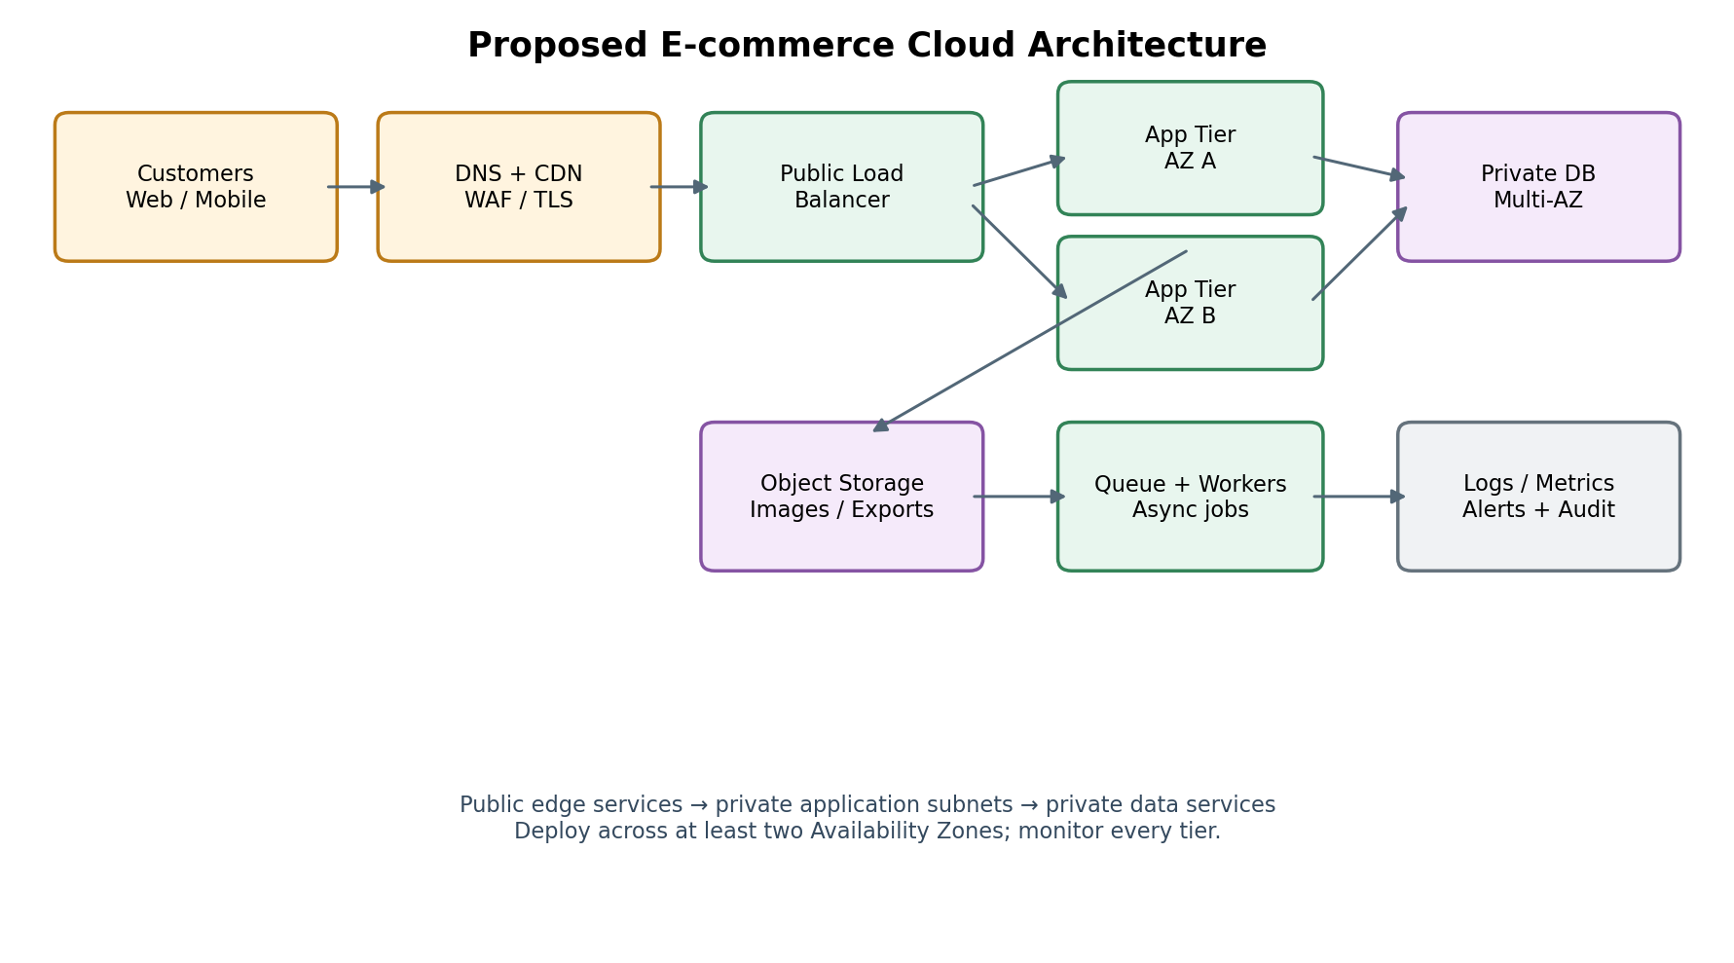

Program | Cloud Engineering Trainee
Task | Week 1 — Cloud Infrastructure Planning and Strategy Simulation
Prepared for | Internship task evaluation
Date | 19 October 2026

Planning assumption: this report describes a vendor-neutral design and maps examples to AWS services. It is a proposed architecture, not a deployed production environment.

1. Executive Summary and Scope
Purpose, assumptions, requirements, and success criteria

Executive summary
This report proposes a cloud architecture for a fictional online retailer that sells products through a public web and mobile experience. The platform must remain responsive during promotions, protect customer and payment-related information, recover from infrastructure failures, and keep operating costs aligned with demand. The design uses managed services, multiple Availability Zones, private application and data tiers, automated scaling, centralized observability, and tested backup procedures.
The recommended baseline is a small, multi-AZ deployment that can scale horizontally. Static assets are served through a content delivery network (CDN); a web application firewall (WAF) filters common attacks; a load balancer distributes requests to application instances or containers; and the application tier accesses a private relational database. Object storage holds product images, exports, and other durable objects. A queue decouples slow tasks such as order notifications and image processing from customer-facing requests.

Business and technical objectives
- Availability: tolerate the loss of one application Availability Zone without a full service outage.
- Performance: deliver cached content close to customers and scale compute capacity as traffic rises.
- Security: use least privilege, encryption, private networking, secure secrets, audit logging, and layered protection.
- Cost control: right-size resources, use autoscaling, set budgets and alerts, and review utilization.
- Recoverability: define measurable RTO/RPO targets and prove that backups can be restored.
- Maintainability: automate repeatable deployments and monitor service health using actionable alerts.

Planning assumptions
Area | Assumption used for this design
Workload | Retail catalogue, search, shopping cart, checkout, customer accounts, and order history.
Traffic | Normal traffic is moderate; promotional events can create short, sharp peaks.
Data | Relational transactions are important; images and downloadable files are object data.
Regions | One primary region with multi-AZ resilience; a second region is a recovery target.
Payments | Use a compliant payment service provider; do not store raw card data in the application database.
Budget | No fixed budget supplied; cost is optimized through managed services and measurement.

The design should be refined once traffic forecasts, data residency obligations, availability targets, and a monthly spending limit are confirmed.

2. Requirements Analysis and Proposed Architecture
Translate business needs into design decisions

Functional requirements
- Customers can browse products, search the catalogue, register/sign in, add items to a cart, and place orders.
- The platform records orders and payment-provider references consistently.
- Staff can update product information and view order status through an authenticated administrative interface.
- Background work—emails, stock synchronization, reports, and image transformations—runs asynchronously.

Non-functional requirements
Requirement | Proposed target / design response
Availability | Multi-AZ deployment; target 99.9% monthly availability as an initial planning objective, subject to business approval.
Latency | Aim for common cached page assets to load quickly; measure p95 API latency and set service-specific SLOs.
Scalability | Scale stateless application capacity horizontally; queue and worker capacity scale independently.
Security | TLS in transit, encryption at rest, least-privilege IAM, private subnets, WAF, and audit trails.
Durability | Managed database backups and versioned object storage; verify restoration through scheduled tests.
Operations | Central logs, metrics, traces where supported, dashboards, alarms, runbooks, and change control.

High-level request flow
A customer resolves the store domain through managed DNS. The CDN caches static content and forwards dynamic requests to the public entry point. WAF rules inspect traffic. The load balancer routes requests to healthy application targets in private subnets across two or more Availability Zones. The application reads and writes to a private managed database and object storage. Queue-backed workers handle tasks that should not delay checkout. Logs and metrics from all tiers feed a central monitoring service.
Important boundary: the diagram is conceptual. Exact subnet sizes, service SKUs, throughput settings, and redundancy options should be validated against the selected cloud provider and region.

3. Cloud Service Selection and Justification
Illustrative AWS mapping; equivalent managed services may be substituted
Layer | Recommended service pattern | Reason for selection
DNS and edge | Amazon Route 53 + Amazon CloudFront | Managed DNS, caching, lower origin load, and edge delivery.
Web protection | AWS WAF; managed TLS certificates | Filters common web exploits and encrypts browser-to-edge traffic.
Ingress | Application Load Balancer | Health checks and Layer 7 routing to healthy targets.
Application compute | Amazon ECS on AWS Fargate, or EC2 Auto Scaling | Managed container option reduces server administration; EC2 may suit specialized control/cost needs.
Database | Amazon RDS for PostgreSQL/MySQL, Multi-AZ | Managed backups, patching options, monitoring, and high-availability deployment.
Object storage | Amazon S3 with versioning and lifecycle rules | Durable storage for product images, exports, and backups.
Async processing | Amazon SQS + worker service | Buffers bursts and isolates background tasks from customer requests.
Secrets and keys | AWS Secrets Manager + AWS KMS | Central secret rotation and managed encryption keys.
Monitoring | Amazon CloudWatch + AWS CloudTrail | Metrics, logs, alarms, and account/API audit history.
Network | Amazon VPC, public/private subnets, NAT as needed | Segmentation and controlled outbound access.

Why managed services?
Managed services can reduce routine operational work and provide integrated health, backup, and scaling features. They do not remove the need for configuration, patch planning, access review, quota management, or testing. A service should be selected only after checking regional availability, limits, pricing dimensions, and the team's operational skills.

Selection trade-offs
- Fargate reduces host management; EC2 can offer more control and may be economical for steady, predictable utilization.
- A relational database is appropriate for order and payment-reference consistency; a cache can be added only when measurements justify it.
- Multi-AZ database availability improves resilience but costs more than a single-AZ development setup.
- A second region improves disaster recovery but adds replication, data-transfer, testing, and operational complexity.

4. Network Design and Security Controls
Layered controls and a restricted trust boundary

Network segmentation
- Create a dedicated VPC with public subnets for the internet-facing load balancer and private subnets for application targets in at least two Availability Zones.
- Place the database in isolated private subnets with no public IP address and no direct internet route.
- Permit inbound HTTPS to the public entry point; allow application traffic only from the load balancer security group.
- Allow database connections only from the application security group on the required database port.
- Use NAT gateways or controlled egress alternatives only where private workloads require outbound internet access; monitor their data-processing cost.
- Use VPC endpoints for supported AWS services when they improve security, reliability, or data-transfer economics.

Identity and access management
Apply least privilege: each workload receives a separate IAM role with only the actions and resources it needs. Avoid long-lived access keys in source code. Use multifactor authentication for privileged human access, federated identity where available, and separate development, test, and production accounts or environments.

Data protection
- Enforce HTTPS/TLS for user and service connections; validate certificates and modern protocol settings.
- Encrypt database storage, snapshots, object storage, logs, and backups at rest using managed encryption keys.
- Store credentials and API tokens in a secrets manager, rotate them where feasible, and prevent them from appearing in logs.
- Use S3 Block Public Access, narrowly scoped bucket policies, versioning, and lifecycle controls.
- Minimize sensitive data collection and retention. Keep raw payment card data with a suitable payment provider rather than storing it in the retailer's database.
- Enable audit logs and protect log destinations against unauthorized modification or deletion.

Application-layer safeguards
Validate inputs on the server, use parameterized database queries, apply secure session and cookie settings, implement rate limits, and protect administrative routes with strong authentication. Use dependency and container-image scanning in the delivery pipeline. WAF is a useful layer, not a replacement for secure application code or patching.

5. Load Balancing, Auto-Scaling, and Performance
Prepare for ordinary demand and promotional spikes

Load balancing
The application load balancer distributes HTTP/HTTPS requests across healthy targets in multiple Availability Zones. Health checks should test meaningful application readiness without being so deep that a temporary dependency issue removes every target. Configure graceful deregistration so active requests can finish during deployments and scale-in events.

Scaling policy
Signal | Possible response | Guardrail
CPU / memory utilization | Scale out application tasks or instances | Use sustained thresholds and cooldown behavior to avoid oscillation.
Request count per target | Add capacity when request pressure rises | Tune using load tests and p95 latency, not a single metric alone.
Queue depth / message age | Scale background workers | Set maximum concurrency to protect databases and third-party APIs.
Scheduled promotion | Pre-scale before expected traffic | Confirm capacity quotas and run a rehearsal.
Database connections / latency | Tune connection pools; consider read replicas or caching if suitable | Do not scale app workers without protecting database connection limits.

Performance practices
- Cache versioned static assets at the CDN and set appropriate cache-control headers.
- Compress text responses and optimize image size and format; avoid sending oversized product images to mobile devices.
- Use pagination and bounded queries; add indexes based on query plans and measured workload.
- Move non-critical tasks to queues and make consumers idempotent so retries do not create duplicate orders or notifications.
- Use connection pooling and explicit request timeouts; implement bounded retries with exponential backoff and jitter.
- Run load tests that model normal traffic, sudden bursts, long-duration load, and partial dependency failure.

Deployment strategy
Use rolling or blue/green deployments with health gates and a documented rollback path. Database schema changes should be backward-compatible where possible: deploy additive changes first, migrate data, then remove obsolete fields in a later release. Keep production configuration separate from application code.

6. Data Strategy and Cost Estimation
Choose storage by access pattern and estimate using measured quantities

Data and storage design
Data type | Storage approach | Operational notes
Orders, customers, inventory | Managed relational database | Use transactions, constraints, backups, and carefully managed schema changes.
Product images and exports | Object storage | Use versioning, lifecycle transitions, and CDN caching where appropriate.
Session/cart state | Managed cache or database-backed sessions | Select based on consistency, expiry, scale, and recovery requirements.
Background work | Durable queue | Use dead-letter queues, retry limits, and idempotent consumers.
Logs and audit events | Central log service / archive bucket | Define retention and access policy; avoid logging secrets or payment data.

Cost estimation method
A defensible estimate should be calculated from the actual region, configuration, and workload assumptions rather than a single unsupported monthly figure. Use the cloud provider's pricing calculator and record the date and inputs. The following cost model provides a repeatable framework.
Cost component | Quantity / driver to estimate | Cost-control action
Compute | Average and peak task/instance count × hours | Autoscale, right-size, review utilization, schedule non-production shutdowns.
Load balancing | Hours plus processed bytes / capacity units | Keep target count appropriate; measure traffic and avoid unnecessary duplicate load balancers.
Database | Instance class, storage, I/O, backup retention, Multi-AZ | Right-size after tests; tune queries; set retention intentionally.
Object storage | GB-month, requests, retrieval and transfer | Lifecycle old data; compress assets; choose access tiers based on real access patterns.
CDN and data transfer | Outbound GB, request count, origin fetches | Cache more static content and reduce payload sizes.
Networking | NAT gateway hours and processed data, endpoints | Review egress paths and endpoint economics.
Observability | Log ingestion, retention, metrics, traces | Set retention, filter noisy logs, and alert on anomalous ingestion.
Disaster recovery | Replicated data, standby capacity, test activity | Choose warm standby or backup-and-restore based on approved RTO/RPO.

Budget governance
- Set a monthly budget, forecast, and alerts at meaningful thresholds (for example, 50%, 80%, and 100%).
- Tag resources by environment, owner, application, and cost centre; review untagged resources.
- Separate one-time migration or testing costs from recurring operating costs.
- Review cost per order and cost per active customer alongside total spend.
- Do not trade away backups, security, or required availability solely to meet a short-term cost target.

7. Availability, Backup, and Disaster Recovery
Define recovery objectives and rehearse the plan

Resilience approach
Multi-AZ deployment protects against some single-zone failures; it does not protect against every regional outage, accidental deletion, compromised credentials, or application-level data corruption. Recovery planning therefore combines redundancy, backups, access controls, monitoring, and practiced procedures.
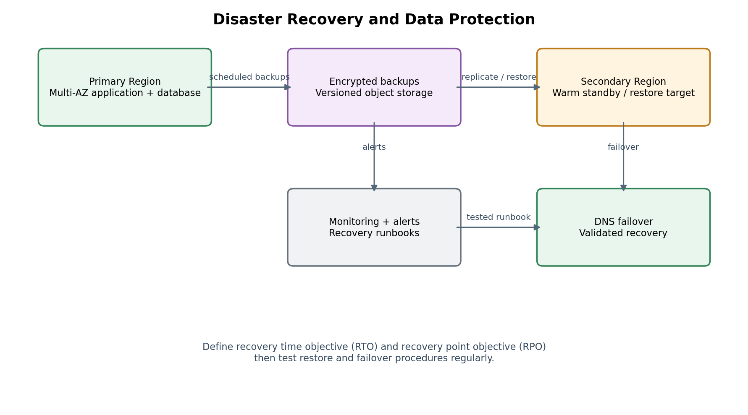

Recovery objectives
Term | Definition | Initial planning proposal
RTO | Recovery Time Objective: maximum acceptable time to restore service. | 4 hours for a major regional disruption, subject to business approval.
RPO | Recovery Point Objective: maximum acceptable data loss measured in time. | 15 minutes for critical order data if the selected replication/backup design supports it.
Backup retention | How long recoverable copies are retained. | Example: daily backups for 35 days plus longer retention where policy requires.
Recovery pattern | How the secondary environment is prepared. | Backup-and-restore or warm standby; choose after comparing cost and RTO.

Backup and restore controls
- Enable automated database backups and point-in-time recovery where supported.
- Version object data and protect backup accounts/buckets from ordinary production deletion privileges.
- Use cross-region copies for critical recovery assets where required by the agreed strategy.
- Run scheduled restore tests and record restore duration, data consistency, and missing dependencies.
- Keep runbooks for region recovery, database restoration, DNS changes, credential rotation, and stakeholder communications.
- Test failback carefully; do not direct traffic back to the primary region until data consistency and service health are verified.
Recovery objective values above are proposed examples, not guaranteed service capabilities. Confirm that backup frequency, replication lag, regional service availability, and restore throughput can actually meet them.

8. Risk Assessment and Mitigation Plan
Identify failure modes before they become incidents
Risk | Likelihood / impact | Mitigation and evidence
Traffic spike exhausts compute | Medium / High | Autoscaling, CDN caching, load tests, quota checks, pre-scaling for campaigns.
Database overload or connection exhaustion | Medium / High | Connection pools, query/index review, bounded concurrency, alarms, tested recovery.
Credential leak or excessive permissions | Medium / Critical | Least privilege, MFA, secret manager, rotation, audit monitoring, incident playbook.
Web exploit or bot abuse | Medium / High | WAF, rate limiting, secure coding, dependency scanning, patching, threat monitoring.
Accidental data deletion / corruption | Low–Medium / Critical | Versioning, protected backups, restricted deletion, point-in-time recovery, restore tests.
Regional outage | Low / High | Documented DR pattern, cross-region recovery assets, tested DNS/failover runbook.
Unexpected cloud bill | Medium / Medium–High | Budgets, anomaly alerts, resource tags, log-retention controls, periodic cost review.
Deployment introduces defect | Medium / High | CI tests, staged rollout, health gates, rollback plan, backward-compatible schema changes.
Third-party payment/email outage | Medium / Medium–High | Timeouts, queues, retries with limits, circuit breakers, reconciliation and status messaging.
Insufficient monitoring or alert fatigue | Medium / High | Service-level indicators, actionable thresholds, ownership, alert review and incident drills.

Incident response sequence
- Detect and classify the incident; identify customer impact and the service owner.
- Stabilize the system: limit harmful traffic, roll back a defective release, or isolate compromised credentials.
- Communicate status through the approved channel without exposing sensitive information.
- Recover service using the relevant runbook and verify transaction integrity.
- Preserve logs and audit evidence; involve security/legal contacts when required.
- Complete a blameless post-incident review with root causes, measurable actions, owners, and due dates.

Risk ownership
Every high-impact risk should have a named owner, a review date, and a measurable mitigation. The engineering lead owns architecture and recovery readiness; the security owner reviews identity and data controls; the application owner validates functional correctness; and the finance or project owner monitors cost. For a real deployment, these roles should be assigned explicitly.

9. Implementation Roadmap, Validation, and Conclusion
A practical sequence for turning the design into a tested environment

Phased implementation plan
Phase | Activities | Exit criteria
1. Discover | Confirm traffic profile, availability needs, data classification, compliance, budget, region, and RTO/RPO. | Approved requirements and assumptions register.
2. Foundation | Create accounts/environments, VPC, subnets, IAM roles, logging, encryption, and network controls as code. | Security baseline reviewed; no unintended public data services.
3. Application platform | Deploy edge, load balancer, application service, database, object storage, and queue. | Smoke tests pass; private data access and health checks verified.
4. Reliability | Configure autoscaling, backups, alarms, dashboards, and runbooks. | Load test passes agreed thresholds; restore test recorded.
5. Security validation | Scan dependencies/images, review permissions, test WAF/rate limits, and check secret handling. | No unresolved critical findings; exceptions documented and approved.
6. Cost and launch review | Validate pricing calculator assumptions, budgets, tags, quotas, rollback, and operational ownership. | Go-live checklist signed off; support and escalation paths known.

Acceptance checklist
- Architecture diagram and service choices are documented with rationale.
- Public exposure is limited to intended edge/ingress components; database is private.
- TLS, encryption at rest, least privilege, secrets management, and audit logs are enabled.
- Load balancer health checks, autoscaling, graceful deployment, and rollback have been tested.
- Backups are configured, a restore has been completed, and RTO/RPO assumptions are validated.
- Cost estimate records region, usage quantities, pricing date, exclusions, and monthly budget alerts.
- Risks have owners and mitigations; operational runbooks and monitoring are reviewed.

Conclusion
The proposed architecture balances scalability, resilience, security, and cost control by separating the web edge, application compute, data storage, and asynchronous processing layers. Multi-AZ application capacity and managed database availability reduce the impact of individual component failures; CDN caching and independent worker scaling support traffic bursts; and layered identity, network, encryption, and audit controls reduce exposure. Backups alone are not enough: recovery objectives must be approved and restoration must be tested.
The next step is to replace planning assumptions with the retailer's real workload profile, compliance obligations, and budget, then build a small proof of concept using infrastructure as code. Load tests, security reviews, cost estimates, and disaster-recovery exercises should provide evidence before production launch.

References and further reading
- AWS Well-Architected Framework: https://docs.aws.amazon.com/wellarchitected/latest/framework/welcome.html
- AWS Architecture Center: https://aws.amazon.com/architecture/
- Amazon VPC User Guide: https://docs.aws.amazon.com/vpc/latest/userguide/what-is-amazon-vpc.html
- Elastic Load Balancing documentation: https://docs.aws.amazon.com/elasticloadbalancing/
- Amazon RDS documentation: https://docs.aws.amazon.com/AmazonRDS/latest/UserGuide/Welcome.html
- AWS Pricing Calculator: https://calculator.aws/
- AWS Backup documentation: https://docs.aws.amazon.com/aws-backup/latest/devguide/whatisbackup.html
Note: Service names and documentation links are provided for study and planning. Confirm current features, regional availability, pricing, and service quotas before implementation.

