

High Level Design & Low Level Design

**Index**

1. Introduction ------------------------------------------------ 3

1.1 Intended audience ------------------------------------------------ 3

1.2 Project purpose ------------------------------------------------ 3

1.3 Key project objective ------------------------------------------------ 4

1.4 Project scope ------------------------------------------------ 4

2. Design overview ------------------------------------------------ 4

*Zone Representative Application —--------------------------------------------- 5

*Central Representative Application —---------------------------------------------- 5

*Population Census Reports –----------------------------------------------- 6

* Population Census Queries —---------------------------------------------- 6

2.1 Design Objectives —---------------------------------------------- 7

2.2 Design Alternatives —---------------------------------------------- 7

2.3 User Interface Paradigms —---------------------------------------------- 8

2.4 Validations —----------------------------------------------- 8

-

3. System architecture ------------------------------------------------ 9

3.1 Database architecture ------------------------------------------------10

4. Detailed system design ------------------------------------------------11

4.1 Flowchart of application ------------------------------------------------12

4.2 Sequence Diagram ------------------------------------------------13

4.3 ER Diagram ------------------------------------------------14

4.4 Use-Case Diagram ------------------------------------------------15

4.5 Flowchart for Zone Registration ------------------------------------------------16

4.6 Flowchart for Central Command ----------------------------------------------17

4.7 Flowchart for Gender Report function —------------------------------------------18

4.8 Flowchart for Maintain Database Function —-----------------------------------------19

5. Tools Report ------------------------------------------------20

5.1 Strace -----------------------------------------------20

5.2 Valgrind -----------------------------------------------21

5.3 CppCheck -----------------------------------------------22

5.4 Gcov -----------------------------------------------23

5.5 Gprof —--------------------------------------------24

6. Testing -----------------------------------------------24

6.1 Unit Testing -----------------------------------------------25

6.2 Integration Testing --------------------------------------------25

6.2.1 Add Citizen --------------------------------------------25

6.2.2 modify Citizen --------------------------------------------26

6.2.3 View Citizen -------------------------------------------27

6.2.4 Queries –-------------------------------------------27

6.2.5 Gender Wise Report —---------------------------------------28

6.2.6 Change Admin ID —----------------------------------------30

6.2.7 Validations -------------------------------------------30

7. Requirements Traceability Matrix(RTM) ------------------------------------------------31

**1. Introduction**

The introduction of the software requirement specification provides an overview of the entire software. The entire SRS with overview description purpose, scope, tools used and basic description. The aim of this document is to gather, analyse and give an in-depth .so in Dynaland is a country with population of around 20 crore.Earlier they used to have a population census every 4 years which has completely manual.The reports were taking a lot of time to be compiled and generated.Also that the govt.since they have the census coming up after 6 months they have decided to automate the system.

**1.1 Intended Audience: -**

The intended audience for this application can be any country that wants to hold a population census for their citizens by replacing the manual traditional method to a fully automated method. Which will not only help to reduce the manual labour but also be more fast and efficient in giving timely much more accurate reports based on the data.

**1.2 Project Purpose: -**

The purpose of this document is to show the requirements for the Dynaland Automated Population Census Application , which helps in the census of population Automated because of more population in Dynaland country they decided to census the population for every 4 years which was completely manual. The reports were taking a lot of time to generate so decided to things become easier to census population fastly so decided to census coming up after 6 months to automate the system.which will help them in Getting timely and correct reports. save time and money for the process of planning for the welfare of people through the correct data.

**1.3 Key Project Objectives: -**

1. Allow the Zone Representative to add Citizen’s Information
2. Creating population Census Application
3. Allows the Central Representative of the country to update the changes in Citizen’s information
4. Displays all the reports and queries required.
5. Modify/Update the Citizen Data.
6. Necessary Calculations for generating the reports.

**1.4 Project scope : -**

This project aims to create the Reports of Dynaland Automated Population Census Application. In which the Government should prepare reports about the census population Automatically . This saves time and money in the census population. so introduced an Automated concept to easily census the population.

**2. Design Overview: -**

* **Zone Representative comprises the following modules in Population Census Application :**

| Name of the Module | Add Module |
| --- | --- |
| Handled by |  |
| Description | The Zone Representative adds the record in the database |

* **Central Representative comprises of the following modules in Population Census Application :**

| Name of the Module | Change Admin ID and password module |
| --- | --- |
| Handled by |  |
| Description | Changing the Admin details and password for admin |

| Name of the Module | Maintaining Citizen database module |
| --- | --- |
| Handled by |  |
| Description | This module contains various options like view and edit the changes in citizen database |

| Name of the Module | Reports Module |
| --- | --- |
| Handled by |  |
| Description | Contains reports like % of age group , % of male and female population , farming population, Below Poverty Line population. |

| Name of the Module | Queries Module |
| --- | --- |
| Handled by |  |
| Description | Consists of queries like Literacy Rate, highest Literacy rate , % of rural and urban population and highest male and female population zone. |

* **Population Census comprises of the following modules in reports:**

| Name of the Module | Age Group Module |
| --- | --- |
| Handled by |  |
| Description | It will show the percentage of citizen from different age group like <18, 18-40 , >40 for each zone and entire country |

| Name of the Module | Gender Group Module |
| --- | --- |
| Handled by |  |
| Description | It will show the percentage of population of male ,female and transgender from each zone and whole country |

| Name of the Module | Farming Population Module |
| --- | --- |
| Handled by |  |
| Description | It will show the percentage of citizen having occupation as farming from different zone and entire country |

## 

| Name of the Module | Below Poverty Line Group Module |
| --- | --- |
| Handled by |  |
| Description | Citizens having income less than 100000 are categorized as below poverty line hence the percentage of BPL over different zones and the whole country is calculated. |

* **Population Census comprises of the following modules in Queries:**

| Name of the Module | Literacy Rate Module |
| --- | --- |
| Handled by |  |
| Description | By using this query the representative of the central government will be able to view the percentage of the literate population of the country. |

| Name of the Module | Zone with highest Literacy Rate Module |
| --- | --- |
| Handled by |  |
| Description | By using this query the representative of the central government will be able to know which zone has the highest number of literacy rate. |

| Name of the Module | BPL Average income Module |
| --- | --- |
| Handled by |  |
| Description | By using this query the representative of the central government will be able to know the average annual income of the below poverty level people. |

| Name of the Module | Rural and urban Population module |
| --- | --- |
| Handled by |  |
| Description | By using this query the representative of the central government will be able to know the percentage of people living in the urban and rural areas. |

| Name of the Module | Zone with highest male and female population Module |
| --- | --- |
| Handled by |  |
| Description | By using this query the representative of the central government will be able to know which are the zones having the highest number of males and females. |

## 

## 2.1 Design Objectives:

1. Creating an easy to use Population Census Application.
2. Categorize citizens based on their zone location.
3. Merging all zone data into a central database.
4. Central admin monitoring and updating over citizen data.
5. Generate accurate reports based on citizen data available.
6. Responsive to Queries.
   1. **Design Alternative: -**

We have used classes for different functionalities and also we have used STL libraries for storing and manipulating data effectively , linked list structure is used to store data i.e.. SSID, Name, Address, Age, Gender, Annual income, Occupation, Qualification, House type , No of dependents and area type like rural or urban.

### 

### 2.3 User Interface Paradigms: -

The Population Census Application provides an option to Central and zone representatives to manage and add citizens data respectively and generate various reports and queries from the database .

### Validation: -

* SSIS should not be blank and Duplication is not allowed and characters aren't allowed in the SSID.
* In case of integer validation, if the entered SSID is not Integer it displays the message SSID must contain Integer only and should not contain more than 9 digits.
* We check for the validity of the name,Citizen name should not be empty and only alphabets.
* In case of Address validation we check that it should not be blank.
* Age should only contain integers and characters are not allowed,Also should be in a particular range between 1-120.
* Gender should also consist of character alphabets only and particularly gender should be entered as “m” for male , “f” for female and “t”for transgender only.
* Annual income shall be integers only and the minimum limit for annual income is set as 1000 .
* Occupation shall be entered as alphabets strictly .
* For checking the validity for qualification, the qualification of the citizen should contain characters and if there is no qualification for citizen then “NA” will be accepted , it cannot be blank.
* We check the validity for house type as it should accept only single characters such as “o” for own and “r” for rented strictly no other characters or integers are allowed.
* No dependents for citizens shall not be greater than 20 dependents hence only integer values less than 20 and no character values are allowed.
* We check the validity for area type as it should accept only single characters such as “r” for rural areas and “u” for urban areas.

**3. SYSTEM ARCHITECTURE: -**

**3.1. Database Architecture**

The architecture used in this system comprises of the database architecture. It is a representation of the database management system design, wherein you can design, develop, implement and maintain the database. This architecture allows dividing the database into different components that can be independently modified, changed, replaced and altered as required for the system.

The database architecture is divided into three tiers namely:-

* 1 - Tier Architecture
* 2 - Tier Architecture
* 3 - Tier Architecture

Our system is based on the Tier 1 model of the database architecture. In this type of model the database is directly available to the user, the user can directly access the database and all of its contents. Which enables the user to directly interact and execute operations.

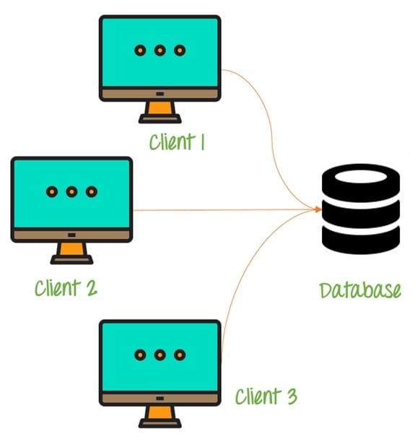

Some of the characteristics of Database Architecture are:

Self-Describing Nature of a Database System :

* One of the most fundamental characteristics of the database approach is that the database system contains not only the database itself but also an entire definition or description of the database structure and constraints also known as metadata of the database.

Isolation between Data, Programs and Data Abstraction:

* In a traditional file processing system, the structure of database knowledge files is embedded within the application programs, so any changes to the structure of a file may require changing all programs that access that file.

Support for Multiple Views of the Data :

* A database sometimes has many users, each of whom may require a special perspective or view of the database.

Sharing of knowledge and Multi-user Transaction Processing :

* A multi-user DBMS, as its name implies, must allow multiple users to access the database at an equivalent time or concurrently.

**4. DETAILED SYSTEM DESIGN:**

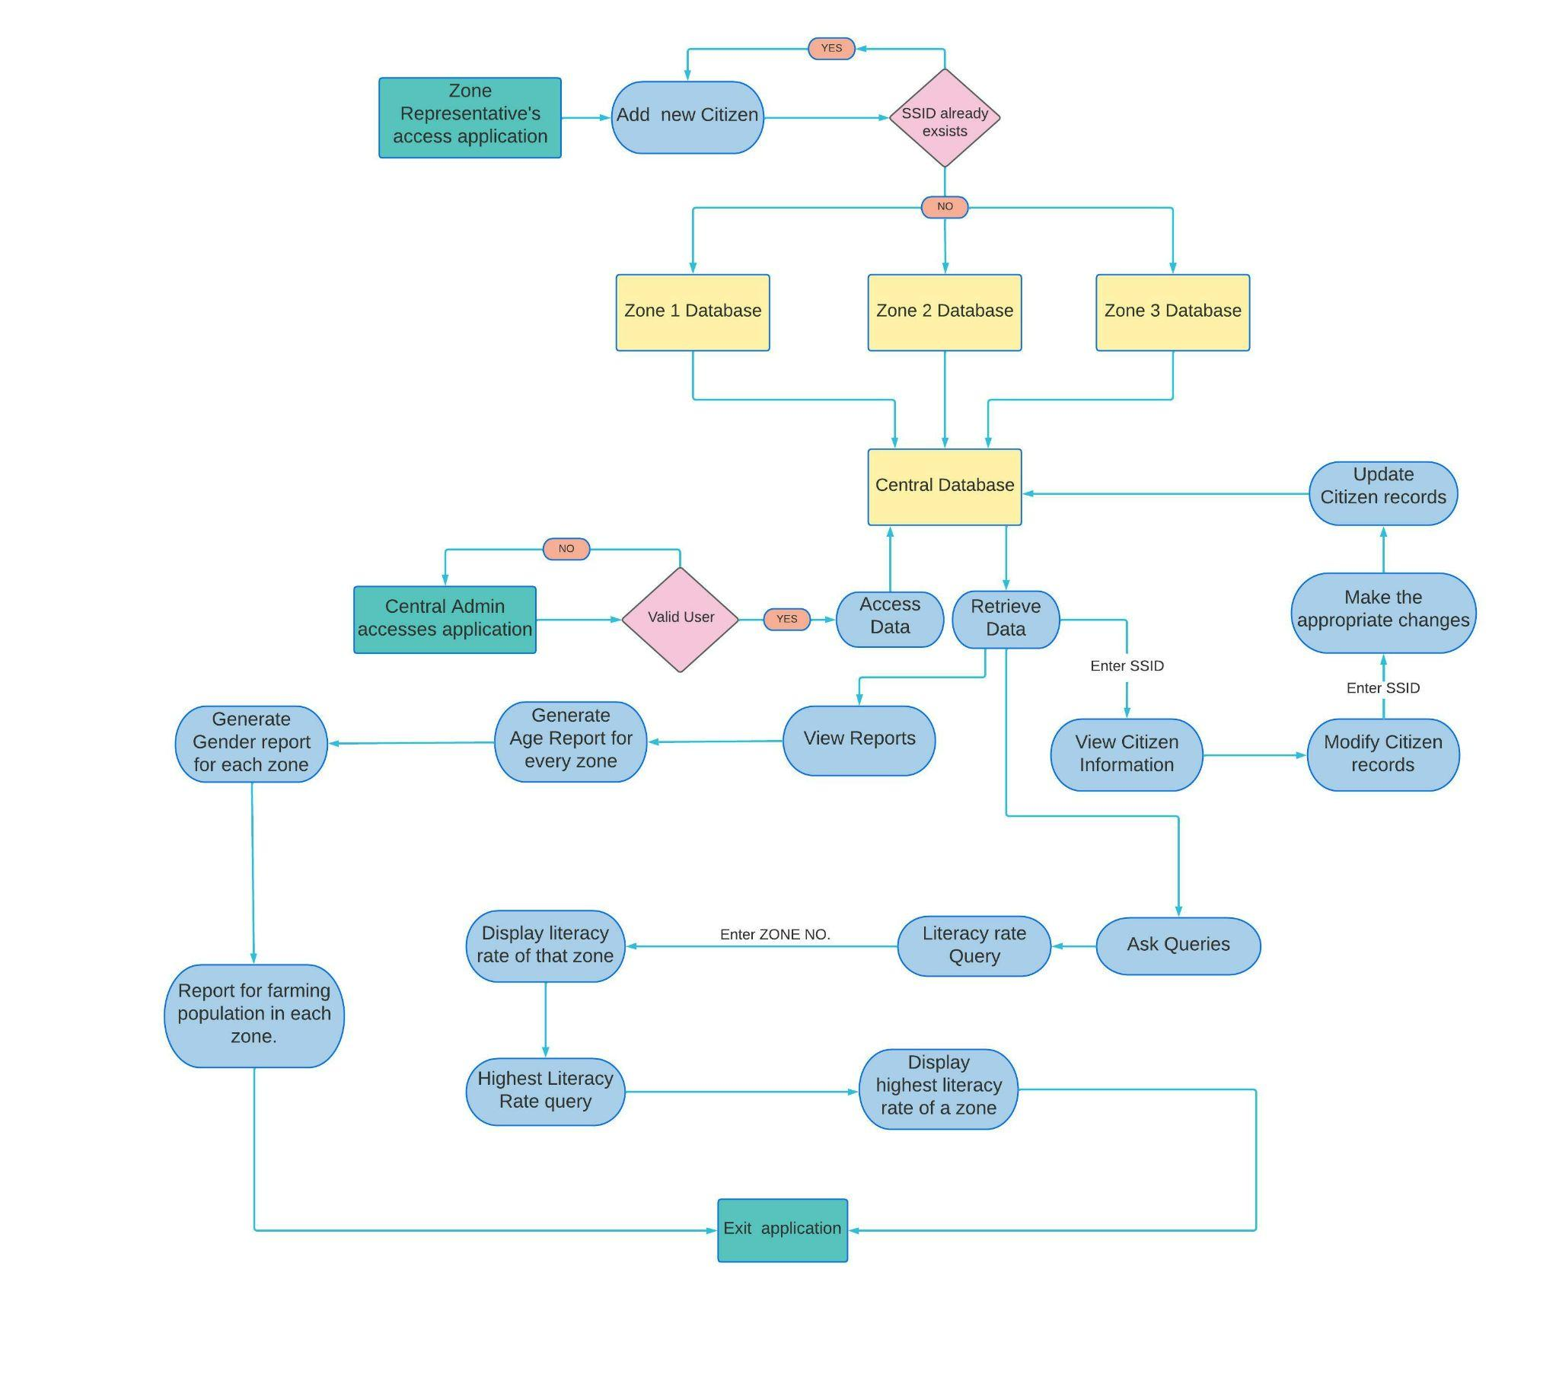

**4.1 Flowchart of the Application.**

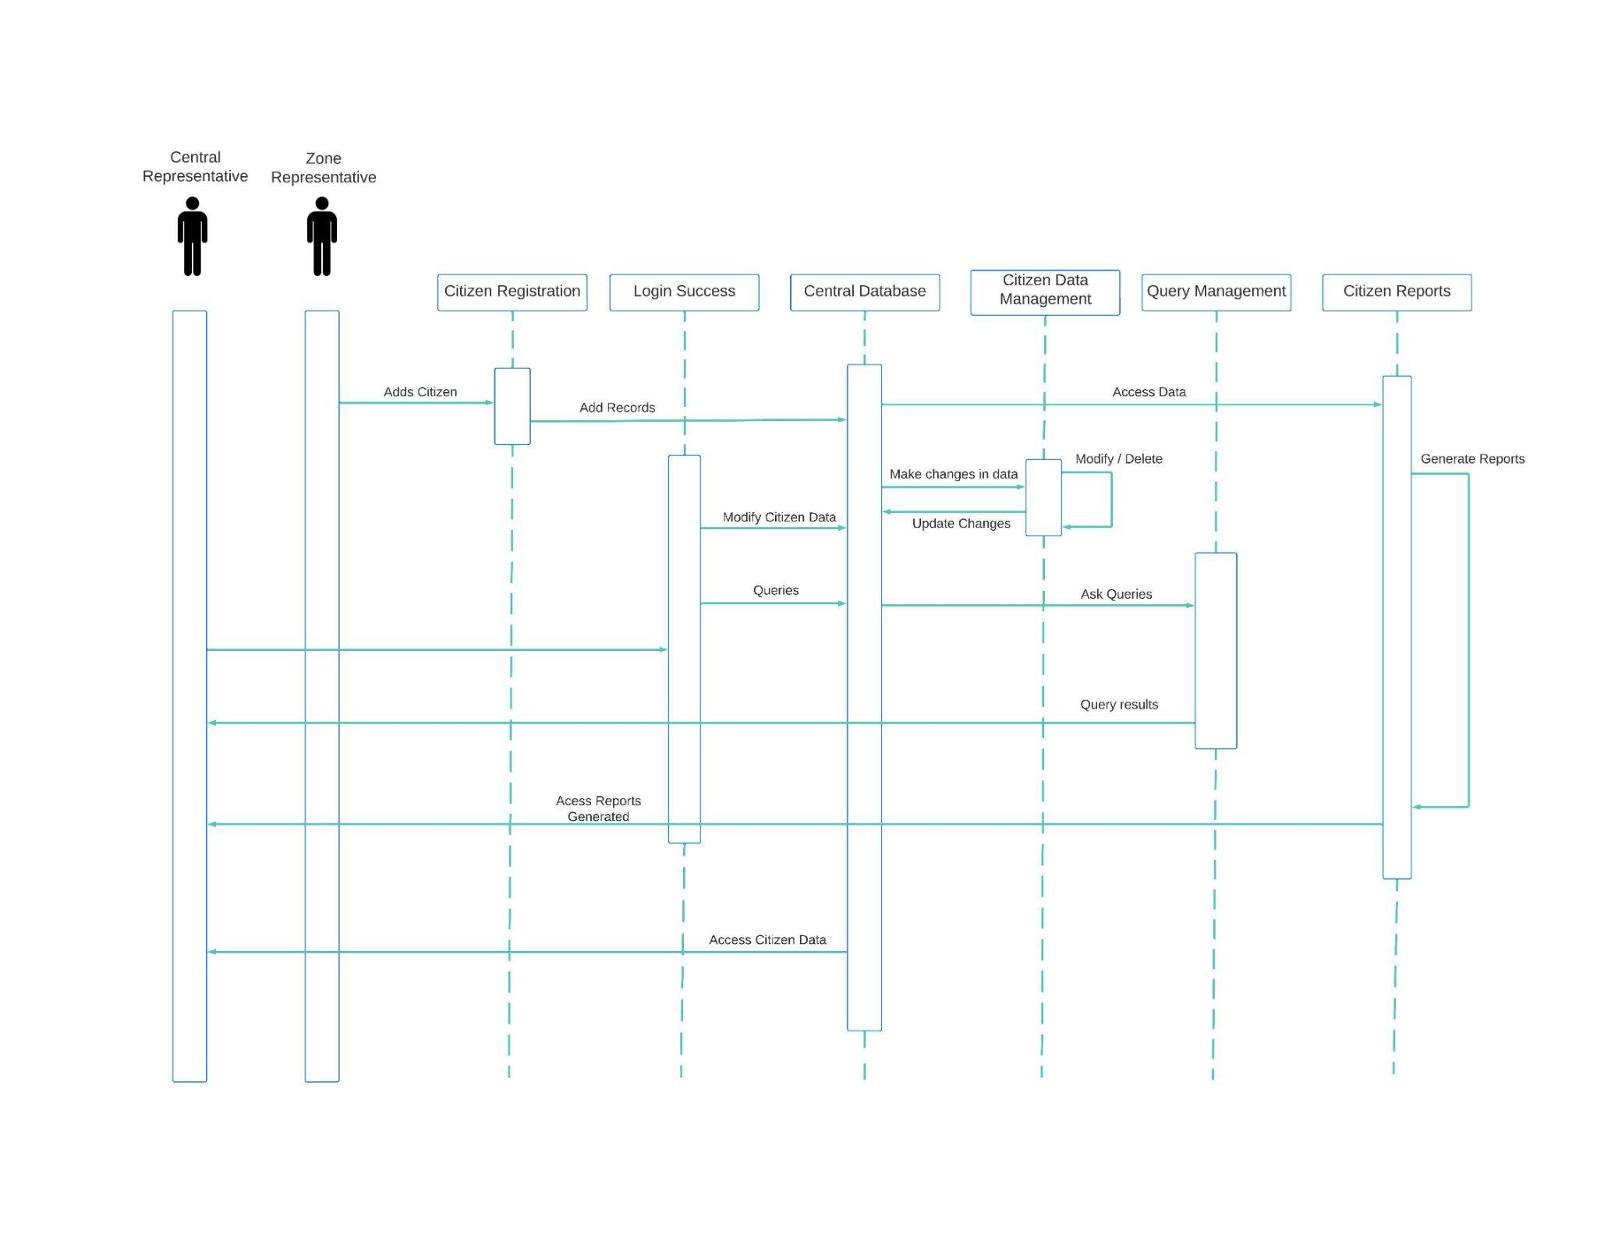

**4.2 Sequence Diagram of the application.**

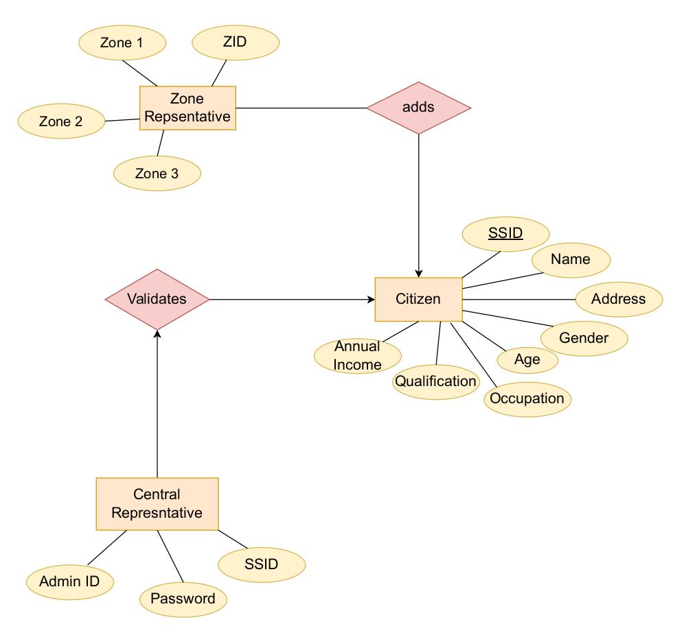

**4.3 Entity Relationship Diagram**

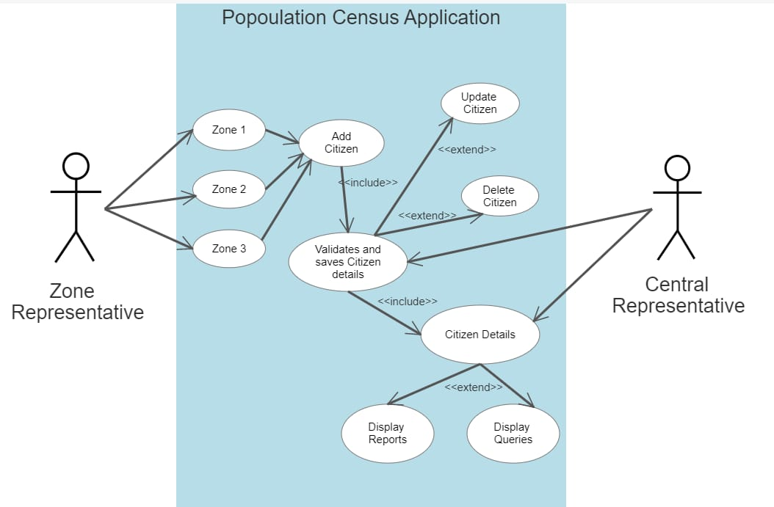

**4.4 Use Case Diagram of the Application**

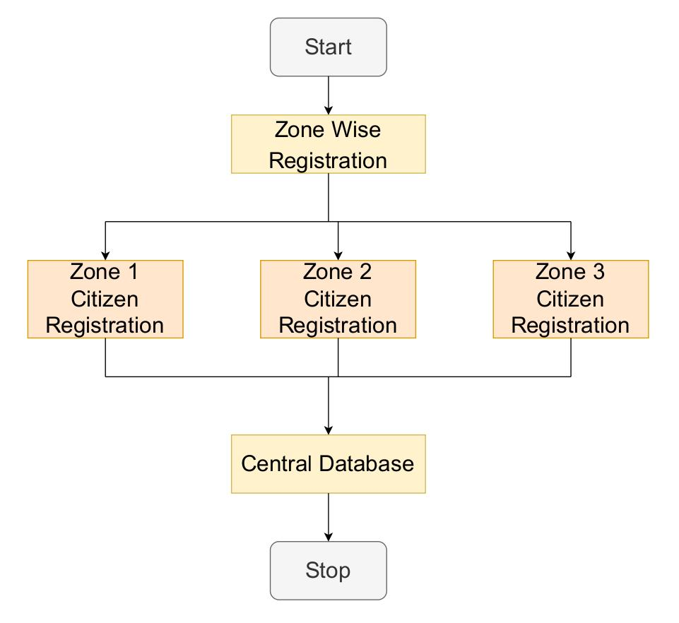

**4.5 Flow Chart for Zone Registration function**

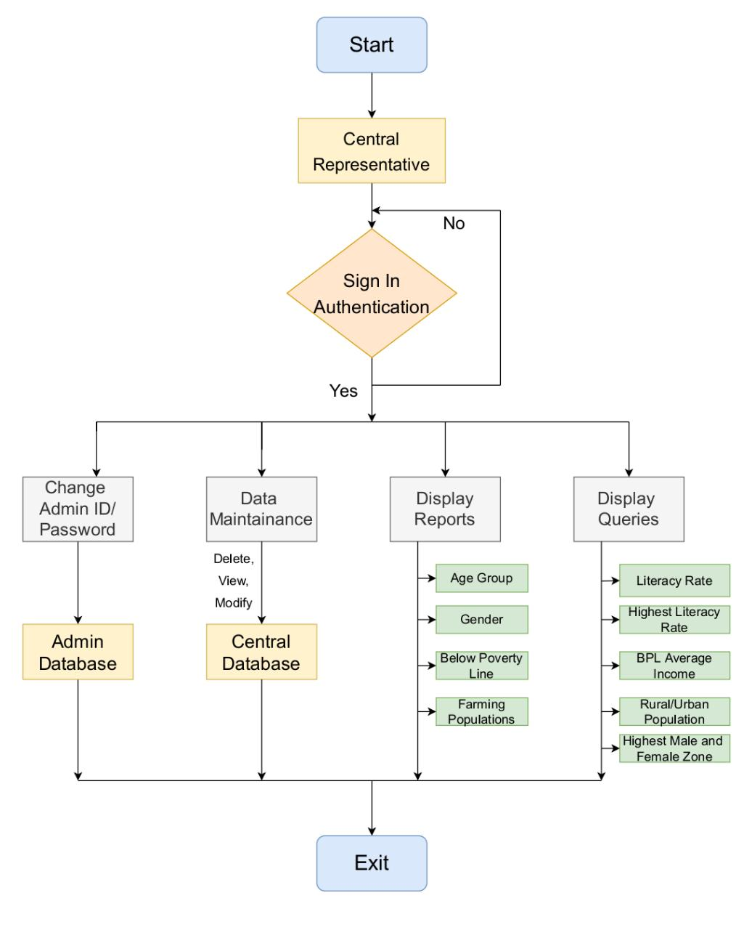

**4.6 Flow chart for Central command of the application**

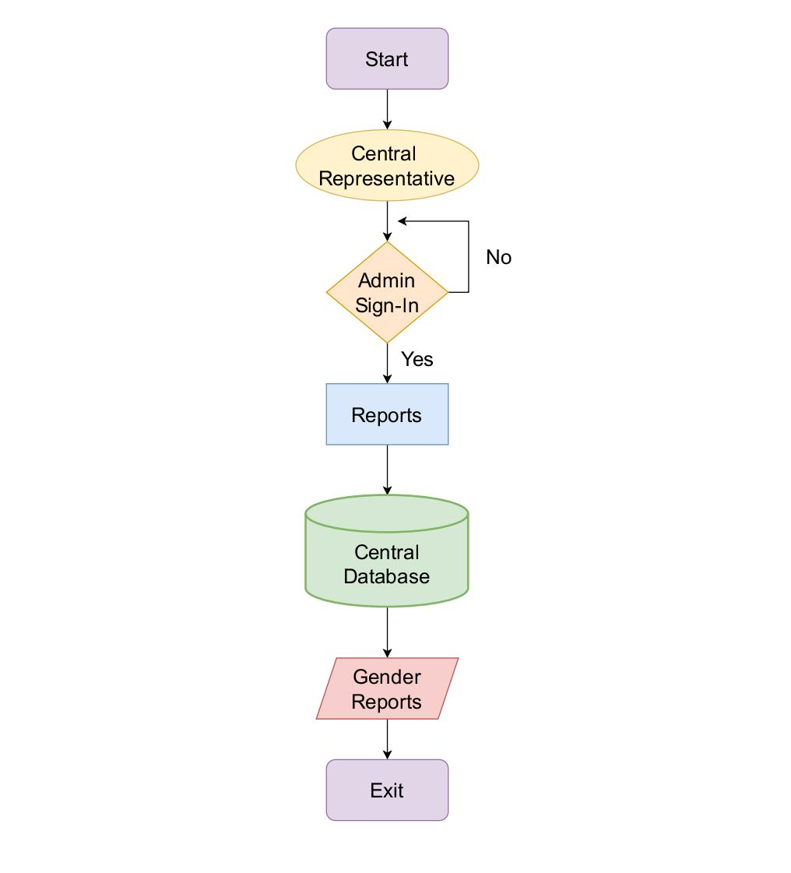

**4.7 Flow chart for Gender report function of the application**

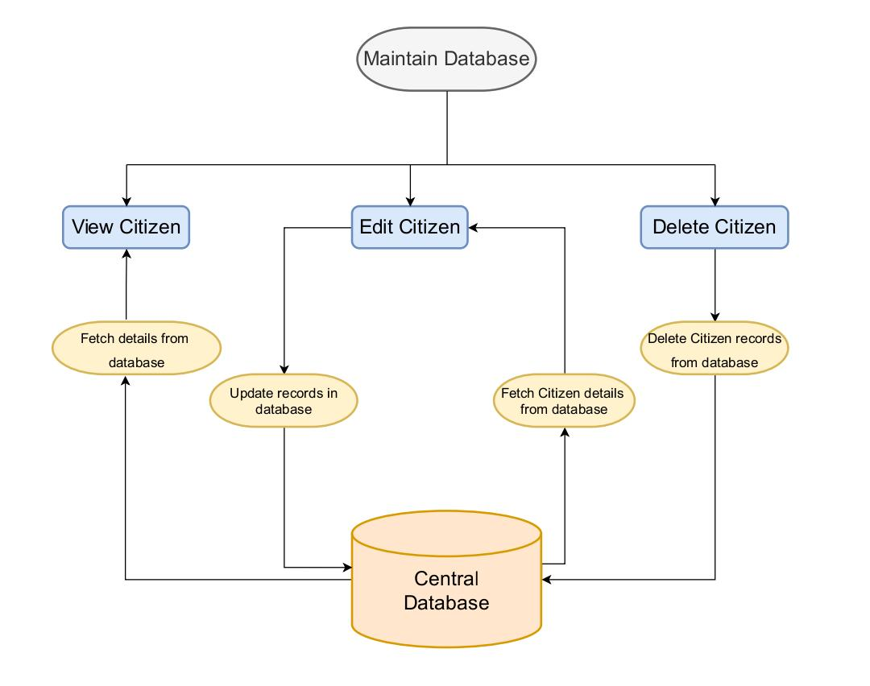

**4.8 Flow chart for Maintain database function of the application**

**5. TOOLS REPORT**

**5.1 Strace**

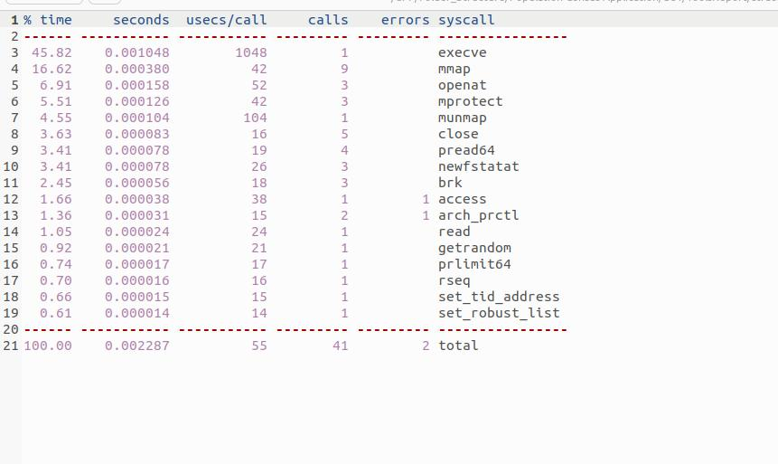

**5.2 Valgrind**

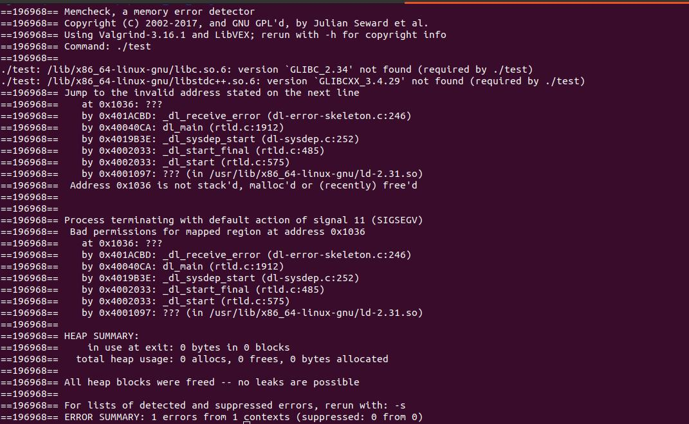

**5.3 CPP Check**

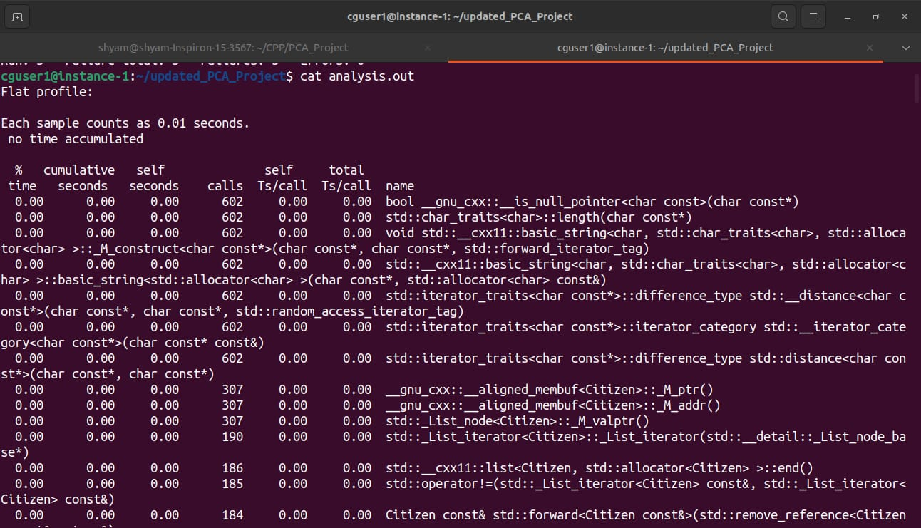

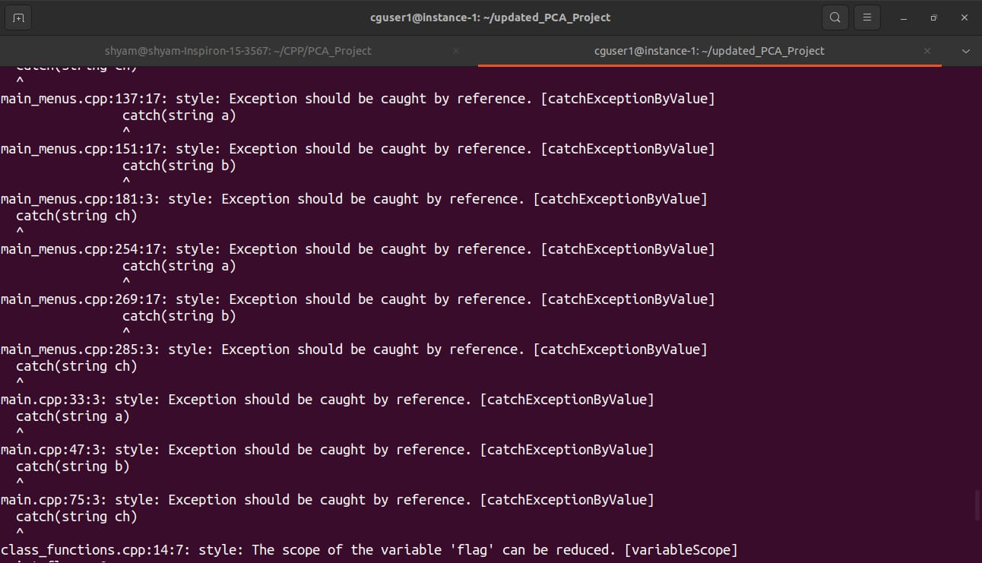

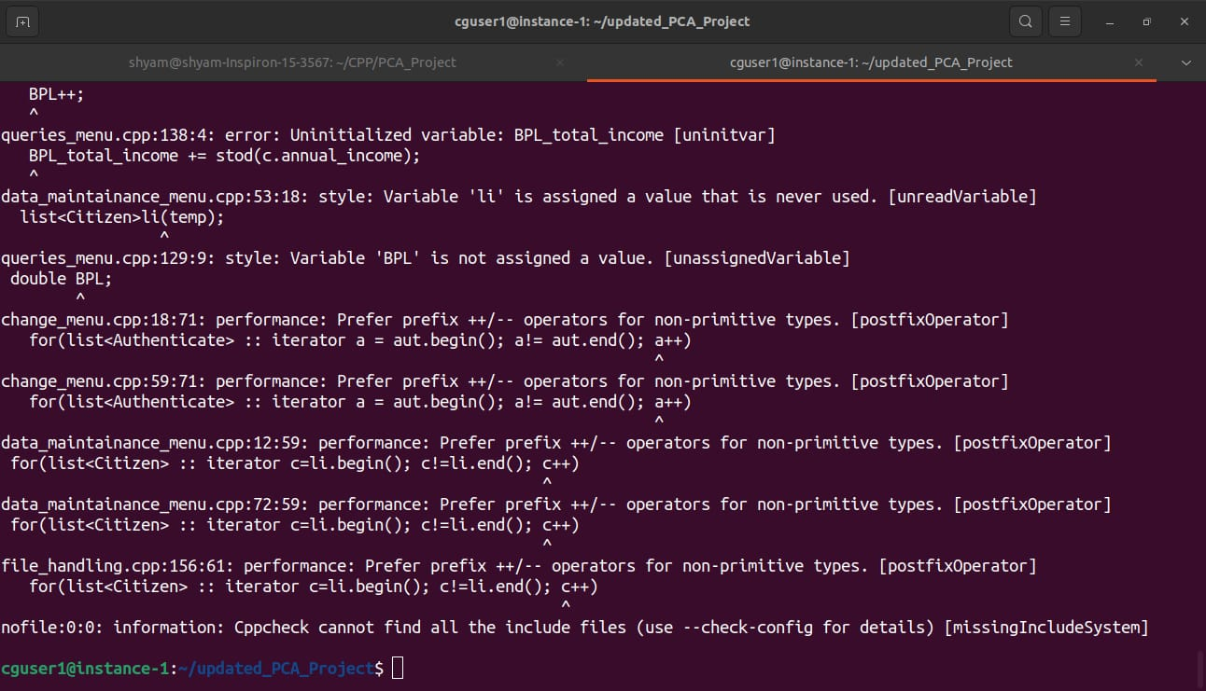

**5.4 Gcov**

**Main.cpp.gcov**

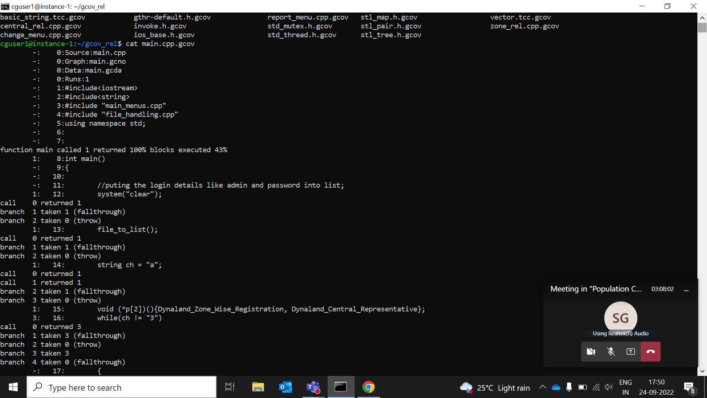

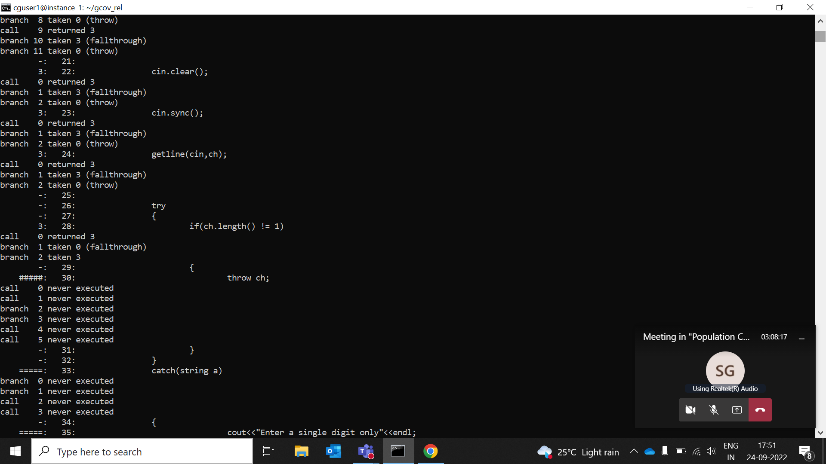

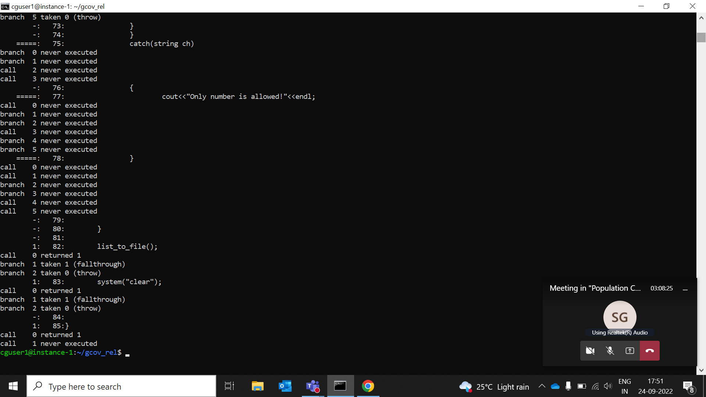

**5.5 Gprof**

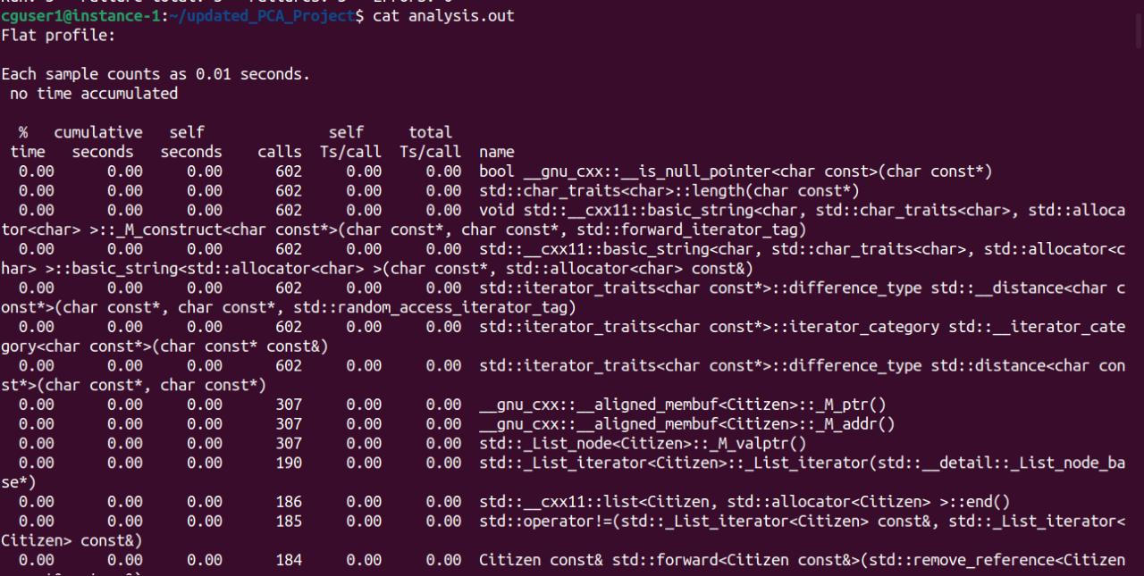

**6. Testing**

**6.1 Unit Testing**

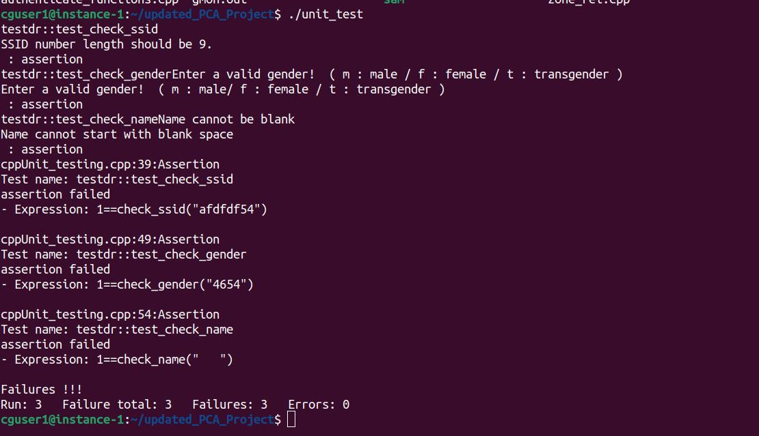

**6.2 Integration Testing**

**6.2.1 Add**

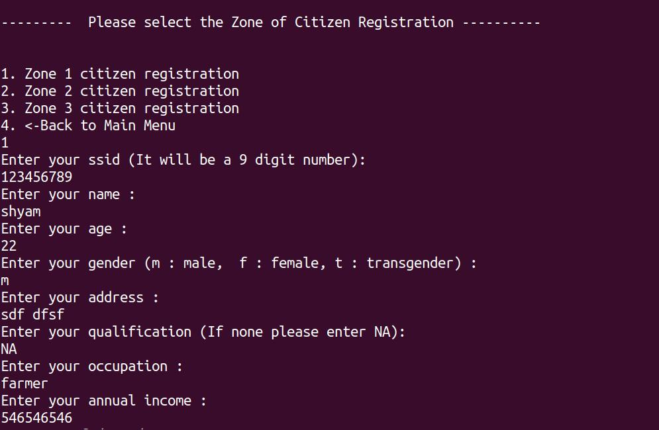

**6.2.2 Modify**

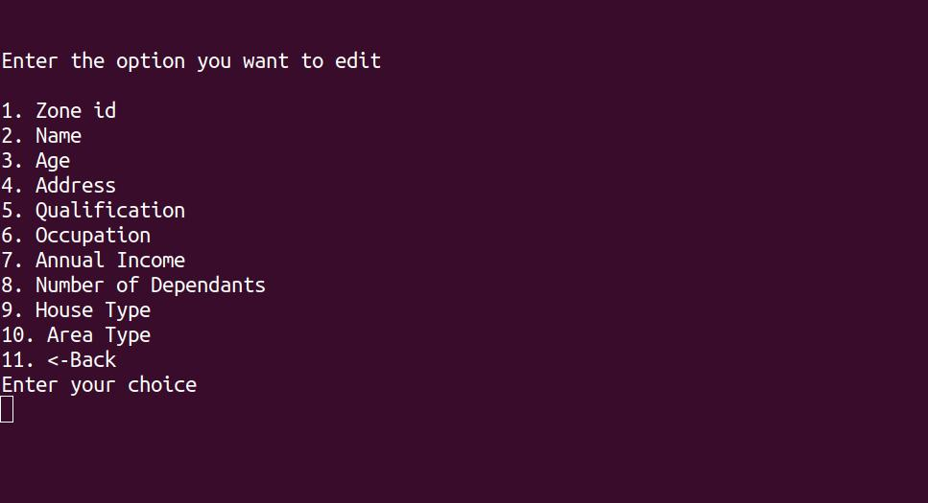

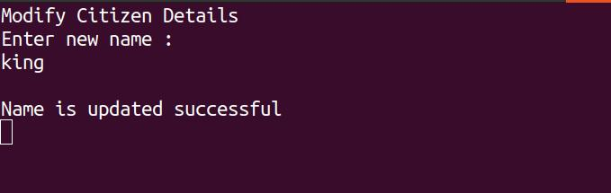

**6.2.3 : View**

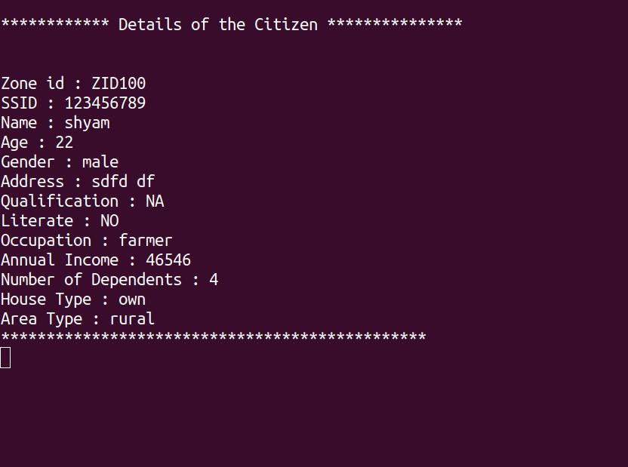

**6.2.4 Query**

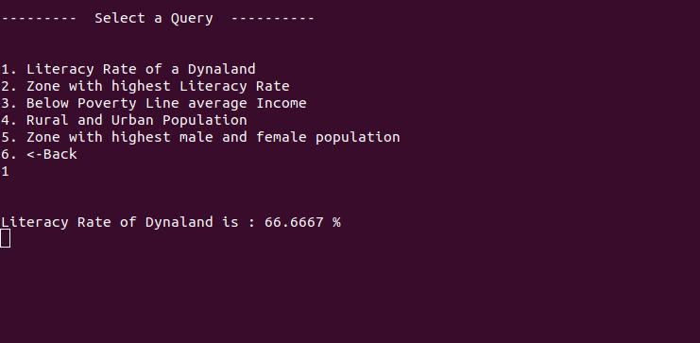

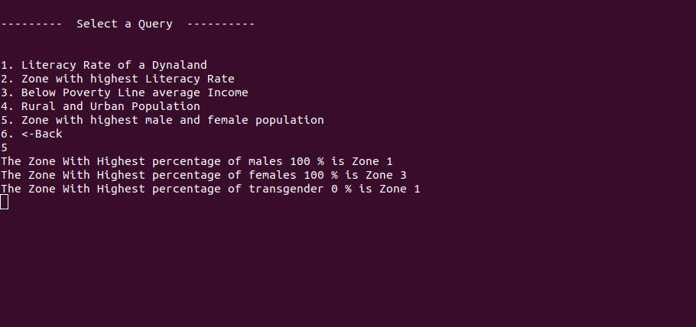

**6.2.5Gender wise report**

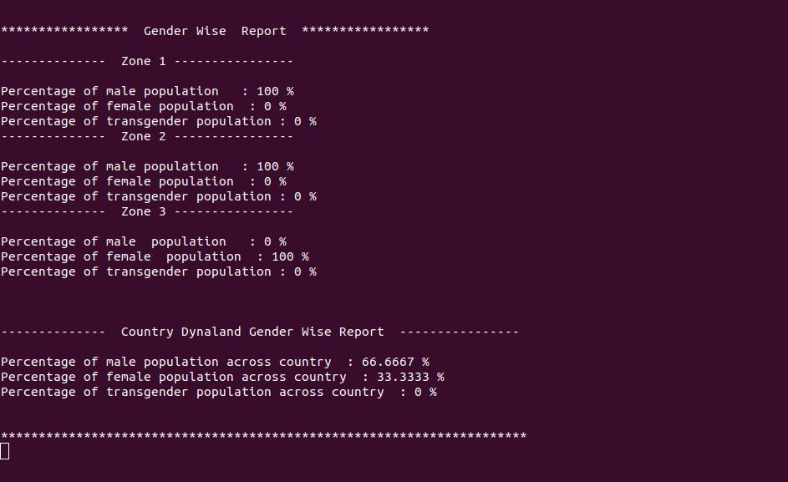

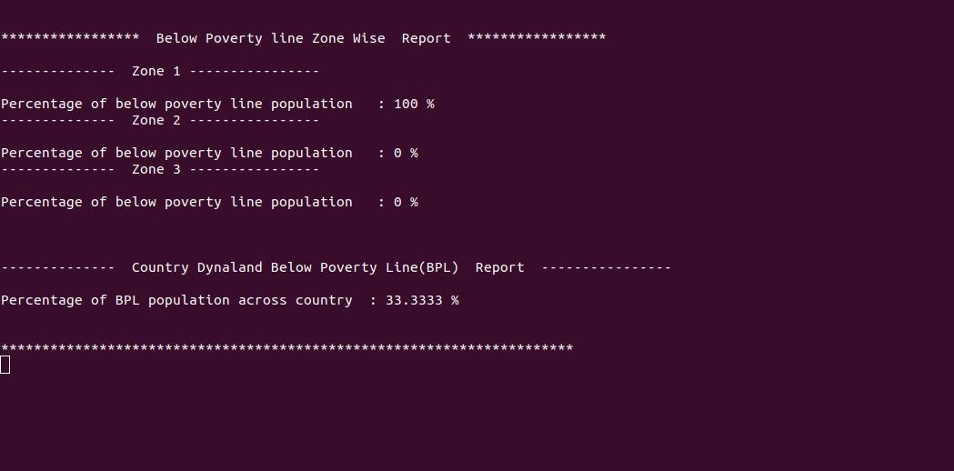

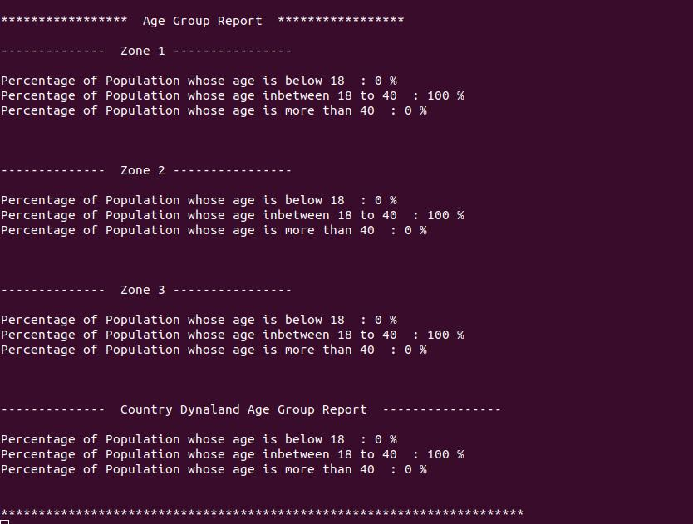

**6.2.6change admin i**

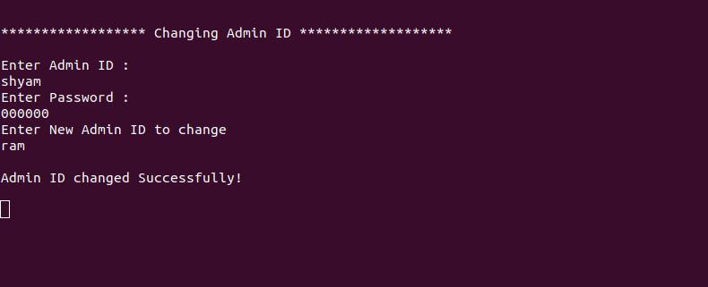

**6.2.7 Validation**

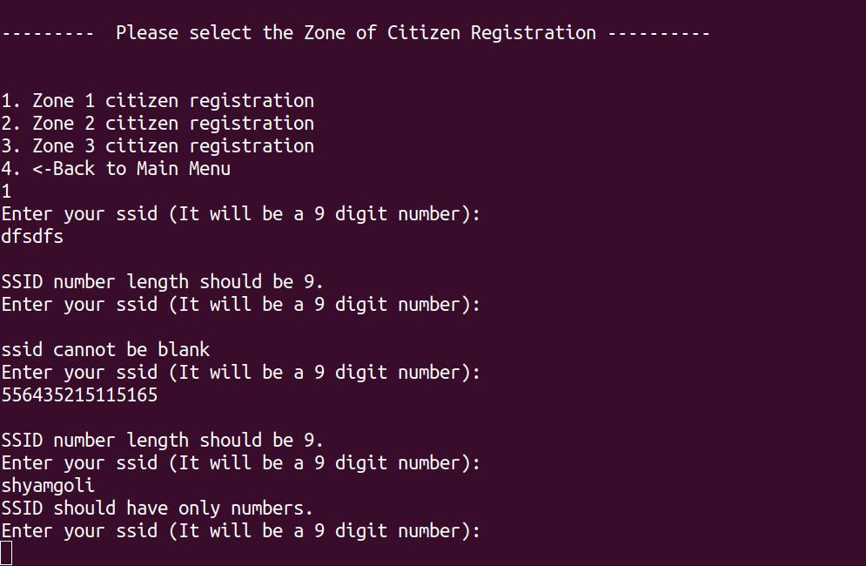

**7. Requirements Traceability Matrix(RTM)**

