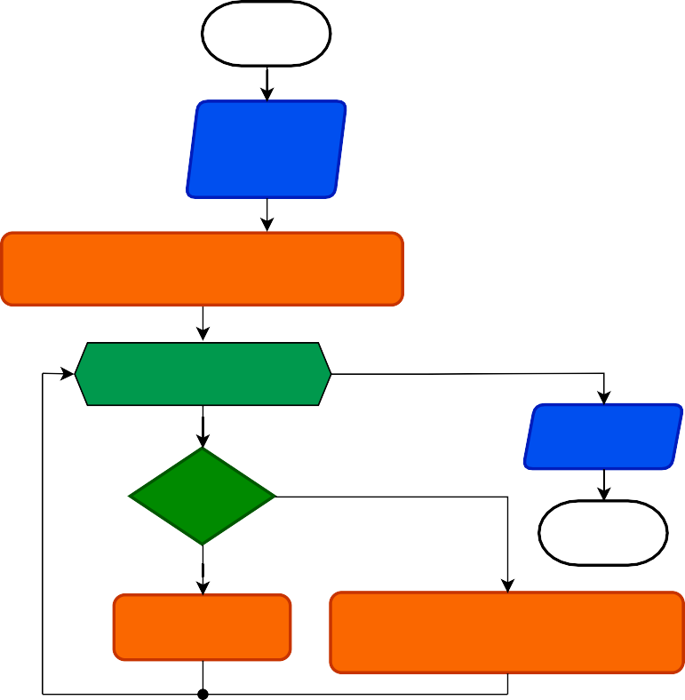



НАЧАЛО

char* one

char* two

i = 0, 10, 1

one[i] > two[i]

return 1

one[i] < two[i]

КОНЕЦ

return 0

КОНЕЦ

ChekStr



НАЧАЛО

const char* str

int len char* buf char f

buf = (char*)malloc(len + 1)

f = 0 buf[len] = '\0'

i = 0, len, 1

buf[i] = ' '

return buf

str[i] == '\0'

&& f != 1

КОНЕЦ

f == 0

f = 1

buf[i] = str[i]

StrToCharArray

|  |  |
| --- | --- |
| ToString | НАЧАЛО |
| int num int len char* str  str = (char*)malloc(len + 1) str[len] = '\0'  i = len - 1, 0, 1  return str  num == 0  КОНЕЦ  str[i] = ' ' str[i] = '0' + (num % 10)  num /= 10 | |



НАЧАЛО

char* src

char* buf int size char i char j

i, size - 1, 1

j, size - 1, 1

src[size - i -2] != ' '

buf[size - j - 2] = ' '

buf[size - j - 2] = src[size - i -2]

j++

return buf

КОНЕЦ

StrToRight



НАЧАЛО

unsigned int num

char str[40] char i char j

i = 1

j = 0 str[39] = '\0'

i < 40

i++

return str

(i % 5) == 0 &&

i != 0

КОНЕЦ

str[39 - i] = '0' + ((num >> j) & 1)

j++

ToBinCode



НАЧАЛО

char* src

char* buf char& errFlag char i

char j

i = 0

j = 0

buf = (char*)malloc(12) buf[11] = '\0'

src[0] == '+' ||

src[0] == '-'

buf[j] = src[i]

i++ j++

i, 10, 1

buf[i] = ' '

j == 0

errFlag = 1

Да

src[i] < 48 &&

src[i] > 57

Нет

Нет

src[i] != ' ' &&

src[i] != '\0' &&

src[i] != '\n' &&

src[i] != -2

return buf

КОНЕЦ

Да

errFlag = 3

buf[j] = src[i]

j++

Filter