# What is Dynare?

[Dynare](https://www.dynare.org/) is a software platform for handling a wide class of economic models, in particular dynamic stochastic general equilibrium (DSGE) and overlapping generations (OLG) models. Dynare offers a user-friendly and intuitive way of describing these models. It is able to perform simulations of the model given a calibration of the model parameters and is also able to estimate these parameters given a dataset. In practice, the user will write a text file containing the list of model variables, the dynamic equations linking these variables together, the computing tasks to be performed and the desired graphical or numerical outputs.

To run Dynare, you have the choice between running it on MathWorks MATLAB (proprietary) or GNU Octave (free software).

We ask you to install first Matlab and then Dynare following the procedure below.

# Dynare installation

## Step 1: Install Matlab

Install Matlab by following the procedure described here:   
[**https://dirnum.univ-amu.fr/fr/private/achats-logiciels**](https://dirnum.univ-amu.fr/fr/private/achats-logiciels)

Detail:

a. Go to <https://www.mathworks.com/academia/tah-portal/aix-marseille-universite-31651599.html> and click on 'S'enregistrer'.  
b. Login with your AMU email adress (use ENT if necessary)

c. Fill your profile

d. Download MATLAB using the menu "mon compte" (circle icon on the top and right of your initials).

## Step 2: Install Dynare

Once Matlab has been installed, you can install Dynare 5.3 using the link:

[**https://www.dynare.org/download/**](https://www.dynare.org/download/)

Dynare will be installed on C:\dynare

## Step 3: Tell Matlab where Dynare is

Open Matlab and create a permanent link to Dynare

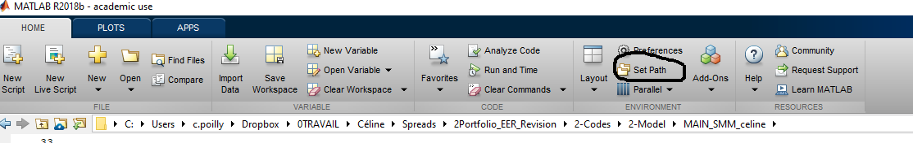

## Step 4: test

Check by running the .mod file RBC_CME_basic.mod, provided by [Johannes Pfeifer](https://sites.google.com/site/pfeiferecon/dynare).