BLUESTOCK MUTUAL FUND ANALYTICS PLATFORM
Capstone Project Report
Submitted By
KRITHIK S

Introduction
The mutual fund industry has emerged as one of the fastest-growing subsectors in the finance industry, which provides an effective means for wealth creation among investors. With more access to financial data, there exists a requirement for platforms that would help convert the data into useful information for investors and fund managers. The main aim of this project is to develop an all-inclusive Mutual Fund Analytics Platform that uses the combination of tools including Python, SQLite, and Microsoft Power BI. Datasets including historical Net Asset Value (NAV), transactions made by investors, benchmark indices, portfolios, and funds' information have been integrated in the solution using ETL process. Several financial performance indicators including Compound Annual Growth Rate (CAGR), Sharpe Ratio, Value at Risk (VaR), Conditional Value at Risk (CVaR), and Rolling Sharpe Ratio have been calculated to measure investment performance and risk associated with them. The development of interactive dashboards using Power BI has been done for visualization of industry trends, comparisons between funds, SIP growth, and investor analytics.

Contents
Introduction 1
Executive Summary 3
Data 3
ETL (Extract, Transform, Load) 4
EDA Findings 5
Performance Analysis 7
Dashboard 9
Recommendations 11
Limitations 12
Future Scope 13
Conclusion 15

Executive Summary
In this project, I have provided an end-to-end solution in the form of Mutual Fund Analytics Platform that was developed by using the technologies of Python, SQLite, and Microsoft Power BI. The analytics platform analyses the performance of the mutual funds, behaviour of investors, and market trends. For this, multiple datasets were used that contained the details about the funds, historical NAV, investor transactions, benchmark index, and portfolios of the mutual funds. ETL methodology is followed in this project for data cleaning, data transformation, and data feature engineering before the analysis process begins. Some of the key metrics like CAGR, Sharpe ratio, Var, CVaR, rolling Sharpe ratio, and HHI were calculated in order to analyse the performance of the mutual funds and portfolios risks. Investor analysis was also done through the use of some techniques like cohort analysis and SIP continuation analysis. Multiple dashboards were created in Power BI to visualize the trends of mutual funds industry, fund performance, investor behaviour, and SIP growth.

Data
Dataset Name | Description | Purpose in Project
01_fund_master.csv | Contains master information about mutual fund schemes such as AMFI code, scheme name, category, fund house, plan type, and benchmark. | Used as the primary reference table for fund details and dashboard filters
02_nav_history.csv | Historical Net Asset Value (NAV) records of mutual funds across different dates. | Used to calculate daily returns, CAGR, Sharpe Ratio, VaR, CVaR, and Rolling Sharpe Ratio.
03_aum_by_fund_house.csv | Assets Under Management (AUM) aggregated by different fund houses. | Used to analyze industry size, fund house market share, and AUM trends.
04_monthly_sip_inflows.csv | Monthly SIP (Systematic Investment Plan) inflow data. | Used to analyze SIP growth trends and compare SIP inflows with benchmark indices.
05_category_inflows.csv | Monthly investment inflows categorized by mutual fund category. | Used to identify the most popular investment categories and analyze category-wise fund flows.
06_industry_folio_count.csv | Industry-wide investor folio counts over time. | Used to study investor participation and industry growth.
07_scheme_performance.csv | Performance metrics of mutual fund schemes, including returns, risk measures, and financial ratios. | Used for fund comparison, risk-return analysis, and recommendation engine.
08_investor_transactions.csv | Individual investor transaction records including SIPs, lump sum investments, and redemptions. | Used for investor analytics, cohort analysis, SIP continuation analysis, and transaction trend analysis.
09_portfolio_holdings.csv | Portfolio allocation of each mutual fund across different sectors or securities. | Used to compute portfolio diversification and Herfindahl-Hirschman Index (HHI).
10_benchmark_indices.csv | Historical benchmark index values (e.g., Nifty 50). | Used to compare mutual fund performance against market benchmarks.

ETL (Extract, Transform, Load)
The ETL framework was designed to help ensure that all datasets from raw mutual fund data are clean, consistent, and ready for analysis. The Extraction stage involved collecting data from multiple CSV files which include datasets about fund master data, NAV history, AUM, SIP inflow, investor transaction details, fund portfolio holding, benchmark index, and scheme performance. In the Transformation stage, the dataset had duplicate data removed, missing values managed through appropriate methods, date format standardized, and data type validated. The additional features included calculating daily return and monthly summary, as well as creating financial metrics for analytical purposes. The transformed datasets were also combined through the use of common identifier like AMFI Code to create relationship among datasets. Finally, in the Loading stage, the cleaned datasets were saved as processed CSV files and loaded into Power BI for visual representation and dashboard creation.

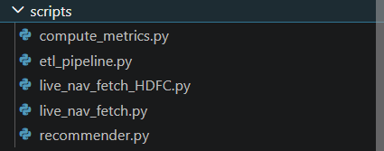

EDA Findings
EDA was performed on the mutual fund data sets to understand the underlying structure, quality, and trends before performing any further advanced financial analysis. Quality checks for data ensured that there were no duplicates in the data, missing values were dealt with in an appropriate manner, and that dates were uniform across all datasets. Analysis of historical NAV proved that there has been constant long-term growth in almost all mutual fund schemes but with fluctuations depending upon the market situation. The analysis done at the industry level indicated that there has been continuous growth in Assets Under Management (AUM). This implied that there has been increased participation of investors in mutual funds. Monthly trend for SIP inflows illustrated a consistent growth in systematic investment plans, implying the increasing popularity of such disciplined investing strategies. The category wise inflow analysis made it clear that equity and large-cap mutual funds have been the most liked investment categories. The investor transaction analysis suggested that SIPs formed the major part of investment activity and not lump sum and redemption investments. The benchmark index analysis revealed that the top mutual funds have been following the market movements.

Nav Trend
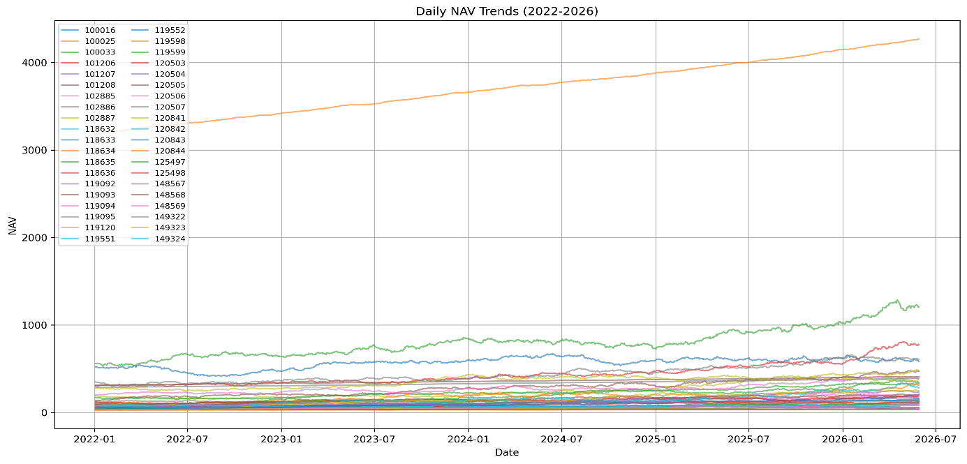

SIP Trend
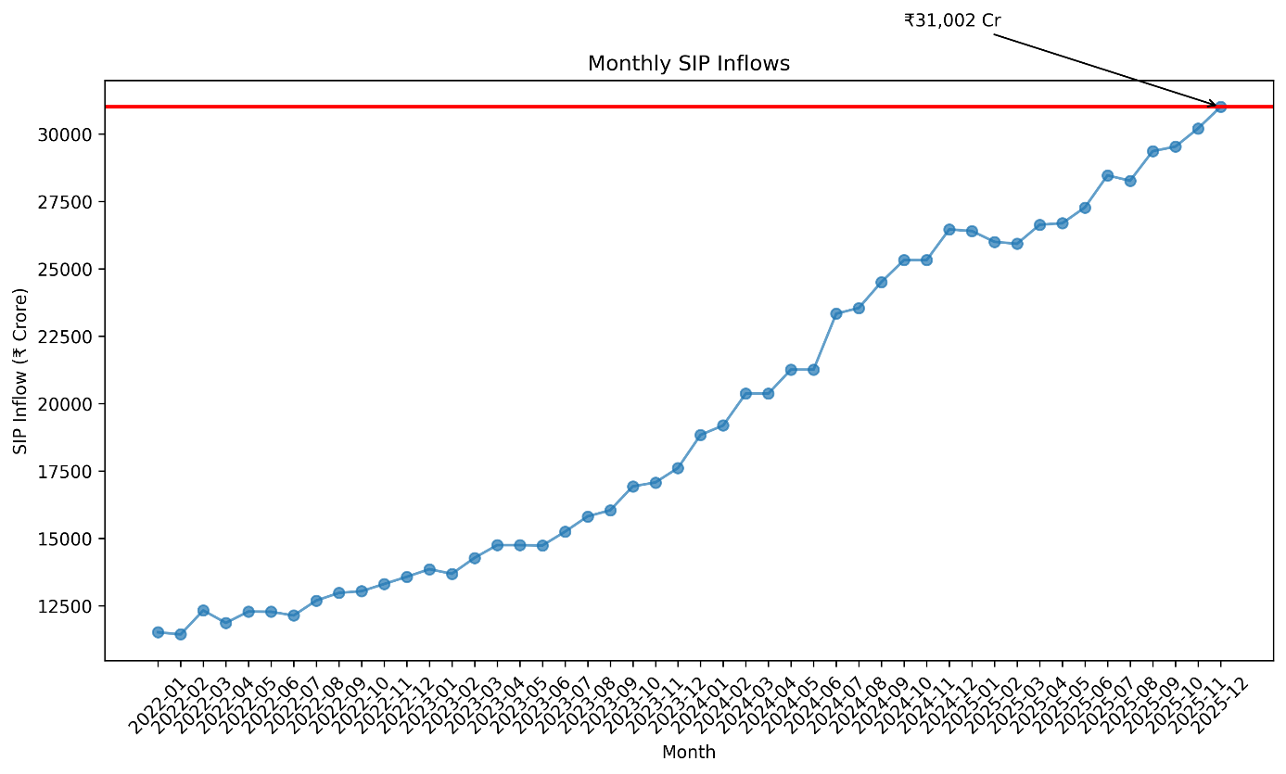

Category inflows
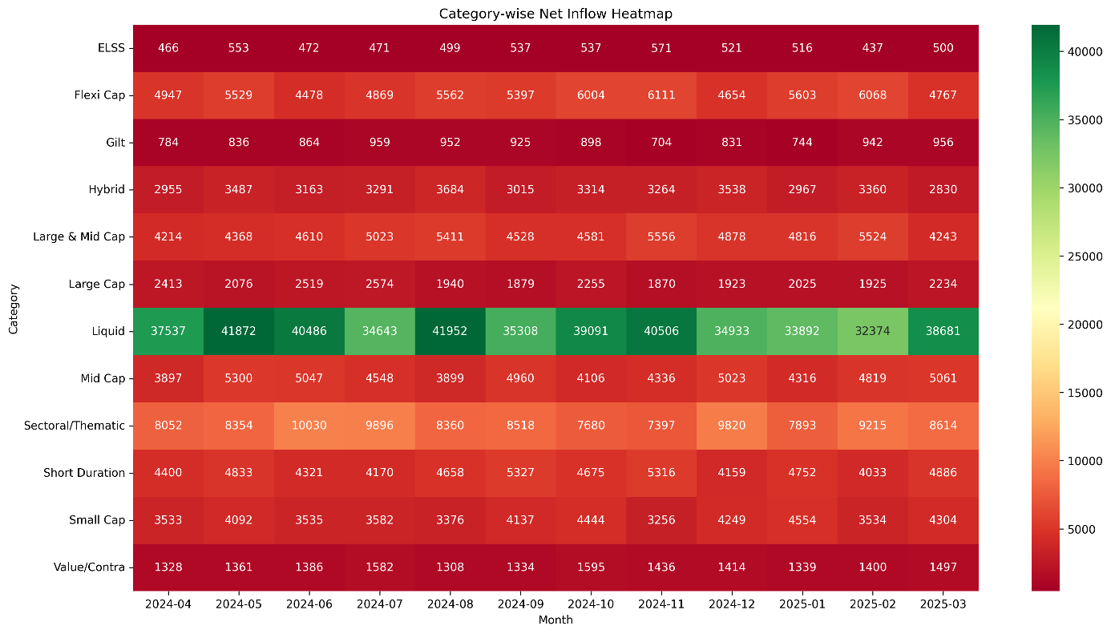
Industry AUM Trend
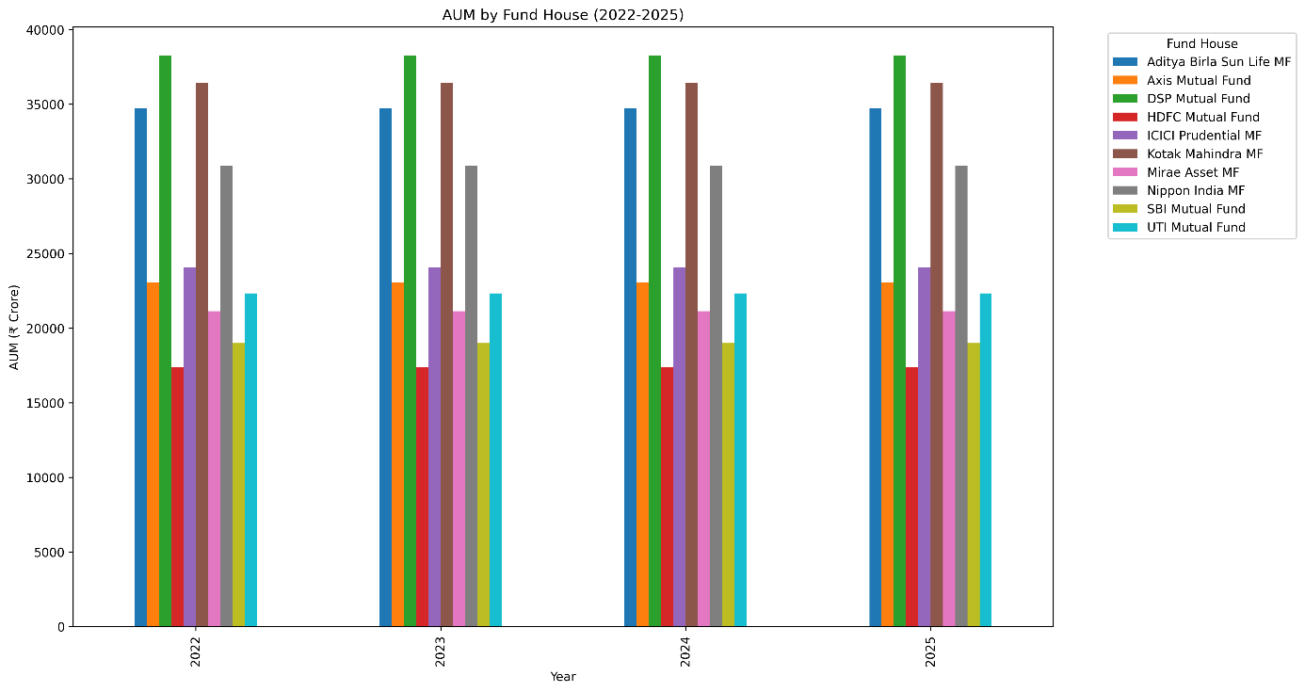

Performance Analysis
The performance analysis involved evaluation of mutual fund schemes through a complete range of financial and risk-adjusted performance measures. Historical NAVs were utilized to derive daily return as well as annualized return on each of the schemes. Compound Annual Growth Rate (CAGR) was computed for 1 year, 3 years and 5 years to measure the growth rate of funds. The risk-adjusted performance was measured through Sharpe Ratio and Sortino ratio where returns were measured against total risk and downside risk respectively. Alpha and Beta ratios were computed by considering the fund returns against NIFTY 100 index to measure excess returns and market sensitivity. The maximum drawdown ratio was computed to measure the largest drop from the highest level of fund values. After that, a Fund Score was computed using scores of CAGR, Sharpe Ratio, Alpha, Expense Ratio and Maximum Drawdown. This allowed us to objectively rank the mutual funds. At last, the best performing funds were analyzed against NIFTY 50 and NIFTY 100 indices through cumulative return analysis.

Risk Vs Return Plot
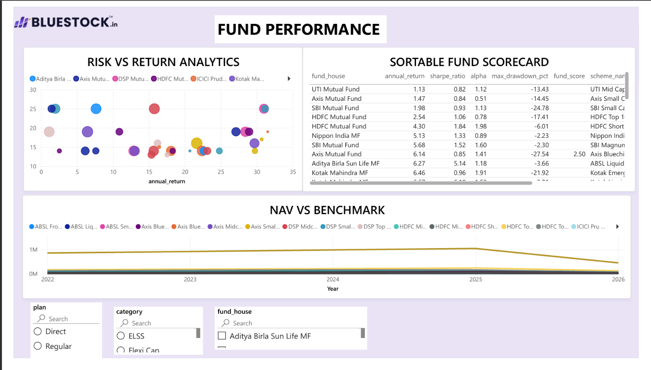

NAV vs Benchmark
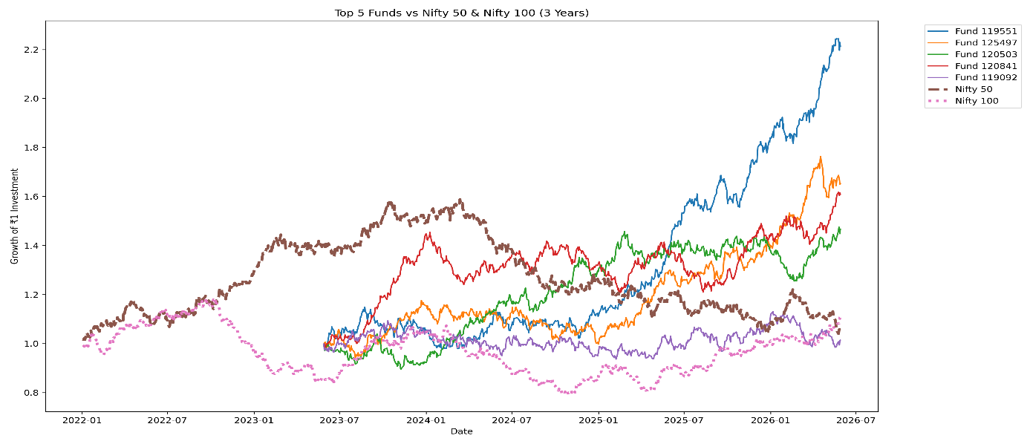

Sector Concentration
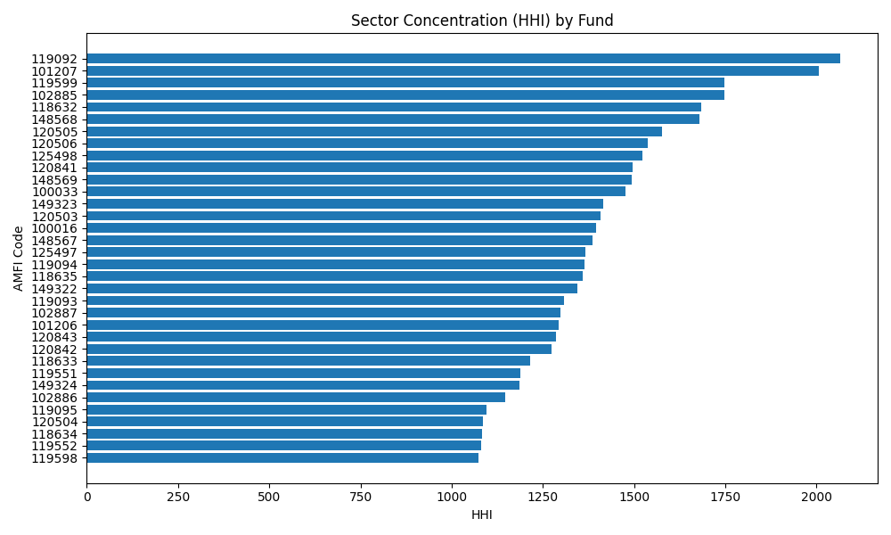

Dashboard
Industry Overview-Page 1
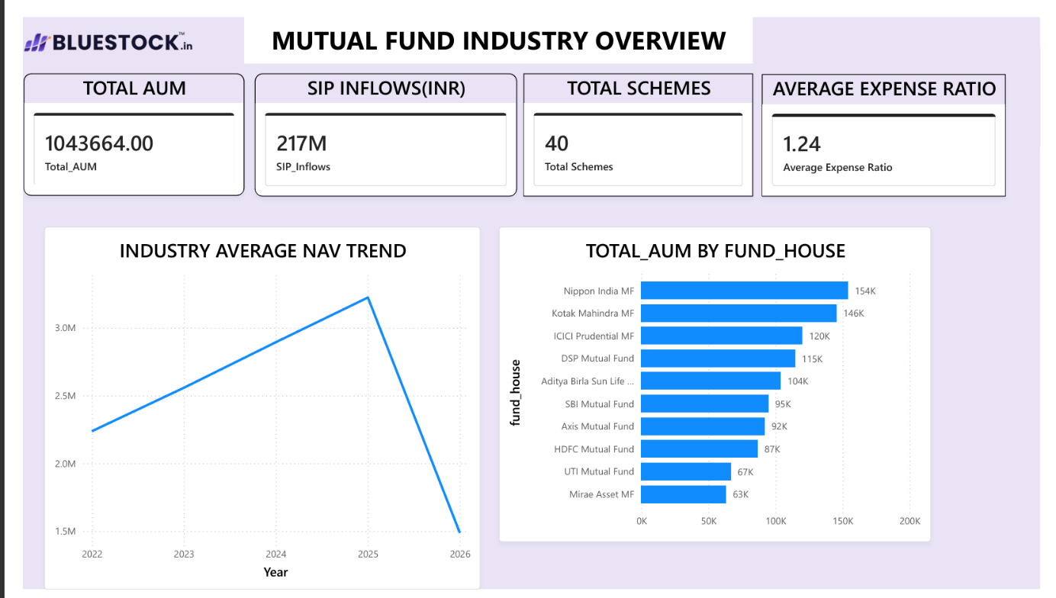

Fund Performance -page 2



Investor Analytics-Page 3
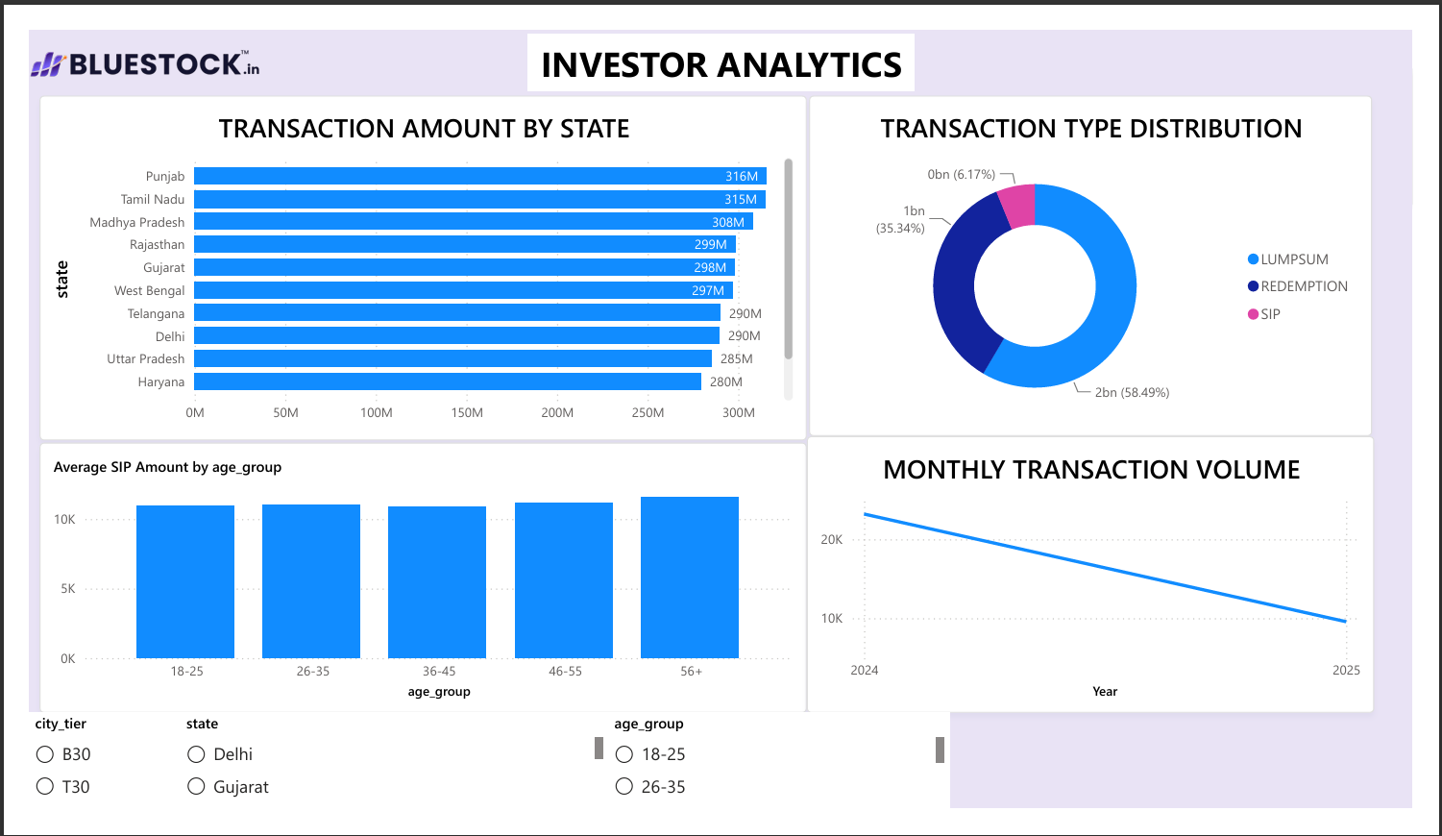

SIP and Market Trends-Page 4
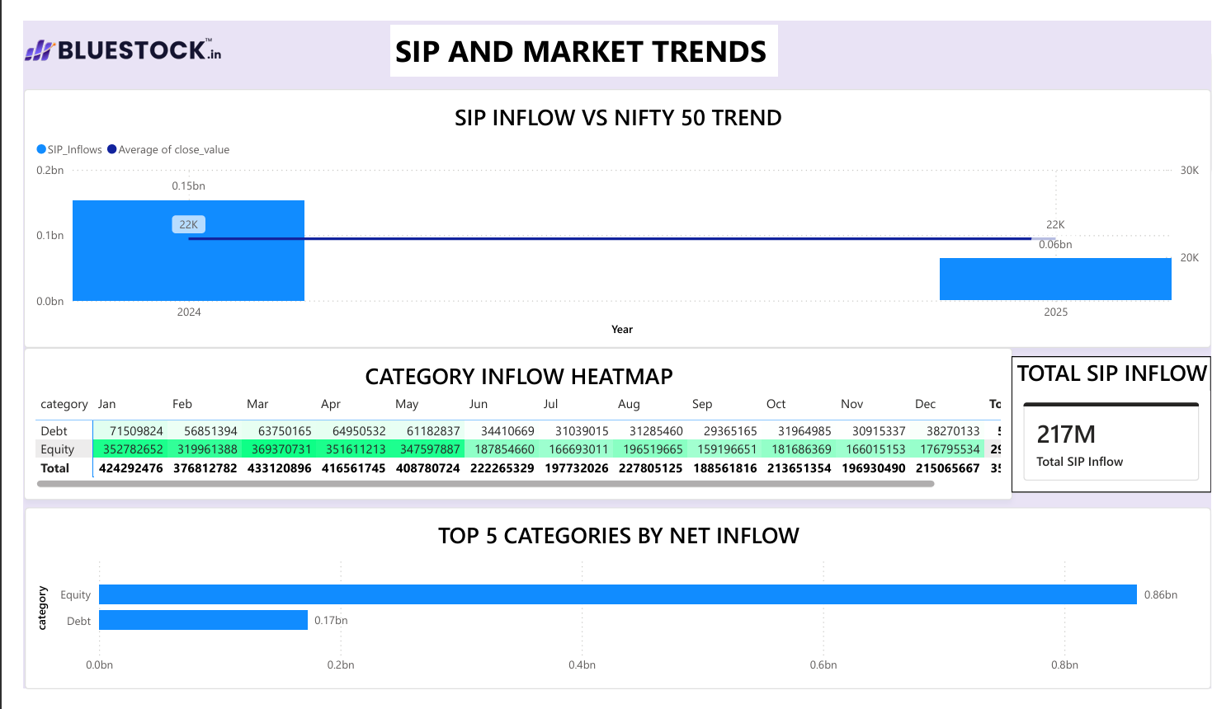

Recommendations
Improve Portfolio Diversification
Portfolio concentration through the use of Herfindahl Hirschman Index (HHI) indicates that there are mutual funds whose portfolios are highly concentrated in terms of certain sectors. Although it is possible to get high returns from investments made in certain sectors, especially when the market favors these sectors, it increases the level of concentration risk for investors. It is important for fund managers to rebalance their portfolio at regular intervals in order to avoid concentration in a particular sector.
Improve Risk Monitoring
Value at Risk (Var), Conditional Value at Risk (CVaR), Maximum Drawdown, and Rolling Sharpe Ratio are some examples of risk measures that can offer insight into the risks that mutual funds face. It is recommended that asset management firms keep an eye on these measures and examine the portfolio when risk levels surpass certain thresholds.

Favor Investments under Systematic Investment Plan (SIP)
From the above analysis, it is clear that investments done through SIP have played a very vital role in ensuring the growth of mutual fund investments. Therefore, for this reason, fund houses should be encouraged to make investments via SIP due to its benefits like rupee cost averaging.

Take Advantage of Personalized Mutual Fund Recommendations
The recommended system indicates that mutual funds can be assigned to investors depending on their risk tolerance levels. The banks should consider expanding the technique through the addition of other factors related to investors, including age, investment period, earnings, financial objectives, and investing experience.

Investor Retention Improvement
Through the SIP continuation analysis, it is clear that there are investors whose pattern of investment is inconsistent. It can be possible that the investors who have a long break between the SIP transactions will stop making investments. There is a need for the fund houses to target such customers and retain them.

Improve Benchmark Comparison
The benchmark indices like NIFTY 50 and NIFTY 100 serve as a key point of comparison for the evaluation of mutual fund performance. The future reports' dashboard should enable investors to measure the performance of mutual funds based on multiple benchmark indices in various market cycles.

Enhance the Functionality of the Interactive Dashboard
The designed Power BI dashboard is useful in providing an understanding of the performance of industries, behavior of investors and fund analysis. Some other functionalities that may enhance user experience include trend analysis prediction, drill-through report, customized alert, mobile responsive, and artificial intelligence insights.

Limitations
Requiring Historical Data
The research depends mainly on the use of historical data related to mutual funds and market performance. Even though there can be many learnings from historical data about fund performance, the same cannot help us predict future market performance. There will be many economic and geopolitical factors that will affect future performance.

No Use of Live Market Data
Most of the data collected in this project were static data collected in the form of CSV files. Even though the data for benchmark have been used, the dashboard does not depend on live market data. Therefore, this means that the analysis is based only on historical market data.

Rule-Based Recommendation Engine
The recommendation engine built in this project for recommending mutual funds is a rule-based one based on the risk tolerance of investors. This is simple to use and implement but it does not make use of historical market data or investor data.

Limited Portfolio Holdings Data
Portfolio concentration calculations are affected by changes in fund composition, classifications and portfolio holdings data. Detailed information about portfolio holdings will help to enhance portfolio risk assessment.

Benchmarks Restrictions
This research project will consider mutual funds' performance mainly against the benchmark index such as NIFTY 50 and NIFTY 100. In addition, other types of mutual funds should be assessed with respect to specific benchmarks for each type.

Assumption Simplifications of Some Financial Metrics
Some financial ratios such as Sharpe Ratio, Alpha, Beta, and VaR imply some statistical assumptions. They do not take into account all aspects of market behaviours during crises or other periods of extreme volatility.

Data Restrictions
Analytical outcomes depend greatly on the amount and precision of the available dataset. The absence of data may have an effect on some calculations and behavior analysis.

Scope Limitations
In the context of this research project, only equity mutual funds and several benchmark indices were taken into account. There are no ETFs, debt funds, hybrid funds, international funds and commodity funds considered in the current analysis.

Future Scope
Recommendation of Funds using Machine Learning Algorithms
The existing recommendation algorithm works on the principle of rules based on risk-appetite of the investors. The future scope includes the use of advanced machine learning algorithms such as Random Forest, XGBoost or Neural Networks that will help recommend personalized funds for the investors using their demographic profile, past investments, financial targets and other market movements.
Incorporation of Real Time Data Analytics
The existing model is largely dependent on the historical data. The inclusion of real time financial API like that of AMFI, NSE and BSE would help update the NAV, benchmark and other market movements in real time and provide analysis to the investors.

Prediction of Market Movements
Forecasting approaches based on time-series analysis like ARIMA, Prophet, LSTM and Transformer models could be included in the project to help forecast the NAV changes in the future.

Advanced Risk Analytics
The future iterations of the platform can include further risk analysis methods such as Monte Carlo Simulation, Stress Testing, Value-at-Risk at various confidence levels, Conditional Drawdown Risk, and Scenario Analysis. These methods will contribute to more efficient analysis of risks associated with portfolios under various market scenarios.

Cloud-Based Deployment
The analytics platform can be provided as a web or mobile app running in the cloud to provide investors with dashboards, suggestions, and insights related to the portfolio management no matter where they are located. Cloud-based deployment will allow for better scalability and collaboration capabilities.

AI-Powered Chatbot
An AI-powered chatbot based on LLMs can be utilized to answer investor questions, provide explanations regarding fund performance, describe current market situation and suggest appropriate investment strategy.

Optimization of Portfolios
In future research, techniques of portfolio optimization may be used via Modern Portfolio Theory (MPT), mean-variance optimization or Black-Litterman models. The methods will assist the investors to obtain optimal levels of expected returns by optimizing risks.

Conclusion
The Mutual Fund Analytics Platform is an excellent example of the utilization of data engineering, financial analytics, and business intelligence concepts in performing analytical studies on the mutual fund industry of India. The project involves integration of several datasets through a systematic ETL process, along with carrying out thorough exploratory and financial analysis using Python. Key metrics such as CAGR, Sharpe Ratio, Alpha, Beta, Value at Risk, Conditional Value at Risk, Rolling Sharpe Ratio, and Herfindahl-Hirschman Index were calculated in order to measure performance of mutual funds, downside risks, and portfolio diversification.
Analyses related to customers including Cohort Analysis, SIP Continuation Analysis, and Transaction Trend Analysis gave important information about investment behaviour and interactions of customers. A recommendation system based on certain rules has been designed in order to recommend suitable mutual funds based on the risk tolerance of investors.
Power BI dashboards have been utilized in order to give interactive visualizations of the industry trends, mutual fund performance, customer analytics, and market comparison through charts, KPIs, filters, and drill-through functionality.

