**周亚男**

**2020131062**

**202班**

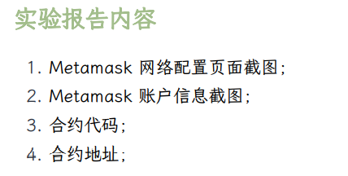

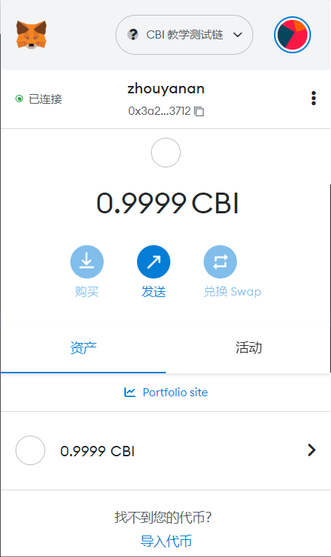

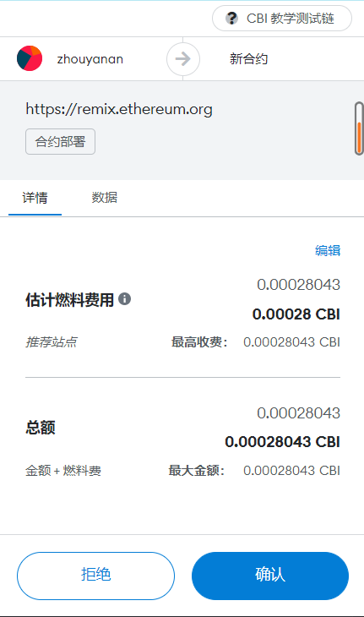

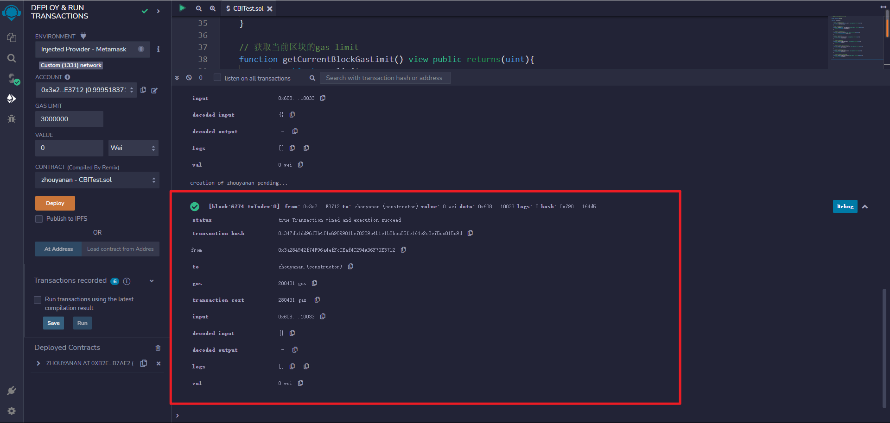

合约地址：0xB2E810ac42c8A18bb3D1Af4B8f13220C702b7Ae2  
合约代码：

// SPDX-License-Identifier: MIT

pragma solidity ^0.8.0;

contract zhouyanan{

    //获取一个地址的CBI余额

    function getBalance(address _user) view public returns(uint){

        return _user.balance;

    }

    //获取一个区块的哈希值

    function getHash(uint _blockNumber) view public returns(bytes32){

        return blockhash(_blockNumber);

    }

    // 获取上一个区块的哈希值

    function getLastBlockHash() view public returns(bytes32){

        return blockhash(block.number-1);

    }

    //获取当前的时间戳

    function getCurrentTimestamp() view public returns(uint){

        return block.timestamp;

    }

    // 获取当前区块的高度

    function getCurrentBlockHeight() view public returns(uint){

        return block.number;

    }

    // 获取当前区块的难度(difficulty)

    function getCurrentBlockDifficulty() view public returns(uint){

        return block.difficulty;

    }

    // 获取当前区块的gas limit

    function getCurrentBlockGasLimit() view public returns(uint){

        return block.gaslimit;

    }

    // 获取当前区块的coinbase账户

    function getCurrentBlockAccount() view public returns(address){

        return block.coinbase;

    }

}

实验结果：

