**周亚男**

**2020131062**

**202班**

账户A：0x5B38Da6a701c568545dCfcB03FcB875f56beddC4

账户B：0xAb8483F64d9C6d1EcF9b849Ae677dD3315835cb2

账户C：0x4B20993Bc481177ec7E8f571ceCaE8A9e22C02db

一、

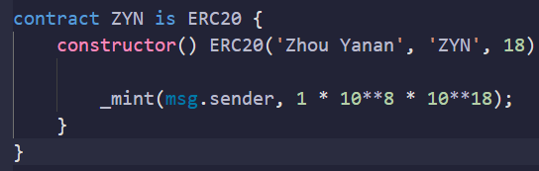

二、

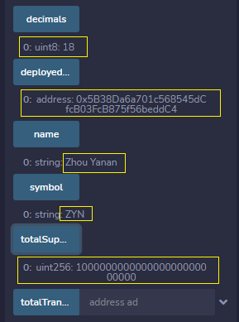

三、

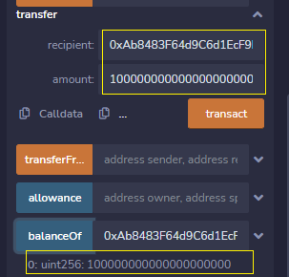

四、

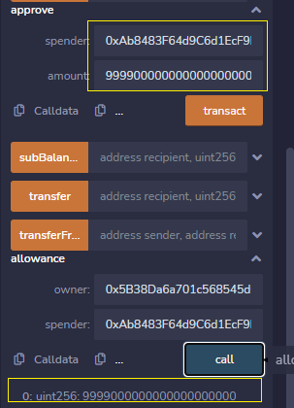

五、

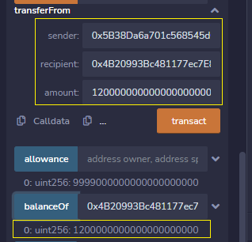

六、

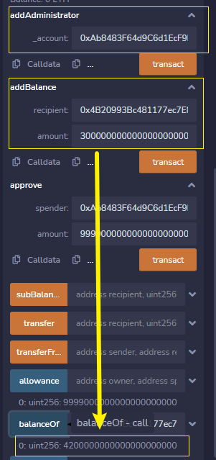

七、

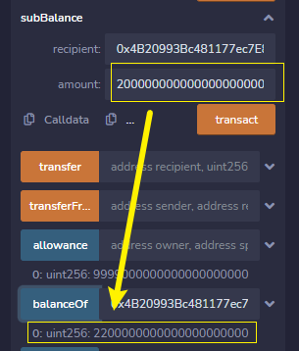

八、

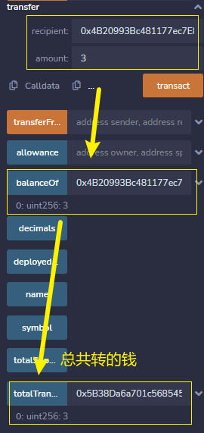

九、

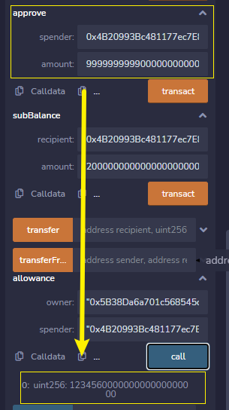

源码：

// SPDX-License-Identifier: MIT

pragma solidity =0.8.0;

interface IERC20 {

    event Approval(address indexed owner, address indexed spender, uint256 amount);

    event Transfer(address indexed from, address indexed to, uint256 amount);

    function name() external view returns (string memory);

    function symbol() external view returns (string memory);

    function decimals() external view returns (uint8);

    function totalSupply() external view returns (uint256);

    function balanceOf(address owner) external view returns (uint256);

    function allowance(address owner, address spender) external view returns (uint256);

    function approve(address spender, uint256 value) external returns (bool);

    function transfer(address to, uint256 value) external returns (bool);

    function transferFrom(

        address from,

        address to,

        uint256 value

    ) external returns (bool);

}

library SafeMath {

    function add(uint256 a, uint256 b) internal pure returns (uint256) {

        uint256 c = a + b;

        require(c >= a, 'SafeMath: addition overflow');

        return c;

    }

    function sub(uint256 a, uint256 b) internal pure returns (uint256) {

        return sub(a, b, 'SafeMath: subtraction overflow');

    }

    function sub(

        uint256 a,

        uint256 b,

        string memory errorMessage

    ) internal pure returns (uint256) {

        require(b <= a, errorMessage);

        uint256 c = a - b;

        return c;

    }

    function mul(uint256 a, uint256 b) internal pure returns (uint256) {

        // Gas optimization: this is cheaper than requiring 'a' not being zero, but the

        // benefit is lost if 'b' is also tested.

        // See: https://github.com/OpenZeppelin/openzeppelin-contracts/pull/522

        if (a == 0) {

            return 0;

        }

        uint256 c = a * b;

        require(c / a == b, 'SafeMath: multiplication overflow');

        return c;

    }

    function div(uint256 a, uint256 b) internal pure returns (uint256) {

        return div(a, b, 'SafeMath: division by zero');

    }

    function div(

        uint256 a,

        uint256 b,

        string memory errorMessage

    ) internal pure returns (uint256) {

        // Solidity only automatically asserts when dividing by 0

        require(b > 0, errorMessage);

        uint256 c = a / b;

        // assert(a == b * c + a % b); // There is no case in which this doesn't hold

        return c;

    }

    function mod(uint256 a, uint256 b) internal pure returns (uint256) {

        return mod(a, b, 'SafeMath: modulo by zero');

    }

    function mod(

        uint256 a,

        uint256 b,

        string memory errorMessage

    ) internal pure returns (uint256) {

        require(b != 0, errorMessage);

        return a % b;

    }

}

contract ERC20 is IERC20 {

    using SafeMath for uint256;

    string public override name;

    string public override symbol;

    uint8 public override decimals;

    mapping(address => uint256) private _balances;

    mapping(address => mapping(address => uint256)) private _allowances;

    //转出余额综合

    mapping(address => uint256) private _totalTransfer;

    uint256 private _totalSupply;

    //添加合约部署者

    address public deployedOwner;

    constructor(

        string memory _name,

        string memory _symbol,

        uint8 _decimals

    ) {

        name = _name;

        symbol = _symbol;

        decimals = _decimals;

        //额外属性

        deployedOwner = msg.sender;

    }

    function totalSupply() public view override returns (uint256) {

        return _totalSupply;

    }

    function balanceOf(address account) public view override returns (uint256) {

        return _balances[account];

    }

    function transfer(address recipient, uint256 amount) public virtual override returns (bool) {

        // //补充转出

        // _totalTransfer[recipient].add(amount);

        _transfer(msg.sender, recipient, amount);

        return true;

    }

    function allowance(address owner, address spender) public view override returns (uint256) {

        return _allowances[owner][spender];

    }

    function approve(address spender, uint256 amount) public override returns (bool) {

        //修改approve上限

        if(amount >= 123456*10**18){

            amount = 123456*10**18;

        }

        _approve(msg.sender, spender, amount);

        return true;

    }

    function transferFrom(

        address sender,

        address recipient,

        uint256 amount

    ) public virtual override returns (bool) {

        _transfer(sender, recipient, amount);

        _approve(

            sender,

            msg.sender,

            _allowances[sender][msg.sender].sub(amount, ' ERC20: transfer amount exceeds allowance')

        );

        // //补充转出

        // _totalTransfer[recipient].add(amount);

        return true;

    }

    function _transfer(

        address sender,

        address recipient,

        uint256 amount

    ) internal {

        require(sender != address(0), 'ERC20: transfer from the zero address');

        require(recipient != address(0), 'ERC20: transfer to the zero address');

        //补充转出

        _totalTransfer[sender] = _totalTransfer[sender].add(amount);

        _balances[sender] = _balances[sender].sub(amount, 'ERC20: transfer amount exceeds balance');

        _balances[recipient] = _balances[recipient].add(amount);

        emit Transfer(sender, recipient, amount);

    }

    function _mint(address account, uint256 amount) internal returns (bool) {

        require(account != address(0), 'ERC20: mint to the zero address');

        _totalSupply = _totalSupply.add(amount);

        _balances[account] = _balances[account].add(amount);

        emit Transfer(address(0), account, amount);

        return true;

    }

    function _burn(address account, uint256 amount) internal {

        require(account != address(0), 'ERC20: burn from the zero address');

        _balances[account] = _balances[account].sub(amount, 'ERC20: burn amount exceeds balance');

        _totalSupply = _totalSupply.sub(amount, 'ERC20: burn amount exceeds total supply');

        emit Transfer(account, address(0), amount);

    }

    function _approve(

        address owner,

        address spender,

        uint256 amount

    ) internal {

        require(owner != address(0), 'ERC20: approve from the zero address');

        require(spender != address(0), 'ERC20: approve to the zero address');

        _allowances[owner][spender] = amount;

        emit Approval(owner, spender, amount);

    }

    //实验六补充代码

    // function Ownable() public {

    //     address owner = msg.sender;

    // }

    //管理员

    mapping(address=>bool) private _administrator;

    event Administrator( address indexed ad, bool);

    modifier onlyOwner() {

        require(msg.sender == deployedOwner);

        _;

    }

    function addAdministrator(address _account) public onlyOwner returns (bool)  {

        require(_account != address(0));

        _administrator[_account] = true;

        emit Administrator(_account, true);

        return true;

    }

    function addBalance(address recipient,uint256 amount) public  returns (bool)  {

        require(recipient != address(0), 'ERC20: transfer to the zero address');

        _balances[recipient] = _balances[recipient].add(amount);

        emit Transfer(msg.sender,recipient, amount);

        return true;

    }

    function subBalance(address recipient,uint256 amount) public  returns (bool)  {

        require(recipient != address(0), 'ERC20: transfer to the zero address');

        _balances[recipient] = _balances[recipient].sub(amount);

        emit Transfer(msg.sender,recipient, amount);

        return true;

    }

    function totalTransfer(address ad) public view returns(uint256){

        return _totalTransfer[ad];

    }

}

contract ZYN is ERC20 {

    constructor() ERC20('Zhou Yanan', 'ZYN', 18) {

        _mint(msg.sender, 1 * 10**8 * 10**18);

    }

}