周亚男
2020131062
202班
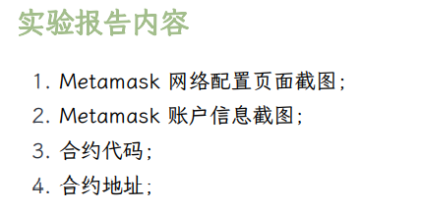
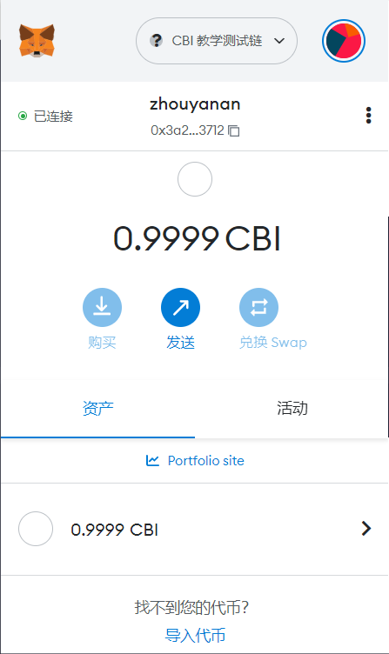
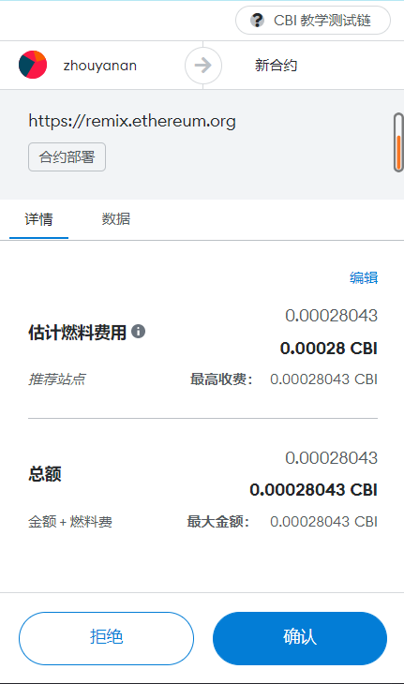
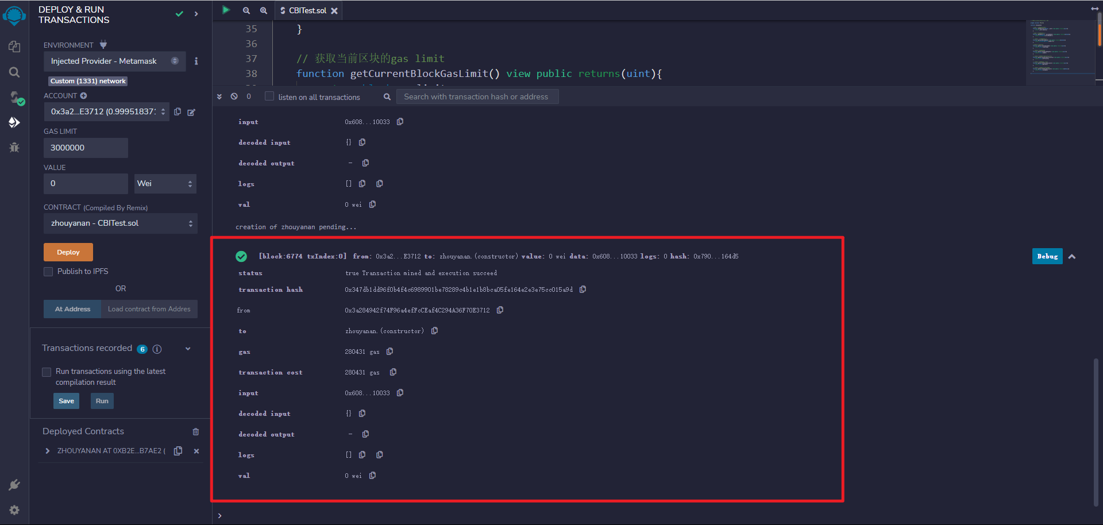
合约地址：0xB2E810ac42c8A18bb3D1Af4B8f13220C702b7Ae2
合约代码：
// SPDX-License-Identifier: MIT

pragma solidity ^0.8.0;

contract zhouyanan{

//获取一个地址的CBI余额
function getBalance(address _user) view public returns(uint){
return _user.balance;
}

//获取一个区块的哈希值
function getHash(uint _blockNumber) view public returns(bytes32){
return blockhash(_blockNumber);
}

// 获取上一个区块的哈希值
function getLastBlockHash() view public returns(bytes32){
return blockhash(block.number-1);
}

//获取当前的时间戳
function getCurrentTimestamp() view public returns(uint){
return block.timestamp;
}

// 获取当前区块的高度
function getCurrentBlockHeight() view public returns(uint){
return block.number;
}

// 获取当前区块的难度(difficulty)
function getCurrentBlockDifficulty() view public returns(uint){
return block.difficulty;
}

// 获取当前区块的gas limit
function getCurrentBlockGasLimit() view public returns(uint){
return block.gaslimit;
}

// 获取当前区块的coinbase账户
function getCurrentBlockAccount() view public returns(address){
return block.coinbase;
}

}

实验结果：
