周亚男
2020131062
202班

账户A：0x5B38Da6a701c568545dCfcB03FcB875f56beddC4
账户B：0xAb8483F64d9C6d1EcF9b849Ae677dD3315835cb2
账户C：0x4B20993Bc481177ec7E8f571ceCaE8A9e22C02db

一、
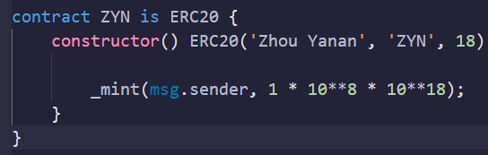

二、
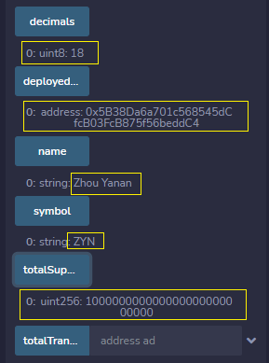

三、
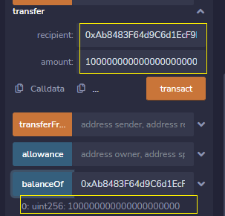

四、
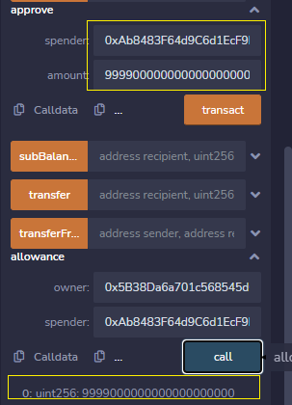

五、
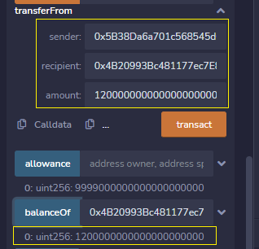

六、
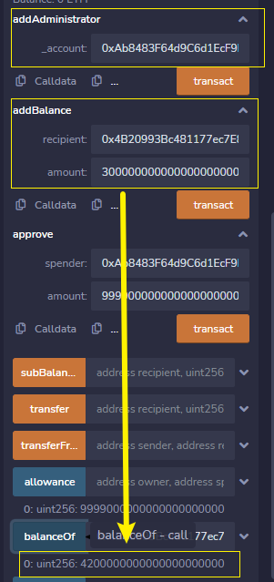

七、
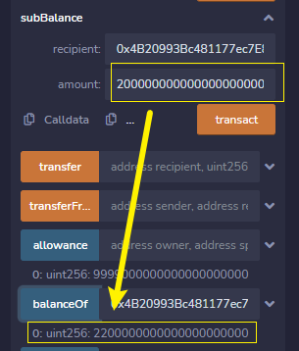

八、
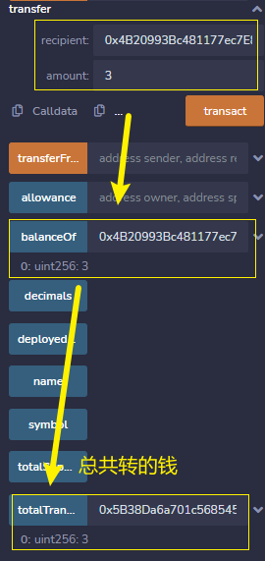

九、
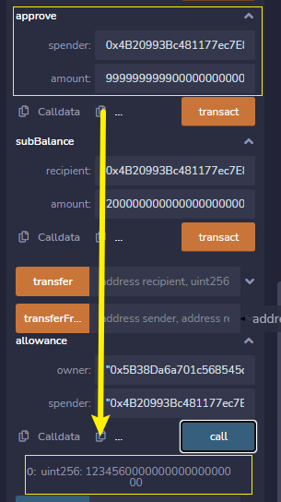

源码：
// SPDX-License-Identifier: MIT

pragma solidity =0.8.0;

interface IERC20 {
event Approval(address indexed owner, address indexed spender, uint256 amount);
event Transfer(address indexed from, address indexed to, uint256 amount);

function name() external view returns (string memory);

function symbol() external view returns (string memory);

function decimals() external view returns (uint8);

function totalSupply() external view returns (uint256);

function balanceOf(address owner) external view returns (uint256);

function allowance(address owner, address spender) external view returns (uint256);

function approve(address spender, uint256 value) external returns (bool);

function transfer(address to, uint256 value) external returns (bool);

function transferFrom(
address from,
address to,
uint256 value
) external returns (bool);
}

library SafeMath {
function add(uint256 a, uint256 b) internal pure returns (uint256) {
uint256 c = a + b;
require(c >= a, 'SafeMath: addition overflow');

return c;
}

function sub(uint256 a, uint256 b) internal pure returns (uint256) {
return sub(a, b, 'SafeMath: subtraction overflow');
}

function sub(
uint256 a,
uint256 b,
string memory errorMessage
) internal pure returns (uint256) {
require(b <= a, errorMessage);
uint256 c = a - b;

return c;
}

function mul(uint256 a, uint256 b) internal pure returns (uint256) {
// Gas optimization: this is cheaper than requiring 'a' not being zero, but the
// benefit is lost if 'b' is also tested.
// See: https://github.com/OpenZeppelin/openzeppelin-contracts/pull/522
if (a == 0) {
return 0;
}

uint256 c = a * b;
require(c / a == b, 'SafeMath: multiplication overflow');

return c;
}

function div(uint256 a, uint256 b) internal pure returns (uint256) {
return div(a, b, 'SafeMath: division by zero');
}

function div(
uint256 a,
uint256 b,
string memory errorMessage
) internal pure returns (uint256) {
// Solidity only automatically asserts when dividing by 0
require(b > 0, errorMessage);
uint256 c = a / b;
// assert(a == b * c + a % b); // There is no case in which this doesn't hold

return c;
}

function mod(uint256 a, uint256 b) internal pure returns (uint256) {
return mod(a, b, 'SafeMath: modulo by zero');
}

function mod(
uint256 a,
uint256 b,
string memory errorMessage
) internal pure returns (uint256) {
require(b != 0, errorMessage);
return a % b;
}
}

contract ERC20 is IERC20 {
using SafeMath for uint256;

string public override name;
string public override symbol;
uint8 public override decimals;

mapping(address => uint256) private _balances;
mapping(address => mapping(address => uint256)) private _allowances;

//转出余额综合
mapping(address => uint256) private _totalTransfer;

uint256 private _totalSupply;
//添加合约部署者
address public deployedOwner;

constructor(
string memory _name,
string memory _symbol,
uint8 _decimals
) {
name = _name;
symbol = _symbol;
decimals = _decimals;
//额外属性
deployedOwner = msg.sender;
}

function totalSupply() public view override returns (uint256) {
return _totalSupply;
}

function balanceOf(address account) public view override returns (uint256) {
return _balances[account];
}

function transfer(address recipient, uint256 amount) public virtual override returns (bool) {

// //补充转出
// _totalTransfer[recipient].add(amount);

_transfer(msg.sender, recipient, amount);
return true;
}

function allowance(address owner, address spender) public view override returns (uint256) {
return _allowances[owner][spender];
}

function approve(address spender, uint256 amount) public override returns (bool) {
//修改approve上限
if(amount >= 123456*10**18){
amount = 123456*10**18;
}

_approve(msg.sender, spender, amount);
return true;
}

function transferFrom(
address sender,
address recipient,
uint256 amount
) public virtual override returns (bool) {
_transfer(sender, recipient, amount);
_approve(
sender,
msg.sender,
_allowances[sender][msg.sender].sub(amount, ' ERC20: transfer amount exceeds allowance')
);

// //补充转出
// _totalTransfer[recipient].add(amount);
return true;
}

function _transfer(
address sender,
address recipient,
uint256 amount
) internal {
require(sender != address(0), 'ERC20: transfer from the zero address');
require(recipient != address(0), 'ERC20: transfer to the zero address');

//补充转出
_totalTransfer[sender] = _totalTransfer[sender].add(amount);

_balances[sender] = _balances[sender].sub(amount, 'ERC20: transfer amount exceeds balance');
_balances[recipient] = _balances[recipient].add(amount);

emit Transfer(sender, recipient, amount);
}

function _mint(address account, uint256 amount) internal returns (bool) {
require(account != address(0), 'ERC20: mint to the zero address');

_totalSupply = _totalSupply.add(amount);
_balances[account] = _balances[account].add(amount);
emit Transfer(address(0), account, amount);
return true;
}

function _burn(address account, uint256 amount) internal {
require(account != address(0), 'ERC20: burn from the zero address');

_balances[account] = _balances[account].sub(amount, 'ERC20: burn amount exceeds balance');
_totalSupply = _totalSupply.sub(amount, 'ERC20: burn amount exceeds total supply');
emit Transfer(account, address(0), amount);
}

function _approve(
address owner,
address spender,
uint256 amount
) internal {
require(owner != address(0), 'ERC20: approve from the zero address');
require(spender != address(0), 'ERC20: approve to the zero address');

_allowances[owner][spender] = amount;
emit Approval(owner, spender, amount);
}

//实验六补充代码

// function Ownable() public {
// address owner = msg.sender;
// }

//管理员
mapping(address=>bool) private _administrator;
event Administrator( address indexed ad, bool);

modifier onlyOwner() {
require(msg.sender == deployedOwner);
_;
}

function addAdministrator(address _account) public onlyOwner returns (bool) {
require(_account != address(0));
_administrator[_account] = true;
emit Administrator(_account, true);
return true;
}

function addBalance(address recipient,uint256 amount) public returns (bool) {

require(recipient != address(0), 'ERC20: transfer to the zero address');

_balances[recipient] = _balances[recipient].add(amount);
emit Transfer(msg.sender,recipient, amount);
return true;
}

function subBalance(address recipient,uint256 amount) public returns (bool) {

require(recipient != address(0), 'ERC20: transfer to the zero address');

_balances[recipient] = _balances[recipient].sub(amount);
emit Transfer(msg.sender,recipient, amount);
return true;
}

function totalTransfer(address ad) public view returns(uint256){
return _totalTransfer[ad];
}

}

contract ZYN is ERC20 {
constructor() ERC20('Zhou Yanan', 'ZYN', 18) {

_mint(msg.sender, 1 * 10**8 * 10**18);
}
}

