2020131062
周亚男
202

一．
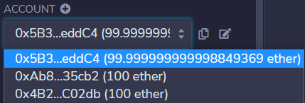
账户1：0x5B38Da6a701c568545dCfcB03FcB875f56beddC4
账户2：0xAb8483F64d9C6d1EcF9b849Ae677dD3315835cb2
账户3：0x4B20993Bc481177ec7E8f571ceCaE8A9e22C02db

二．
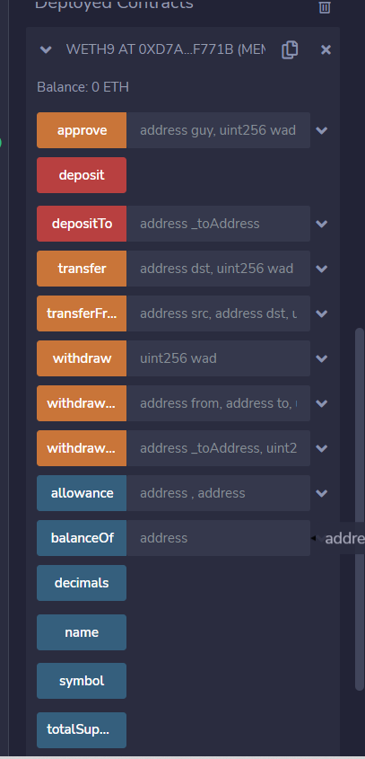

三．
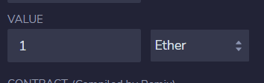

四．
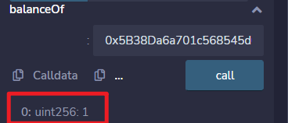
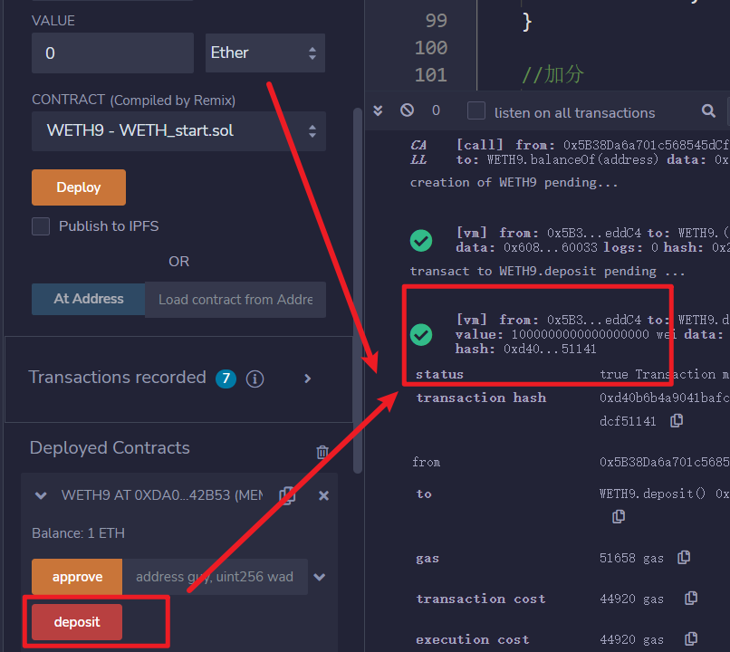

五．
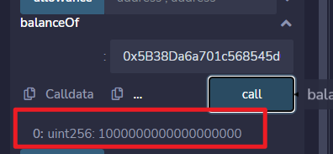

六．
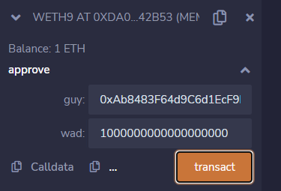

七．
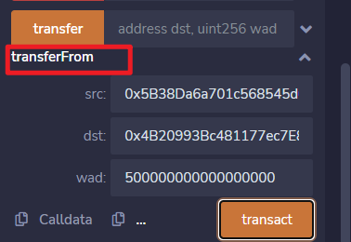
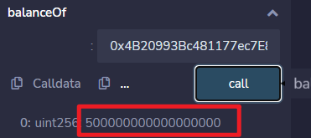

八．
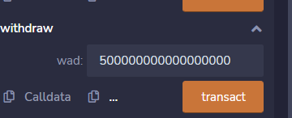
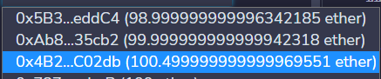

九．
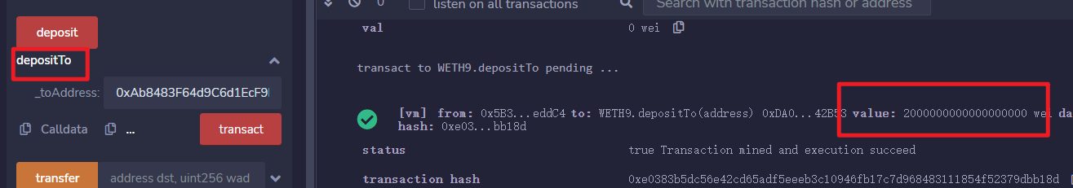
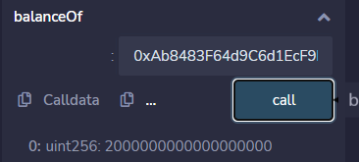

十．
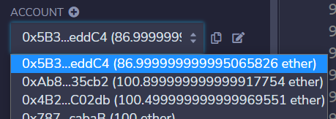
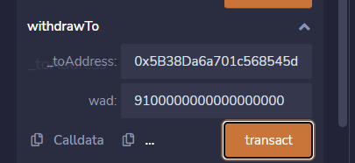
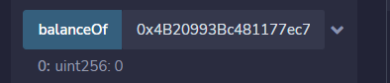

十一。


转账之前
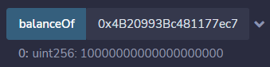

转账中
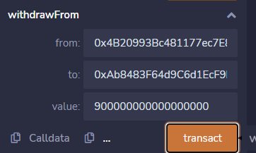

转账后
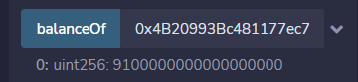

//解释eth和weth的联系与区别
// weth类似于黄金 eth类似于金钱
// 两个之间按比例兑换

//解释payable的作用
// 给合约或者变量一个支付通道，对应着以太币的支出收入

代码：
// SPDX-License-Identifier: GPL-3.0-or-later

pragma solidity 0.7.6;

contract WETH9 {
string public name = "Wrapped ETH";
string public symbol = "WETH";
uint8 public decimals = 18;

event Approval(address indexed src, address indexed guy, uint256 wad);
event Transfer(address indexed src, address indexed dst, uint256 wad);
event Deposit(address indexed dst, uint256 wad);
event Withdrawal(address indexed src, uint256 wad);

//增加事件
event WithdrawTo(address indexed src, address indexed dst,uint256 wad);
event DepositTo(address indexed src, address indexed dst,uint256 wad);

mapping(address => uint256) public balanceOf;
mapping(address => mapping(address => uint256)) public allowance;

function totalSupply() public view returns (uint256) {
return address(this).balance;
}

//要求deposit()必须转账 然后支付以太币？
receive() external payable {
deposit();
//补充
// withdrawTo();
}

//在发钱给合约时会改变msg.value的值。msg.value的值以wei为单位，数值大小为给合约打的wei的数量。
function deposit() public payable {
balanceOf[msg.sender] += msg.value;
emit Deposit(msg.sender, msg.value);
}

function withdraw(uint256 wad) public {
require(balanceOf[msg.sender] >= wad);
balanceOf[msg.sender] -= wad;
//这句的意义在哪里 转钱给自己
msg.sender.transfer(wad);
emit Withdrawal(msg.sender, wad);
}

function approve(address guy, uint256 wad) public returns (bool) {
allowance[msg.sender][guy] = wad;
emit Approval(msg.sender, guy, wad);
return true;
}
//调用者转钱给别人
function transfer(address dst, uint256 wad) public returns (bool) {
return transferFrom(msg.sender, dst, wad);
}

//和erc20的效果不一样了，这里直接转账了
function transferFrom(
address src,
address dst,
uint256 wad
) public returns (bool) {

require(balanceOf[src] >= wad);

//别人给我的亲属卡，我提取出来给别人

if (src != msg.sender && allowance[src][msg.sender] != uint256(-1)) {
require(allowance[src][msg.sender] >= wad);
allowance[src][msg.sender] -= wad;
}

balanceOf[src] -= wad;
balanceOf[dst] += wad;

emit Transfer(src, dst, wad);
return true;
}

//增加函数

//充钱时也可以打给别人账户，不一定非要自己的
function depositTo(address _toAddress) public payable {
balanceOf[_toAddress] += msg.value;
emit Deposit(_toAddress, msg.value);
emit DepositTo(msg.sender,_toAddress, msg.value);
}

//提现也可以提现到别人的账户
function withdrawTo(address payable _toAddress,uint256 wad) public {
require(balanceOf[msg.sender] >= wad);
balanceOf[msg.sender] -= wad;
// msg.sender.transfer(wad);
_toAddress.transfer(wad);

emit Withdrawal(msg.sender, wad);
emit WithdrawTo(msg.sender,_toAddress, wad);
}

//加分

//A提现 B打钱 C接收
function withdrawFrom(address from,address payable to,uint256 value) public returns(bool) {

require(allowance[from][msg.sender] >= value);
require(balanceOf[from] >= value);

allowance[from][msg.sender] -= value;
balanceOf[from] -= value;

to.transfer(value);
return true;
}

}

//解释eth和weth的联系与区别
// weth类似于黄金 eth类似于金钱
// 两个之间按比例兑换

//解释payable的作用
// 给合约或者变量一个支付通道，对应着以太币的支出收入

