**周亚男 2020131062**

## 完善合约代码

03_AlgorithmicStableCoin_start.sol

// SPDX-License-Identifier: MIT

pragma solidity ^0.8.0;

import "@openzeppelin/contracts/token/ERC20/ERC20.sol";

import "@openzeppelin/contracts/access/Ownable.sol";

import "./03_PriceFeed.sol";

contract AlgorithmicStablecoin is ERC20, Ownable {

    PriceFeed internal priceFeed;

    uint256 public targetPrice = 1 * 10 ** 8; // Target price of 1 USD with 8 decimals

    uint256 public expansionPercentage = 5; // 5% expansion or contraction

    constructor(

        uint256 initialSupply,

        address _priceFeed

    ) ERC20("Algo ZYN", "ALZYN") {

        super._mint(msg.sender, initialSupply);

        priceFeed = PriceFeed(_priceFeed);

    }

    function getLatestPrice() public view returns (uint256) {

        return priceFeed.getLatestPrice();

    }

    function adjustSupply() public onlyOwner {

        uint256 newTotalSupply = (expansionPercentage * balanceOf(msg.sender)) / 100;

        if (getLatestPrice() > targetPrice) {

            _mint(msg.sender, newTotalSupply);

        } else {

            _burn(msg.sender, newTotalSupply);

        }

    }

}

## 实验过程

1. 部署合约  
   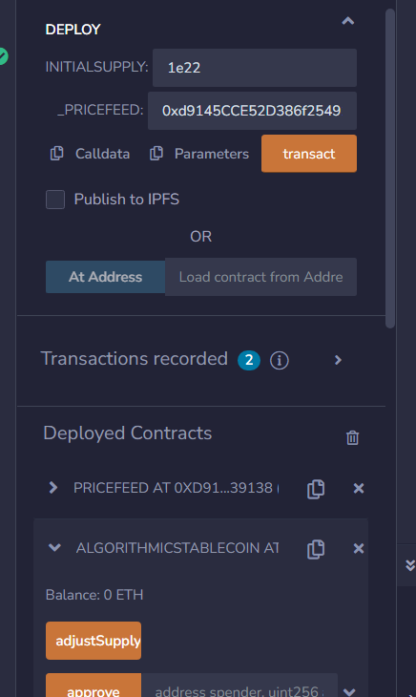
2. 查看owner余额  
   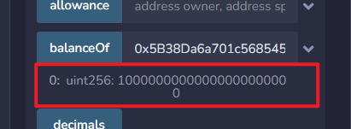
3. 修改价格为2e8  
   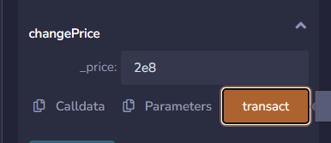
4. 调用adjustsupply
5. 查看owner余额  
   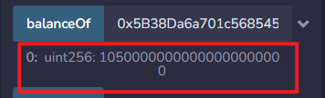
6. 修改价格为0.5e8  
   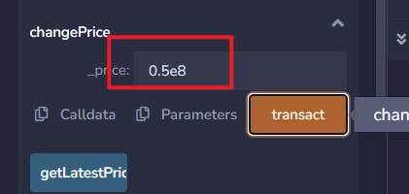
7. 调用adjustsupply
8. 查看owner余额  
   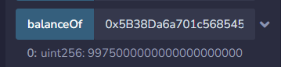
9. 9975 是如何计算出来的？  
   totalsupply*(1+5%)*(1-5%)=9975