**周亚男 2020131062**

## 完善合约代码

TokenA.sol

// SPDX-License-Identifier: SEE LICENSE IN LICENSE

pragma solidity ^0.8.12;

import "@openzeppelin/contracts/token/ERC20/ERC20.sol";

import "@openzeppelin/contracts/access/Ownable.sol";

import "@openzeppelin/contracts/token/ERC20/extensions/ERC20Burnable.sol";

contract TokenA is ERC20, Ownable, ERC20Burnable {

    constructor() ERC20("TokenA", "TokenA") {}

    function mint(address reciever, uint256 amount) public onlyOwner {

        _mint(reciever, amount);

    }

    function _burn(uint256 amount) public onlyOwner {

        burn(amount);

    }

}

TokenB.sol

// SPDX-License-Identifier: SEE LICENSE IN LICENSE

pragma solidity ^0.8.12;

import "@openzeppelin/contracts/token/ERC20/ERC20.sol";

import "@openzeppelin/contracts/access/Ownable.sol";

import "@openzeppelin/contracts/token/ERC20/extensions/ERC20Burnable.sol";

contract TokenB is ERC20, Ownable, ERC20Burnable {

    constructor() ERC20("TokenB", "TokenB") {}

    function mint(address reciever, uint256 amount) public onlyOwner {

        _mint(reciever, amount);

    }

    function _burn(uint256 amount) public onlyOwner {

        burn(amount);

    }

}

002_CSAMM.sol

// SPDX-License-Identifier: MIT

pragma solidity 0.8.16;

import "@openzeppelin/contracts/token/ERC20/IERC20.sol";

import "./TokenA.sol";

import "./TokenB.sol";

contract CSAMM {

    IERC20 immutable token0;

    IERC20 immutable token1;

    uint256 public reserve0;

    uint256 public reserve1;

    uint256 public totalSupply;

    // mapping(address => uint) public balanceOf;

    constructor(address _token0, address _token1) {

        token0 = IERC20(_token0);

        token1 = IERC20(_token1);

    }

    function _mint(address _to, uint256 _amount) private {

        // 此处补全

        require(_to == address(token0) || _to == address(token1));

        require(_amount > 0);

        //mint并不是private 为什么不能调用

        // IERC20(_to).mint(msg.sender, address(this), _amount);

        if (_to == address(token0)) {

            reserve0 += _amount;

            token0.transferFrom(msg.sender, address(this), _amount);

        } else {

            reserve1 += _amount;

            token1.transferFrom(msg.sender, address(this), _amount);

        }

        _update(reserve0, reserve1);

        totalSupply += _amount;

    }

    function _burn(address _from, uint256 _amount) private {

        require(_from == address(token0) || _from == address(token1));

        require(

            _amount > 0 && IERC20(_from).balanceOf(address(this)) >= _amount

        );

        // IERC20(_from)._burn(address(this), _amount);

        if (_from == address(token0)) {

            reserve0 -= _amount;

            token0.transfer(msg.sender, _amount);

        } else {

            reserve1 -= _amount;

            token1.transfer(msg.sender, _amount);

        }

        _update(reserve0, reserve1);

        totalSupply -= _amount;

    }

    function swap(

        address _tokenIn,

        uint256 _amountIn

    ) external returns (uint256 amountOut) {

        amountOut = _amountIn;

        if (_tokenIn == address(token0)) {

            _mint(address(token0), _amountIn);

            _burn(address(token1), amountOut);

        } else {

            _mint(address(token1), _amountIn);

            _burn(address(token0), amountOut);

        }

        return amountOut;

    }

    function addLiquidity(

        uint256 _amount0,

        uint256 _amount1

    ) external returns (uint256 shares) {

        _mint(address(token0), _amount0);

        _mint(address(token1), _amount1);

        return (_amount0 + _amount1);

    }

    function removeLiquidity(

        uint256 _shares

    ) external returns (uint256 d0, uint256 d1) {

        require(_shares > 0 && totalSupply >= _shares);

        d0 = (_shares * reserve0) / totalSupply;

        d1 = _shares - d0;

        _burn(address(token0), d0);

        _burn(address(token1), d1);

        return (d0, d1);

    }

    function _update(uint256 _res0, uint256 _res1) private {

        reserve0 = _res0;

        reserve1 = _res1;

    }

}

## 实验步骤

1. 部署tokenA和tokenB  
   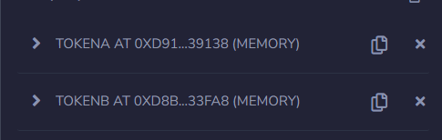
2. 部署csamm合约  
   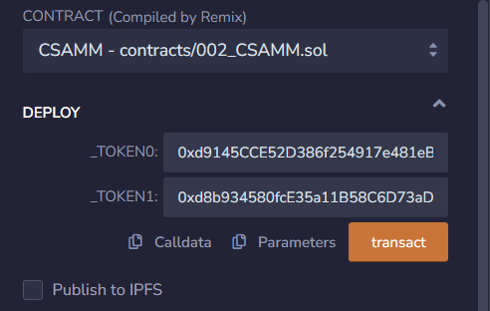
3. 添加流动性  
   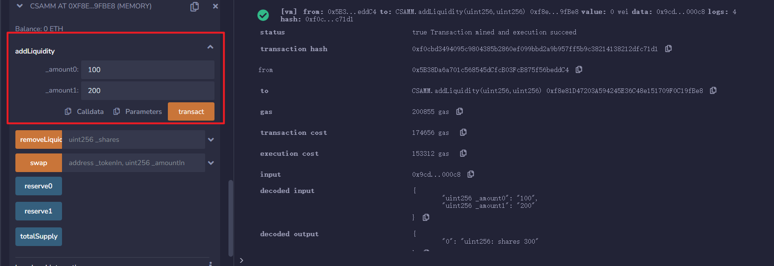
4. 查看状态  
   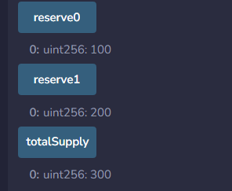
5. 购买25个tokenB  
   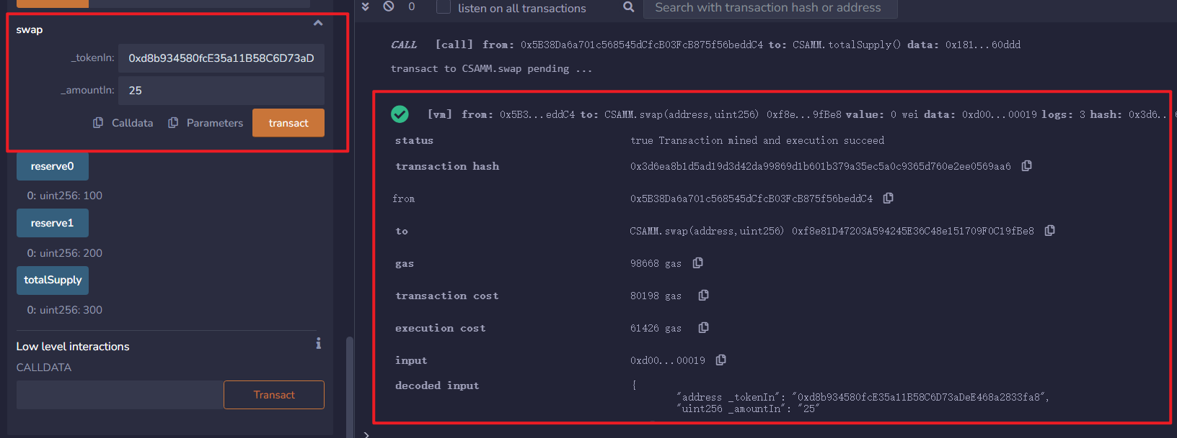
6. 查看状态  
   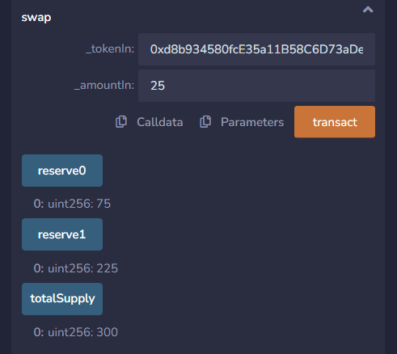
7. 移除流动性150  
   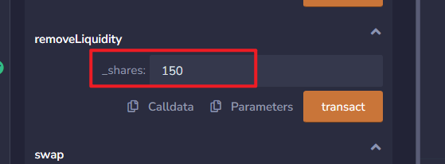
8. 查看状态  
   