**NEWTECH ENTERPRISE**

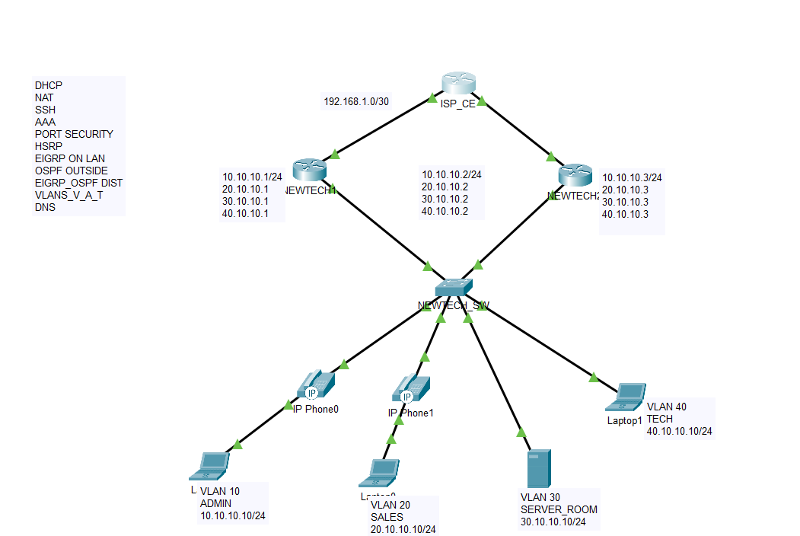

**README**

***This topology has 1 ISP CE routers, 2 LAN Routers, 1 Switch, 4 LAN, 4 voice VLAN***

***The configurations include DHCP,NAT,SSH,AAA,HSRP,EIGRP,VLANS,DNS,STP,PORT SECURITY***

***The STP was configured to match with the HSRP standby as the switch G0/1 interface which is the outbound interface to NEWTECH1(Router) is the primary pass for Vlan 10 and 20, Voice LAN 11 and 21, NEWTECH1 is the primary pass for same VLAN***

***Whereas***

***switch G0/2 interface which is the outbound interface to NEWTECH2(Router) is the primary pass for Vlan 30 and 40, Voice LAN 31 and 41, NEWTECH2 is the primary pass for same VLAN***

***Also an access-list was configured to make sure that only the TECH department can login to the various nodes with telnet and SSH***

**PING TEST FROM LAN(ADMIN) TO ISP**

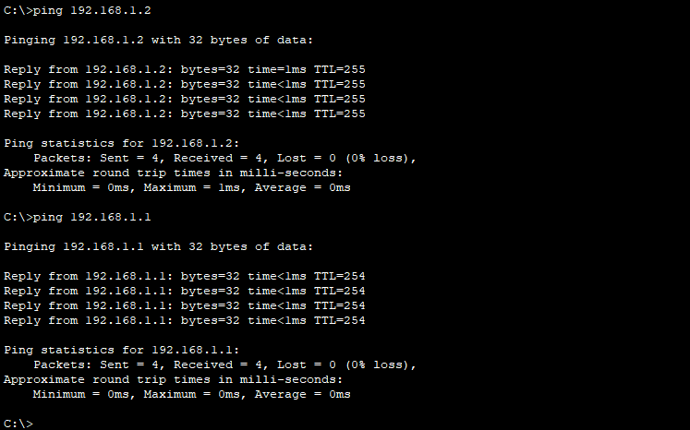

**This shows the successful connection from the LAN(ADMIN DEPT) to the ISP interface facing the LAN.**

**NEWTECH_SW**

**Hostname NEWTECH_SW**

**Vlan 10**

**Name admin**

**Vlan 11**

**Name adm_v**

**Vlan 20**

**Name sales**

**Vlan 21**

**Name sales_v**

**Vlan 30**

**Name Server_room**

**Vlan 31**

**Name server_v**

**Vlan 40**

**Name Tech**

**Vlan 41**

**Name tech_v**

**username good secret good1**

**aaa new-model**

**aaa authentication login default local**

**aaa authentication enable default enable**

**access-list 10 permit 40.10.10.0 0.0.0.255**

**Line console 0**

**privilege level 15**

**motd-banner**

**exec-timeout 5 30**

**login authentication default**

**exit**

**ip default-gateway 40.10.10.1**

**ip domain-name goodnews**

**exit**

**interface vlan 40**

**ip address 40.10.10.4 255.255.255.0**

**Exit**

**crypto key generate rsa**

**1024**

**ip ssh version 2**

**line vty 4 15**

**transport input all**

**privilege level 15**

**motd-banner**

**exec-timeout 5 30**

**login authentication default**

**Exit**

**interface FastEthernet0/1**

**description to vlan10_11**

**switchport mode access**

**switchport access vlan 10**

**switchport voice vlan 11**

**spanning-tree portfast**

**spanning-tree bpduguard enable**

**switchport port-security**

**switchport port-security maximum 4**

**switchport port-security violation restrict**

**switchport port-security mac-address sticky**

**interface FastEthernet0/2**

**description to vlan20_21**

**switchport mode access**

**switchport access vlan 20**

**switchport voice vlan 21**

**spanning-tree portfast**

**spanning-tree bpduguard enable**

**switchport port-security**

**switchport port-security maximum 4**

**switchport port-security violation restrict**

**switchport port-security mac-address sticky**

**interface FastEthernet0/3**

**description to vlan30_31**

**switchport mode access**

**switchport access vlan 30**

**switchport voice vlan 31**

**spanning-tree portfast**

**spanning-tree bpduguard enable**

**switchport port-security**

**switchport port-security maximum 4**

**switchport port-security violation restrict**

**switchport port-security mac-address sticky**

**interface FastEthernet0/4**

**description to vlan40_41**

**switchport mode access**

**switchport access vlan 40**

**switchport voice vlan 41**

**spanning-tree portfast**

**spanning-tree bpduguard enable**

**switchport port-security**

**switchport port-security maximum 4**

**switchport port-security violation restrict**

**switchport port-security mac-address sticky**

**interface GigabitEthernet0/1**

**description to NEWTECH1**

**switchport mode trunk**

**switchport trunk native vlan 50**

**switchport trunk allowed vlan 10-45**

**spanning-tree portfast trunk**

**spanning-tree vlan 10-21 cost 10**

**spanning-tree vlan 10-21 port-priority 32**

**spanning-tree vlan 30-41 cost 50**

**spanning-tree vlan 30-41 port-priority 64**

**interface GigabitEthernet0/2**

**description to NEWTECH2**

**switchport mode trunk**

**switchport trunk native vlan 50**

**switchport trunk allowed vlan 10-45**

**spanning-tree portfast trunk**

**spanning-tree vlan 30-41 cost 10**

**spanning-tree vlan 30-41 port-priority 32**

**spanning-tree vlan 10-21 cost 50**

**spanning-tree vlan 10-21 port-priority 64**

**NEWTECH1**

**Hostname NEWTECH1**

**username good secret good1**

**aaa new-model**

**aaa authentication login default local**

**aaa authentication enable default enable**

**access-list 10 permit 40.10.10.0 0.0.0.255**

**access-list 1 permit 10.10.10.0 0.0.0.255**

**access-list 1 permit 20.10.10.0 0.0.0.255**

**access-list 1 permit 30.10.10.0 0.0.0.255**

**access-list 1 permit 40.10.10.0 0.0.0.255**

**ip domain-name goodnews**

**Line console 0**

**privilege level 15**

**motd-banner**

**exec-timeout 5 30**

**login authentication default**

**exit**

**crypto key generate rsa**

**1024**

**ip ssh version 2**

**line vty 4 15**

**access-class 10 in**

**transport input all**

**privilege level 15**

**motd-banner**

**exec-timeout 5 30**

**login authentication default**

**Exit**

**ip nat inside source list 1 interface g0/2 overload**

**interface GigabitEthernet0/1.10**

**encapsulation dot1Q 10**

**ip address 10.10.10.1 255.255.255.0**

**standby 1 ip 10.10.10.2**

**Standby 1 preempt**

**Standby 1 priority 120**

**Ip nat inside**

**interface GigabitEthernet0/1.20**

**encapsulation dot1Q 20**

**ip address 20.10.10.1 255.255.255.0**

**standby 1 ip 20.10.10.2**

**Standby 1 preempt**

**Standby 1 priority 120**

**Ip nat inside**

**interface GigabitEthernet0/1.30**

**encapsulation dot1Q 30**

**ip address 30.10.10.1 255.255.255.0**

**standby 1 ip 30.10.10.2**

**Standby 1 priority 100**

**Ip nat inside**

**interface GigabitEthernet0/1.40**

**encapsulation dot1Q 40**

**ip address 40.10.10.1 255.255.255.0**

**standby 1 ip 40.10.10.2**

**Standby 1 priority 100**

**Ip nat inside**

**int g0/1**

**ip nat inside**

**Desc to LAN**

**No sh**

**int g0/2**

**ip add 192.168.1.2 255.255.255.0**

**Desc to ISP**

**ip nat outside**

**No sh**

**router eigrp 1**

**network 10.10.10.0 0.0.0.255**

**network 20.10.10.0 0.0.0.255**

**network 30.10.10.0 0.0.0.255**

**network 40.10.10.0 0.0.0.255**

**network 192.168.1.0 0.0.0.3**

**ip dhcp excluded-address 10.10.10.1 10.10.10.5**

**ip dhcp excluded-address 20.10.10.1 20.10.10.5**

**ip dhcp excluded-address 30.10.10.1 30.10.10.5**

**ip dhcp excluded-address 40.10.10.1 40.10.10.5**

**Ip dhcp pool pool4**

**Default-router 10.10.10.2**

**Network 10.10.10.0 255.255.255.0**

**Ip dhcp pool pool1**

**domain-name MTN**

**dns-server 8.8.8.8**

**Exit**

**Ip dhcp pool pool2**

**Default-router 20.10.10.2**

**Network 20.10.10.0 255.255.255.0**

**Ip dhcp pool pool1**

**domain-name MTN**

**dns-server 8.8.8.8**

**Exit**

**Ip dhcp pool pool3**

**Default-router 30.10.10.2**

**Network 30.10.10.0 255.255.255.0**

**Ip dhcp pool pool1**

**domain-name MTN**

**dns-server 8.8.8.8**

**Exit**

**Ip dhcp pool pool1**

**Default-router 40.10.10.2**

**Network 40.10.10.0 255.255.255.0**

**Ip dhcp pool pool1**

**domain-name MTN**

**dns-server 8.8.8.8**

**exit**

**NEWTECH2**

**Hostname NEWTECH2**

**username good secret good1**

**aaa new-model**

**aaa authentication login default local**

**aaa authentication enable default enable**

**access-list 10 permit 40.10.10.0 0.0.0.255**

**access-list 1 permit 10.10.10.0 0.0.0.255**

**access-list 1 permit 20.10.10.0 0.0.0.255**

**access-list 1 permit 30.10.10.0 0.0.0.255**

**access-list 1 permit 40.10.10.0 0.0.0.255**

**ip domain-name goodnews**

**Line console 0**

**privilege level 15**

**motd-banner**

**exec-timeout 5 30**

**login authentication default**

**exit**

**crypto key generate rsa**

**1024**

**ip ssh version 2**

**line vty 4 15**

**access-class 10 in**

**transport input all**

**privilege level 15**

**motd-banner**

**exec-timeout 5 30**

**login authentication default**

**Exit**

**ip nat inside source list 1 interface g0/0 overload**

**interface GigabitEthernet0/1.10**

**encapsulation dot1Q 10**

**ip address 10.10.10.3 255.255.255.0**

**standby 1 ip 10.10.10.2**

**Standby 1 priority 100**

**Ip nat inside**

**interface GigabitEthernet0/1.20**

**encapsulation dot1Q 20**

**ip address 20.10.10.3 255.255.255.0**

**standby 1 ip 20.10.10.2**

**Standby 1 priority 100**

**Ip nat inside**

**interface GigabitEthernet0/1.30**

**encapsulation dot1Q 30**

**ip address 30.10.10.3 255.255.255.0**

**standby 1 ip 30.10.10.2**

**Standby 1 preempt**

**Standby 1 priority 120**

**Ip nat inside**

**interface GigabitEthernet0/1.40**

**encapsulation dot1Q 40**

**ip address 40.10.10.3 255.255.255.0**

**standby 1 ip 40.10.10.2**

**Standby 1 preempt**

**Standby 1 priority 120**

**Ip nat inside**

**int g0/2**

**ip nat inside**

**Desc to LAN**

**No sh**

**int g0/0**

**ip add 192.168.2.2 255.255.255.0**

**Desc to ISP**

**ip nat outside**

**No sh**

**router eigrp 1**

**network 10.10.10.0 0.0.0.255**

**network 20.10.10.0 0.0.0.255**

**network 30.10.10.0 0.0.0.255**

**network 40.10.10.0 0.0.0.255**

**network 192.168.2.0 0.0.0.3**

**ip dhcp excluded-address 10.10.10.1 10.10.10.5**

**ip dhcp excluded-address 20.10.10.1 20.10.10.5**

**ip dhcp excluded-address 30.10.10.1 30.10.10.5**

**ip dhcp excluded-address 40.10.10.1 40.10.10.5**

**Ip dhcp pool pool4**

**Default-router 10.10.10.2**

**Network 10.10.10.0 255.255.255.0**

**Ip dhcp pool pool1**

**domain-name MTN**

**dns-server 8.8.8.8**

**Exit**

**Ip dhcp pool pool2**

**Default-router 20.10.10.2**

**Network 20.10.10.0 255.255.255.0**

**Ip dhcp pool pool1**

**domain-name MTN**

**dns-server 8.8.8.8**

**Exit**

**Ip dhcp pool pool3**

**Default-router 30.10.10.2**

**Network 30.10.10.0 255.255.255.0**

**Ip dhcp pool pool1**

**domain-name MTN**

**dns-server 8.8.8.8**

**Exit**

**Ip dhcp pool pool1**

**Default-router 40.10.10.2**

**Network 40.10.10.0 255.255.255.0**

**Ip dhcp pool pool1**

**domain-name MTN**

**dns-server 8.8.8.8**

**Exit**

**ISP**

**hostname ISP**

**username good secret good1**

**aaa new-model**

**aaa authentication login default local**

**aaa authentication enable default enable**

**access-list 10 permit 40.10.10.0 0.0.0.255**

**ip domain-name goodnews**

**Line console 0**

**privilege level 15**

**motd-banner**

**exec-timeout 5 30**

**login authentication default**

**exit**

**crypto key generate rsa**

**1024**

**ip ssh version 2**

**line vty 4 15**

**access-class 10 in**

**transport input all**

**privilege level 15**

**motd-banner**

**exec-timeout 5 30**

**login authentication default**

**Exit**

**router eigrp 1**

**network 192.168.2.0 0.0.0.3**

**network 192.168.1.0 0.0.0.3**