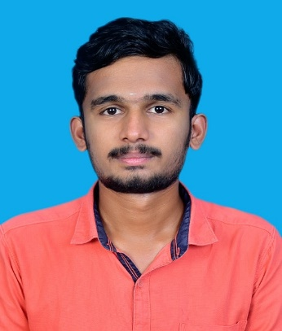

# Contact

GOPAALAKRISNAN C

### C O M P U T E R S C I E N C E E N G I N E E R I N G S T U D E N T

A highly motivated and dedicated computer science professional looking for a challenging and high-performance-oriented role in the field of computer engineering and implementing my expertise and skills to the growth of the company and myself.

# Education



### +919487215350

 gopaalakrisnanc@gmail.com

### Nazareth,Tamil Nadu

**www.linkedin.com/in/gopaalakrisnan-c-76b141290**

**https://github.com/GOPAALAKRISNAN3012**

**2021 - 2025**

**B.E Computer Science and Engineering - 7.1 CGPA**

**2020-2021 HSC-89.5**

Kanchi Sri Sankara AMHSS

**2019-2020 SSLC-74.5**

Kanchi Sri Sankara AMHSS

*National Engineering College - K.R. Nagar, Kovilpatti*

# Skills

Programming Languages :

Java

Web Technologies : HTML,CSS

Javascript

Problem Solving Git,Github

# Achievements

Spearheaded technical & Non technical events for the Department Symposium.

Leetcode - 10+ problems solved

Sri rama krishna college,coimbatore.

Won 1st prize

**Area of Interest**

* Front end Development
* SQL

# Internships

# Internshala-Machine Learning(12 weeks)

# Oracle Apex(16 weeks)

# Certifications

Front-End Development HTML - Great Learning CSS3 - Infosys SpringBoard

NPTEL:-

1.Cloud Computing

2.Introduction To Industry 4.0 And Industrial Internet Of Things

3.Software Testing (IIITB)

4.Software Conceptual Design

# Projects

## College Management System (completed)

*Low code Sql*

The College Management System, built on Oracle APEX, optimizes academic processes, improving data management and facilitating seamless communication within the college.

## Portfolio (completed)

*HTML,CSS*

My portfolio is a curated showcase of my diverse skills and projects, reflecting my expertise in areas such as web development, design, and problem-solving.

HTML



**HTMl(Completed)**

Html

Developed a web page of top 5 Instagram celebrites using basic html.

**OccationOrganizerHub(Completed)**

The Occasion Organizer Hub is a dynamic platform I created to streamline event planning.

**Spotify Clone(Completed)**

**Html,Css**

My Spotify Clone project replicates the key features of the popular music streaming platform, demonstrating my proficiency in recreating complex applications and showcasing front-end skills.