Product Line Profitability & Margin Performance Analysis
Nassau Candy Distributor
Research Paper: Exploratory Analysis, Insights and Recommendations
Prepared by: Gopal Krushna Panda
Centurion University of Technology and Management
Unified Mentor Data Analytics Project
October 2026

Abstract
This study analyses 10,194 cleaned order records of Nassau Candy Distributor, covering 02 Jan 2024 to 31 Dec 2025, to find out which product lines truly drive profit and which weaken the company's margins. Total sales of $141,784 generated a gross profit of $93,443, a gross margin of 65.9%. Profit is highly concentrated: 5 of 15 products (33%) deliver 80% of profit, and the Chocolate division alone accounts for 92.9% of revenue. Kazookles is the weakest product at a 7.7% margin, and the Other division earns 44.8% against 65.9% for the company overall. The paper closes with pricing, sourcing and portfolio recommendations.

1. Introduction

1.1 Background
For a distributor, sales volume alone can be misleading. Some products sell in large quantities but earn little profit, consume a disproportionate share of manufacturing cost, or appear successful while quietly weakening the overall margin. To stay competitive, Nassau Candy needs to know which products truly drive profit, which divisions underperform, and where pricing, sourcing or portfolio decisions are needed.

1.2 Problem statement
The organisation lacks clear visibility into which product lines deliver the highest gross margin, whether high-sales products are actually profitable, how profitability varies across divisions, and which products represent margin risk. Without this, decisions on pricing, promotions and the product portfolio remain reactive and based on intuition.

1.3 Objectives
- Measure gross margin, profit per unit and profit contribution for every product.
- Rank products and identify high-profit, high-sales/low-margin and low-sales/low-profit groups.
- Compare divisions on revenue, profit and margin, and detect structural margin problems.
- Measure profit concentration using Pareto (80/20) analysis and identify over-dependency risk.
- Diagnose cost structure and flag products for repricing, cost renegotiation or discontinuation review.
- Deliver an interactive Streamlit dashboard so stakeholders can explore the results themselves.

2. Data and Methodology

2.1 Dataset
The dataset contains order-level records with order and shipping dates, customer geography, division, product, sales, units, cost and gross profit. After cleaning, 10,194 records remain, covering 15 products in 3 divisions (Chocolate, Other, Sugar) between 02 Jan 2024 and 31 Dec 2025.

2.2 Data cleaning and validation
The following steps were applied before any analysis, using Python (pandas):
- Column names and text labels (division, product, region) were trimmed and standardised, including consistent product-name formatting.
- Exact duplicate records were removed.
- Records with invalid dates, or with missing sales, cost or gross profit, were removed.
- Records with zero or negative sales, or negative cost, were removed.
- Missing or invalid unit values were filled with the median units for the same product.
- Gross profit was cross-checked against Sales minus Cost.
Table 1 summarises the effect of each cleaning step.
Cleaning step | Rows
Rows in raw file | 10,194
Duplicate rows removed | 0
Rows removed: invalid/missing Order Date | 0
Rows removed: missing Sales/Cost/Profit | 0
Rows removed: zero or negative Sales | 0
Rows removed: negative Cost | 0

Table 1: Data cleaning summary

2.3 Metrics and KPIs
KPI | Definition
Gross Margin (%) | Gross Profit ÷ Sales × 100
Profit per Unit | Gross Profit ÷ Units
Revenue Contribution | Product sales ÷ total sales
Profit Contribution | Product gross profit ÷ total gross profit
Margin Volatility | Standard deviation of the product's monthly gross margin

Products are grouped by comparing them with the portfolio: 'High profit / High margin' products have profit at or above the median and margin at or above the overall margin; 'High sales / Low margin' products have sales at or above the median but margin below the overall margin; 'Low sales / Low profit' products fall below the median on both.

3. Overall Performance
Metric | Value
Total sales | $141,783.63
Total cost | $48,340.83
Total gross profit | $93,442.80
Overall gross margin | 65.91%
Units sold | 38,654
Profit per unit | $2.42
Products analysed | 15

Table 2: Company-level key performance indicators

4. Product-Level Profitability

4.1 Highest-profit products
Wonka Bar - Scrumdiddlyumptious is the largest profit contributor with $19,358 (20.7% of total profit). Table 3 lists the five most profitable products.
Product | Division | Sales | Gross Profit | Margin % | Profit/Unit
Wonka Bar - Scrumdiddlyumptious | Chocolate | $27,875 | $19,358 | 69.4 | $2.50
Wonka Bar - Triple Dazzle Caramel | Chocolate | $28,485 | $18,610 | 65.3 | $2.45
Wonka Bar - Milk Chocolate | Chocolate | $26,868 | $17,443 | 64.9 | $2.11
Wonka Bar - Nutty Crunch Surprise | Chocolate | $23,575 | $16,820 | 71.3 | $2.49
Wonka Bar - Fudge Mallows | Chocolate | $24,890 | $16,594 | 66.7 | $2.40

Table 3: Top five products by gross profit
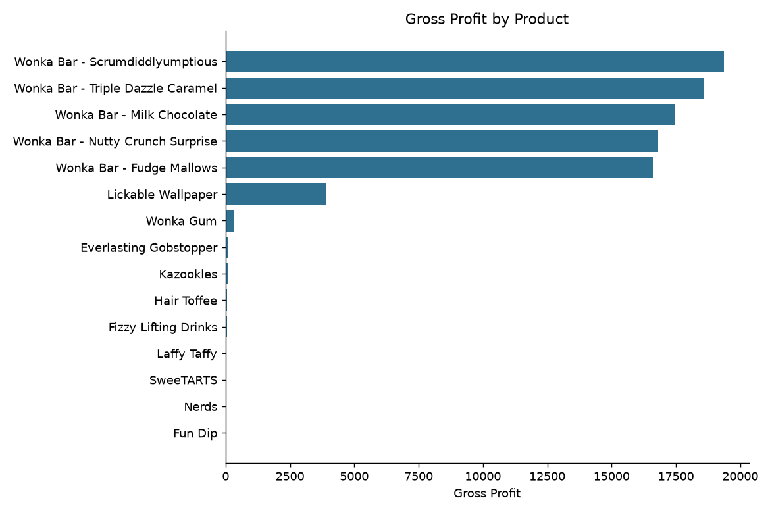
Figure 1: Gross profit by product

4.2 Margin leaderboard
Everlasting Gobstopper has the highest margin at 80.0%, while Kazookles has the lowest at 7.7%. Table 4 shows the five weakest margins; Figure 2 marks in red every product below the overall margin of 65.9%.
Product | Division | Sales | Gross Profit | Margin % | Cost % of Sales
Kazookles | Other | $1,206 | $93 | 7.7 | 92.3
Fun Dip | Sugar | $12 | $5 | 40.0 | 60.0
SweeTARTS | Sugar | $62 | $29 | 46.7 | 53.3
Nerds | Sugar | $15 | $7 | 46.7 | 53.3
Lickable Wallpaper | Other | $7,860 | $3,930 | 50.0 | 50.0

Table 4: Five lowest-margin products
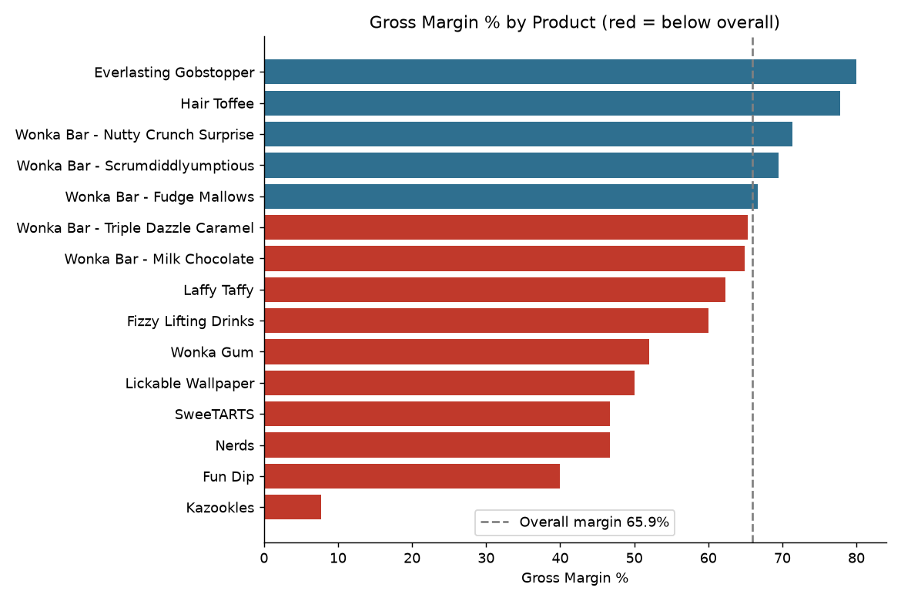
Figure 2: Gross margin % by product (red = below overall margin)

4.3 Product groups
Group | Products
High profit / High margin | Wonka Bar - Scrumdiddlyumptious; Wonka Bar - Nutty Crunch Surprise; Wonka Bar - Fudge Mallows; Everlasting Gobstopper
High sales / Low margin | Wonka Bar - Triple Dazzle Caramel; Wonka Bar - Milk Chocolate; Lickable Wallpaper; Wonka Gum; Kazookles
Low sales / Low profit | Hair Toffee; Fizzy Lifting Drinks; Laffy Taffy; SweeTARTS; Nerds; Fun Dip

Table 5: Product classification

5. Division-Level Performance
Division | Sales | Gross Profit | Margin % | Revenue Share % | Profit Share %
Chocolate | $131,693 | $88,825 | 67.5 | 92.9 | 95.1
Other | $9,663 | $4,333 | 44.8 | 6.8 | 4.6
Sugar | $427 | $285 | 66.6 | 0.3 | 0.3

Table 6: Division performance
The Chocolate division generates 92.9% of revenue and 95.1% of profit, so it carries the business. The Other division has the weakest margin (44.8%) and its profit share (4.6%) is below its revenue share (6.8%), which points to a structural margin issue. The Sugar division is very small, with only $427 in sales (0.30% of revenue).
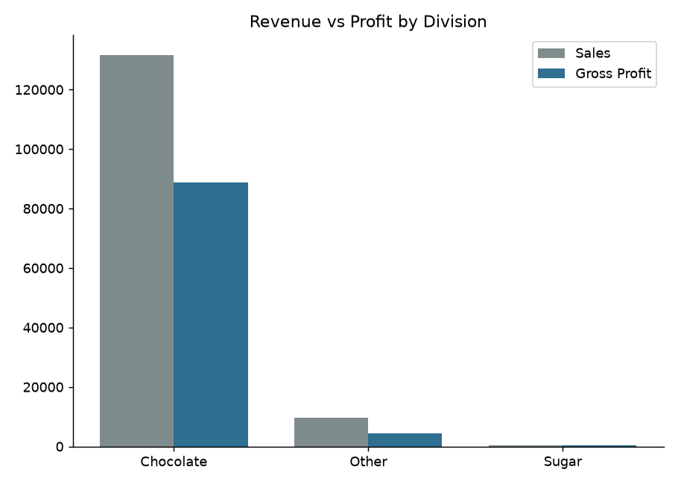
Figure 3: Revenue versus gross profit by division
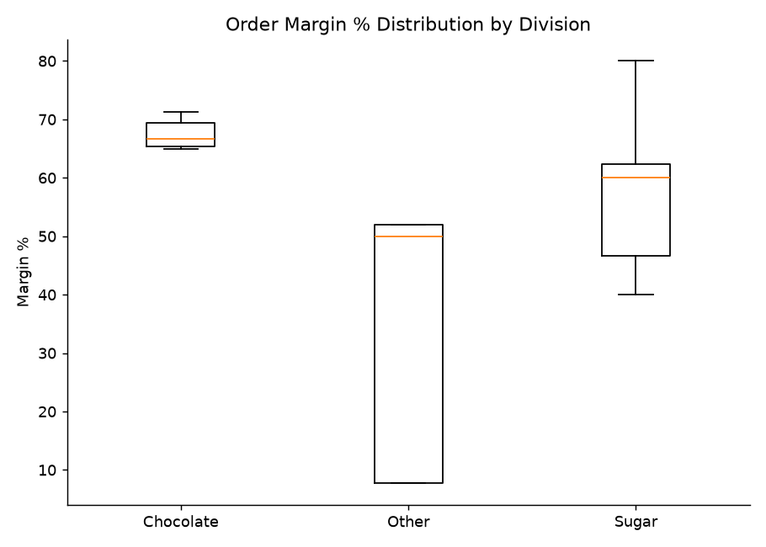
Figure 4: Distribution of order-level margin by division

6. Profit Concentration (Pareto) Analysis
5 of 15 products (33%) generate 80% of revenue, and 5 of 15 (33%) generate 80% of profit. The products behind 80% of profit are: Wonka Bar - Scrumdiddlyumptious, Wonka Bar - Triple Dazzle Caramel, Wonka Bar - Milk Chocolate, Wonka Bar - Nutty Crunch Surprise, Wonka Bar - Fudge Mallows. 5 of these 5 products belong to the Chocolate division. The single largest product contributes 20.7% of total profit. This is a clear over-dependency risk: a supply, quality or demand problem affecting a few chocolate products would hit the whole business.
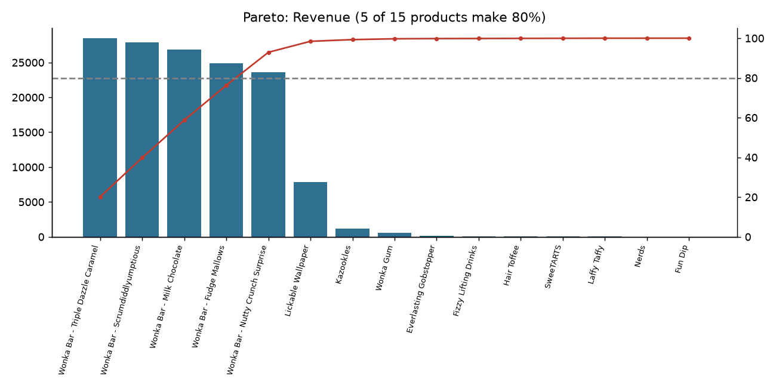
Figure 5: Pareto chart of revenue
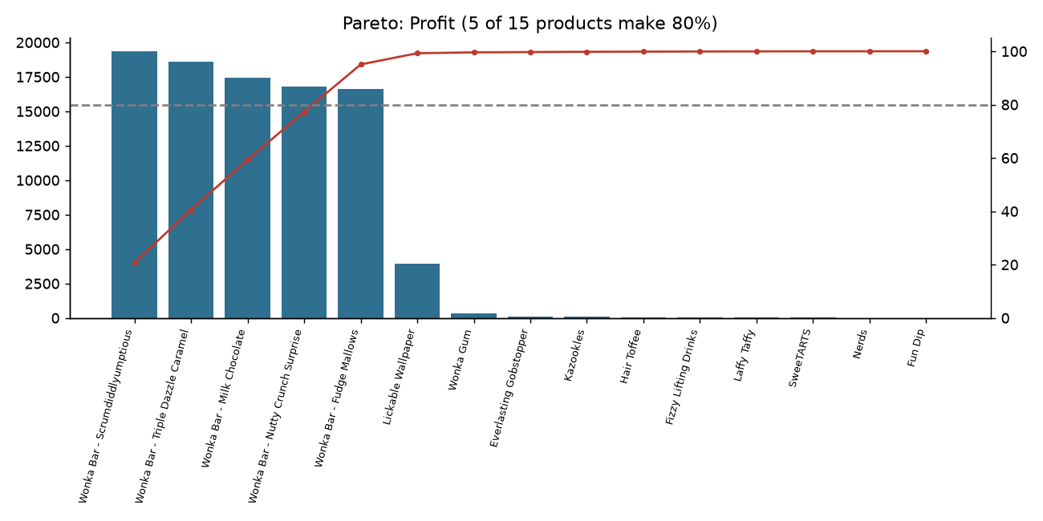
Figure 6: Pareto chart of gross profit

7. Cost Structure Diagnostics
Figure 7 plots total cost against total sales for each product. Points far above the dashed break-even line have cost close to or above sales; points well below it are healthy. Bubble size shows units sold.
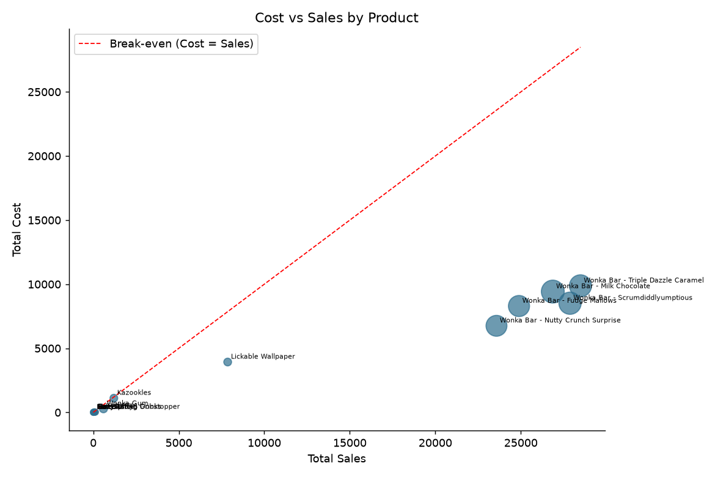
Figure 7: Cost versus sales by product
Products with a margin below the overall margin are flagged: 'Cost renegotiation' when sales are at or above the median (the product sells well but costs too much), 'Discontinuation review' when both sales and profit are below the median, and 'Repricing' otherwise.
Product | Division | Sales | Margin % | Flag
Kazookles | Other | $1,206 | 7.7 | Cost renegotiation
Fun Dip | Sugar | $12 | 40.0 | Discontinuation review
Nerds | Sugar | $15 | 46.7 | Discontinuation review
SweeTARTS | Sugar | $62 | 46.7 | Discontinuation review
Lickable Wallpaper | Other | $7,860 | 50.0 | Cost renegotiation
Wonka Gum | Other | $598 | 52.0 | Cost renegotiation
Fizzy Lifting Drinks | Sugar | $79 | 60.0 | Discontinuation review
Laffy Taffy | Sugar | $54 | 62.3 | Discontinuation review
Wonka Bar - Milk Chocolate | Chocolate | $26,868 | 64.9 | Cost renegotiation
Wonka Bar - Triple Dazzle Caramel | Chocolate | $28,485 | 65.3 | Cost renegotiation

Table 7: Products flagged for action

8. Key Insights
- Profit comes from a few products: 5 products (33% of the range) deliver 80% of profit, and 5 of them are Chocolate products.
- High overall margin hides weak spots: the company margin is 65.9%, but Kazookles earns only 7.7% (cost is 92.3% of its sales).
- The Other division earns 44.8% margin versus 67.5% in Chocolate, so mix shift toward Other would dilute total margin.
- Size of the prize: a 1-point margin gain in Chocolate is worth about $1,317, more than a 10-point gain on Kazookles (about $121). The biggest profit lever is the core range, not the weakest product.
- 6 products each sold under $100 in total. Their low profit comes mainly from low volume, so the question for them is demand, not just pricing.

9. Recommendations
- Protect the core: secure supply, quality and stock levels for Wonka Bar - Scrumdiddlyumptious, Wonka Bar - Triple Dazzle Caramel, Wonka Bar - Milk Chocolate, Wonka Bar - Nutty Crunch Surprise, Wonka Bar - Fudge Mallows, since they generate 80% of profit.
- Reduce concentration risk: build second-tier growth by promoting mid-performing products and testing new items, so profit does not rest on 5 products.
- Fix Kazookles: review its selling price and renegotiate its manufacturing cost, then decide whether to keep it if its margin stays near 8%.
- Review the Other division: compare prices and unit costs product by product, and target a margin closer to the company average.
- Decide on low-volume products (Hair Toffee, Fizzy Lifting Drinks, Laffy Taffy, SweeTARTS, Nerds, Fun Dip): either invest in demand (promotion, wider distribution) or rationalise them, rather than leaving them unmanaged.
- Monitor margin monthly using the dashboard and its margin-threshold slider, so that products drifting below the target are caught early.

10. Limitations
- Only gross profit (Sales minus manufacturing cost) is available. Shipping, marketing and overhead costs are not included, so net profit may differ.
- Margins are high compared with typical confectionery benchmarks; it is worth confirming how 'Cost' is defined in the source system.
- Flags and product groups are relative to the portfolio average and median, so products only slightly below average (for example, within about one percentage point) may be flagged. The dashboard threshold slider lets users apply their own target.
- Some products have very small sales, so their margins and volatility figures are based on little data and should be treated with caution.
- The analysis covers one dataset and period; seasonality and trends beyond this window are not assessed.

11. Conclusion
Nassau Candy is profitable overall (65.9% gross margin), but its profit is concentrated in a handful of chocolate products, and a few products and one division earn clearly lower margins. Acting on the actions above (protecting the core range, fixing the weakest product and division, and managing low-volume items) would move the company from reactive to data-driven decisions. The accompanying Streamlit dashboard allows these findings to be monitored and updated.

Appendix A: Full product metrics
Product | Sales | Units | Gross Profit | Margin % | Profit/Unit | Volatility
Wonka Bar - Scrumdiddlyumptious | $27,875 | 7,743 | $19,358 | 69.4 | $2.50 | 0.0
Wonka Bar - Triple Dazzle Caramel | $28,485 | 7,596 | $18,610 | 65.3 | $2.45 | 0.0
Wonka Bar - Milk Chocolate | $26,868 | 8,267 | $17,443 | 64.9 | $2.11 | 0.0
Wonka Bar - Nutty Crunch Surprise | $23,575 | 6,755 | $16,820 | 71.3 | $2.49 | 0.0
Wonka Bar - Fudge Mallows | $24,890 | 6,914 | $16,594 | 66.7 | $2.40 | 0.0
Lickable Wallpaper | $7,860 | 393 | $3,930 | 50.0 | $10.00 | 0.0
Wonka Gum | $598 | 478 | $311 | 52.0 | $0.65 | 0.0
Everlasting Gobstopper | $130 | 13 | $104 | 80.0 | $8.00 | 0.0
Kazookles | $1,206 | 371 | $93 | 7.7 | $0.25 | 0.0
Hair Toffee | $76 | 17 | $60 | 77.8 | $3.50 | 0.0
Fizzy Lifting Drinks | $79 | 21 | $47 | 60.0 | $2.25 | 0.0
Laffy Taffy | $54 | 27 | $33 | 62.3 | $1.24 | 0.0
SweeTARTS | $62 | 41 | $29 | 46.7 | $0.70 | 0.0
Nerds | $15 | 10 | $7 | 46.7 | $0.70 | 0.0
Fun Dip | $12 | 8 | $5 | 40.0 | $0.60 | 0.0

Appendix B: Streamlit dashboard
The interactive dashboard (app.py) provides four modules:
- Product Overview: margin leaderboard, profit contribution chart and product table.
- Division Performance: revenue versus profit comparison and margin distribution.
- Cost vs Margin: cost-sales scatter plot and margin-risk flags.
- Profit Concentration: Pareto charts and dependency indicators.
Users can filter by date range and division, set a margin threshold, and search for products. Run it with: streamlit run app.py

