Untitled Digging Game

Game Introduction:
The game begins with a cinematic cutscene. The player approaches a fully built house, but as they draw near, it suddenly collapses and breaks into pieces. From the ruins, a man appears—The Builder. He guides the player to the initial Sand Area, introducing the core loop of digging, completing quests, and gathering materials to rebuild the house.

Concept Visualization

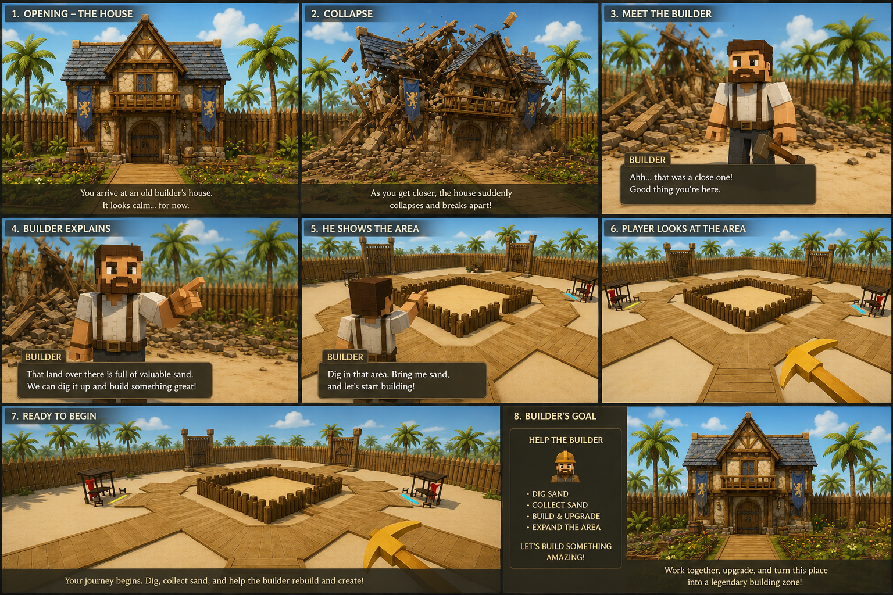








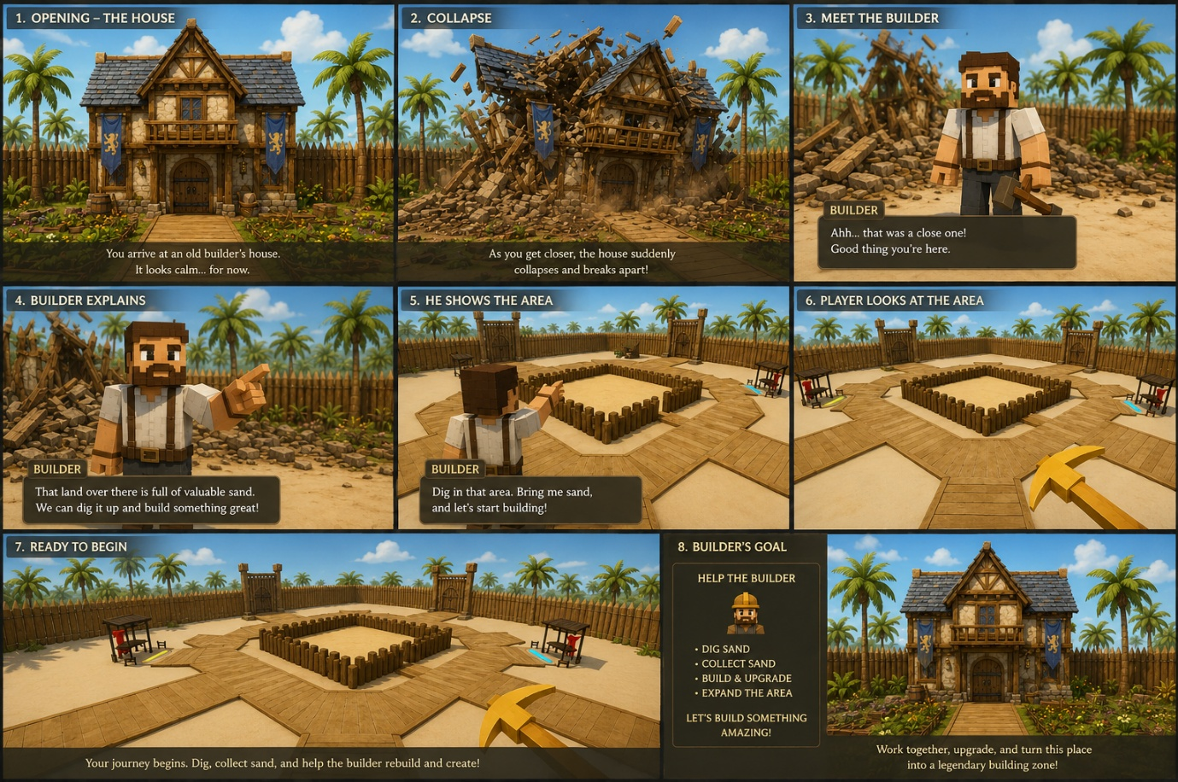



There are 5 Phases in this Game
- Phase 1: Site Preparation
- Phase 2: Basement Work
- Phase 3: Industrial Stage
- Phase 4: Woodwork
- Phase 5: Wrap up

Players go through each phase to complete the game, The main motive of the game is to rebuild the house

Each phase builder will ask for some resources or money which player needs to grind through the sand area which was introduced in the starting cut scene.

Core game mechanic is the digging part in the game

There will be a big sand area in the center of the world, where player can dig for sand.

Players will get four primary resources while digging
- Sand
- Iron
- Gold
- Diamond

Player’s use digging tools to dig and also have backpack to manage resource
Digging tools properties
- Break power
  - How much sand it can dig.

- Break Time
  - How much time it takes to dig the sand.

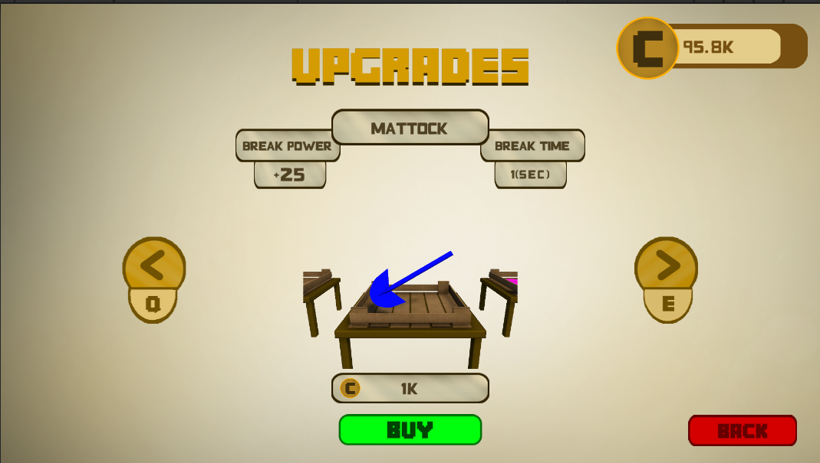

There are total of 8 digging tools in games
- Trowel
- Medium Shovel
- Spade
- Mattock
- Rotary Drill
- Jackhammer
- Earth Auger
- Terraformer

Also backpack which has 8 tiers, on upgrading these tiers, player can carry more resource, making him spend more time in digging

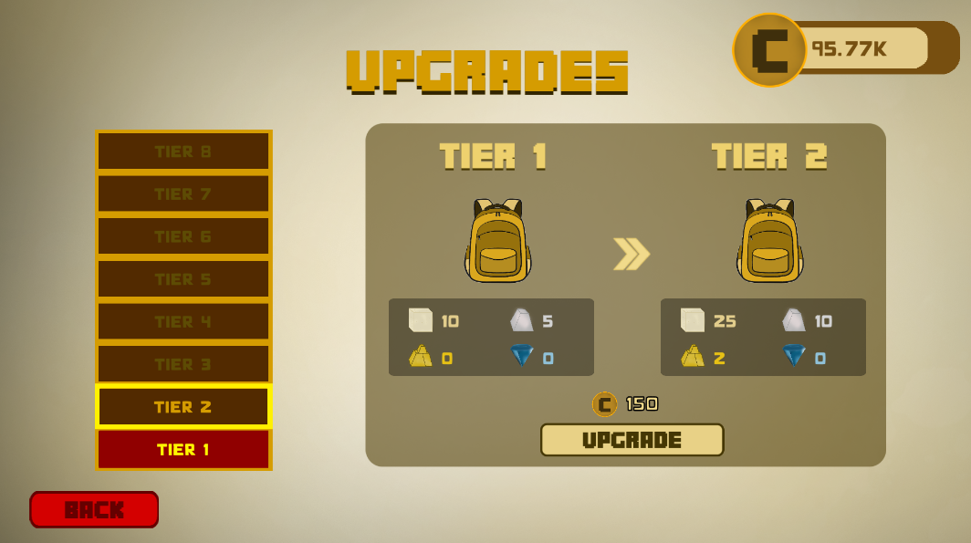

Once the backpack is full, player can store all this in the storage, there is a storage booth player can visit the booth, and store all the primary resources, Player can’t dig further if the backpack is full

These stored resources can be reused in trading in the final phase.
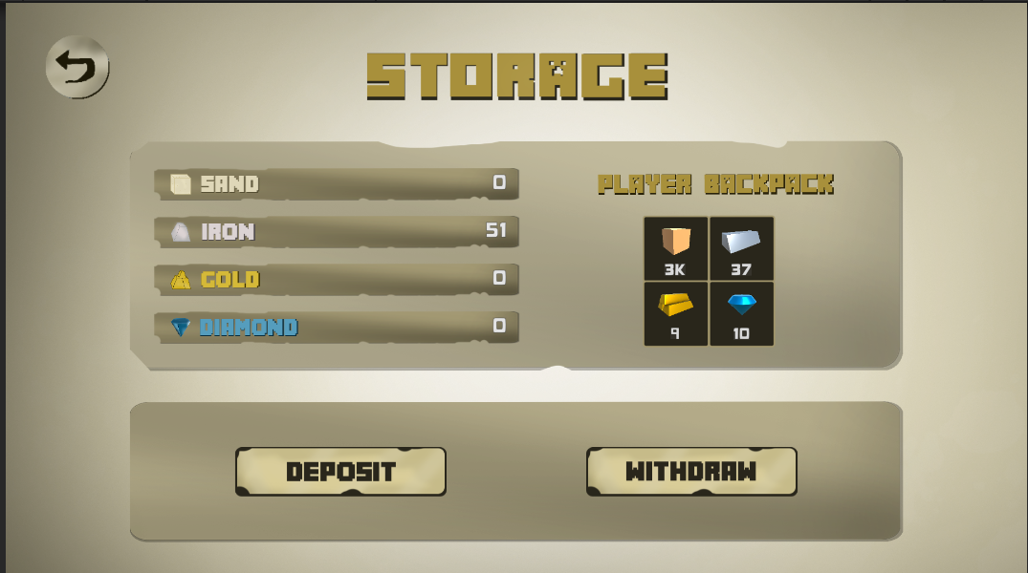
How players earn coins?
- Players complete quests and earn coins
- There will be a quest booth, who will have three active quests, on completing the quest, player will get reward
- Once the set of three quest is complete, another set of three quest will appear.
- On doing this, the reward will also increase

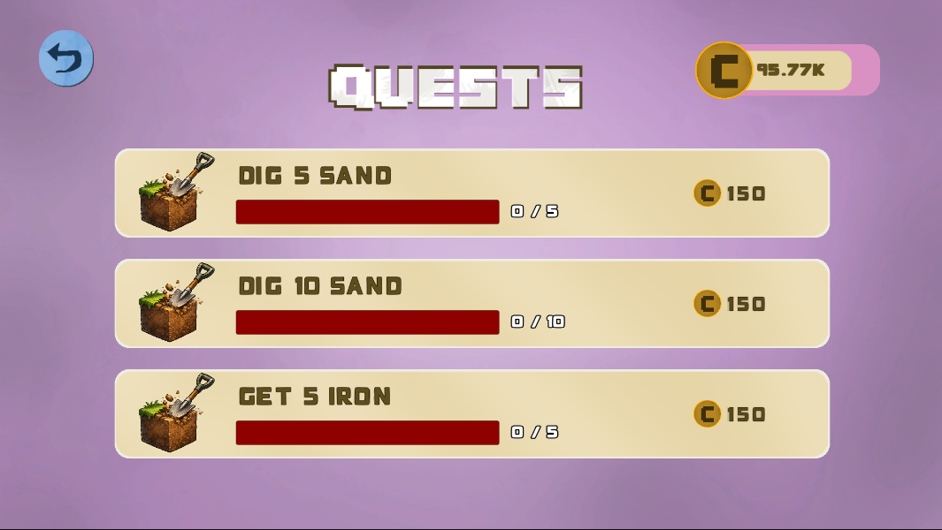

Phase 1: Site Preparation

Goal of the Phase:
- Prepare the site for construction
  - There will be a lot of broken parts in the area which need to be cleared out.

  - The Builder will ask for money in Phase One to do this.

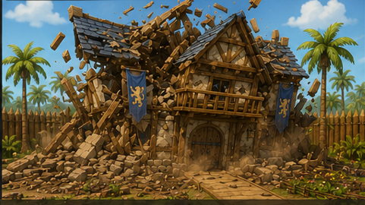

Motive of Phase 1
- Introduce the player to the game world.
- Teach the player how to earn money to complete objectives.
- Teach the player how quests work, how storage works, and how backpacks efficiently manage resources.

Phase completion:
- In this phase, there are no industrial mechanics. The player only digs, completes quests, and earns money. Once the required amount is earned, Phase 1 is complete.

Phase 2: Base Work

Goal of the Phase:
- Once site preparation is complete, the builder asks for items to build the basement/foundation.

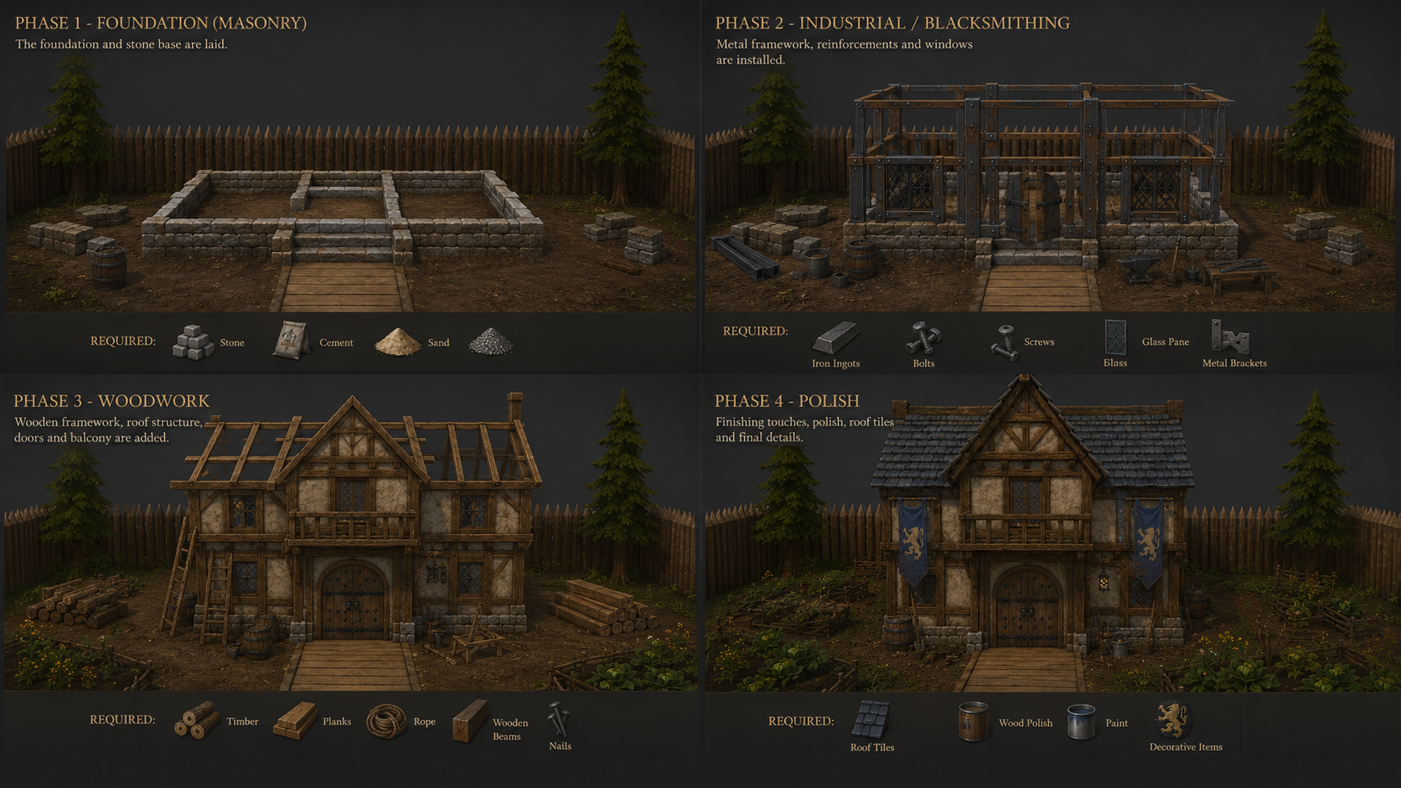

The resources are categorized into two types
- Primary Resources
- Secondary Resources

Primary resources are obtained through digging
- Sand
- Iron
- Gold
- Diamond
Secondary resources are obtained through industrial machines using the primary resources

This phase introduces the industrial area, starting with two machines: the Mortar (makes sand cement) and the Kiln (makes heavy blocks).

Machine Properties
- Fuel: The shop will start selling fuel. Players must buy and use fuel to run the machines.
- Convert Time: How much time it takes to make the final product.
- Queue: Players can stack the next process in the waiting queue. After one process is done, it jumps to the next.

Machine Upgrades
- Using coins, players can upgrade machines to:
  - Decrease convert time
  - Increase fuel capacity (can convert more inputs)
  - Unlock more queue slots.

Phase Completion:
- Players gather primary resources, use the machines to make secondary resources requested by the builder, and hand them over. This completes Phase 2, and the basement is laid.

Phase 3: Industrial Stage

Goal of the phase:
- The main goal of the third phase will be steel, building a strong foundation for the building.
- Here we make resources using the secondary resources.



Finding Molds (Exploration)
- Players will have to find chests with a specific index. On opening that chest, the player will get Molds.

Builder will ask for:
- Nuts
- Bolts
- Steel Rods
- Steel Plates
Production Chains
- Iron is base for everything
  - Steel is made using Iron.
  - Steel Rods are made using Rod Molds and Steel.
  - Steel Plates are made using Plate Molds and Steel.
  - Nuts are made using Nut Molds and Steel Rods.
  - Bolts are made using Bolt Molds and Steel Rods.

Machines in this Phase
- Steel Mill: Used to make Steel from Iron.
- Steel Press: Used to make rods, Plates, Nuts and Bolts by changing molds.

What will Player learn in this Phase?
- Players will get to know about Molds.
- Players will know how to make resources by switching Molds.
- Players will know how to make resources from secondary resources.

Phase Completion:
- Once all the resources are ready, the player can approach the builder and complete the phase. So, the foundation work is complete.

Phase 4: Woordwork

Goal of the phase:
- The main purpose of this phase is to cover the house with wood. The Builder will ask for specific items which the player must grind to gather.



What's New in this Phase?
- Saplings: Introduced as a new item that can be bought in the shop for coins, acting as a late-game currency sink.

- Forestry Section: A new section opens at the start of Phase 4. The player plants saplings here, waits for them to grow, chops them down for wood logs, and feeds them into machines.

Builder Needs
- Wooden Planks
- Wooden Beams
- Glass Panes
- Nails

Machines in this Phase
All new machines use the established logic of Fuel, Convert Time, Queues, and Coin Upgrades.
- Plank Machine: Converts Wood Logs into Wooden Planks.
- Beams Machine: Converts Wood Logs into Wooden Beams.
- Glass Machine: Converts Sand into Glass Panes.
- Nail Machine: An all-in-one press that takes Steel Rods (from Phase 3), draws them into wire, and cuts them into Nails.

Phase Completion:
The player grinds these four items utilizing previous underground mechanics alongside the new surface forestry mechanics. Once the required items are handed over to the Builder, the house's woodwork is completed, and the game progresses to the final Phase 5.

Phase 5: Wrap Up

Goal of the Phase:
- Now that all the wooden work is done, the player needs to do some polish work on the house.



Builder Needs
In this phase, the builder will ask for finishing touches:
- Lights
- Paintings
- Carvings
- All other polish things

The Trading Section
We open the final section in this phase, which is Trading.
- In this section, there will be a lot of trading booths.
- The player can go trade with the dealers for the required final items.
- Once the player trades for these items, they hand them over to the builder to complete the game.

