**Context Level / Level 0**

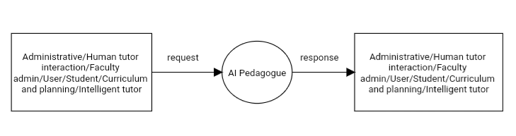

Figure 5.2 Context diagram (Level 0)

**Level 1 of Administrative**

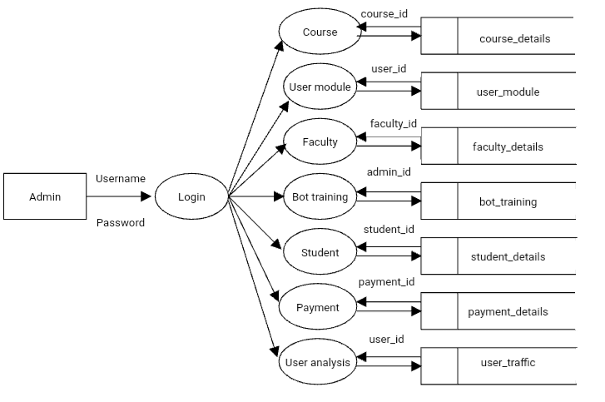

Figure 5.3 Level 1

Level 2 of Administrative

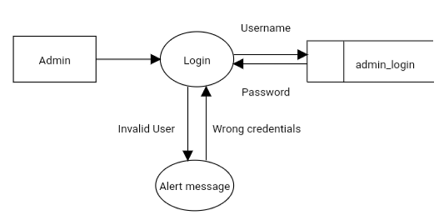

Figure 5.4 Level 2 (Admin)

Level 3ofAdministrative

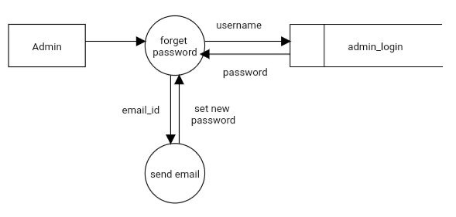

Figure 5.5 Level 3 (Admin)

Level 4 of Administrative

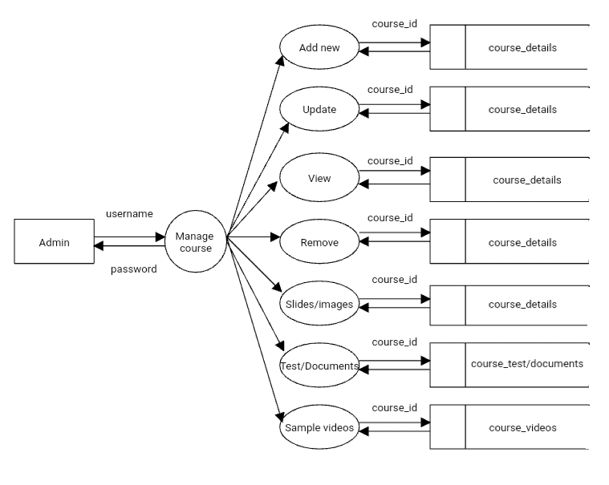Figure 5.6 Level 4 (Admin)

Level 5 of Administrative

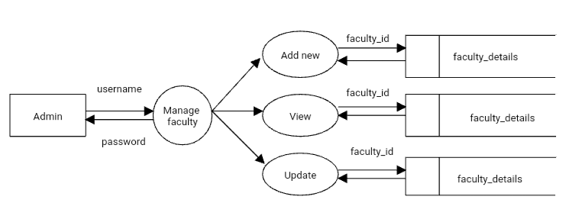

Figure 5.7 Level 5 (Admin)

Level 6 of Administrative

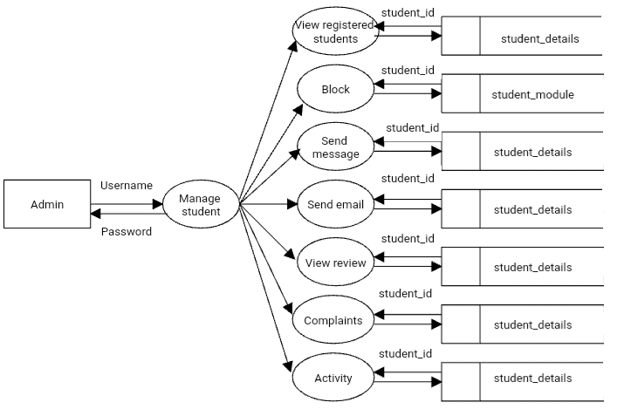

Figure 5.8 Level 6 (Admin)

Level 7 of Administrative

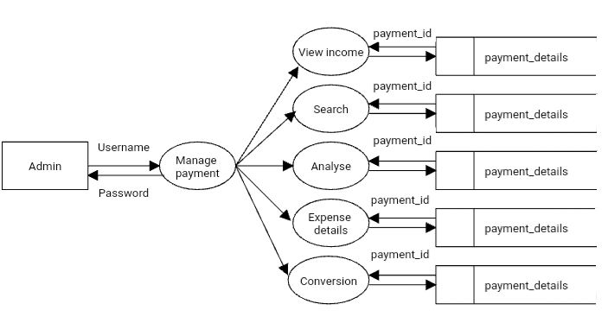

Figure 5.9 Level 7 (Admin)

Level 8 of Administrative

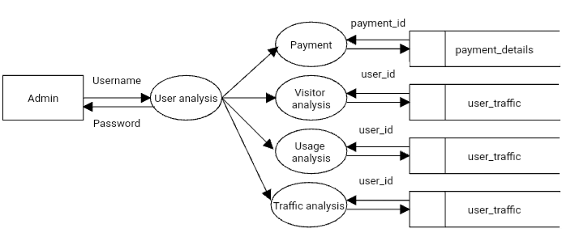

Figure 5.10 Level 8 (Admin)

**Level 1 of Human Tutor Interaction ( Bot Training )**

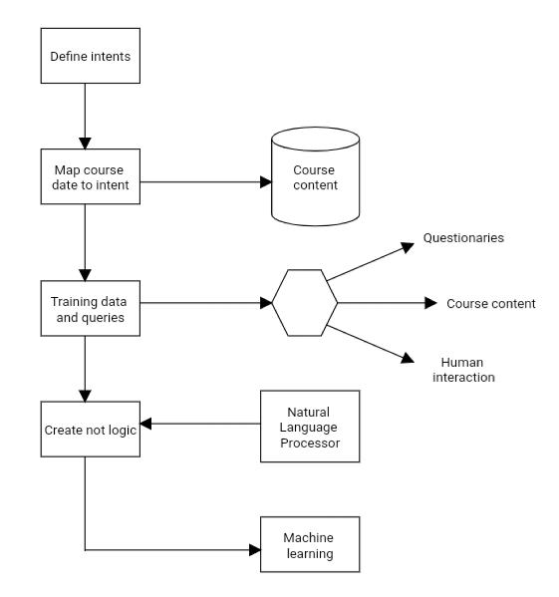

Figure 5.11 Level 1 (Human Tutor Interaction)

Level 2 of Human Tutor Interaction

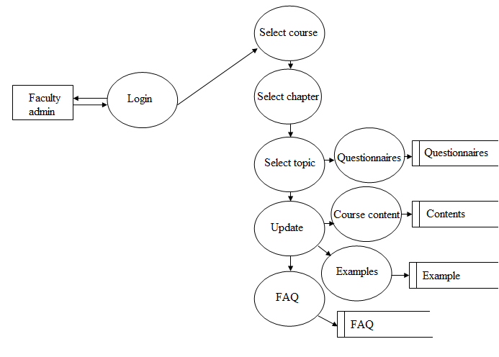

Figure 5.12 Level 2 (Human Tutor Interaction)