STOCK PRICE FORECASTING USING DEEP LEARNING
MODELS: AN APPLICATION OF LSTM AND DEEPAR
A Case Study of Cipla Ltd. (CIPLA.NS)
Project submitted to

CENTER FOR BUDGET STUDIES,CUSAT

Submitted by
Gopikrishna Jayan

ABSTRACT
Stock market forecasting has become an important application of artificial intelligence in finance. Accurate prediction of stock prices helps investors make better investment decisions and manage investment risk. This study aims to forecast the future stock performance of Cipla Ltd. using two deep learning models: Long Short-Term Memory (LSTM) and DeepAR.
Historical stock price data were collected from Yahoo Finance for the ticker CIPLA.NS, covering the period from January 2018 to June 2026. The LSTM model was used to predict future closing prices, while the DeepAR model was used to forecast future daily log returns, which were subsequently converted back into price levels. TensorFlow/Keras was used to implement the LSTM model, whereas PyTorch (GluonTS) was used for the DeepAR model. The performance of both models was evaluated using Root Mean Squared Error (RMSE), Mean Absolute Error (MAE), Mean Absolute Percentage Error (MAPE), and the R-squared (R²) statistic.
The results indicate that LSTM effectively predicts future stock prices, achieving a MAPE of 2.00% and an R² of 0.8650, while DeepAR provides useful probabilistic forecasts of daily log returns. The study concludes that both models are effective for short-term stock market forecasting and can support investors in making informed investment decisions regarding Cipla Ltd.
Keywords: Stock Market Forecasting, Deep Learning, LSTM, DeepAR, Cipla Ltd.

INTRODUCTION
The stock market is one of the most popular investment avenues for individuals and institutions. Investors purchase shares with the expectation of earning returns through price appreciation and dividends. However, stock prices change continuously due to company performance, economic conditions, government policies, and market sentiment. Therefore, predicting future stock prices has become an important area of financial research.
Investment decisions are also influenced by investor psychology. Behavioural factors such as herd behaviour, overconfidence, and loss aversion often affect investment decisions. Using data-driven forecasting models can reduce emotional bias and help investors make better financial decisions.
This study focuses on Cipla Ltd., one of India's leading pharmaceutical companies. Founded in 1935 by Dr. Khwaja Abdul Hamied and headquartered in Mumbai, Maharashtra, Cipla operates in more than 80 countries and is listed on both the National Stock Exchange (NSE: CIPLA.NS) and the Bombay Stock Exchange (BSE). The company has a strong presence across key therapeutic areas, including Respiratory, Cardiology, Oncology, HIV/AIDS, and Diabetes care, and possesses a long trading history that makes it well suited for time-series forecasting.
In this project, two deep learning models are used. The Stacked LSTM model predicts future closing stock prices directly, while the DeepAR model forecasts future daily log returns, which are then converted back into price levels. Historical stock price data were collected from Yahoo Finance, and the models were evaluated using RMSE, MAE, MAPE, and R². The study compares the performance of both models in short-term stock forecasting.
Stock prices fluctuate frequently, making investment decisions difficult. Traditional forecasting methods may not capture complex market patterns effectively. Deep learning models can learn from historical data and improve prediction accuracy. This study examines how LSTM and DeepAR can be applied to forecast the short-term performance of Cipla Ltd. and support informed investment decisions.

REVIEW OF LITERATURE
Hochreiter and Schmidhuber (1997) introduced the Long Short-Term Memory (LSTM) network, which solved the limitations of traditional recurrent neural networks by learning long-term dependencies in sequential data.
Nelson et al. (2017) used LSTM neural networks for stock market prediction and found that the model produced better forecasting accuracy than conventional neural network approaches.
Fischer and Krauss (2018) demonstrated that LSTM outperformed several traditional machine learning models in predicting financial market movements because it effectively captured complex time-series patterns.
Salinas et al. (2020) developed the DeepAR model for probabilistic time-series forecasting. The model predicts future values along with their uncertainty, making it useful for financial forecasting and risk analysis.

RESEARCH GAP
Most earlier studies focused on either stock price prediction or return prediction using a single model. This study combines a Stacked LSTM for direct stock price forecasting and DeepAR for probabilistic log-return forecasting, providing a broader analysis of Cipla Ltd.'s short-term market performance.

RESEARCH OBJECTIVES
- To predict the future closing prices of Cipla Ltd. shares using the Stacked LSTM deep learning model.
- To forecast the future daily log returns of Cipla Ltd. using the DeepAR model.
- To compare the forecasting performance of LSTM and DeepAR using RMSE, MAE, MAPE, and R².

RESEARCH METHODOLOGY
This study follows a quantitative research approach to forecast the future stock performance of Cipla Ltd. Two deep learning models, Stacked LSTM and DeepAR, were used to analyse historical stock market data and generate seven-day forecasts. The study is based on secondary data collected from Yahoo Finance. Historical daily closing prices of Cipla Ltd. (CIPLA.NS) were downloaded for the period January 2018 to June 2026, covering a total of 2,096 trading days.
The downloaded data were cleaned before model training. Missing values were removed and the closing price was selected as the primary variable for analysis. For the LSTM model, the closing prices were normalised using a MinMax Scaler, and a 120-day sliding window of past prices was used to predict the next day's price. For the DeepAR model, daily log returns were calculated from the closing prices and used to train the probabilistic forecasting model; the predicted returns were then converted back into closing price levels.
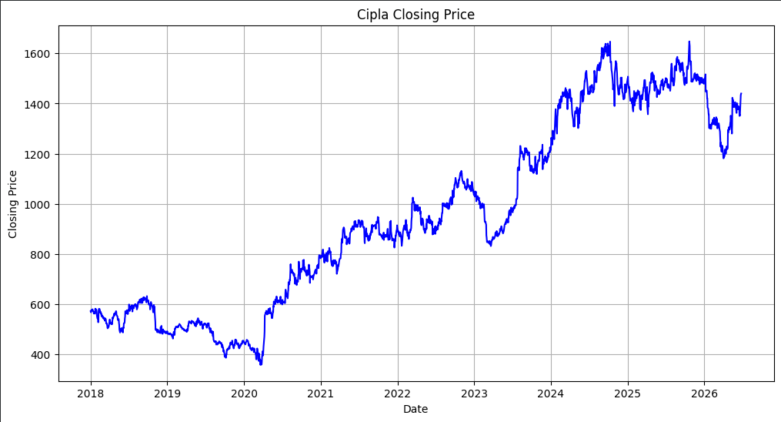
Figure 1: Cipla Ltd. Historical Closing Price (2018–2026)

Stacked LSTM Model
The Stacked LSTM model was developed using the TensorFlow and Keras libraries. LSTM is a type of Recurrent Neural Network (RNN) that is designed to learn patterns from sequential data and retain long-term information. The model architecture consisted of an input layer of the previous 120 days of normalised prices, followed by two stacked LSTM layers of 50 units each (with a dropout of 0.2 after each layer), and a final dense output layer that produces the predicted closing price. Early stopping was used to prevent overfitting.
Parameter | Value
Lookback Window | 120 Days
LSTM Units (per layer) | 50
Dropout | 0.20
Optimizer | Adam
Learning Rate | 0.0005
Epochs | 20
Batch Size | 32
Train–Test Split | 80% / 20%
Early Stopping | Patience = 10
Table 1: Stacked LSTM Model – Hyperparameters

DeepAR Model
The DeepAR model was implemented using the PyTorch framework via the GluonTS library. Unlike LSTM, which predicts the closing price directly, DeepAR generates probabilistic forecasts of daily log returns, allowing the model to estimate future returns while quantifying uncertainty through a Student-T output distribution. The forecasting pipeline converts historical prices into log returns, trains the DeepAR network on these returns, and finally converts the predicted returns back into forecasted closing prices.
Parameter | Value
Framework | PyTorch (GluonTS)
Context Length | 120 Days
Prediction Length | 7 Days
Hidden Size | 50
Recurrent Layers | 2
Batch Size | 32
Learning Rate | 0.001
Dropout | 0.20
Output Distribution | Student-T
Epochs | 100
Table 2: DeepAR Model – Architecture and Parameters

Evaluation Metrics
The forecasting performance of the models was evaluated using four standard metrics:
- Root Mean Squared Error (RMSE): Measures prediction accuracy by giving higher importance to larger errors.
- Mean Absolute Error (MAE): Measures the average difference between actual and predicted values.
- Mean Absolute Percentage Error (MAPE): Measures the prediction error in percentage terms.
- R-squared (R²): Measures how well the predicted values explain the variance in the actual values.
These metrics were used to compare the forecasting accuracy of the LSTM and DeepAR models.

RESULTS AND DISCUSSION
This chapter presents the forecasting results obtained from the Stacked LSTM and DeepAR models. Both models were trained using historical stock price data of Cipla Ltd. collected from Yahoo Finance.

LSTM Model Performance
The Stacked LSTM model was evaluated using RMSE, MAE, MAPE, and R².
36.94  RMSE | 28.33  MAE | 2.00%  MAPE | 0.8650  R²

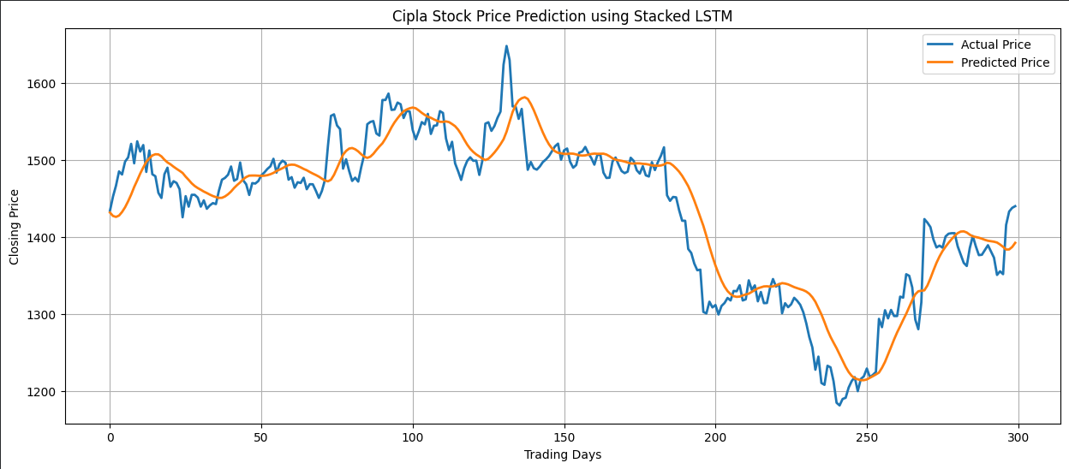
Figure 2: Actual vs Predicted Closing Price – Stacked LSTM
Interpretation: The predicted prices closely followed the actual stock prices during the testing period, with the model achieving a strong R² of 0.8650 and a low MAPE of 2.00%. The model successfully captured the overall price trend, including major upward and downward swings, showing that the Stacked LSTM is effective for short-term stock price forecasting.

DeepAR Model Performance
The DeepAR model was evaluated on the log-return scale using RMSE, MAE, MAPE, and R². These metrics are not directly comparable with LSTM's price-scale metrics, since DeepAR operates on daily log returns rather than absolute prices.
0.0225  RMSE | 0.0156  MAE | 1.98%  MAPE | -0.568  R²

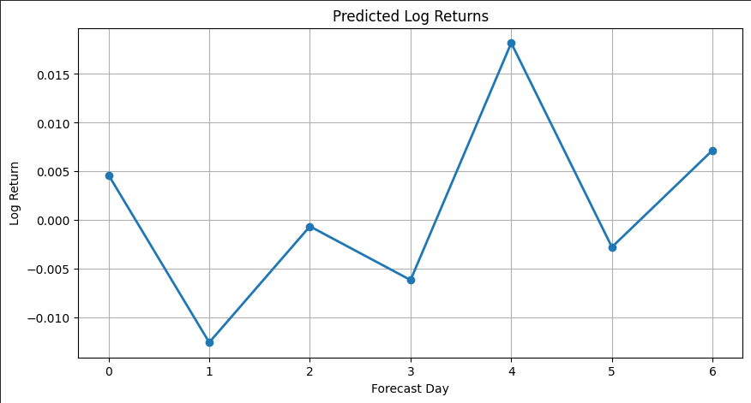
Figure 3: DeepAR – Predicted Log Returns (7-Day Horizon)
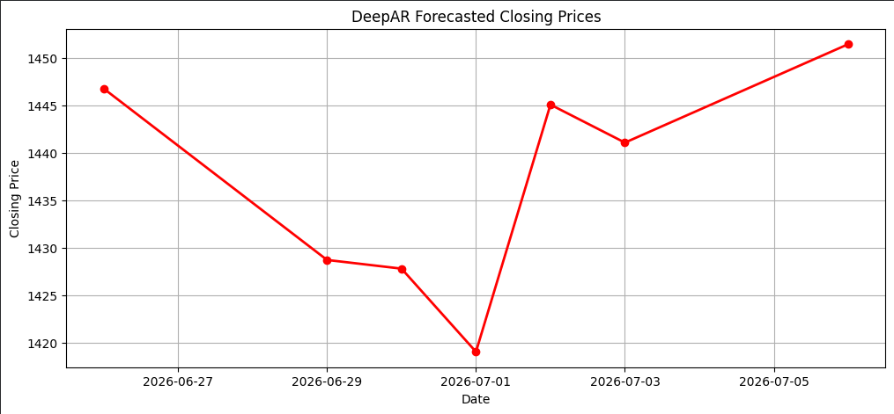
Figure 4: DeepAR – Forecasted Closing Prices (7-Day Horizon)
Interpretation: The DeepAR model predicted daily log returns within a narrow range, indicating that it effectively captured the normal fluctuations in Cipla Ltd.'s stock returns. The negative R² on the log-return scale is common when forecasting financial returns, since actual return values are very small and close to zero, making variance-based metrics like R² less informative; the MAPE of 1.98% nonetheless reflects a reasonably tight forecast on this scale. After conversion to price levels, the DeepAR model produced a stable, slightly upward-trending price path for the forecast horizon.

Seven-Day Forecast Comparison: LSTM vs DeepAR
The trained LSTM and DeepAR models were used to forecast the closing prices of Cipla Ltd. for the next seven trading days.
Date | LSTM Forecast (₹) | DeepAR Forecast (₹)
26-Jun-2026 | 1399.12 | 1446.78
29-Jun-2026 | 1403.99 | 1428.72
30-Jun-2026 | 1407.83 | 1427.80
01-Jul-2026 | 1410.94 | 1419.04
02-Jul-2026 | 1413.56 | 1445.08
03-Jul-2026 | 1415.83 | 1441.08
06-Jul-2026 | 1417.86 | 1451.46
Table 3: Seven-Day Forecasted Closing Prices – LSTM vs DeepAR
Observations:
- Both models successfully forecasted the next 7 trading days for Cipla Ltd.
- LSTM predicts the closing price directly, whereas DeepAR predicts daily log returns that are converted back into price levels.
- DeepAR forecasts are generally higher than LSTM's forecasts over the seven-day horizon.
- Both models indicate a relatively stable to slightly increasing price trend for Cipla Ltd.

DISCUSSION
The study successfully generated seven-day forecasts using both deep learning models. The Stacked LSTM model effectively predicted future stock prices by learning historical price patterns, achieving a strong fit (R² = 0.8650) on the testing data. The DeepAR model, in contrast, provided probabilistic forecasts of daily log returns, offering additional insight into the uncertainty surrounding Cipla Ltd.'s short-term returns.
Overall, the LSTM model is more suitable for direct stock price prediction and demonstrated superior historical accuracy, whereas the DeepAR model is useful for analysing expected returns and the associated investment risk. The two models' seven-day forecasts both point toward a stable-to-slightly-increasing price trend for Cipla Ltd., with DeepAR projecting marginally higher valuations than LSTM. Using both models together provides a more comprehensive understanding of Cipla Ltd.'s short-term stock performance.

WAY FORWARD
The findings of this study show that deep learning models can effectively forecast the short-term stock performance of Cipla Ltd. However, the accuracy of the models can be further improved by incorporating additional variables such as technical indicators (RSI, MACD, and Moving Averages), trading volume, and pharmaceutical-sector news sentiment (e.g., drug approvals, regulatory actions). Future studies may also compare the performance of LSTM and DeepAR with advanced deep learning models such as GRU and Transformer-based architectures. In addition, integrating real-time stock market data can make the forecasting system more useful for investors and financial analysts tracking Cipla Ltd.

CONCLUSION
Stock market forecasting is an important tool for investors to understand future market movements and make informed investment decisions. This study analysed the stock performance of Cipla Ltd. using two deep learning models, Stacked LSTM and DeepAR.
The LSTM model was used to predict future closing prices directly, while the DeepAR model was used to forecast daily log returns, which were converted back into price forecasts. Historical stock data collected from Yahoo Finance were used to train and evaluate both models. The LSTM model closely tracked the historical price trend, achieving an R² of 0.8650 and a MAPE of 2.00%, and produced reliable short-term price forecasts. The DeepAR model successfully predicted daily log returns and provided useful insights into short-term market uncertainty, despite the inherent difficulty of explaining variance in very small return values.
Overall, the study demonstrates that both LSTM and DeepAR are effective tools for stock market forecasting. While LSTM is suitable for predicting future stock prices with strong historical accuracy, DeepAR is useful for analysing expected returns and investment risk through a probabilistic lens. The combined use of these models provides a broader understanding of Cipla Ltd.'s stock market behaviour and supports better investment decision-making.
2  Models Compared | 7  Day Forecast Horizon | 86.5%  LSTM R² Score | 2.00%  LSTM MAPE

REFERENCES
Fischer, T., & Krauss, C. (2018). Deep learning with long short-term memory networks for financial market predictions. European Journal of Operational Research, 270(2), 654–669. https://doi.org/10.1016/j.ejor.2017.11.054
Hochreiter, S., & Schmidhuber, J. (1997). Long short-term memory. Neural Computation, 9(8), 1735–1780. https://doi.org/10.1162/neco.1997.9.8.1735
Cipla Limited. (2025). Annual Report 2024–25. https://www.cipla.com/investors
Nelson, D. M. Q., Pereira, A. C. M., & Oliveira, R. A. (2017). Stock market's price movement prediction with LSTM neural networks. In 2017 International Joint Conference on Neural Networks (IJCNN) (pp. 1419–1426). IEEE. https://doi.org/10.1109/IJCNN.2017.7966019
Salinas, D., Flunkert, V., Gasthaus, J., & Januschowski, T. (2020). DeepAR: Probabilistic forecasting with autoregressive recurrent networks. International Journal of Forecasting, 36(3), 1181–1191. https://doi.org/10.1016/j.ijforecast.2019.07.001
TensorFlow. (2025). TensorFlow documentation. https://www.tensorflow.org/
PyTorch. (2025). PyTorch documentation. https://pytorch.org/
GluonTS. (2025). GluonTS: Probabilistic time series modeling documentation. https://ts.gluon.ai/
Yahoo Finance. (2025). Cipla Limited (CIPLA.NS) historical market data. https://finance.yahoo.com/

