The Giant Panda

The giant panda, which only lives in China outside of captivity, has captured the hearts of people of all ages across the globe. From their furry black and white bodies to their shy and docile nature, they are considered one of the world's most loved animals.

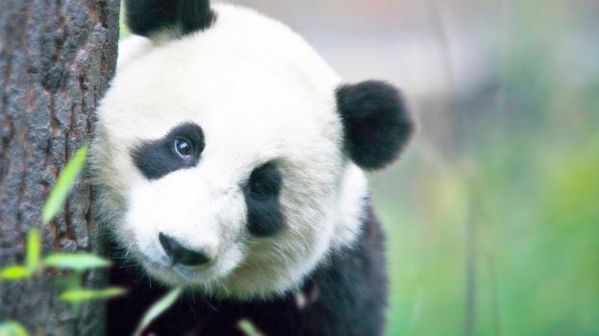

**Quick Fact** The estimated number of giant pandas in the wild varies between 1,500 and 3,000.

# Intriguing Giant Panda Mysteries

While most adore their fluffy fur and round heads, which help give them their cuddly bear quality, others are fascinated by the many mysteries of the giant panda. Did you know that the giant panda may actually be a raccoon, they have an opposable pseudo thumb, and that they’re technically a carnivore even though their diet is primarily vegetarian? These things and more have baffled scientists and naturalists for hundreds of years.

## Tiny Cubs

*An infant giant panda cub is about the size of a croissant, weighs less than a teacup and is about 900 times smaller than its mother. An average adult mother weighs around 91 kilograms (200 pounds) while newborn weighs only 83 to 190 grams (3 to 4 ounces).*

**Other Fun Giant Panda Facts**

1. Researchers have recently discovered that the gene responsible for tasting savory or umami flavors, such as meat, is inactive in giant pandas.
2. For many centuries, giant pandas were thought to be a mythical creature, like a dragon or unicorn.
3. Unlike other bears in the region, giant pandas don’t hibernate.